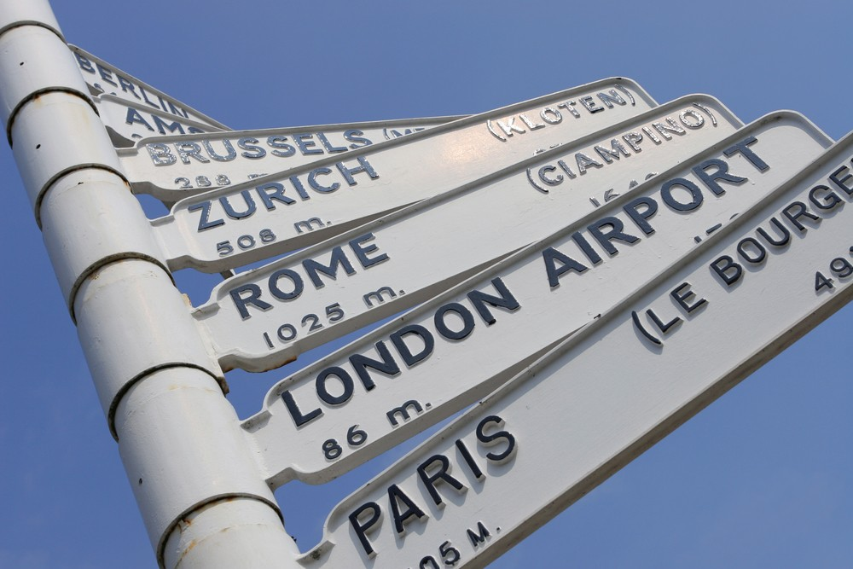

The Graduate Centre for Europe Eighth Annual Conference

‘Travelling Europe’: Interdisciplinary Perspectives on Place and Space

Wednesday 26th and Thursday 27th March 2014
Muirhead Tower, University of Birmingham

Guest Registration

Name:

Email address:

Institutional affiliation (Department and University):

Level of study (Masters/PhD; First/Second/Third/Writing-Up):

Subject area:

Dietary requirements:

Attending Wednesday (Yes/No):

Attending Thursday (Yes/No):

Please return your completed form to gcfe@contacts.bham.ac.uk

