Andrea Mulas – Postgraduate Travel Grant Report

My Postgraduate Travel Grant allowed me a research visit to the University of Virginia, for the duration of 1 month, in the laboratory of a collaborator (Prof. Lin Pu). It has been a successful experience, as I have been able to meet students and researchers of one of the top public American universities, and experience a different lifestyle and working attitude. I got to know the way the researchers in the group of the collaborator perform their experiment and I could use this new knowledge to carry out some important experiments that will be included in my thesis and in a future publication in collaboration between the two groups.

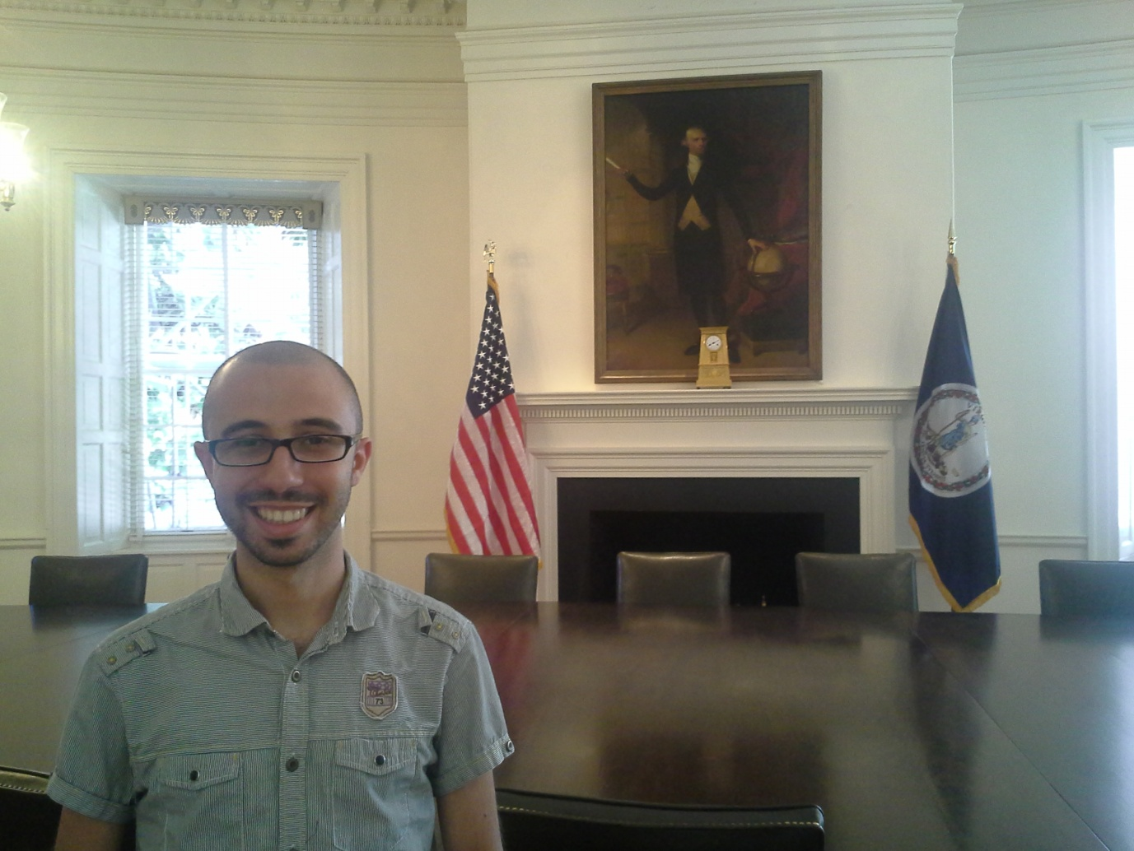
Picture taken inside the main hall of the University of Virginia

