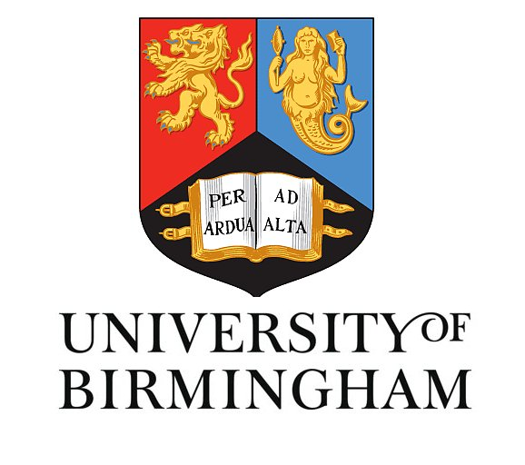
Antoine Sallustrau
3rd Year PhD
Tucker group
School of Chemistry
University of Birmingham

ISBOMC 2012 conference report

The 6th International symposium on Bioorganometallic chemistry conference, organised by Prof. Heintz-Bernhard Kraatz, was taking place at the university of Toronto Scarborough in Canada from the 8th to the 12th of July 2012. This meeting brought together international scientists to discuss about new advances in supramolecular chemistry, drug discovery, therapeutics and diagnostics. Most of the biggest names in these domains gave outstanding presentations on those subjects.

As an example of talk, directly linked to my subject of research, Prof. Anne Vessieres presented the development of new organometallic drugs bases and the use of metal carbonyl complexes for quantification of tracers. Her group synthesised ferrocenyl derivatives that showed major anti-proliferative effects on different types of cancer cells.
Another interesting presentation done by Prof. Severin summarised the synthesis of receptors and sensors for specific analytes like lithium, chloride or fluoride involving organometallic transition complexes like ruthenium or rhodium.
Prof. Romao brought attention to carbon monoxide (CO). This gas is known to be lethal but if the doses administrated are controlled, it can bring beneficial therapeutic effects on a variety of diseases issues like organ transplant, myocardial infarcts and many others. Some really interesting CO-Releasing Molecules (CORM) based on Ruthenium complexes have been developed by his group and showed promising results.

Moreover, I presented a poster of my work that attracted attention. Propositions of postdocs were mentioned as well, leading to really interesting and productive discussions.

