Conference Report
by Damian Weske
I was awarded a travel bursary from the School of Chemistry at the University of Birmingham to attend the RSC Macrocyclic and Supramolecular Chemistry Meeting 2012. This meeting was held at the School of Biological and Chemical Sciences, Queen Mary, London from the 17th to the 18th of December 2012. This is most important national conference in my working area. As I am in my final year of PhD this was a great opportunity to present my work and meet the leading experts and colleagues in this particular field of research. The atmosphere was electric with interesting work presented by speakers from all over the world. In this fruitful environment new ideas came straight away.
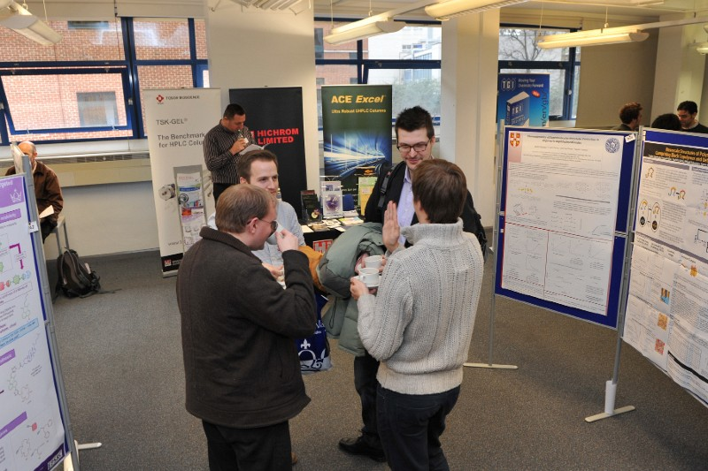
I presented my work in a flash talk during the conference and received very good feedback, as well as new suggestions for my project. I felt that my hard work over the past years was recognized.
All this would not have been possible without the generous contribution of the School of Chemistry to cover the costs to be able to attend this event. Thank you very much!

