Conference Report
by Natalia Calle Alonso
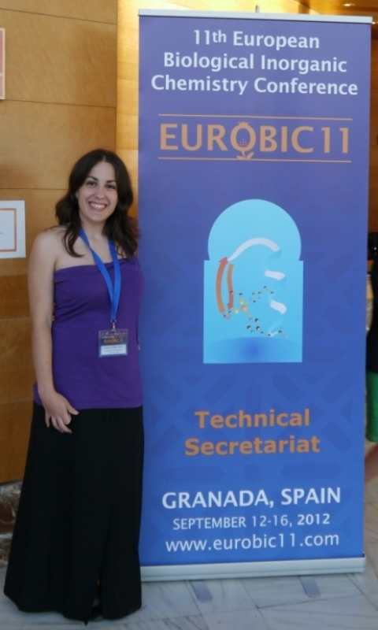
In April 2012 I was awarded a travel bursary from the School of Chemistry at the University of Birmingham to attend the 11th European Biological Inorganic Chemistry Conference being held in Granada (Spain) from the 12th to the 16th of September 2012. This is one of the most important conferences in the field I work in. As I am in my final year of PhD this was a great opportunity for networking during lunch, coffee breaks and poster sessions. The environment was great and full of good thinking with over 380 delegates from all over the world. There were 9 plenary lectures and 28 keynote talks given by some of the most renowned scientists in the bio-inorganic chemistry area.
When I presented my work I received many compliments and suggestions. This part was great as I felt that my contribution to the conference was not futile and that the hard work I have been doing during the last few years was recognized as good quality work.
All this would not have been possible without the generous contribution of the School of Chemistry to cover some of the costs to be able to attend this event. Thank you very much!

