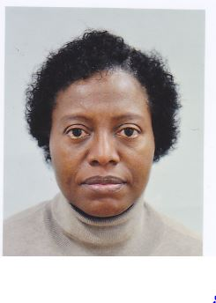This year’s annual meeting of the Clay Mineral Society marked the 50th anniversary of the society and it was held from October 6th-10th 2013 in the Urbana Champaign campus of the University of Illinois, USA. It attracted academics and professionals of different branches of science from different countries, with keen interest in clay science and technology.
I had the privilege of making an oral presentation on modified clays for environmental applications, with particular focus on waste water treatment or remediation. In addition I listened to a number of presentations that were made by colleagues from different scientific background, with common interests in utilising clay for a variety of productive purposes such as; Modified Clays for environmental Application, CO₂ sequestration, formation of land fill barriers, for drilling & mining and many more. All of which showed that the world of clay mineralogy is actively involved in sustainable development and environmental protection. I was particularly excited to observe that the trend of most researches presented, are geared towards environmental remediation which is the ultimate objective of our research study.
In the course of the conference, I had the opportunity to: interact with experts with similar research interests including those that have been referenced over and over in related literatures; have close contact and relationship with and exchange ideas with colleagues of similar research interest. I also made a field trip to Starve rock and Mathiessien State Park where we viewed and learnt about some geologic features in their natural setting and the mineral resources of the area.
I appreciate my supervisor Dr I.J Shannon for the opportunity given me to present at this remarkable conference. I also acknowledge the School of Chemistry, University of Birmingham for the support given me.

