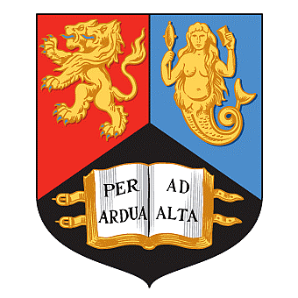

SCHOOL OF CHEMISTRY
School seminar

PROFESSOR ROBIN PERUTZ,
FRS
UNIVERSITY OF YORK

THE CHALLENGE OF CO₂ REDUCTION: CONVERSION OF SOLAR ENERGY TO CHEMICAL ENERGY OF FUELS

HAWORTH 203

FRIDAY, 2ND NOV 2012

3PM

Host: DR Z PIKRAMENOU

