

Centre for Human Brain Health

Annual Report 2024

We discover
We activate
birmingham.ac.uk

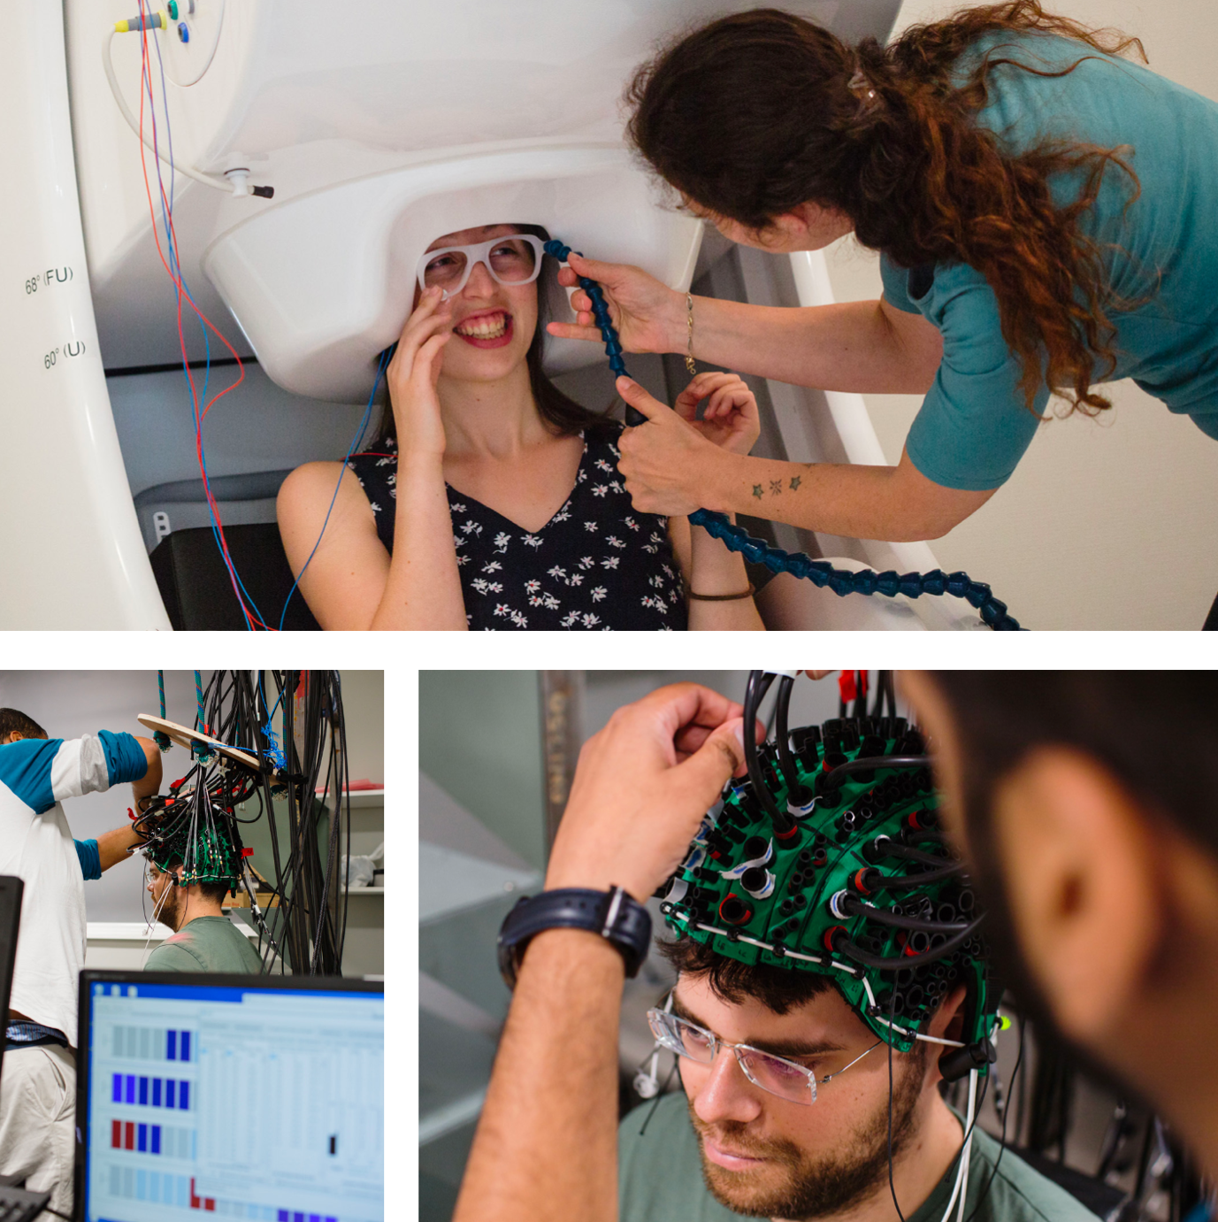

Foreword from the Co-Directors

It is with great pleasure that we present the 2024 Annual Report for the Centre for Human Brain Health (CHBH). This year has been one of significant expansion and development for the centre. Our sleep and brain stimulation laboratories have undergone significant upgrades, providing new opportunities for impactful research across our six research themes. CHBH members have had substantial funding success, and we have welcomed several new PIs to our vibrant human neuroscience community.

We extend our sincere thanks to the entire CHBH team – researchers, professional services staff, and students – for their dedication and contribution to our collective success. This year has also seen the departure of one of our founding Co-Directors, Professor Ole Jensen. Ole’s leadership and collegiate approach will be missed, but we wish him well in his new role at the University of Oxford and look forward to continued and new collaborations.

This report highlights the breadth and depth of research conducted at the CHBH, showcasing research projects including the development of state-of-the-art neuroimaging sensors, infant neuroimaging and brain-computer-interfaces that span the full spectrum of human brain health across the lifespan.

In 2024, the CHBH received a substantial £10 million in funding from funders including Wellcome Leap, the Medical Research Council, and the Biotechnology & Biological Sciences Research Council. This funding will support research on a range of topics, including predicting chronic pain after surgery, the neural mechanisms and modulation of skilled movement planning, emotional processing in infants, and spinal signals underlying human motivation. This investment underscores the quality and importance of the research being conducted at the Centre. We are also delighted to have welcomed several new Principal Investigators to the CHBH team, including Dr. Enrico Amico from the School of Mathematics, Dr. Rickson Mesquita and Dr. Jian Liu from the School of Computer Science, and Dr. Giulia Orioli from the School of Psychology. These new colleagues bring unique expertise including advanced network analysis, optical imaging, computational neuroscience and developmental neuroscience, contributing to the interdisciplinary strength and profile of our Centre.

We are equally proud of our contributions to education and training. The launch of our new MSc programme in Cognitive Neuroimaging and Data Science MSc (CNDS), taught by PIs at the CHBH, attracted a talented cohort of students and provides them with hands-on experience in cutting-edge neuroimaging methods and data analysis.

One of the highlights this year was the hosting of six international conferences and workshops led by core PIs at the CHBH. These events focussed on a range of topics including cognitive control processes, computational social cognition, neuroimaging and neurorehabilitation. CHBH researchers played a pivotal role in spearheading knowledge exchange and forging new partnerships within academia, as well as developing links across sectors with clinicians, patients and industry.

In the coming years, CHBH is well-positioned to continue making significant strides in basic and translational human brain research. We invite you to explore this report and learn more about some of the research highlights at the Centre in 2024.

Katja and Andy, CHBH Co-Directors 2024



Professor Andrew Bagshaw

Email: a.p.bagshaw@bham.ac.uk
LinkedIn: andrew-bagshaw-3313821ab/
Bluesky: bagshaap.bsky.social



Dr Katja Kornysheva

Email: k.kornysheva@bham.ac.uk
X: @KatjaKornysheva
Website: sites.google.com/site/kkornysheva

Centre for Human Brain Health

The Centre for Human Brain Health (CHBH) is a leading research facility focused on understanding the human brain, its healthy functioning, and how to maintain and restore it. The Centre aims to break down traditional academic and clinical boundaries to gain insights into brain health across the lifespan, from childhood to late adulthood. With a diverse interdisciplinary team and cutting-edge brain imaging technologies, CHBH conducts research on the influence of lifestyle, developmental, and societal factors on brain health. The Centre’s research is supported by a broad range of funding bodies and its findings are regularly published in prestigious journals, making significant contributions to the field of human neuroscience.

Since inception, the CHBH has generated funding from a wide range of sources, our top funders being:

- European Commission
- The Wellcome Trust
- Medical Research Council (MRC)
- National Institute for Health and Care Research (NIHR)
- Engineering & Physical Science Research Council (EPSRC)
- Ministry of Defence
- Biotechnology & Biological Sciences
- Research Council (BBSRC)
- Economic & Social Research Council (ESRC)
- The Royal Society
- Home Office

£10 million total funding in 2024

Our largest funders in 2024 include:

Wellcome Leap Inc.
Biotechnology & Biological Sciences (BBSRC)
Medical Research Council (MRC)
Engineering and Physical Science Research Council (EPSRC)
Leverhulme Trust
The Academy of Medical Sciences

CHBH research themes

- Lifespan and Brain Health
- Cognitive Computational Neuroscience
- Social Interaction and Communication
- Learning, Memory and Performance
- Awareness, Consciousness and Sleep
- Neuroimaging Methods and AI

The Centre for Human Brain Health: (CHBH) is committed to pioneering research that transforms our understanding of the human brain and its complex functions. Our mission is to enable basic human neuroscience research and translation. By fostering an inclusive, internationally collaborative and interdisciplinary environment, we bring together world-class researchers from diverse fields to tackle the most pressing challenges in human neuroscience.

Research facilities within the CHBH

The Centre is home to state-of-the-art brain imaging facilities, which are used to uncover the mechanisms supporting cognition in both the healthy and the dysfunctional brain. These include:

- Magnetic Resonance Imaging (MRI), providing a range of options for stimulus delivery and physiological and behavioural recordings
- Magnetoencephalography (MEG), which allows for continuous recordings of ongoing brain activity with a millisecond time resolution and advanced analysis tools to identify where in the brain the measured electrophysiological activity is generated
- Electroencephalography (EEG), three high-performance EEG laboratories for accurate timing and application of auditory and visual stimulation (concurrently or separately)
- Sleep laboratories, equipped with 32-channel EEG amplifiers and peripheral equipment for experimental testing and stimulus delivery. Biological sampling capability includes single assessment urine, saliva and blood or continuous sampling of blood via an in-dwelling intravenous line.
- Functional Near-Infrared Spectroscopy (fNIRS), housing the Imagent (v2) system that allows non-invasive functional imaging of the brain
- Optically Pumped Magnetometer (OPM) laboratory, where we are developing new sensors to be used for magnetoencephalography (MEG) using quantum technology, as well as installing a whole-head system using commercial sensors for adult and paediatric neuroimaging.
- Non-Invasive Brain Stimulation, housing the equipment required for both transcranial magnetic (TMS) and electrical (TES) non-invasive brain stimulation experiments as well as new Focused Ultrasound Stimulation (FUS) equipment, which has the capability to combine ultrasound brain stimulation with fMRI

Access our facilities

The CHBH is a university facility and all of these modalities and collaborative expertise are available for the university community, so get in touch if you’re interested.

Contact us:

Email: chbh@contacts.bham.ac.uk
X: @theCHBH
Website: birmingham.ac.uk/chbh

Participate in brain research at the CHBH: birmingham.ac.uk/research/ centres-institutes/human-brain- health/participate

To find out more, contact us: birmingham.ac.uk/chbh

Welcoming new principal investigators to the CHBH team

Over the past year we’ve welcomed several new colleagues who bring exciting new approaches to the CHBH. We’ve also cemented our relationships with other Centres and Institutes within and external to the University, to develop a vibrant community of brain researchers.

Dr Rickson Mesquita
Associate Professor in Computer Science, School of Computer Science

Dr Mesquita obtained his PhD at the University of Campinas in Brazil, followed by a postdoctoral position at the University of Pennsylvania, USA. He moved back to Brazil as an Assistant and Associate Professor at the Institute of Physics of the University of Campinas for over 13 years before joining the University of Birmingham as an Associate Professor in September 2023.
Rickson’s research is focused on the development of instrumentation and data analysis methods using non-invasive optical imaging for functional and clinical neuroscience. He is particularly interested in measuring cerebral blood flow with diffuse correlation spectroscopy (DCS) and translating these techniques to clinical settings. These approaches are developed alongside novel algorithms for accurate quantification of cerebral oxygenation using functional near-infrared spectroscopy (fNIRS), as well as the integration of fNIRS/DCS with other modalities
to quantify neurovascular coupling, oxygen consumption, and other neurophysiological quantities relevant for clinical contexts. Together, these efforts and collaborations have fostered opportunities to address relevant neuroscience challenges, including the functional correlates of brain plasticity in several contexts, ranging from development to disease prognosis and rehabilitation.

Email: r.c.mesquita@bham.ac.uk
X: @mesquitarc
Website: rcmesquita.github.io

Dr Enrico Amico
Assistant Professor in Applied Mathematics, School of Mathematics

Enrico is a physicist by training, turned into a network neuroscientist during his PhD and Postdoctoral research. After earning his Bachelor’s and Master’s in Physics in 2012 from Federico II University in Napoli, Italy, Enrico enrolled in a joint PhD programme between the Coma Science Group of Professor Steven Laureys, University of Liège, and the Marinazzo Lab at the University of Ghent, Belgium. During his four years there as a PhD student he mainly focused on implementing new methods for brain connectivity assessment across levels of consciousness. In 2016, he joined the CONNplexity Lab (headed by Professor Joaquín Goñi) as a postdoctoral researcher, where he made contributions on proposing new network science models for functional and structural brain connectomics. From 2020 to 2024, Enrico was an SNSF Ambizione Fellow at EPFL and University of Geneva (hosted by Professor Dimitri Van de Ville).

Enrico is currently the director of the AMICO Lab at the University of Birmingham, where he and his team explore different research lines in brain networks and complex systems.

His research areas include network neuroscience, brain connectomics, computational neuroimaging, and complex systems.
Email: e.amico@bham.ac.uk
X: @enri_amico
Website: amicolab.org

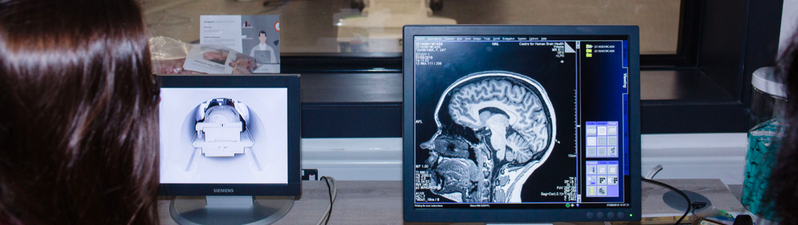

Dr Giulia Orioli

Assistant Professor in Psychology, School of Psychology

Giulia completed her PhD at the University of Padova, in Italy, under the supervision of Professor Teresa Farroni. Her doctoral thesis investigated newborns’ and infants’ representation of peripersonal space, i.e. the space immediately surrounding the body, where every human action and interaction take place. After her PhD, Giulia was a postdoctoral research associate at Goldsmiths, University of London, and at the University of Birmingham, working with Professor Andy Bremner. Before joining the School of Psychology as an Assistant Professor in March 2024, she held a Leverhulme funded Early Career Fellowship at the University of Birmingham, investigating how newborns and infants develop the understanding of the complex relationships between their bodies and selves and the external world.

Giulia is a developmental cognitive neuroscientist working with infants in their first year of life and in particular with newborns. Her research investigates how from very early on in life newborns and infants begin to perceive themselves as integrated in the world around them, by investigating the development of the relationship between the body and the physical and social space surrounding it. To investigate these topics, Giulia uses a variety of infant-friendly behavioural and neuroimaging techniques, including eye tracking, EEG, and OPM-MEG.
Email: g.orioli@bham.ac.uk
X: @GiuliaOrioli
Bluesky: @giuliaorioli.bsky.social

Dr Jian Liu

Associate Professor in Computer Science, School of Computer Science

Jian Liu received his PhD in Mathematics from UCLA, where he worked with Dean Buonomano on neural network modelling.
His research interests include fundamental questions of neural computation, computational neuroscience, and brain-inspired computation for intelligence, where he analyses experimental data of neuronal recordings and behaviours from animals
and humans.

Email: j.liu.22@bham.ac.uk
X: @JianKLiuNC
Websites: sites.google.com/site/jiankliu

Research Highlights

URKI Future Leaders Fellowship

CHBH research themes: Learning, memory and performance, and Neuroimaging methods and AI

The brain is not just sitting idle when we are about to initiate an everyday action such as tying shoelaces or handwriting – skills most people take for granted. Instead, neural patterns during planning are like an instructive code, directly linked to the following action. Unfortunately, current approaches to movement rehabilitation do not take this into account. Instead, the focus is normally on time-intensive repetitive movement exercises, sometimes combined with invasive brain surgery to restore motor function. Katja Kornysheva, Associate Professor and Co-Director of the CHBH set out to address this limitation in her UKRI Future Leaders Fellowship awarded in 2024. This provides £2.2M of funding over four years with the prospect for follow-on funding up to seven years.

The UKRI FLF project will assemble an interdisciplinary team that will use state-of-the-art neuroimaging and neurostimulation techniques to study the neural basis of skilled action
planning and develop non-invasive neurotechnological tools that modify neural patterns prior to movement initiation to assist neurorehabilitation. The research programme will enable Kornysheva’s team at the CHBH to simultaneously explore fundamental neuroscientific hypotheses and drive clinical advancements toward neurorehabilitation tools that enhance recovery for patients with diverse neurological and neurodevelopmental conditions impacting movement planning and coordination.

Dr Katja Kornysheva
Associate Professor and Head of Skilled Action & Memory Lab

Email: k.kornysheva@bham.ac.uk
X: @KatjaKornysheva
Website: sites.google.com/site/kkornysheva

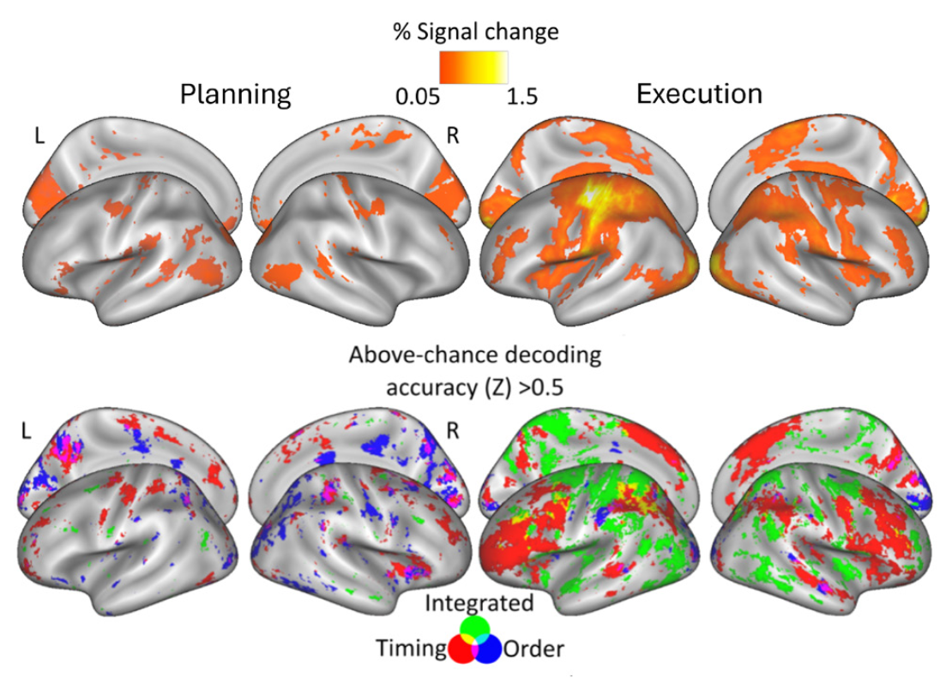


Research Highlights
Wellcome Leap
CHBH research theme: Life span and brain health

The opioid crisis is a global public health emergency, affecting millions of individuals and communities worldwide. Each year, approximately 310 million major surgeries are performed globally, including 6 million in the UK. For many, opioids are first encountered when prescribed for post-surgery pain relief. Alarmingly, the UK filed more opioid prescriptions in 2019 than any other country. While most individuals discontinue opioid use without issues, some become trapped in addiction. Identifying these vulnerable subgroups offers critical insights for risk assessment and targeted interventions to address the crisis.

Ali Mazaheri, Associate Professor at the CHBH, has been awarded a multi- million-pound contract from the Wellcome Leap Untangling Addiction Program to investigate how neurobiological, cognitive, and metabolic profiles can be integrated to screen patients most at risk of developing addiction to opiate-based prescription painkillers after major surgery. He is leading a multidisciplinary team of University of Birmingham researchers from the CHBH, School of Psychology, the Institute for Inflammation and Ageing, and the Institute of Cancer and Genomic Sciences, along with University Hospitals Birmingham NHS Foundation Trust. By building detailed patient profiles, the team aims to better understand how individuals respond to pain management, enabling clinicians to design personalised pain management plans that support recovery while minimising the risk of addiction.
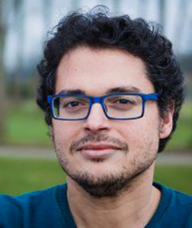
Dr Ali Mazaheri, Associate Professor at the CHBH and Head of NeuroResilience Lab

Email: a.mazaheri@bham.ac.uk
LinkedIn: ali-mazaheri-b2b0a1110
Website: acornstudy.co.uk/


Research highlights

Contributions of key brain areas during development for reward learning in young children

CHBH research themes: Lifespan and brain health, Cognitive computational neuroscience, Learning and memory and performance

How do different brain regions contribute to children’s developing ability to learn from feedback? This study investigates the distinct roles of the hippocampus and striatum in value-based learning, with a focus on how feedback timing affects decision-making. We followed a group of children over two years, assessing how immediate versus delayed feedback influenced their learning processes. By using computational models and functional magnetic resonance imaging (fMRI) scans, we examined how structural changes in the brain support learning behaviors during this crucial developmental stage.

Findings indicated that the hippocampus, typically associated with memory formation, was linked to improved learning from delayed feedback, similar to patterns observed in adults.

However, unlike in adults where the striatum primarily supports immediate feedback processing, children’s striatal volume was associated with learning from both immediate and delayed feedback, suggesting a more generalized role for the striatum in early development. Throughout the study, children’s decision- making grew increasingly goal-directed, reflecting maturing learning strategies. These results indicate an early cooperative interaction between the hippocampal and striatal systems that may lay the foundation for more specialised functions as the brain matures. This research sheds light on how children learn from experiences across different timescales and has potential implications for tailoring educational feedback to align with developmental stages, optimising learning efficacy.

Dr Lei Zhang,
Associate Professor, Director of Postgraduate Research, School of Psychology

Email: l.zhang.13@bham.ac.uk
X: @lei_zhang_lz
LinkedIn: leizhang-lz

Falck, J., Zhang, L., Raffington, L., Mohn, J. J., Triesch, J., Heim, C., & Shing, Y. L. (2024). Hippocampus and striatum show distinct contributions to longitudinal changes in value-based learning in middle childhood. Elife, 12, RP89483. doi.org/10.7554/eLife.89483.3

Research highlights

International Collaboration Unveils the Brain Structural Correlates of Conduct Disorder in Youth

CHBH research theme: Lifespan and brain health

Conduct disorder (CD) is a psychiatric disorder diagnosed in children and adolescents, with a prevalence of 4.6% in 5-19-year-olds in the UK. Youth with CD display persistent and repetitive rule-breaking
and aggressive behaviours such as lying, stealing, fighting, setting fires, property destruction and bullying. Importantly, in children aged 0-14 years, CD carries the highest burden of any mental disorder in childhood, yet its neurobiological underpinnings remain unclear. Prior research on brain structural changes associated with CD have been limited by small sample sizes and varied methodologies, leading to inconsistent findings.

To address these gaps, the ENIGMA (Enhancing NeuroImaging Genetics Through Meta-Analysis)-Antisocial Behavior working group launched a large-scale study using harmonised methods. Co-led by Professor Stephane De Brito and Dr Yidian Gao, the study pooled MRI data from 27 research groups and 104 scientists based in 20 countries across Europe, Asia, North and South America. This collaboration established the largest neuroimaging dataset of CD to date, comprising 1,185 youth with CD and 1,253 typically developing controls, including a substantial representation of female participants (339 girls with CD and 446 typically developing girls).

The findings, published in The Lancet Psychiatry, reveal widespread reductions in cortical surface area across 26 brain regions and smaller subcortical volumes (i.e., amygdala, nucleus accumbens, hippocampus, and thalamus) in youth with CD compared to typically developing peers. Additionally, increased cortical thickness was observed in the caudal anterior cingulate cortex and the banks of the superior temporal sulcus. Most of these differences remained significant after adjusting for ADHD comorbidity and IQ. Minimal differences were observed between DSM-defined CD subtypes based on age of onset or the presence of callous-unemotional traits; however, those with high callous-unemotional traits (i.e., lack of empathy and remorse, arrogance and being manipulative) showed more extensive differences from controls than those with lower levels of callous-unemotional traits.

This study provides robust evidence of subtle yet widespread brain structural alterations in youth with CD across subtypes and sexes, identifying brain structural differences primarily in cortical surface area. This study contributes to a growing body of research calling for increased attention to this under-recognised disorder in both research and clinical practice.


Professor Stephane De Brito

Professor of Developmental Psychopathology and Neuroscience, School of Psychology

Email: s.a.debrito@bham.ac.uk
X: @SCAN_Lab
LinkedIn: stephane-de-brito-b4422367

Dr Yidian Gao

Postdoctoral Researcher, School of Psychology
Email: yidiangao2017@gmail.com
X: @gao_yidian
LinkedIn: yidian-gao-16b81524a

Gao, Y.*, Staginnus, M.*, Townend, S., Arango, C., Bajaj, S., Banaschewski, T., Barker, E. D., Benegal, V., Berluti, K., Bernhard, A., Blair, R. J. R., Boateng, C. P. S., Bokde, A. L. W., Brandeis, D., Buitelaar, J. K., Burt, S. A., Cardinale, E. M., Castro-Fornieles, J., Chen, H., Chen, X., Chester, S. C., Colins, O. F., Cornwell, H., Craig, M., Cubillo, A. I., Desrivieres, S., Díaz, D. E., Dietrich, A., Dong, D., Dykstra, A. H., Franke, B., Freitag, C. M., Glennon, J. C., Gonzalez-Madruga, K., Hagan, C. C., Hoekstra, P. J., Holla, B., Hyde, L. W., Ibrahim, K., Jabeen, N., Jackson, R. L., Jiang, Y., Kohls, G., Konrad, K., Kypta-Vivanco, A., Lamers, K., Ma, R., Marsh, A. A., Martinelli, A., Martinot, J.-L., Michalska, K. J., Ming, Q., Minosse, S., Mitchell, C., Monk, C. S., Murphy, D., Mycue, L. E., Naaijen, J., Oosterling, M., Passamonti, L., Pauli, R., Penzol Alonso, M. J., Phillips, H., Ploe, M. L., Raschle, N. M., Roberts, R., Rogers, J. C., Rosa-Justicia, M., Sagar-Ouriaghli, I., Schulze, U. M. E., Schumann, G., Sethi, A., Smaragdi, A., Sonuga-Barke, E. J. S., Stadler, C., Stevens, M. C., Sukhodolsky, D. G., Sully, K., Sun, X., Toschi, N., Townsend, C. D., van der Wee, N. J. A., Vermeiren, R., Viding, E., Wang, X., Westerman, H. B., Wu, Q., Yao, S., Zhang, J., Zhou, J., Zhou, J., Jahanshad, N., Thomopoulos, S. I., Ching, C. R. K., Kang, M. J. Y., Thompson, P. M., Klapwijk, E. T., Pine, D. S., Baskin-Sommers, A., Cecil, C. A. M., Aghajani, M., Walton, E., Fairchild, G., & De Brito, S. A. (2024). Cortical structure and subcortical volumes in conduct disorder: a coordinated analysis of 15 international cohorts from the ENIGMA-Antisocial Behavior Working Group. The Lancet Psychiatry, 11(8), 620-632. doi:10.1016/S2215-0366(24)00187-1

Research highlights

Next-generation quantum sensors detect human biomagnetism

CHBH research theme: Neuroimaging methods and AI

CHBH researchers are advancing the development of next- generation quantum-based sensors for brain imaging. Optically pumped magnetometers (OPMs) are super-sensitive magnetic field sensors capable of detecting brain activity. However, due to their sensitivity, they also record magnetic noise generated by electrical devices and urban traffic, even when the noise source is far from the brain. Harry Cook, PhD student at the Quantum Neuroscience Lab, led by Dr Anna Kowalczyk and Professor Giovanni Barontini, has demonstrated the potential of optically pumped magnetic gradiometers (OPMG) for brain applications (PhysicsWorld).

The OPMG developed by the team at the CHBH is designed to selectively record brain signals while suppressing interference from external sources such as cars, lifts, and electronics and it is also more resilient to higher magnetic fields. The team aims to study connectivity in the brain by measuring its reaction to a controlled stimulus, such as those delivered via transcranial magnetic stimulation (TMS). TMS is a non-invasive brain stimulation method that uses high magnetic field pulses to induce or suppress neuronal activity. It is extremely challenging to build a sensor able to survive in the vicinity of TMS pulses, and even harder to make one that can record the brain signals few milliseconds after the pulse. However, the OPMG sensor is designed to be compatible with this method. The CHBH team is making great progress in finalising the new prototype and will be testing the system early next year.

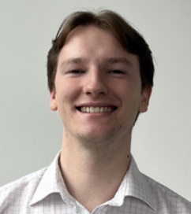
Harry Cook
PhD Student, University of Birmingham
Email: hxc214@student.bham.ac.uk
LinkedIn: harrycook3
X: x.com/HarryCook38
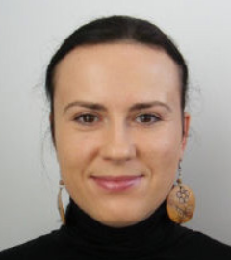
Dr Anna Kowalcyzk,
Assistant Professor, School of Psychology
Email: a.u.kowalczyk@bham.ac.uk
LinkedIn: anna-kowalczyk-a78a5b94
X: x.com/QN_lab


Professor Giovanni Barontini
Professor of Physics,
School of Physics and Astronomy
Email: g.barontini@bham.ac.uk

Research highlights

Developing new methods for studying the infant brain: the first UK OPM MEG environment for infants

CHBH research themes: Neuroimaging methods and AI, Learning and memory and performance.

Team: Dr Barbara Pomiechowska (Lead), Dr Anna Kowalczyk (Lead), Dr Giulia Orioli, Dr Andrew Quinn, Dr Ana Pesquita, Karthika Kamath

Collaborators: Prof. Andrew J. Bremner, Dr Kyungmin An, Prof. Ole Jensen

During the first year of life, the infant brain grows and changes at an incredible pace. Over the past few decades, neuroscientists have made considerable progress in studying how brain development supports infant emerging learning and social skills, yet our understanding of early brain function is severely limited by the lack of infant-friendly imaging methods capable of capturing with high precision where and when brain activity unfolds. Magnetoencephalography with Optically Pumped Magnetometers (OPM-MEG) comes in as a game-changing technology that is giving us for the first time an opportunity to capture infant brain activity down to milliseconds and millimetres.

The CHBH researchers from the Birmingham Babylab and Quantum Neuroscience group developed the UK’s first ever setup for OPM- MEG with infants (below 3 months of age). This makes us one of only five teams in the world to achieve this. Since this technology is so new, we had to do a lot of groundwork such as designing a setup that is comfortable for very young babies, creating special testing procedures to make sure our young participants are comfortable and happy, and developing new ways of analysing data.

In our first pilot studies, we worked with 2-month-old infants and their families. The babies took part in a simple sound experiment called an “auditory oddball task”, where we played them a mix of simple tones and syllables. This study will allow us to confirm that we can confidently measure well-known brain responses with OPM-MEG, before moving on to investigating exciting new scientific questions.

Importantly, this incredible achievement was made possible by the fruitful collaboration across several different disciplines, including physics, developmental neuroscience, and signal processing.
By working together we are opening a brand-new window into understanding how the infant brain learns at the earliest stages of development.



Dr Barbara Pomiechowska
Assistant Professor, School of Psychology
Bluesky: bsky.app/profile/bpomie.bsky.social
Website: bpomie.github.io
Bluesky: bsky.app/profile/bbabylab.bsky.social
Instagram: instagram.com/birminghambabylab

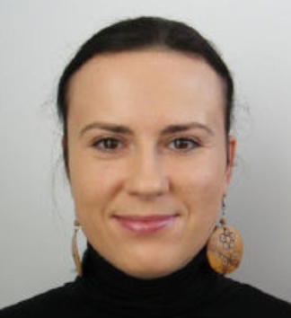

Dr Anna Kowalcyzk
Assistant Professor, School of Psychology
Email: a.u.kowalczyk@bham.ac.uk
LinkedIn: anna-kowalczyk-a78a5b94
Website: x.com/QN_lab

Celebrating our early career researchers

We asked our two Early Career Researchers (ECRs) representatives on the CHBH Management Committee about their research and experiences in the world of academia so far.

The life of an Early Career Researcher (ECR) at the CHBH is filled with creativity and opportunities for growth, often spiced up with exciting travels to conferences. However, behind the scenes, it requires a great deal of focus and adaptability. Much of the time is dedicated to collecting data in the lab, coding analysis, and writing papers in the office, away from the complexities of running a research centre like the CHBH. The environment of the CHBH allows ECRs to focus solely on the scientific pursuits, making it a perfect workplace. Over the past year, we had the privilege of representing the ECRs at the CHBH in the monthly management meetings. These meetings are crucial as they involve making important decisions about the present and future of the centre. Ensuring ECR representation in these discussions is fundamental to address the needs and concerns of the ECR community. During these meetings, we had the opportunity to present various issues raised by ECRs to the Co-Directors and Modality Leads. Topics such as lab availability and showcasing the inclusivity of the CHBH were discussed. We also got the opportunity to organize an ECR poster reception, to present past and ongoing projects at the CHBH and to meet and connect. Receiving the support of the senior staff was an incredibly rewarding experience, and we hope this collaborative spirit continues in the future.


Dr Oscar Ferrante, Postdoctoral researcher
Email: o.ferrante@bham.ac.uk
X: @ferrante_oscar
LinkedIn: oscar-ferrante-700880250

Dr Selma Lugtmeijer, Postdoctoral researcher
Email: s.lugtmeijer@bham.ac.uk
X: @LugtmeijerSelma
LinkedIn: selma-lugtmeijer-45ba46b1

From PhD to Postdoc: Experiences unveiled

We asked one or our postdoctoral researchers about their experience in the world of academia so far.

Having completed my PhD with Professor Andrew Bagshaw and Professor Stephen Mayhew, I have been fortunate to continue my research at the Centre as a Postdoctoral Researcher. My current research, funded by the BBSRC, focusses on the role of the thalamus in sleep and attention, with a specific focus on the thalamic reticular nucleus (TRN). This structure is key to understanding how the brain regulates the flow of sensory information, enabling the suppression of distracting stimuli during both wake and sleep. In collaboration with the Sir Peter Mansfield Imaging Centre at the University of Nottingham and the Institute of Health and Neurodevelopment at Aston University, we are leveraging ultra-high field MRI to obtain high-resolution images of the TRN, which we then study during sleep and attention using simultaneous EEG-fMRI.

Being formally trained in psychology, I have greatly valued the interdisciplinary nature of this project. Working with experts from diverse fields has exposed me to new perspectives on neuroscientific research while allowing me to contribute my own expertise to collaborative efforts. This approach has been fundamental in driving the project and in my own development as a researcher.

Dr Brandon Ingram
Postdoctoral researcher
Email: b.ingram.1@bham.ac.uk
LinkedIn: brandon-ingram-1a0a5711b

International Society of MR Radiographers and Technologists
Nina Salman, our Chief Radiographer at the CHBH, has been elected as the PRESIDENT of the ISMRT (International Society of MR Radiographers and Technologists) for a three-year term starting in May 2025. The ISMRT serves as a global platform for education, information, and research in MRI for Radiographers worldwide.

With her extensive governing board experience as ISMRT Chair of Marketing and ISMRT Chair of Global Relations, Nina has been instrumental in developing the Emerging Regions initiative. She has successfully established MRI
divisions in Vietnam, India, Chile, Japan, and Africa, elevating the standards
for MRI Radiographers and providing them with opportunities for growth and advancement and knowledge sharing. Nina is currently working on developing standardized MRI Operating Local Rules and Standard Operating Procedures for hospitals in Africa. This initiative aims to ensure consistent and high-quality MRI practices across the region.

Nina also leads the ISMRT British and Irish Division, serves as the executive secretary for the ISMRM British and Irish Chapter, and has joined on the new ISMRM Sustainability Advisory Committee. In this role, she is enthusiastic about working on global initiatives such as MRI life cycle assessments to minimise energy consumption and improve operational efficiency, thereby reducing carbon footprint.

Supported by leadership training programmes at the University of Birmingham, including Herschel, Aditi, and ILM 5, Nina is eager to work with the Board of Trustees to guide the ISMRT’s direction, engage in strategic planning and implement new initiatives in MRI education and advancements. Her goal is to inspire, unite, and elevate the global MR community and grow membership with the establishment of new divisions, chapters and collaborations. Notably, she is proud to be the first president of South Asian ethnicity to hold this leadership position, which brings her a profound sense of responsibility and representation.

Nina Salman, Chief Radiographer
Email: n.salman@bham.ac.uk
LinkedIn: linkedin.com/in/nina-salman-124741bb

Event and engagement spotlight

The CHBH has played a pivotal role in fostering scientific exchange throughout 2024, hosting six international conferences and workshops in cognitive neuroscience, human neuroimaging and clinical translation.
These events provided invaluable platforms for researchers, clinicians, and industry experts to exchange ideas, share cutting- edge advancements in computational and technical methodologies, and establish new collaborative projects.

Among the highlights was the Control Processes Conference in May, which brought together leading Principal Investigators from around the world studying cognitive control from diverse perspectives, from cognitive psychology, computational modelling, neuroscience, anatomy, disease and disorder research to animal models.

In June, the FluxKit Workshop offered specialized training in state-of-the-art magnetoencephalography (MEG) data analysis, focussing on PhD and postdoctoral researchers. Delegates gained theoretical insights into electrophysiology and practical experience with the FLUX platform, covering data preprocessing, source modelling, and best practices in reporting and open science.

The Birmingham-Leiden Summer School in July provided an exceptional learning opportunity for early career researchers to leverage the recent advances in computational social cognition research, building on significant expertise in such tools at the University of Birmingham and the University of Leiden, and aiming to train the next generation of social cognition researchers in computational modelling techniques. The summer school included comprehensive training in gold-standard practices, as well as embedding attendees in contemporary theoretical debates and featured keynote lectures by distinguished experts.

Another standout event was the VIII Biennial Meeting of the Society for Functional Near-Infrared Spectroscopy (SfNIRS) in September, which attracted a record number of participants, offered educational training in fNIRS data analysis and instrumentation, and highlighted groundbreaking advancements in fNIRS research.

At the end of September the Mind in Motion: Advances in Digital Neurorehabilitation Workshop brought together neuroscientists, industry innovators, clinicians, and patients from the UK and overseas to address the critical need for alternative approaches to clinic-based rehabilitation for neurological disorders, including stroke, Parkinson’s disease, spinal cord injury, and chronic pain. The workshop highlighted the limitations of current practices, as well as state-of-the-art and future technologies needed to develop innovative, scalable, and sustainable digital solutions.

Finally, the MEG-UKI 2024 Conference in October brought together researchers in MEG and optically-pumped-magnetometer (OPM) technologies from prominent centres in the UK, Ireland, and beyond. The event began with in-depth workshops on advanced topics such as cutting-edge sensor development and paediatric neuroimaging, followed by keynote addresses from leading scientists, as well as talks and poster sessions showcasing the use of MEG and OPM across cognitive and clinical neuroscience.

Through these internationally facing impactful events, CHBH has further solidified its reputation as a leading institution in human cognitive neuroscience and neuroimaging, driving research innovation and education with basic and translational impact.
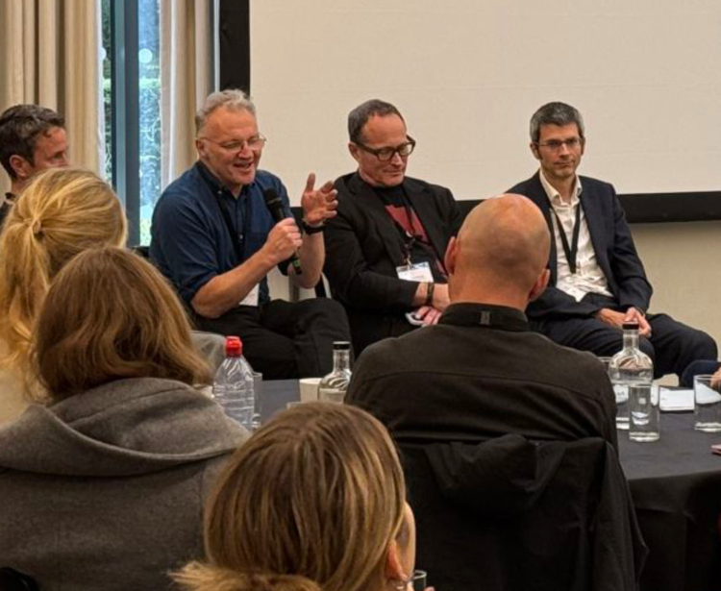

Impact on education: MSc Cognitive Neuroimaging and Data Science

CHBH strives to be at the forefront of research-led teaching, providing in-house training in cognitive neuroscience and multimodal neuroimaging for both undergraduate and postgraduate students.
The academic year 2023/2024 marked the start of a new chapter in postgraduate education at the CHBH. It was the first year we ran our new flagship MSc programme, Cognitive Neuroimaging and Data Science (CNDS), offering students a choice of designing their own learning pathway by taking either a more cognitive or computational focus on neuroscience and brain imaging. Our aim is to align the teaching on this programme not only with CHBH research themes but also the CHBH research philosophy of transparent and reproducible science supported by open-source programming. CNDS MSc students are provided with hands-on experience of the full range of neuroimaging methods (MRI, MEG, OPM, EEG, brain stimulation and fNIRS) housed at the CHBH, and learn how to apply programming skills to analysis of large and multimodal (neuroscientific/neuroimaging) data. Our students have access and are taught how to use the University supercomputer and other HPC services (BlueBEAR) in various brain imaging workshops and while completing their dissertation projects.

We are exceptionally proud that half of our 2023/2024 CNDS cohort achieved MSc with distinction, a testament to their hard work and engagement in the course. We are looking forward to congratulating our students and celebrating with them at the December graduation.

At the end of September 2024, we welcomed the second cohort of CNDS students and are delighted that the programme significantly grew with over 40 new very enthusiastic students joining the CHBH community. As a result, the CHBH corridors are significantly busier and noisier.
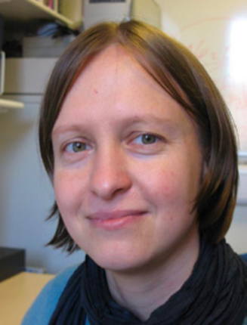
Dr Magda Chechlacz,
Assistant Professor in Cognition and Ageing and CHBH Education & CNDS MSc Programme Lead
Email: m.chechlacz.1@bham.ac.uk

Intercalated BSc Human Neuroscience

In partnership with the University of Birmingham Medical School, each year the CHBH hosts medical students completing an intercalated BSc in Human Neuroscience.

These students pause completion of their medical degree for one year, commonly after the third year of their five-year programme, to complete the 1-year BSc.

They choose a set of academic modules offered by the School of Sport, Exercise and Rehabilitation Sciences; Psychology; Biosciences; and Philosophy and complete a dissertation project under direct supervision of a CHBH faculty member.

This interdisciplinary programme is highly competitive, attracting academically strong medics with a view to future specialisation in fields like psychiatry, neurology and neurosurgery.

Dr Clayton Hickey

Associate Professor in Psychology and BSc Neuroscience Programme Lead
Email: c.m.hickey@bham.ac.uk
Website: cognitionlab.org

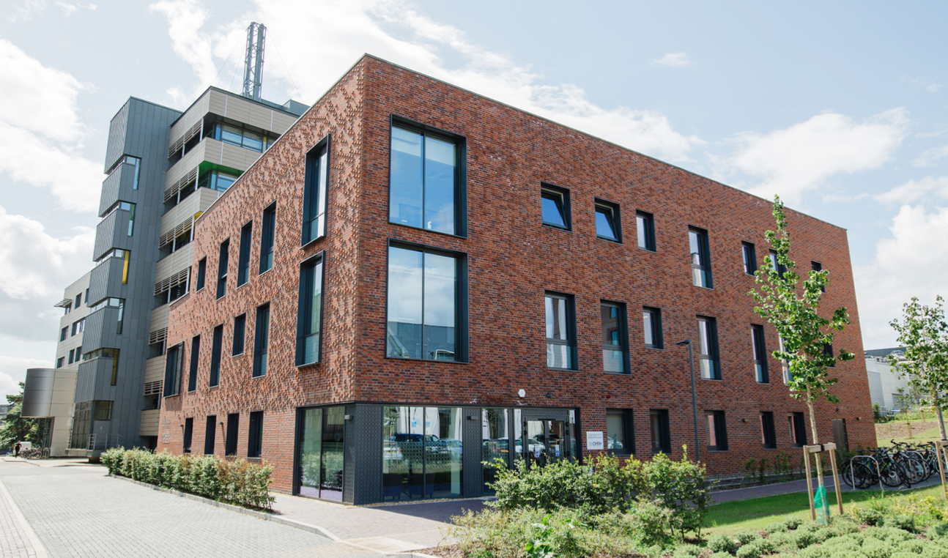

Contact

Email: chbh@contacts.bham.ac.uk
X: @theCHBH
Website: birmingham.ac.uk/chbh
Bluesky: thechbh

Co-Directors
Professor Andrew Bagshaw, CHBH Co-Director
Dr Katja Kornysheva, CHBH Co-Director

Participate in brain research at the CHBH birmingham.ac.uk/ research/centres-institutes/ human-brain-health/participate
To find out more contact us birmingham.ac.uk/chbh


Edgbaston,
Birmingham,
B15 2TT,
United Kingdom,
birmingham.ac.uk

