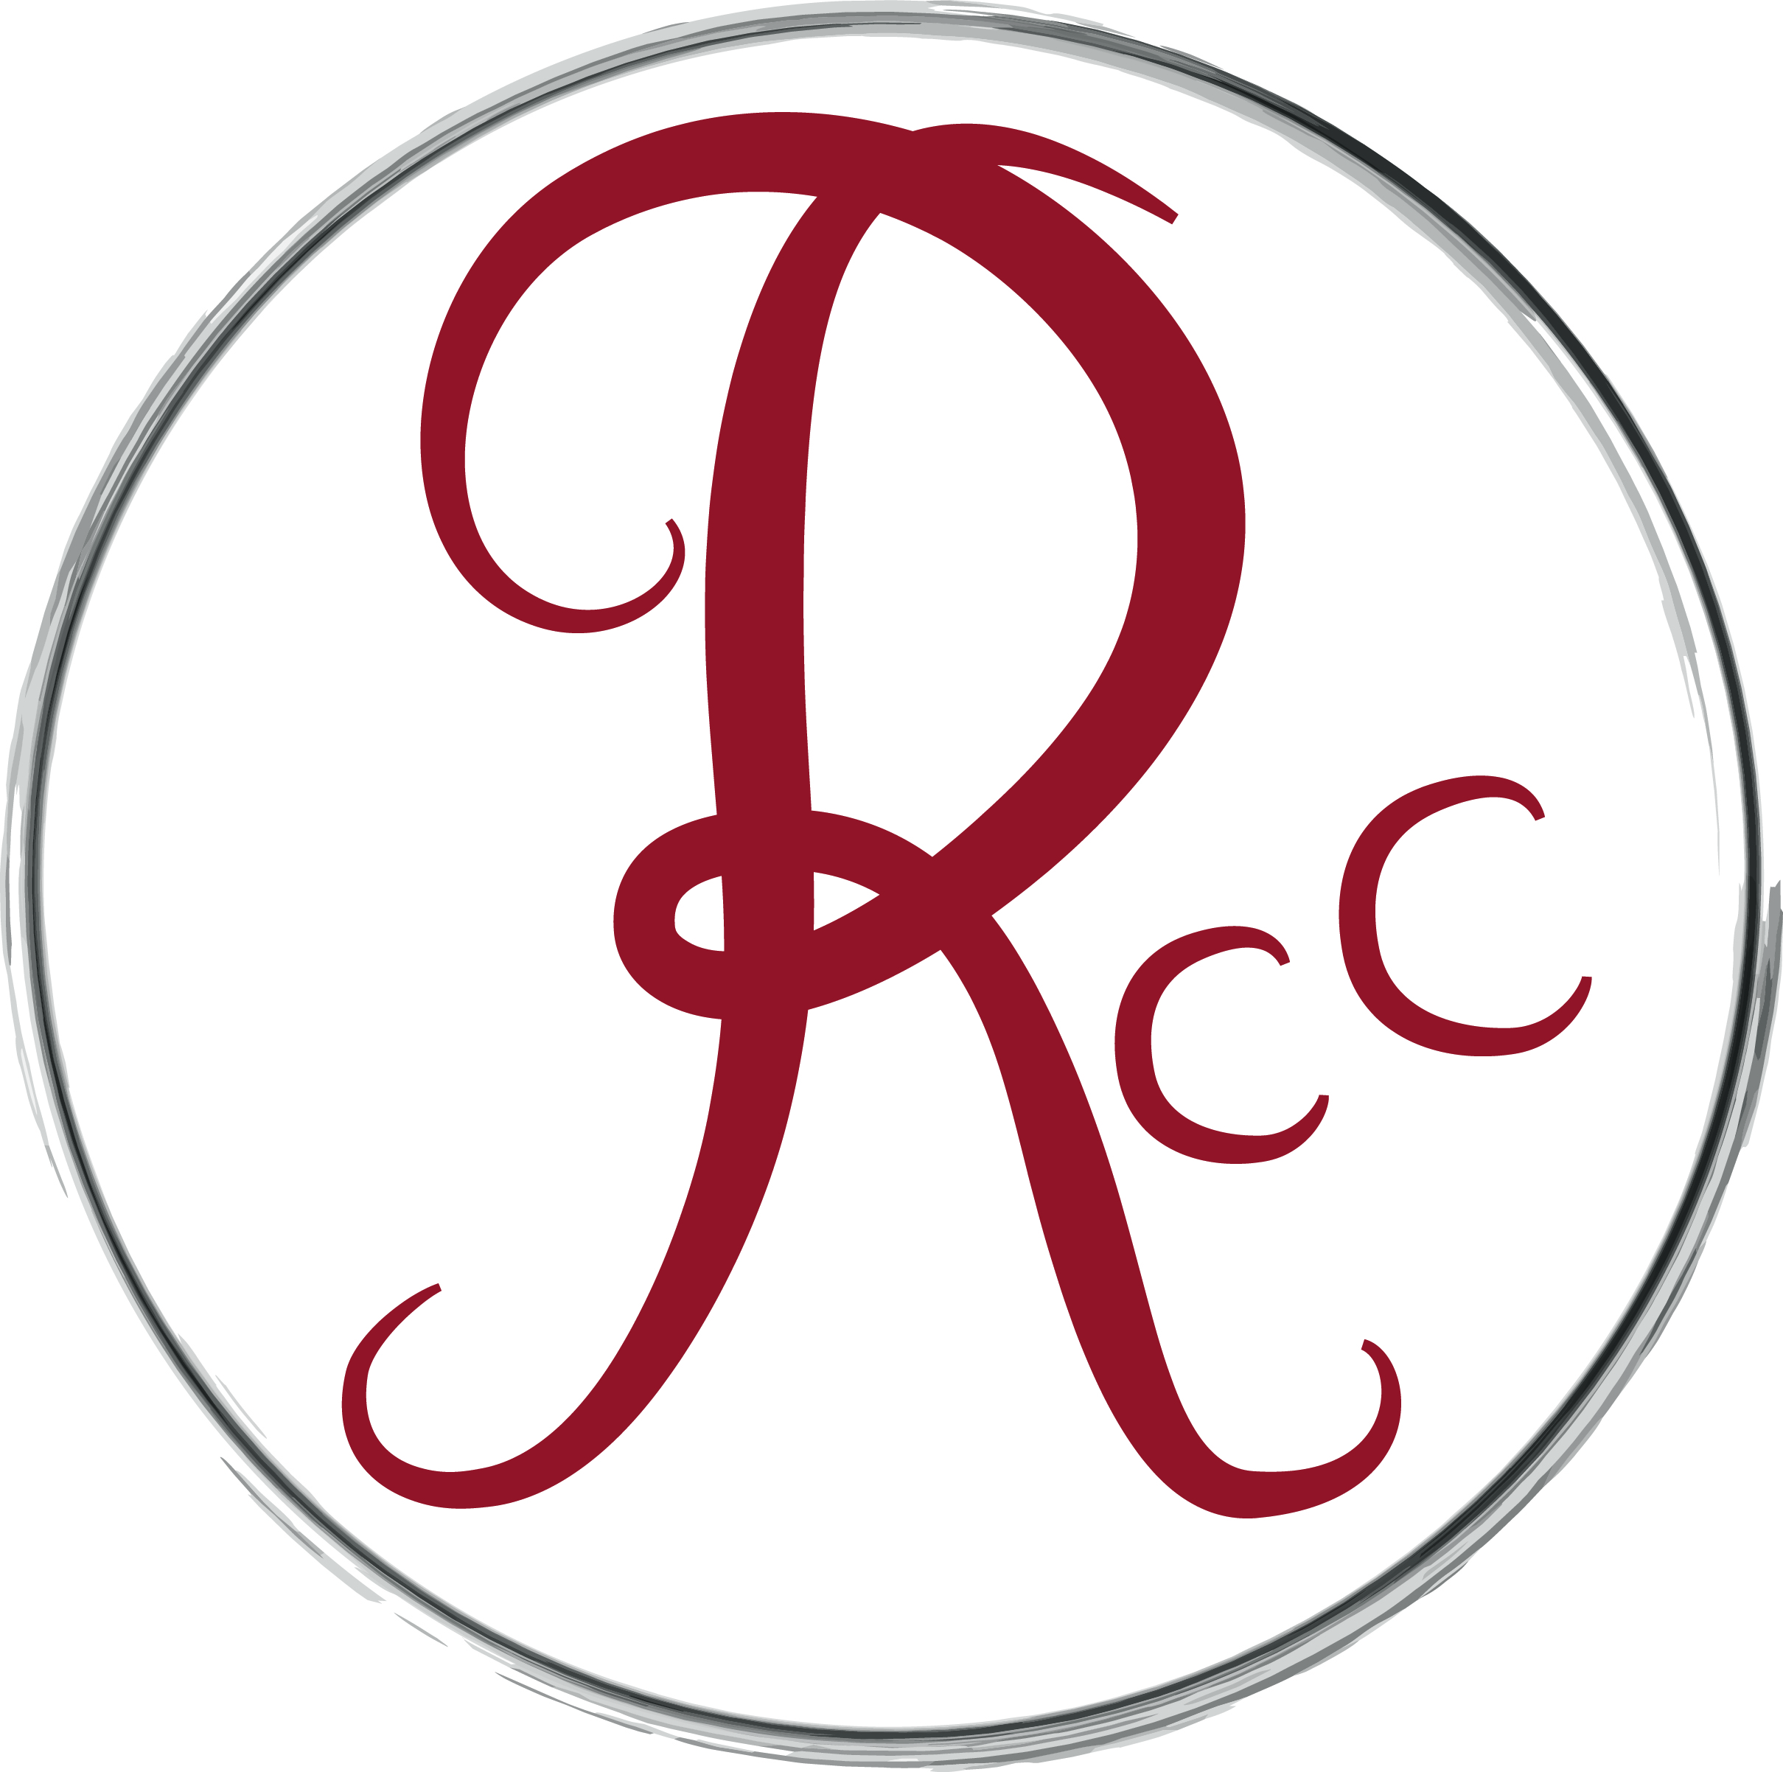
Volunteering with the Research and Cultural Collections, 2013/2014

From Egyptian shabti figures to nineteenth century medical waxes, from West African Masks to modern British landscape paintings, the Research and Cultural Collections hosts a vast range of extraordinary artefacts that play a valuable social, cultural and educational role in university life and wider communities. Research and Cultural Collections has a vibrant programme of student projects for both undergraduate and postgraduate students. Participants work alongside the curatorial team to undertake projects that are beneficial to both parties, taking into account the student's areas of interest.

Why Volunteer?
- Gain valuable experience of the museum world
- Learn a range of new skills, useful for future employment in a range of sectors
- Expand your knowledge of the museums and collections
- Meet new people from across the University and other cultural organisations
- Opportunities for professional development and a reference for future employment

Voluntary roles within the Research and Cultural Collections team are split into four main areas: documentation and digital access; curatorial; collections care; and education and outreach. There will naturally be overlap between these roles and you may be asked to complete tasks outside of your main area of work.

What is expected of volunteers?
Voluntary positions with RCC are in high demand. We ask for all volunteers to commit to at least a half day session per week (Monday - Thursday, morning 09.30 – 12.30 or afternoon, 13.30 – 16.30). We will be flexible in relation to that, but ask that you commit to a minimum of a term and bear in mind that we have limited capacity for volunteers. If your circumstances change and you can no longer commit to your work experience, we would ask you step down so that another student can take your place.

Documentation and digital access
Documentation is core to all museums and supports all other areas of activity. As documentation experience is one of the main skills required for entry level museum work, this would best suit individuals who are looking to enter the sector.

Activities might include:
- Digitisation/photography and working with Photoshop
- Working with our collections database, MIMSY XG and updating locations records
- Initial cataloging of objects
- Curatorial archive research to build object records
- Object significance assessments

Person specification
- Attention to detail
- Excellent organisational skills

Collections care
This position would be best suited to an individual who would like practical, hands-on museum experience and/or is considering a career in the sector.

Activities, after training, might include:
- Basic cleaning and conservation of objects e.g. cleaning and waxing outdoor sculpture
- Basic paper conservation
- Object condition reporting
- Monitoring environmental conditions and checking pest traps

Person specification
- Sensitivity to handling fragile objects
- Manual dexterity
- Excellent team working skills
- Attention to detail

Curatorial
This role would be best suited to individuals considering a career in the sector or looking to develop their research and written communication skills for different audiences. There may be overlap between roles, for example, curatorial volunteers might be asked to assist in cataloguing objects, before researching and using them in a display. The main focus of this role however would be interpretation and research relating to the collections.

Activities might include:
- Object research and writing basic descriptions
- Researching, producing and mounting labels for objects and artwork
- Exhibitions work - involvement in curating small displays, generally as part of a team
- Digital interpretation e.g. curating flickr exhibitions
- Social media
- Object significance assessments

Person specification
- Excellent research and written communication skills
- An interest in museums and the cultural sector

Education and access
This role would be suited to individuals looking to enter the museum/cultural sector and would like to develop their public speaking skills or those who are interested in a career in education or public outreach.

Activities might include:
- Delivering guided tours
- Involvement in education and outreach classes
- Researching and compiling educational handling boxes
- Assisting with the research and production of children’s guides to the collections

Person specification
- Excellent presentation skills
- A passion for communicating with a range of audiences

