Passive constructions in English and Chinese
A corpus-based contrastive study

Tony McEnery and Richard Xiao
Department of Linguistics
Lancaster University
{a.mcenery, z.xiao}@lancaster.ac.uk

For decades, passives as a major grammatical category in both English and Chinese have been subject to much research, both corpus-based and non-corpus-based. A number of contrastive studies of passives in English and Chinese have been published, but they have not used corpus data, being based, rather, on a handful of examples which are common to nearly all of those papers (e.g. Fan 1994; Wang 1997; Yu 2001; Zhou and Xia 2002; Gu 2003). The work presented in this article combines the corpus methodology with a contrastive perspective, seeking to provide a more systematic account of passive constructions in the distinct languages on the basis of corpus data.

Four corpora are used in this study. The Freiburg-LOB corpus (i.e. FLOB) is an update of LOB (Lancaster-Oslo-Bergen corpus of British English, see Johansson, Leech and Goodluck 1978) which sampled texts published in 1991-1992 (Hundt, Sand and Siemund 1998). A second corpus, the Lancaster Corpus of Mandarin Chinese (i.e. LCMC), was designed as a Chinese match for FLOB, representing written Chinese published in China in the early 1990s (McEnery, Xiao and Mo 2003). Both corpora consist of five hundred 2,000-word samples taken proportionally from the same 15 genres in English and Chinese, each totalling one million words. The two comparable corpora have not only made it possible to compare English and Chinese in general, they have also allowed us to reveal more fine-grained genre distinctions between the two languages. The genres covered in FLOB/LCMC and their proportions are given in Table 1.

Code | Genre | No. of samples | Proportion
A | Press reportage | 44 | 8.8%
B | Press editorials | 27 | 5.4%
C | Press reviews | 17 | 3.4%
D | Religion | 17 | 3.4%
E | Skills, trades and hobbies | 38 | 7.6%
F | Popular lore | 44 | 8.8%
G | Biographies and essays | 77 | 15.4%
H | Miscellaneous (reports, official documents) | 30 | 6%
J | Science (academic prose) | 80 | 16%
K | General fiction | 29 | 5.8%
L | Adventure fiction | 24 | 4.8%
M | Science fiction | 6 | 1.2%
N | Adventure fiction | 29 | 5.8%
P | Romantic fiction | 29 | 5.8%
R | Humour | 9 | 1.8%
Total |  | 500 | 100%
Table 1 Genres covered in LCMC

In addition to written corpus data, two spoken corpora of sampling periods similar to that of FLOB/LCMC are used in this study to compare written and spoken English/Chinese. We decided to use only typical spoken data, i.e. dialogue while excluding transitory genres such as written-to-be-spoken scripts or prepared speech. For English, we used the demographic sampled component of the British National Corpus (the World Edition, hereafter referred to as BNCdemo), which contains approximately four million words of conversational data sampled during 1985-1994 in the UK (Aston and Burnard 1998). For Chinese, only a much smaller corpus was available to us, the Callhome Mandarin Chinese Transcript released by the Linguistic Data Consortium in 1996. The corpus comprises a contiguous 5 or 10 minute segment taken from 120 unscripted telephone conversations between native speakers of Mandarin Chinese, totalling approximately 300,000 words. As these corpora are of different sizes, the raw frequencies extracted from them were normalised to a common basis or the proportional data for each corpus was used where appropriate.

In the remainder of this article, we will first discuss passive constructions in English and Chinese, on the basis of which similarities and differences between the two languages will be explored.

1. Passives in English
1.1. Passive variants in English
The passive in English is grammatically marked by a copular verb followed by a past particle. The structure be + past particle can be considered as the norm for English passives. However, be in the structure can also be replaced by other copular verbs such as get, become, feel, look, remain and seem because the passive meaning is essentially expressed by past participles. There are clear differences between be passives and these variants in their structural configuration – the latter require the auxiliary verb do in negations and questions, for example. In addition to such surface differences, there are further differences between the two, which will be explored in this section. Nevertheless, we will confine our discussion to be and get passives as the use of other passive constructions is limited by the lexical meanings of those semi-linking verbs. We will also exclude the pseudo-passive forms with get as identified (Types b–f) in Carter and McCarthy (1999: 46-47), because it is more appropriate, in our view, to treat those pseudo-passives as causative constructions. Note that be and get passives are not always interchangeable because of the differences discussed below. For example, get passives only occur in dynamic events (cf. Cheshire forthcoming) while be passives are not sensitive to the semantic feature of dynamicity. Quirk et al (1985: 162) note that ‘[t]he get passive provides a convenient way of avoiding the passive with be in cases where there is a potential confusion between the normal passive interpretation and that of the “statal passive”’ (e.g. The chair was broken). This is made possible by the dynamic nature of the get passive. Also, when the passivised verb is followed by an infinitival complement, only the be passive is appropriate (cf. Palmer 1974: 341-370). For example, in they liked to be seen to go to church (BNC: KD6), be seen cannot be replaced by get seen.

It has been observed that some sentences in the active voice can also express a passive meaning (e.g. Kenneth 1993). For example, it is said that These clothes wash well is equivalent to These clothes are washed well. Nevertheless, while the two sentences express a sort of passive meaning – clothes do not wash themselves – the active form indicates the inherent property of these clothes (i.e. they can be washed well) whereas the passive form expresses a different meaning (i.e. they are washed well on a particular occasion). Given these differences, and considering that unmarked passives cannot be studied efficiently using a corpus-based approach, we will not consider notional passives in this paper.

Corpus | Be passive |  | Get passive
Corpus | Frequency | Per 100K words | Frequency | Per 100K words
FLOB | 9908 | 854 | 59 | 5
BNCdemo | 5001 | 101 | 1300 | 26
Total | 14909 | 955 | 1374 | 31
Table 2 Frequencies of be and get passives in FLOB and BNCdemo

It can be said that the be passive is the unmarked passive form in English while the get passive is the marked form. The get passive has long been considered as a problematic construction and has aroused much interest from researchers. Carter and McCarthy (1999) provide an excellent review of previous studies, both corpus-based and non-corpus-based, of the get-passive when they discuss the implications of this construction for an interpersonal grammar on the basis of samples from the CANCODE spoken corpus (Carter and McCarthy 2004). This section compares the two alternative passive forms in terms of their syntactic features, semantic/pragmatic properties, and their distributions across genres, on the basis of the written data from FLOB and the spoken data from BNCdemo. The frequencies of be and get passives are given in Table 2. For easy comparison, normalised frequencies (per 100,000 words) are also given. Note that, unless otherwise stated, the frequencies used in this section only include the structure be/get followed immediately by the past participle of a lexical verb (excluding auxiliary verbs be, do and have etc), thus instances such as was badly damaged where there is an intervening adverbial are excluded. We made this decision so as to ensure the frequencies of be and get passives are comparable while being able to exclude occurrences such as get followed by a noun plus a past participle, a structure conveying a causative rather than passive meaning. The fixed expression such as get rid of and repetitions in the spoken data were also excluded. It can be seen from Table 2 that be passives are predominantly more frequent than get passives, especially in written English. In addition to this quantitative contrast, there are other differences between the two alternative passive constructions, which will be explored in the following sections.

1.2. Long vs. short passives
As the passive voice is often used as a strategy that allows language users to avoid mentioning the agent, it can be expected that agentless passives are significantly more frequent than those with an agent. Following Biber et al (1999: 935), we refer to passives with an agent as ‘long passives’ and to those which leave the agent unexpressed as ‘short passives’. Table 3 gives the frequencies of long and short passives. As can be seen, in FLOB the short form of the be passive is over eight times as frequent as its long form while for the get passive the short form is over ten times as frequent as the long form. The contrast in BNCdemo is even more marked, where short forms of be and get passives are over 18 and 37 times as frequent respectively as their long forms. Clearly, short passives are predominantly more frequent than long passives in both written and spoken English, as illustrated in Fig. 1. Short passives are also significantly more common in spoken than written English (LL=209.225 for 1 degree of freedom, p<0.001).

A further difference related to the long vs. short distinction is that get passives are more likely (LL=76.015 for 1 degree of freedom, p<0.001) than be passives to occur without an agent, as shown in Fig. 2. The agents in get passives are typically impersonal (e.g. got caught by the police) or even inanimate (e.g. got knocked down by a car). When personal agents appear, they are typically informationally dense and thus semantically indispensable (e.g. The bleeding fat girl, he got asked out by her). While agency generally plays a secondary role in passives, the tendency to leave the agent unexpressed in get passives appears to further downgrade the agent and highlight the patient and event (cf. Carter and McCarthy 1999: 44), a phenomenon that we will discuss later.

Corpus | Be passive |  | Get passive
Corpus | Long | Short | Long | Short
FLOB | 1073 (10.8%) | 8835 (89.2%) | 5 (8.5%) | 54 (91.5%)
BNCdemo | 256 (5.1%) | 4745 (94.9%) | 34 (2.6%) | 1266 (97.4%)
Table 3 Long vs. short passives in FLOB and BNCdemo

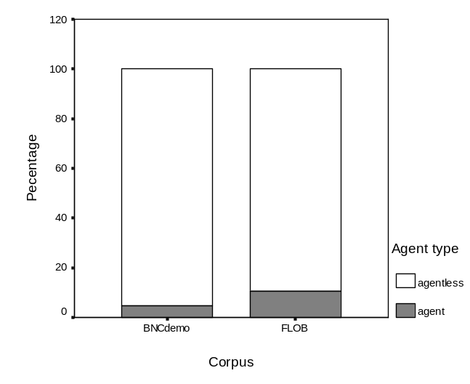
Fig. 1 Long vs. short passives in written and spoken English

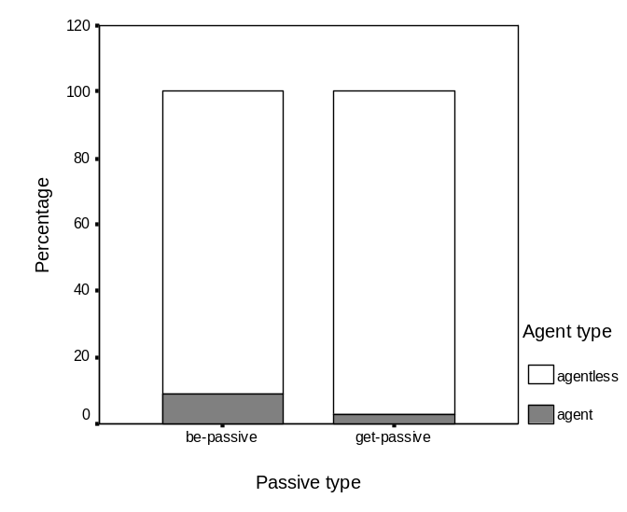
Fig. 2 Long vs. short be/get passives

1.3. Adverbials in be and get passives
Carter and McCarthy (1999: 53) observe that adverbials are rare in get passives and that when such adverbials do occur, they typically ‘have an intensifying or focusing role’. Other types of adverbial (e.g. those expressing time, place and manner) are nearly non-existent unless they are semantically indispensable for adverbial complementation. This observation is generally supported by our data. Fig. 3 compares the proportions of be (17.7%) and get (7%) passives with an adverbial in our corpora. Note that only adverbials occurring between be/get and the past participle and those following the past participle immediately were counted in this section.

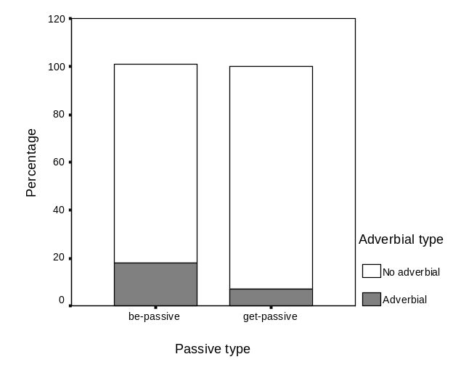
Fig. 3 Passives with/without an adverbial in FLOB and BNCdemo

While adverbials in be passives are not restricted by adverbial types, in get passives they are typically intensifying adverbials. Of the 28 instances of adverbials occurring between get and the past participle in our corpora, 23 are intensifying modifiers, including a (little) bit (7 instances), so (2), really (2), somewhat (2), absolutely, better (known), completely, like, slightly, sufficiently, as well as swear words bloody (2) and fucking (2). Swear words like fucking are frequently used as intensifiers (cf. McEnery and Xiao 2004). The other five instances of adverbials are all informationally heavy and semantically indispensable: accidentally, brutally, mistakenly, regularly and today. In comparison, post-modifying adverbials are more diversified, including 7 instances of intensifiers (at all (2), a bit, as much as, like, slightly, so much), 26 instances of time adverbials (now (12), early/earlier (3); today (3), yet (3), yesterday (2), by now, overnight, soon), 10 instances of place adverbials (here (3), there (3), home (2), outside and to camp), 10 instances of manner (quickly (4), together (2), appropriately, badly, loud and properly), and finally 20 instances of other adverbials (again (13), actually (2), once (2), as well and too). In spite of this diversity, adverbials are significantly more frequent in be passives than in get passives in both corpora (LL=127.957 for 1 degree of freedom, p<0.001). It is also of interest to note that while the proportions of be passives with an adverbial are very similar in the written and spoken corpora (17.3% and 19.5% for FLOB and BNCdemo respectively), the proportion of get passives with an adverbial in spoken English (6.6%) is significantly lower than that in written English (15.2%). Since adverbials ‘focus[ing] on the verb might serve to defocus the subject/patient’ (Carter and McCarthy 1999: 53), the general absence of adverbials in get passives, like the predominance of short get passives, puts more emphasis on the patient. This patient-focused feature of the get passive is closely associated with its attitudinal nature, which we will discuss in the following section.

1.4. Semantic and pragmatic properties
As noted in the previous section, get passives are frequently used to indicate speaker attitude towards the events described, i.e. whether they have positive or negative consequences (cf. Hatcher 1949; Lakoff 1971). In contrast, be passives do not appear to be used in this way. To evaluate this hypothesis, we examined all instances of the get passive in FLOB (59 instances) and BNCdemo (1,300 instances) and compared them with 1,000 concordances of be passives randomly sampled from 9,908 occurrences in FLOB and 1,000 random samples from 5,001 occurrences in BNCdemo. Table 4 shows the distribution of these passive constructions across three meaning categories. As can be seen, get passives are indeed used more frequently to express speaker attitude – typically viewing the consequences as unfortunate.

Passive type | Negative | Positive | Neutral
Be passives | 15% | 4.7% | 80.3%
Get passives | 37.7% | 3.4% | 58.9%
Table 4 Semantic properties of be and get passives in FLOB and BNCdemo

The attitudinal role of the get passive is closely associated with the nature of their collocations. As we are only interested in finding out which verbs collocate with be and get passives, significant collocations are defined here as verbs immediately following be/get with a z score greater than 3 and a minimum frequency of 3. In FLOB only one such collocation (married) was found, which is neutral. Among the collocations of the get passive in BNCdemo, 46.5% (33 out of a total of 71) are negative, a proportion considerably higher than those for the be passive in both FLOB (8%) and BNCdemo (27%). This does not mean, however, that get passives are more frequently negative in spoken English. In fact, they are not. The proportion of negative instances in FLOB (27 out of a total of 59, i.e. 45.8%) is higher than that in BNCdemo (485 out of 1,300, i.e. 37.3%). The relatively low proportion of negative instances in BNCdemo can be accounted for by the exceptionally high co-occurrence frequency of a few neutral verbs, most noticeably married (with a co-occurrence frequency of 166) and paid (125), dressed (48) and changed (48). Carter and McCarthy (1999: 52-53) find it unsurprising that ‘attitude is often strongly marked in utterances to do with money and payment, and upon the recipients of payment’ because ‘[p]ayment, or lack of it, and how much people earn is, in most societies, a matter of interest, debate, and, not infrequently, of controversy, criticism, wonder, pleasure, and annoyance’. The same can be said of marriage. Nevertheless, the attitudinal role of the get passive alone cannot explain why verbs like dress and change, which are not as ‘noteworthy’ as tell and ask (ibid: 53), occur frequently in get passives. In our view, a more fundamental distinction between the two passive variants lies in that the get passive occurs only in dynamic events while the be passive can occur in both dynamic and static situations. The dynamicity of the get passive is so strong that even a static verb is forced to show a dynamic meaning, as shown in the contrast in (1):

(1) a. Okay to you and me tetanus is known by what? (BNC: KDC)
b. The key is persistence. Get your foot in the door, get known. You have to believe in yourself, despite the difficulties. (FLOB: F)
(2) a. It is a book which asked for trouble by taking on the establishment, and one that was
written by a man who is a former Labour councillor. (FLOB: A)
b. *<…> and one that got written by a man who is a former Labour councillor.
(3) a. Go and get changed! (BNC: KD7)
b. *Go and be changed!
The semantic assimilation is possible because the class meaning of a grammatical structure can override that of individual words (Xiao and McEnery 2004). The conflict between the two results in either a semantic assimilation (1b) or an unacceptable sentence (2b). The dynamic feature of get passives makes it possible for them to occur in imperatives, as shown by the contrast in (3). The difference between be and get passives in this respect is closely allied with the ‘state’ vs. ‘transition’ distinction between be and get as observed by Jespersen (1949: 109). As Chappell (1980) observes, the get passive encodes change of state. This change-of-state feature also accounts for the difference between passive variants such as be married and get married.

A further distinction between be and get passives can be observed from the collocations of the two passive variants. As FLOB only provides one significant collocation of the get passive (i.e. married), we will use BNCdemo, which provides 205 collocations for the be passive and 71 collocations for the get passive. Given that the get passive only occurs in dynamic situations, this quantitative contrast is unsurprising. However, it does suggest that the get passive is more restricted in collocation. A closer inspection of their collocations reveals a stylistic difference between be and get passives. In relation to be passives, the get passive is more likely to co-occur with verbs referring to daily activities, for example, get dressed, get changed, get weighed, get fed (i.e. eat), get washed, get cleaned, and with informal expressions such as get pricked, get hooked, get mixed (up), get carried (away), get muddled (up), get sacked, get kicked (out), get stuffed, get thrown (out), get chucked, get pissed and get nicked. These verbs are rarely found among the top 100 collocations for the be passive in BNCdemo, suggesting that get passives are more informal in style be passives.
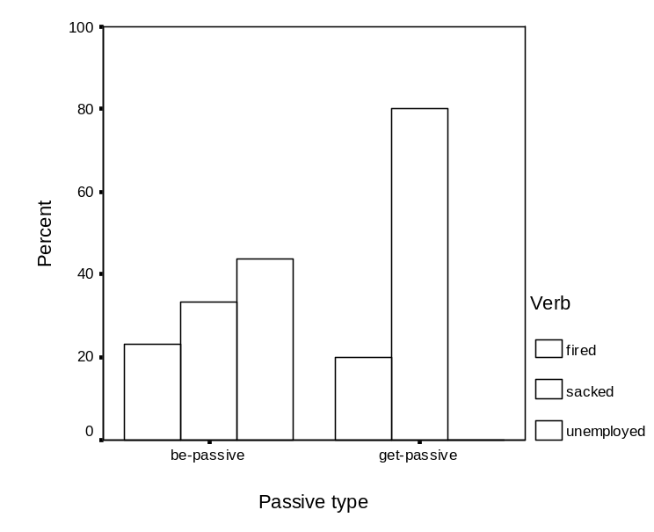
Fig. 4 Be/get unemployed/fired/sacked in BNCdemo

The frequencies of be/get unemployed/fired/sacked illustrate this point well. These expressions refer to the same thing (i.e. getting out of job), but the formal way to express this idea is to use unemployed; fired is less formal while sacked is most colloquial. Fig. 4 compares their proportions in BNCdemo. As can be seen, unemployed occurs most frequently in the be passive but is non-existent in the get passive while the colloquial form sacked is most frequent in the get passive. The form fired, which is less formal than unemployed but more formal than sacked, is found in both be and get passives. This example suggests that in contexts where both passive variants are felicitous, the get passive is more informal than the be passive (compare be/get asked, be/get told, be/get invited, be/get killed etc). Since style is closely related to genres, the next section further explores the distribution of English passives across 16 genres.

1.5. Genre distinctions
In Biber’s (1988) multi-dimensional analysis of English genres, be passives (both long passives and short passives) are an important linguistic feature that is positively weighted on the dimension of abstract vs. non-abstract distinction. According to Biber (1988: 112, 152), genres with a high frequency of be passives are typically abstract and technical in content, as well as formal in style. This dimension, together with those focusing on the informational and involved distinction on one hand, and the distinction between text-internal and text-external references on the other hand, are important indicators of differences between oralness and literateness.

Genre | Be passive | Percent | Get passive | Percent
A) Press reportage | 952 | 8.33 | 8 | 7.55
B) Press editorials | 919 | 8.04 | 5 | 4.72
C) Press reviews | 557 | 4.87 | 3 | 2.83
D) Religion | 925 | 8.09 | 0 | 0
E) Skills, trades and hobbies | 933 | 8.16 | 14 | 13.21
F) Popular lore | 988 | 8.65 | 7 | 6.6
G) Biographies and essays | 838 | 7.33 | 2 | 1.89
H) Reports, official documents | 1408 | 12.32 | 1 | 0.94
J) Science (academic prose) | 1257 | 11 | 2 | 1.89
K) General fiction | 416 | 3.64 | 3 | 2.83
L) Adventure fiction | 384 | 3.36 | 8 | 7.55
M) Science fiction | 411 | 3.6 | 0 | 0
N) Adventure fiction | 493 | 4.31 | 12 | 11.32
P) Romantic fiction | 348 | 3.04 | 6 | 5.66
R) Humour | 499 | 4.37 | 9 | 8.49
FLOB Total | 853 | 7.46 | 5 | 4.72
BNCdemo | 101 | 0.88 | 26 | 24.53
Table 5 Distribution of be/get passives (per 100K words)

Following this theory, written genres are generally expected to show higher proportions of be passives. This expectation is supported by our data. As can be seen from Table 5, be passives are over 8 times as frequent in FLOB as in BNCdemo. Among the written genres, text categories A-J typically show higher proportions of be passives than K-R (five types of fiction plus humour). Official documents (H) and academic prose (J), in particular, have exceptionally high proportions of be passives. This finding is in line with the observation made by Quirk et al (1985: 166) that passives are generally more commonly used in informative (A-J) than in imaginative writing (K-R). As noted in the previous section, get passives typically occur in colloquial and informal genres. Table 5 shows that get passives are over 5 times as frequent in BNCdemo as in FLOB. Among the written genres, text category E (skills, trades and hobbies) shows an exceptionally high proportion of get passives because this category consists of texts about leisure and thus is informal while humour is very close to spoken language (cf. Collins 1996). In contrast, categories D (religion), H (official document), J (academic prose) and G (biographies) show relatively low proportions of get passives because these are typical written genres in formal style which avoid the get passive (cf. Quirk et al 1985: 161). Science fiction (M) has a low proportion in both be and get passives. The distribution of the two passive variant is diagrammatically shown in Fig. 5, where S refers to BNCdemo.
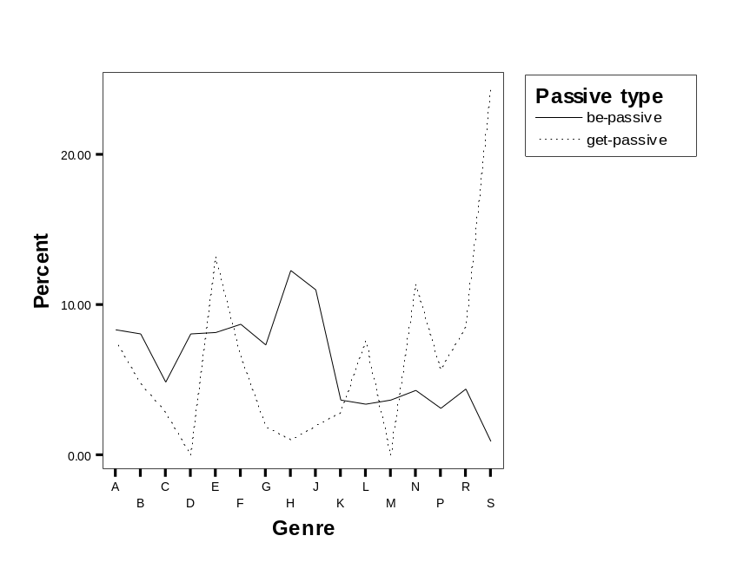
Fig. 5 Distribution of be/get passives across genres

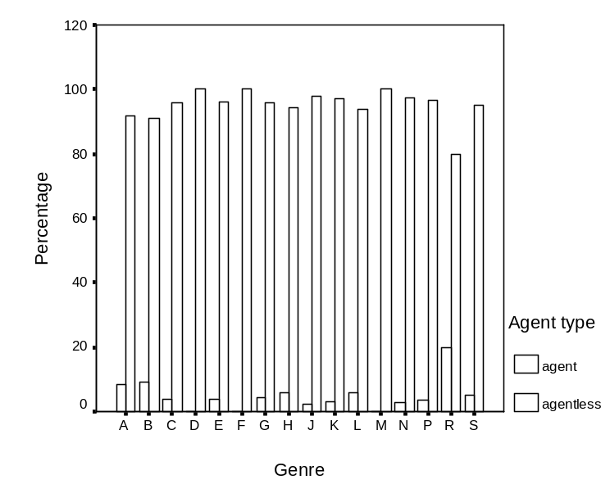
Fig. 6 Distribution of long vs. short be passives across genres

Now let us consider more fine-grained genre distinctions relating to English passives. As get passives are infrequent in FLOB (only 59 instances), a breakdown of their counts across 15 genres would yield frequencies which are too low to allow for a reliable statistical analysis. Hence we will focus upon be passives instead. We noted in an earlier section that while the short forms of be and get passives are predominant in both FLOB and BNCdemo, their combined frequencies are significantly higher in spoken English. This section considers the unmarked passive form – the be passive alone. Fig. 6 shows the distribution of long vs. short be passives across genres. As can be seen, long be passives are extremely rare in text categories D (religion), F (popular reading) and M (science fiction) but relatively frequent (20%) in category R (humour). The proportions of long be passives in all other genres are very similar. It is important to note that while the overall proportion of long be passives (10.8%) for FLOB is higher than that for BNCdemo (5.1%), spoken English does not differ much from most written genres other than humour.
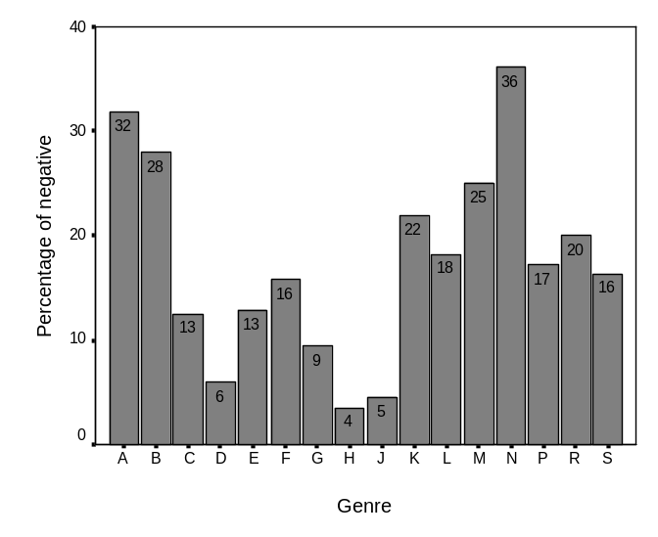
Fig. 7 Proportions of negative be passives in 16 genres

As noted earlier, get passives (37.7%) are used much more frequently in negative situations than be passives (15%). Here we will consider be passives alone. Fig. 7 shows the proportions of negative be passives in 16 genres. It is clear that be passives are most frequently negative in text categories N (adventure fiction), A (news reportage) and B (news review) but are least frequently negative in categories H (official documents), J (academic prose) and D (religion). The negative proportion for the spoken genre (S) is very close to the overall negative proportion of written genres (16% and 15% respectively). This suggests that the English passive norm is typically not associated with an inflictive meaning.

1.6. Syntactic functions of English passives
This section examines the syntactic functions of English passives. English has the distinction between finite and non-finite verb forms. The finite form exclusively functions as a predicate in a sentence/clause while the non-finite forms (e.g. infinitive and -ing) can either function as other sentence/clause elements or co-occur with auxiliary verbs as predicates. We examined the syntactic functions of 2,000 instances of be passives randomly sampled from a total of 9,908 in FLOB and 5,001 in BNCdemo, as well as 59 instances of get passives in FLOB and 1,300 instances in BNCdemo.

The results are given in Table 6. In the table attributive refers to post-modifiers of nouns; adverbial typically refers to adverbial of purpose with an infinitive or the so-called absolute structure consisting of a noun following by an -ing form; complements can be complementary to the subject, object or the predicate adjective. Both infinitival and -ing forms of passives are found in the object position, with the former as the object of a verb (e.g. want) and the latter as the object of a verb or preposition. Only the -ing form of the get passive was found in the subject position in the concordances we examined. It can be seen from the table that English passives (both be and get passives) are by far most frequent in the predicate position. As Biber et al (1999: 937) observe, passive constructions are infrequent in non-finite positions in English. Non-finite forms of passives are relatively common in object and complement positions but rare in the subject position. It is also clear that the distribution of get passives across syntactic functions appears to be more balanced than that of be passives.

Passive type | Function | FLOB | BNCdemo | Total | Percent
Be passive | Attributive | 5 | 3 | 8 | 0.40%
Be passive | Adverbial | 6 | 1 | 7 | 0.35%
Be passive | Complement | 10 | 9 | 19 | 0.95%
Be passive | Object | 9 | 12 | 21 | 1.05%
Be passive | Subject | - | - | - | -
Be passive | Predicate | 970 | 975 | 1945 | 97.25%
Get passive | Attributive | 1 | 8 | 9 | 0.66%
Get passive | Adverbial | 0 | 10 | 10 | 0.74%
Get passive | Complement | 8 | 14 | 21 | 1.55%
Get passive | Object | 5 | 12 | 17 | 1.25%
Get passive | Subject | 1 | 1 | 2 | 0.15%
Get passive | Predicate | 44 | 1255 | 1299 | 95.58%
Table 6 Syntactic functions of English passives

In the section that follows, we will undertake a comparable analysis of passive constructions in Chinese while also paying attention to their language specific features.

2. Passives in Chinese

2.1. Passive variants in Chinese
In relation to English, which typically uses be or get followed by a past participle to mark the passive, Chinese employs a wider range of devices to express passive meaning. The most important passive marker in Chinese is bei, which can mark passive constructions with or without an agent. As in the previous section, we refer to passive constructions profiling the agent as ‘long passives’, as in (4a) and those without profiling the agent as ‘short passives’, as in (4b) (cf. also Ting 1998). Note that the Chinese examples in this paper are given in Romanised alphabet called pinyin. In grammatical glosses, ASP stands for aspect marker, CL for classifier, GEN for genitive, INT for intensifier suo, PSV for syntactic passive marker, PRT for particle, and RVC for resultative verb complement.

(4) a. shishishang, tamen que yi-gege bei ren sha-le (LCMC: N)
in-fact, they but one-by-one PSV somebody kill-ASP
But in fact, they were killed one by one (by somebody).
b. diren bei dabai-le (LCMC: G)
enemy PSV defeat-ASP
The enemy was defeated.
(5) a. zhengzai xi de cai ye rang liushui chongzou-le (LCMC: K)
ASP wash GEN vegetable also PSV flowing-water wash-away-ASP
The vegetables she was washing were also washed away by the flowing water.
b. zhe-xia bu jiao wo cai-zhun-le? (LCMC: F)
this-CL not PSV I guess-right-ASP
Haven’t I guessed right this time?
c. wo mama ye gei ci-le (Callhome)
I mother also PSV fire-ASP
My mother was also fired.
d. ta wei ta de ai suo gandong, ta jueding quanli zhichi
she PSV he GEN love PRT move, she decide full support
ta de shiye (LCMC: P)
he GEN career
She was moved by his love and decided to support his career fully.
(6) a. wo rang ta tou-le liang-kuai qian (Li and Thompson 1989)
I PSV/ask/allow he steal-ASP two-dollar money
I had two dollars stolen by him/I asked (allowed) him to steal two dollars.
b. wo jiao ta tou-le liang-kuai qian
I PSV/order he steal-ASP two-dollar money
I had two dollars stolen by him/I told him to steal two dollars.
c. wo gei ta tou-le liang-kuai qian
I PSV/for he steal-ASP two-dollar money
I had two dollars stolen by him/I stole two dollars for him.

In both cases, bei is a function word without no inherent meaning other than marking passiveness. Bei is not a preposition as has been claimed (e.g. Chao 1968; Li 1994) nor is it a verb (Li 1980; Tang 2001). Neither is bei equivalent to by plus agent or the past participle in English passives. In our view, bei functions like be/get plus past participle in English passives to mark the patient status of the NP in the subject position. In addition to bei, passives in Chinese can be alternatively marked by rang, jiao, gei and the archaic wei…suo structure, as shown in (5). However, rang, jiao and gei have not been fully grammaticalised as passive markers because they are mainly used as lexical verbs, meaning ‘allow; concede’, ‘call; order’, and ‘give’ respectively while gei is typically used as dative marker that introduces the recipient or beneficiary of an action. As such, the examples in (6) are ambiguous (Li and Thompson 1989: 507). In contrast, when these less fully grammaticalised items are replaced by the full passive marker bei, no reading other than the passive is possible.

In addition to the fully fledged bei and the partly grammaticalised rang, jiao and gei, there are a number of lexical verbs with an inherent passive meaning including, for example, ai ‘suffer; endure’, shou ‘suffer; be subjected to’ and zao ‘suffer; meet with’. The constructions containing such intrinsically passive verbs are referred to as ‘automatic passives’ (Zhang 1953), as shown in (7). One important difference between these automatic passives and passive constructions marked by fully or partly grammaticalised passive markers like bei, rang, jiao and gei lies in that the former can take aspect markers whereas the latter cannot.

(7) a. yi-ge shou-le hechi de xiaoxuesheng (LCMC: K)
one-CL suffer-ASP berate GEN schoolchild
a schoolchild who has been berated
b. youzhiyuan suishi you zao pohuai de weixian (LCMC: G)
kindergarten any-time have suffer destroy GEN risk
The kindergarten risked being destroyed at any time.
c. youde haizi zai jia ai-le da, chu jiamen jiu
some children at home suffer-ASP beat, out house-gate then
zhao ren faxie (LCMC: E)
look-for other give-vent-to
Having been beaten up at home, some children let off their anger on others when they go out.
(8) a. fan shao-hao-le (Zhou and Jin 2004: 61)
meal cook-ready-ASP
The meal is ready.
b. *fan bei shao-hao-le
meal PSV cook-ready-ASP
(9) a. weishengjian ni dasao-guo le ma (Jiao and Dou 2002: 83)
bathroom you clean-RVC ASP PRT
Have you cleaned the bathroom?
b. *weishengjian bei ni dasao-guo le ma
bathroom PSV you clean-RVC ASP PRT
(10) a. zhexie tudou hen rongyi qupi (Jiao and Dou 2002: 83)
these potato very easy peel
These potatoes peel easily.
b. *zhexie tudou hen rongyi bei qupi
these potato very easy PSV peel
(11) a. qiqiu chui-po-le (Tang 2004)
balloon blow-break-ASP
The balloon was blown so much that it was broken.
b. qiqiu bei chui-po-le
balloon PSV blow-break-ASP
The balloon was blown so much that it was broken.
(12) a. gou bei ti-le yi-jiao (Jiao and Dou 2002: 84)
dog PSV kick-ASP one-foot
The dog was kicked once.
b. gou ti-le yi-jiao
dog kick-ASP one-foot
The dog kicked once.

It has been observed that passives in Chinese can take the unmarked form, as exemplified in (8). Like ‘automatic passives’ in (7), subjects in these unmarked sentences are all patients. Like those in English, constructions of this kind are often referred to as ‘notional passive sentences’ (e.g. Jiao and Dou 2002), as opposed to syntactically marked passives. Nevertheless, instead of viewing them as passive constructions, it is equally plausible to consider these notional passives as topic sentences, where the subject argument (‘the meal’, ‘the bathroom’ and ‘these potatoes’ in the (a) examples in (8-10) are topics while the other remaining constituents are the comment (cf. Li 1990; Shi 2000; Cann and Wu 2003). While these sentences can express the passive meaning because of the nature of their subjects, and indeed they can be turned into a marked passive when a passive marker is inserted (as in 11), they are nevertheless not passive constructions in a strict sense (see Tang 2004 for a discussion of differences between the two types of sentences). In fact, it is not always possible to insert a passive marker in these sentences (compare (a) and (b) sentences in 8-10). Conversely, even though short passives may differ from so-called notional passive sentences merely by a passive marker, the marker plays a decisive role in differentiating between the active and passive voices (12) (cf. Niu 2003: 39).

As in the previous section, notional passive sentences in Chinese are excluded in this section. Rather, we will focus upon marked passives. Note that while lexical passives do not belong to the grammatical category of passive, they are nevertheless included in this section so that they can be compared with syntactic passives. The following sections will explore these alternative passive markers in terms of their syntactic features, their interaction with aspect, their semantic prosodies, and their distribution across genres.

2.2. Long vs. short passives
As noted in the previous section, there are long and short passives in Chinese. Long passives take an agent while short passive do not. Table 7 gives the frequencies of long and short passives in the LCMC and Callhome corpora. It also shows the proportions of these syntactic and lexical passive markers in the total occurrences of the two corpora. As can be seen, the archaic structure wei…suo is typically (accounting for 60% of its total occurrences) used in modern Chinese as a passive marker (e.g. 5d), though it can also be used in the active voice. Starting in the Tang Dynasty, wei was gradually replaced by bei (cf. Li 1994: 2). Of the total instances of bei 87.3% are used as a passive marker, a proportion which is considerably higher than those for gei, jiao and rang, reflecting the much higher degree of grammaticalisation of bei over the other three syntactic passive markers. The three lexical passive markers are used mainly in ‘automatic passives’. Bei and gei can occur in both long and short passives, but it is more likely that they do not take an agent while wei…suo is typically found in long passives. In contrast, jiao and rang only occur with an agent in long passives (cf. Shi 1997: 51; Tang 2001: 279-280), as shown by the contrast in (13) and (14).

Passive  type | Passive  Marker | % of total  occurrences | Long passive |  | Short passive
Passive  type | Passive  Marker | % of total  occurrences | Frequency | Percent | Frequency | Percent
Syntactic  passive | bei | 87.3% | 511 | 39.3% | 789 | 60.7%
Syntactic  passive | wei…suo | 60.0% | 69 | 100.0% | - | -
Syntactic  passive | gei | 1.5% | 17 | 42.5% | 23 | 57.5%
Syntactic  passive | jiao | 0.4% | 4 | 100.0% | - | -
Syntactic  passive | rang | 1.6% | 15 | 100.0% | - | -
Lexical  passive | ai | 52.6% | 1 | 3.3% | 29 | 96.7%
Lexical  passive | shou | 60.4% | 132 | 31.9% | 282 | 68.1%
Lexical  passive | zao | 82.0% | 34 | 37.4% | 57 | 62.6%

Table 7 Long and short passives in LCMC and Callhome

(13) a. chufei lian ni de linghun ye jiao ta zhanyou-le,
unless even you GEN soul also PSV she occupy-ASP,
ta shi bu hui gandao manzu de (LCMC: P)
she is not will feel satisfy PRT
Unless even your soul is also occupied by her, she will not feel satisfied.
b. *chufei lian ni de linghun ye jiao zhanyou-le…
unless even you GEN soul also PSV occupy-ASP…
(14) a. xiang zhao ren wen, you pa rang ren qiaobuqi (LCMC: R)
want look-for other ask, but fear PSV other look-down-upon
(He) wanted to ask someone, but was afraid of being despised by others.
b. *xiang zhao ren wen, you pa rang qiaobuqi
want look-for other ask, but afraid PSV look-down-upon
(15) a. ta jing bei qinjia gei pian-le (LCMC: P)
she eventually PSV in-laws INT cheat-ASP
She was eventually taken in by her in-laws.
b. wo ma jiao che gei zhuang-shang-le (Shi 1997: 50)
I mom PSV car INT hit-wound-ASP
My mom was injured by a car.
c. huoren bu neng rang niao gei bie-si-le (LCMC: A)
the-living not can PSV piss INT hold-die-ASP
The living should not die of refraining from using the restroom (i.e. one must be flexible).

It has been observed that bei, jiao and rang can co-occur with gei in long passives (e.g. 15). Gei in these examples is different from its passive usage. In this context, gei is an intensifying particle that reinforces the disposal ba construction and syntactic passives (cf. Li and Thompson 1988; Li W. 2004). Its function is comparable to the particle suo in the passive construction ‘wei…suo’ in classic Chinese, which is replaced by bei … suo/gei in modern Chinese. Li W. (2004) observes that the intensifying function of gei developed at the end of the Qing dynasty (1644-1911). This intensifying usage of gei is referred to in Tang (2001: 284) as an ‘affectedness marker’ that reinforces the meaning of affectedness in these constructions. Hence, while examples in (15) can be rewritten felicitously by removing gei, the rewritten sentences will lose the emphatic flavour existing in the original sentences.

In some instances, however, gei in the ‘gei + pronoun’ structure can be interpreted either as an intensifier or as a passive marker even in the same construction depending on the context (cf. Zhang 1999: 81), as shown in the glosses in (16). This is perhaps because the intensifying gei can be understood as the shortened form of the ‘gei + pronoun’ structure; as Tang (2001: 286) observes, ‘the affectedness marker gei in Mandarin was derived by incorporating the pronoun into gei by “radical” contraction’. Unsurprisingly, therefore, the example in (17) allows a number of readings.

(16) a. (duibuqi,) qianbi gei-ni nongdiu-le (Zhang 1999: 81)
(Sorry,) pencil INT-you lose-ASP
Sorry, I lost your pencil.
b. (ni kan,) qianbi gei ni nongdiu-le ba
(you look,) pencil PSV you lose-ASP PRT
Literal: Look, the pencil was lost by you.
(17) lao niu gei ta la-zou-le (Huang 1996: 667)
old cow PSV/INT/for he pull-away-ASP
The old cow was pulled away by him.
The old cow was pulled away.
The old cow was pulled away for him.
(18) a. xiaoxue shi, wo jingchang ai huai haizimen
primary-school when, I often suffer bad children
[de] da (Li 2001: 44)
[GEN] beat
I was often beaten by bad children when I was in primary school.
b. guli xitong bu shou waijie [de] yingxiang (LCMC)
isolate system not suffer outside [GEN] influence
An isolated system is not influenced by the outside world.
c. lü zao waiguo [de] qinlüe (LCMC: G)
repeatedly suffer foreign-country [GEN] invade
(China) was invaded by foreign countries time and again.
(19) a. beizi bei/gei/jiao/rang ta dapo le (Zhou 2004: 14)
cup PSV he break ASP
The cup was broken by him.
b. *beizi bei/gei/jiao/rang ta de dapo-le
cup PSV he GEN break-ASP

It appears that of the three lexical passive markers, ai occurs predominantly in short passives while shou and zao frequently occur without an agent. Note, however, that as ai, shou and zao are verbs, the agent NPs in automatic passives can equally be interpreted as attributive modifiers of nominalised verbs, but this interpretation is impossible in syntactic passives with the four syntactic passive markers, as shown in (18-19).

2.3. Syntactic functions
Another difference in the syntactic features of these passive markers is that they have different probabilities of functioning as different sentence constituents. Unlike English, which has the finite vs. non-finite distinction, Chinese does not formally differentiate between these two forms. Hence, Chinese passive constructions can be either finite or non-finite (even though in reality finite uses, e.g., as predicates, are more common. See below.). In addition to functioning as a predicate, as shown in the examples in the previous sections, a passive construction in Chinese can occur in a sentence as the subject (20a) or object (20b), or as an attributive (20c) or adverbial (20d) modifier. Passive constructions are also likely to occur in nominal phrases such as bei boxue zhe ‘the exploited’, bei tongzhi jieji ‘the ruled’, and bei qinhai ren ‘victim’, though the distinction between the nominal and attributive uses is not always clear-cut.

(20) (a) er ziji diyi-ci bei hushi, geng shi ta you-le
and self first-time PSV ignore, more make she have-ASP
shenchen de shiluo (LCMC: P)
deep GEN loss
And her being ignored for the first time made her feel even more deeply lost.
(b) mengjian bei gou yao shang, yuzhao bei ren wuxian feibang (LCMC: D)
dream-of PSV dog bite wound presage PSV people frame slander
Dreaming of being bitten by a dog is a sign of being framed and slandered.
(c) zai bei qiuji de 12-tian li, Sun Yat-Sen shihu gandao juewang (LCMC:G)
during PSV imprison GEN 12-day in, Sun Yat-Sen appear feel despair
During the 12 days he was imprisoned, Sun Yat-Sen appeared to feel despaired.
(d) ke zhe yiqie, que yin die bei guanya er jiesu-le (LCMC: K)
but this all but because dad PSV lock-up then finish-ASP
But all of this came to an end because of dad’s imprisonment.

Marker | Predicate | Subject | Object | Attributive | Adverbial | Nominal | Total
bei | 966  74.3% | 12  0.9% | 34  2.6% | 194  14.9% | 58  4.5% | 36  2.8% | 1300  66.2%
wei…suo | 66  95.7% | - | - | 3  4.3% | - | - | 69  3.5%
gei | 39  97.5% | - | 1  2.5% | - | - | - | 40  2.1%
jiao | 4  100% | - | - | - | - | - | 4  0.2%
rang | 14  93.3% | - | 1  6.7% | - | - | - | 15  0.8%
Syntactic total | 1089  76.3% | 12  0.8% | 36  2.5% | 197  13.8% | 58  4.1% | 36  2.5% | 1428
ai | 21  70.0% | 2  6.7% | 2  6.7% | 5  16.6% | - | - | 30  1.5%
shou | 309  74.6% | 9  2.2% | 10  2.4% | 61  14.8% | 22  5.3% | 3  0.7% | 414  21.1%
zao | 69  75.8% | 1  1.1% | 3  3.3% | 11  12.1% | 7  7.7% | - | 91  4.6%
Lexical total | 399  74.6% | 12  2.2% | 15  2.8% | 77  14.4% | 29  5.4% | 3  0.6% | 535
Total/  Average | 1488  75.8% | 24  1.2% | 51  2.6% | 274  14.0% | 87  4.4% | 39  2.0% | 1963  100%

Table 8 Syntactic functions of passive constructions in Chinese

Table 8 gives the frequencies of passive constructions with these different syntactic functions in the LCMC and Callhome corpora. As the passive is a verb construction, it can be expected that passive constructions are primarily used as predicates in sentences/clauses. The table shows that apart from this primary use, the attributive use appears to be the second most important syntactic function of passive constructions in Chinese. It can also be seen that passive constructions marked syntactically and lexically can be used as an object. Adverbial uses are found only in passive constructions with bei and shou while with all passive markers, the subject uses are rare. The statistics suggest that in terms of syntactic functions, the differences in the distribution of syntactic and lexical passives in Chinese are marginal. Our data shows that passive constructions typically do not function as complementary elements in Chinese.

2.4. Interaction between passives and aspect
Passive constructions syntactically marked by bei etc are closely linked to aspect. For example, syntactic passives in Chinese convey an aspectual meaning of result that cannot be cancelled when they interact with perfective aspects (see Xiao and McEnery 2004). Table 9 shows the interaction between syntactic and lexical passives with various aspect-related constructions. In addition to the perfective aspect markers -le, -guo and the imperfective aspect marker -zhe, resultative verb complements (RVCs) in Chinese contribute to both situation aspect and viewpoint aspect in that they typically express a telic notion and grammatically mark the completive aspect (see Xiao and McEnery 2004). The structure verb + de + complement can denote either resultativeness or manner, but only the resultative de-structure is relevant to aspect, as in bei da-de biqing-lianzhong ‘have one’s face bashed in’. Negation is relevant here because some aspect markers do not occur in negative sentences. For example, -le is replaced by mei/meiyou ‘not’ when a sentence is negated. All other instances were considered as bare passive constructions. Note that in syntactic passives, aspect markers, RVCs or the resultative de-structure follow the verb phrases preceded by passive markers such as bei rather than the passive marker per se (cf. bei piping-le vs. *bei-le piping ‘was criticised’) while they can follow ai, shou and zao in lexical passives (e.g. cf. ai/shou/zao-le piping vs. ai/shou/zao piping-le ‘was criticised’). Negative adverb mei/meiyou/bu always precede passive markers in both syntactic and lexical passive constructions. The archaic passive form wei…suo does not take aspect markers; it co-occurs with negative adverbs because negation is part of the intended meaning.

Marker | -le | -zhe | -guo | RVC | de-result | negation | Bare | Total
bei | 213  16.4% | 19  1.5% | 4  0.3% | 462  35.5% | 48  3.7% | 50  3.8% | 504  38.8% | 1300  66.2%
wei…suo | - | - | - | - | - | 5  7.2% | 64  92.8% | 69  3.5%
gei | 19  47.5% | 1  2.5% | - | 11  27.5% | 5  12.5% | - | 4  10.0% | 40  2.1%
jiao | 3  75% | - | - | - | - | - | 1  25% | 4  0.2%
rang | 6  40% | - | - | 2  13.3% | - | 4  26.7% | 3  20% | 15  0.8%
Syntactic  total | 241  16.9% | 20  1.4% | 4  0.3% | 475  33.3% | 53  3.7% | 59  4.1% | 576  40.3% | 1428
ai | 7  23.3% | - | 1  3.3% | 2  6.7% | - | - | 20  66.7% | 30  1.5%
shou | 42  10.1% | 4  1.0% | 12  2.9% | - | - | 37  8.9% | 319  77.1% | 414  21.1%
zao | 11  12.1% | 2  2.2% | 1  1.1% | - | - | - | 77  84.6% | 91  4.6%
Lexical total | 60  11.2% | 6  1.1% | 14  2.6% | 2  0.4% | - | 37  6.9% | 416  77.8% | 535
TOTAL | 301  15.3% | 26  1.3% | 18  0.9% | 477  24.3% | 53  2.7% | 96  4.9% | 992  50.6% | 1963  100%

Table 9 Interaction between passives and aspect

It can be seen from the table that bare forms account for the largest proportions for syntactic and lexical passives while of the three aspect markers, -le is most frequently used in both types, which is followed by -zhe and -guo, mirroring the distribution pattern of the three aspect markers in the two corpora – 12,368 instances of -le, 3654 instances of -zhe and 939 instances of -guo. However, there are important differences between syntactic and lexical passives in their interaction with aspect. RVCs and resultative de-structure generally occur more frequently in syntactic passives while the bare forms are considerably more common in lexical passives. RVCs are less frequent in lexical passives because over 40% of instances of shou and zao are found in disyllabic words shoudao and zaodao, where dao functions like an RVC but is not counted as such in this paper.

Marker | Predicate | Subject | Object | Attributive | Adverbial | Nominal | Total
-le | 199  20.6% | - | 2  5.9% | 11  5.7% | 1  1.7% | - | 213  16.4%
-guo | 2  0.2% | - | 1  2.9% | 1  0.5% | - | - | 4  0.3%
RVCs | 392  40.6% | 2  16.7% | 4  11.8% | 55  28.3% | 9  15.5% | - | 462  35.5%
-zhe | 16  1.6% | - | - | 3  1.5% | - | - | 19  1.5%
de-result | 45  4.7% | - | - | 3  1.5% | - | - | 48  3.7%
Negation | 38  3.9% | - | 2  5.9% | 9  4.6% | 1  1.7% | - | 50  3.8%
Bare | 274 28.4% | 10 83.3% | 25 73.5% | 112  57.7% | 47  81.1% | 36  100% | 504  38.8%
Total | 966  100% | 12  100% | 34  100% | 194  100% | 58  100% | 36  100% | 1300  100%
Table 10 A breakdown of syntactic functions and aspect markers in bei passives

The bare forms in syntactically marked passives are less frequent because passive constructions of this type typically encode a result, which is made visible by viewpoint aspects. Bare verbs are uncommon in syntactic passives, especially when the passive constructions function as predicates. To illustrate this point, let us consider passives marked by bei. Table 10 gives a breakdown of syntactic functions and aspect markers in bei passives. As can be seen, whilst passive constructions functioning as nominal phrases, subjects, objects or adverbial modifiers usually do not interact with aspect, bare forms are considerably less frequent in passive constructions in the predicate position. A closer look at the bare forms in the predicate position shows that such bare passives typically occur in the following contexts, which are often associated with the omission of aspect markers in Chinese discourse:

- a preceding modal auxiliary such as hui ‘will’, neng/nenggou ‘can’, yuanyi ‘be willing to’ and keyi ‘may’;
- a preceding time adverbial such as yi/yijing ‘already’, jiang ‘will’, jiuyao/yao ‘will’;
- the shi…de structure;
- the archaic form bei…suo;
- reporting and commanding verbs such as gaozhi ‘tell’, zhishi ‘instruct’, ming ‘order’, pilu ‘expose’, xuangao ‘declare’, and pan ‘sentence’;
- idiomatic verb phrases such as juzhimenwai ‘refuse’, gegejipo ‘destroy one by one’, qianggouyikong ‘sell out’ and xijieyikong ‘loot’;
- a (patient) subject preceded by you ‘have’, as in you yi jumin bei sha ‘One resident was killed’;
- coordinated predicates, e.g. yi-ge bei sha, yi-ge ren aidao ‘one was killed, another was wounded by a knife’;
- a following complementary element such as prepositional phrase;
- and the sentence-final change-of-state le.

2.5. Semantic prosodies
In addition to syntactic features, passive variants in Chinese also differ in their semantic properties. It has been noted that passive constructions in Chinese are ‘usually of unfavourable meanings’ (Chao 1968: 703) in addition to their passive meaning. This is perhaps because the prototypical passive marker bei derived from its main verb usage meaning ‘suffer’ (Wang 1957). However, Chinese passives have been influenced by Western languages so that they are no longer restricted to verbs with an inflictive meaning (ibid), especially in the written language. In other words, language contact and language change have turned the unfavourable connotation of passive constructions into a negative semantic prosody, which is essentially a collocational meaning (cf. Xiao and McEnery 2005).

Passive  Type | Passive  marker | Negative |  | Positive |  | Neutral
Passive  Type | Passive  marker | Freq | Percent | Freq | Percent | Freq | Percent
Syntactic  passive | bei | 670 | 51.5% | 139 | 10.7% | 491 | 37.8%
Syntactic  passive | wei…suo | 13 | 18.9% | 27 | 39.1% | 29 | 42.0%
Syntactic  passive | gei | 27 | 67.5% | 3 | 7.5% | 10 | 25.0%
Syntactic  passive | jiao | 2 | 50.0% | 1 | 25.0% | 1 | 25.0%
Syntactic  passive | rang | 10 | 66.7% | 4 | 26.7% | 1 | 6.6%
Lexical  Passive | ai | 30 | 100.0% | 0 | - | 0 | -
Lexical  Passive | shou | 269 | 65.0% | 100 | 24.1% | 45 | 10.9%
Lexical  Passive | zao | 91 | 100.0% | 0 | - | 0 | -

Table 11 Chinese passive markers across meaning categories

Table 11 shows the distribution of passive markers across meaning categories. Note that the affective meanings of passive constructions can be interpreted not only in relation to the patient subject, but also to the speaker or people concerned when the patient subject is inanimate (cf. Li 1994: 20). It can be seen from the table that Chinese passives more often than not display a negative semantic prosody. The lexical passives marked by ai and zao are always negative because infliction is a connotative meaning inherent in the two verbs. In relation to bei, the archaic form wei…suo shows a less pronounced propensity for negative semantic prosodies because wei, unlike bei, does not have an inflictive meaning, whilst gei is more likely to express unfavourable situations because ‘the semantics of gei “give” is often to offer something at the giver’s cost instead of being benefactive to the giver’ (Yin 2004). It has been observed that the influence of Western language on Chinese passives has largely been confined to the written language (Li 1994: 19) and that jiao, rang and gei are colloquial passive markers (Wang 1957). Based on these observations, the three alternative passive markers are expected to be used more frequently than bei in detrimental situations. Nevertheless, while gei appears to show such a tendency, we cannot draw a firm conclusion from our limited data.

Significant collocations of bei (with a z-score greater than 3.0 and a minimum frequency of 3 within the L0-R4 window) in the LCMC corpus include 31 verbs with a negative meaning (e.g. bang ‘truss up’, jie ‘rob’, pian ‘cheat’ and sha ‘kill’), six verbs with a positive meaning (e.g. pingwei ‘choose…as’, yuwei ‘honour…as’, tisheng ‘promote’ and feng ‘confer (a title)’), and 24 verbs that are neutral (e.g. chengwei ‘call’, renming ‘appoint’ and anpai ‘arrange’). No significant collocations were found for the other three syntactic passive markers in our data. The collocations of shou include five negative verbs (xianzhi ‘constrain’, zhiyue ‘restrict’, ciji ‘stimulate; irritate’, yingxiang ‘affect, impair’ and chongji ‘attack, assault’) and two positive verbs (huanying ‘welcome’ and zhongshi ‘attach importance to’). Only two verb collocations were found for zao (pohuai ‘destroy’ and jujue ‘refuse’), both of which are negative; no significant collocations were found for ai in our data. These collocations confirm the distribution of passive markers across meaning categories as observed in Table 11 and appear to suggest that passive constructions are largely inflictive in nature.

2.6. Genre distinctions
This section explores the distribution of passive constructions across genres by focusing on syntactically marked passives. As the samples for different genres vary in size, the frequencies have been normalised to a common basis for easy comparison. Table 12 shows the normalised frequencies (per 100,000 words) of passive markers in 15 written genres covered in LCMC and the spoken genre in Callhome. As can be seen, the average frequency of syntactic passive markers is over 11 times as frequent in LCMC as in Callhome, suggesting that in relation to written Chinese, passive constructions are considerably less frequent than in spoken Chinese. The overall low frequency of passives in spoken Chinese might suggest that speakers simply try to avoid using passives as much as possible, perhaps because of their negative semantic prosodies (see discussion below). Of the written genres, passive constructions are most frequent in religion texts (D) and mystery/detective stories (L) but least frequent in news editorials (C) and official documents (H), as shown in Fig. 8. It can also be seen from the figure that while the distribution of lexical passive markers show some differences from syntactic passives, they will not change the overall distribution pattern to a great extent because of their relatively low frequencies.

Genre | bei | wei… suo | gei | jiao | rang | ai | shou | zao | Syn.  total | Total
A | 149 | 5 | - | 1 | 2 | 2 | 31 | 12 | 157 | 202
B | 95 | 7 | - | - | - | 2 | 50 | 15 | 102 | 169
C | 38 | 6 | - | - | - | - | 41 | 20 | 44 | 105
D | 206 | 41 | - | - | - | - | 73 | 12 | 247 | 332
E | 73 | 4 | - | - | - | 3 | 50 | 1 | 77 | 131
F | 128 | 8 | - | 1 | - | 2 | 50 | 17 | 137 | 206
G | 177 | 8 | - | - | 2 | 2 | 30 | 10 | 187 | 229
H | 51 | - | - | - | - | - | 33 | 5 | 51 | 89
J | 105 | 12 | - | - | - | - | 62 | 6 | 117 | 185
K | 156 | - | 3 | - | 2 | 7 | 21 | 5 | 161 | 194
L | 221 | - | 2 | 2 | 2 | 2 | 22 | 12 | 227 | 263
M | 138 | 9 | - | - | - | - | 16 | - | 147 | 163
N | 134 | 2 | 22 | - | 3 | 10 | 24 | 5 | 161 | 200
P | 118 | 3 | 5 | 2 | 2 | 3 | 13 | 7 | 130 | 153
R | 70 | - | 11 | - | 11 | 32 | 16 | 5 | 92 | 145
S | 6 | - | 5 | - | 1 |  | 7 |  | 12 | 19
Written | 127 | 7 | 2 | - | 1 | 3 | 39 | 9 | 137 | 188
All | 99 | 5 | 3 | - | 1 | 2 | 32 | 7 | 108 | 149
Table 12 Normalised frequencies of Chinese passive markers (per 100K words)
(Notes: S = Callhome spoken corpus; Written = A – R; All = both written and spoken)
We noted earlier that in English be passives are very common in official documents (H) and academic prose (J), though the frequencies of get passives are relatively low in these genres. In Chinese, however, passive constructions are infrequent in these two genres (see Fig. 8). This is perhaps because English passives (more specifically, be passives) function to mark objectivity and a formal style, passives in Chinese do not have this function.
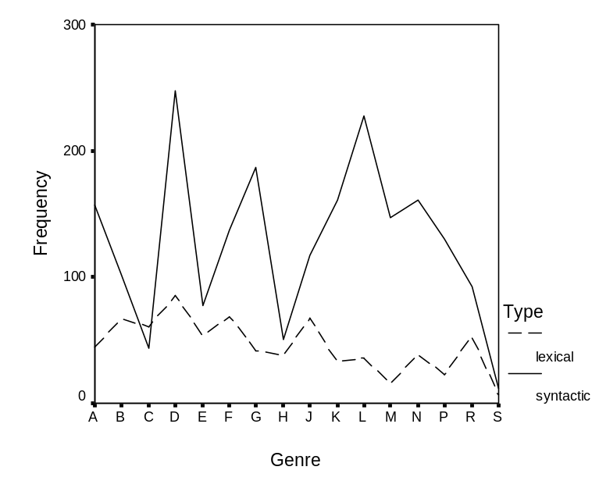

Fig. 8 Overall distribution of passive markers
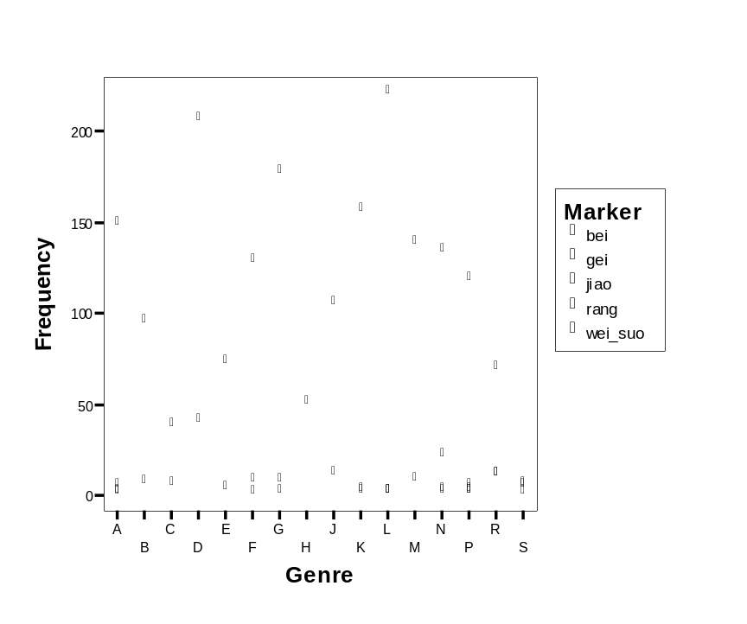

Fig. 9 Distribution of syntactic passives

Fig. 9 shows the distribution of five syntactic passive markers across the 16 genres under consideration. It is clear that bei is found in all genres – it is a ‘universal’ passive marker in Chinese; wei…suo occurs only in written genres while gei, jiao and rang are generally rare in written genres barring martial arts fiction (N) and humour (R). Martial arts stories represent a distinctive genre in that they are written in a form of vernacular Chinese; humour is a colloquial genre that is very similar to spoken language. Even though it has been observed by many scholars that the function of bei is carried out by other passive markers gei, jiao and rang in spoken Chinese (e.g. Hu 1993; Zhang and Fang 1996), these passive variants do not occur frequently in our spoken corpus either, perhaps because jiao and rang are typically used in Northern dialects (cf. Wu and Zhou 2004: 67-68) while gei typically occurs in Southern dialects (Li 1994: 2; Ding and Cao 2000: 76).

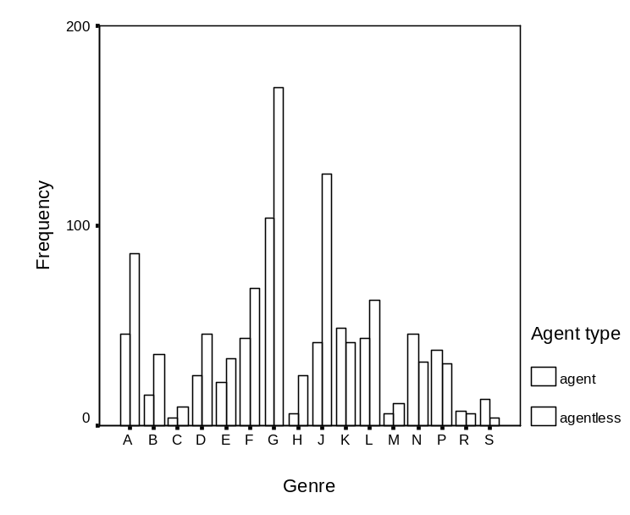

Fig. 10 Distribution of long vs. short passives

The remainder of this section explores the ‘universal’ passive marker bei in more detail. We will first examine the long and short forms of bei passives. Fig. 10 shows the distribution of the two forms across the 16 genres under consideration. As can be seen, the contrast between the two forms is typically less marked in various kinds of fiction (K-P), humour (R) and speech (S); in some of these genres (K, P, R and S), long passives are even more frequent than short passives. As fiction and humour are close to spoken language in many respects, one can reasonably speculate that Chinese speakers tend to use long passives in speech and colloquial genres but short passives in typical written genres such as academic prose (J), official documents (H) and biographies (G).

Li Z. (2004: 9) found on the basis of a corpus of newspaper and a corpus of literary texts that the proportion of negative uses of bei passives in literary texts is considerably greater than in newspaper texts (86.18 % vs. 57%). This finding is generally supported by our data which shows proportions of 51.5% and 66% for news (A-C) and literary (K-P) texts respectively. But our data reveals more fine-grained genre distinctions also. As can be seen in Fig. 11, even different types of news and literary texts can show marked differences. For newspaper texts, news editorials are more likely to use bei passives negatively while for literary texts, mystery/detective stories and martial arts fiction tend to use bei passives in a negative sense more frequently. Bei passives are also predominantly negative in speech. In contrast, they do not show a negative semantic prosody frequently in official documents and academic prose. In general, it is clear that fiction of various kinds and humour bear a closer resemblance to speech than other genres in our corpora as far as the semantic prosodies of bei passive constructions are concerned.
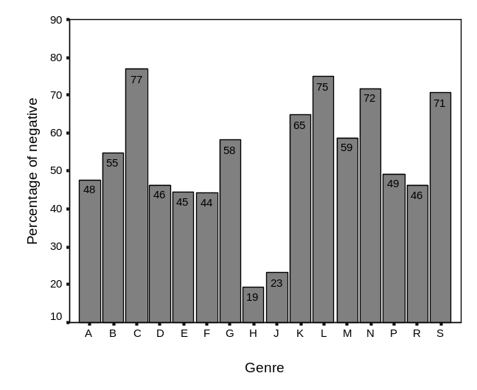
Fig. 11 Proportions of negative bei passives
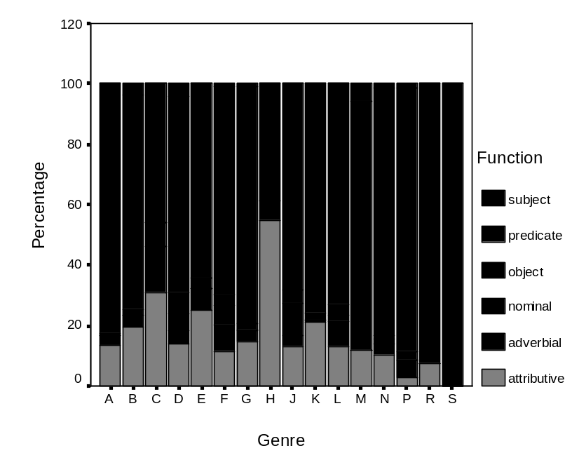

Fig. 12 Syntactic functions of bei constructions

We noted earlier that passive constructions are infrequent in official documents (H) and when used, they do not usually show a negative semantic prosody. Another peculiarity of this genre, as can be seen from Fig. 12, is that the proportion of attributive use of passive constructions – in this case, bei passives – is exceptionally high in relation to other genres. While the predicate use of bei constructions is frequent in all genres, fiction (K-P) and humour (R) are generally closer to speech (S). News reportage (A) is also very similar because this category includes some written-to-be spoken scripts for radio and television broadcasting.

We have so far provided a quantitative analysis of passive constructions in English and Chinese separately. The section that follows will approach passives in the two languages from a contrastive perspective on the basis of this analysis.

3. A contrastive analysis of passives in English and Chinese

This section contrasts syntactically marked passive constructions in Chinese and be/get passives in English since lexical passives in Chinese, in a strict sense, do not belong to the grammatical category of passive. While it is clear that constructions marked by be/get plus a past participle in English and bei/jiao/rang/gei in Chinese both express a basic passive meaning, there are nevertheless a range of differences between the two languages. It is important to note, however, that many of the differences discussed below are quantitative rather than qualitative, reflecting the statistical norms of passives in English and Chinese.

3.1. Overall frequencies

The first obvious difference, as noted previously, is that syntactic passives are by far more frequent in English than in Chinese. There are 995 instances of be passives and 31 instances of get passives per 100,000 words in FLOB and BNCdemo, with a total normalised frequency of 1,026. In contrast, there are 1,428 instances syntactic passives (1,300 instances of bei, 69 instances of wei…suo, 40 instances of gei, 15 instances of rang and 4 instances of jiao) in 1.3 million words of texts from LCMC and Callhome, producing a normalised frequency of 110. Passive constructions are nearly 10 times as frequent in English as in Chinese. Note that the frequency for the English data only includes passive constructions without an intervening adverbial. If occurrences with intervening adverbials are also counted, the frequency for English would be much greater and an even more marked contrast would be expected.

A number of reasons can be forwarded which help to account for this contrast between English and Chinese. Firstly, as the be passive originated from the predicative structure (i.e. a copular verb followed by a subject predicative), this unmarked passive form can be used for both static and dynamic situations while Chinese passives can only occur in dynamic events. Secondly, Chinese passives typically have a negative semantic prosody (see further discussion below) while English passives (especially be passives) do not. Finally, English has a tendency to overuse passives, especially in formal writing, whereas Chinese tends to avoid syntactic passives wherever possible. It has been pointed out that English (official documents, scientific writing and news reportage in particular) ‘is so addicted to the passive voice that you must constantly alert yourself against its drowsy, impersonal pomp’ (Baker 1985: 121) and the excessive use of passives has been criticised by many scholars including Quirk (1968: 170). In a parallel corpus composed of one quarter million English words and over 400,000 Chinese words, only about 20% of be passives are translated into Chinese using syntactically marked passive constructions, with the majorities being translated using so-called notional passives, subject sentences, sentences with vague subjects (e.g. youren ‘someone’, renmen ‘people’, dajia ‘all’) and special sentences (e.g. the disposal ba construction and the predicative shi…de structure). Given that Chinese passives are much more restricted in use than their English counterparts, their low frequency is hardly surprising.

3.2. Agents in long passives
The agent in the long passive in English is introduced by by, which is left out together with the agent in the short passive. In Chinese the agent is introduced by bei in the long passive while in short passive, only the agent, but not bei, is omitted because bei plays the double role of marking passive constructions as well as introducing the agent. It is also apparent that the agent in the long passive normally follows the passivised verb in English but occur before the verb in Chinese.

We noted in earlier sections that short passives typically account for over 90% of total occurrences of be/get passives in both written and spoken English, a proportion slightly higher than what was observed by Quirk et al (1985: 164) – ‘approximately four out of five English passive sentences have no expressed agent’. In Chinese, as noted earlier, three of out of the five syntactic passive markers (wei…suo, jiao and rang) only occur in long passives. For the two remaining passive markers bei and gei which allow both long and short passives, the proportions of short passives (60.7% and 57.5% respectively) are significantly lower than those for English passives. Early Chinese grammarians such as Wang (1984) and Lü and Zhu (1979) noted that an agent must normally be spelt out in passive constructions, though this constraint has become more relaxed nowadays, as can be seen in section 2.2. That may explain why a vague expression such as ren ‘someone’ and renmen ‘people’ is often specified when it is difficult to spell out the agent. In the LCMC corpus, there are 58 instances of ren/renmen ‘someone/people’ as the agent without a modifier, and all of these can be optionally removed without causing loss of information. In contrast, the agents in English long passives are rarely those informationally light vague words such as someone, somebody or people without a post-modifier. In FLOB, for example, there are seven instances of by people, six of which have a post-modifier or are followed by a clause where the agent NP also functions as the subject; and of the five instances of by somebody/someone, three have a post-modifier.

3.3. Semantic properties

A major distinction between passive constructions in the two languages under consideration is that Chinese passives are more frequently used with an inflictive meaning than English passives. With the exception of the archaic form wei…suo, over 50% of passive constructions marked by all syntactic passive markers in Chinese occur in adversative situations, a proportion considerably higher than that for English passives (15% for be passives and 37.7% for get passives). We noted earlier that the prototypical passive marker bei was derived from a verb with an inflictive meaning. As such, Chinese passives were used at early stages primarily for unpleasant or undesirable events. While this semantic constraint on the use of passives has become more relaxed, especially in written Chinese, under the influence of western languages, disyllabic words made up of bei and a single character verb as used in modern Chinese typically refer to something undesirable, as in beibu ‘be arrested’, beifu ‘be captured’, beigao ‘the accused’, beihai ‘be a victim’ and beipo ‘be forced’. In this respect, the get passive is closer to Chinese passives than the unmarked passive be passive, because the use of be passives is more stylistically oriented, i.e. to make the discourse sound more impersonal, objective, formal and technical. Marking negative semantic prosodies is not a basic feature of English passives. Hence unsurprisingly, of the three meaning categories discussed in previous sections, the neutral use of passive is predominant in English, followed by negative and positive categories whereas for
Chinese, the order is different: negative, neutral and positive (cf. Z. Li 2004: 11). In conclusion, positive categories of passive constructions are least frequent in both languages while the difference consists in how much negativity is coded in them.

3.4. Syntactic functions

As passives are basically verb constructions, they are most frequently used as predicates in both English and Chinese. However, the proportion of passive constructions as predicates in English (over 95%) is much higher than that in Chinese (76% on average), though there are great variations in such proportions for different passive markers in Chinese. While passives are more frequent in the object than subject position in both languages, they often function as attributive modifiers in Chinese but as complements in English. In general passive constructions in Chinese (bei passives in particular) are more balanced across syntactic functions than English passives.

It is also important to note that Chinese passives in the predicate position typically interact with aspect. Passive constructions with bare verbs in this position are uncommon, though they are frequent in other sentential positions. The contexts where bare passives occur as predicates are also the same as those which encourage omission of aspect markers in Chinese discourse in general. In English, the interaction between passives and aspect is not so apparent as in Chinese because all English sentences and clauses are formally marked by combined tense-aspect markers.

3.5. Genre distinctions

There are clearly genre variations in the distribution of passive variants in both English and Chinese. In English get passives are most commonly found in informal written genres and colloquial genres while in Chinese syntactic passives with markers other than bei show great variation across genres, with wei…suo typically occurring in formal written genres and jiao, rang and gei in colloquial genres. This section only compares the unmarked be passive in English and the universal bei passive in Chinese.

Passives in English occur more frequently in informative than imaginative genres. Official documents and academic prose, in particular, show very high proportions of passives. In contrast, these two genres have the lowest proportions of passives in Chinese, where mystery/detective stories (L) and religious writing (D) show exceptionally high proportions of passives. The difference in the overall distribution of passives is closely associated with the different functions of passive constructions in the two languages. As noted earlier, the passive is primarily used to mark an impersonal, objective and formal style in English whereas it is typically an ‘inflictive voice’ in Chinese (Lian 1993: 92). Mystery and detective stories are often concerned with victims who suffer from various kinds of mishaps and the attentions of criminals. In religion human beings are passive animals whose fate is controlled by some kind of supernatural force. It is thus hardly surprising to find passive constructions most frequently in the two genres. In English, however, these genres are not obtrusive in English because of the overall high frequencies of passives in informative genres and low frequencies in imaginative genres.

Of the 16 genres under consideration, short passives are predominant in all genres in English but there are considerable variations in Chinese, where long passives appear to be used in speech and colloquial genres and short passives are typical in written genres. In terms of semantic properties, English passives appear to show high proportions of negative cases in imaginative categories (including speech) and news reportage/review but low proportions in official documents, academic prose and religious writing. In Chinese, proportions of negative cases are high in all genres barring official documents and academic prose.

4. Conclusions

This paper explored passive constructions in English and Chinese from a contrastive perspective on the basis of corpus data. It was found that while passive constructions in both languages express a basic passive meaning, they also show a range of differences in terms of overall frequencies, syntactic features and functions, semantic properties, and distributions across genres. These differences are closely associated with the origins and functions of passive constructions in English and Chinese. Methodologically, this study demonstrates that comparable monolingual corpora provide a useful tool for contrastive linguistics.

Acknowledgements

We are grateful to the UK ESRC for supporting our project Contrasting English and Chinese (RES-of 000-23-0553) and thank Hongyin Tao for his valuable comments on an earlier draft of this paper.

References
Aston, G. and Burnard, L. (1998) The BNC Handbook (Edinburgh: Edinburgh University Press).
Baker, S. (1985) The Practical Stylist [6th ed.] (New York: Harper & Row).
Biber, D. (1988) Variation Across Speech and Writing (Cambridge: Cambridge University Press).
Biber, D., Johansson S., Leech G., Conrad S. and Finegan, E. (1999) Longman Grammar of Spoken and Written English (London: Longman).
Cann, R. and Wu, Y. (2003) The dynamic syntax of Chinese passive constructions, in S. Assimakopoulos (ed.) Proceedings of Postgraduate Conference 2003. May 26-28, Edinburgh.
Carter, R. and McCarthy, M. (1999) The English get-passive in spoken discourse: description and implication for an interpersonal grammar. English language and literature 3/1, 41-58.

Carter, R. and McCarthy, M. (2004) Talking, creating: interactional language, creativity, and context. Applied Linguistics 25/1, 62-88.
Chao, Y. (1968) Grammar of Spoken Chinese (Berkeley: University of California Press)

Chappell, H. (1980) Is the get-passive adversative?. Papers in Linguistics 13, 411-452.

Cheshire, J. (Forthcoming) Syntactic variation and spoken language, in L. Cornips and K. Corrigan (eds.) Biolinguistic and Sociolinguistic Accounts of Syntactic Variation: Doubts about Dichotomy (Amsterdam: John Benjamins). Available online from http://alpha.qmul.ac.uk/~uglv003/che.pdf (accessed May 22nd, 2005).

Collins, P. (1996) Get-passives in English. World Englishes 15, 43-56.

Ding, J. and Cao, X. (2000) Qiantan bei-ziju (A brief talk on bei sentences). Daizong Journal 2000/2, 75-76.

Fan, J. (1994) Yingyu he Hanyu beidongshi zhi bijiao (A comparison of passives in English and Chinese). Journal of East China Normal University 1993/3, 95-96.

Gu, T. (2003) Ying Han beidong jushi de bijiao (A comparison of the passive sentences in English and Chinese). Journal of Suzhou Teachers College 18/2, 47-48.

Hatcher, A. (1949) To get/be invited. Modern Language Notes 64, 433-446.

Hu, M. (1993) Yuti yu yufa (Genre and grammar). Hanyu Xuexi (Chinese Studies) 1993/2.
Huang, B. (ed.) (1996) Hanyu Fangyan Yufa Leibian (Encyclopaedia of Chinese Dialectal Grammar) (Qingdao: Qingdao Press).
Hundt, M., Sand, A. and Siemund, R. (1998) Manual of Information to Accompany the Freiburg-LOB Corpus of British English (Freiburg: University of Freiburg).
Jespersen, O. (1949) A Modern English Grammar on Historical Principles (London: Allen & Unwin).
Ji, C. (2001) Beidongju zhong ‘bei’, ‘rang’ de fengong (The distinction between bei and rang in Chinese passives). Journal of Kashgar Teachers College 22/1, 52-55.
Jiao, X. and Dou, Q. (2002) On comparison between the notional passive sentences of English and Chinese. Journal of Northwest Sci-Tech University of Agriculture and Forestry (Social Science) 2/2, 82-84.
Johansson, S., Leech, G. and Goodluck, H. (1978) Manual of Information to Accompany the Lancaster-Oslo/Bergen Corpus of British English, for Use with Digital Computers (Oslo: University of Oslo).
Kenneth W. (1993) The Columbia Guide to Standard American English (New York: Columbia University Press).
Lakoff, R. (1971) Passive resistance, in Chicago Linguistic Society (ed.) Papers from the Seventh Regional Meeting of Chicago Linguistic Society, 149-162.
Li, A. (1990) Order and Constituency in Chinese (Dordrecht: Kluwer).
Li, M. (2001) ‘Bei, shou, ai’ ju bian (Differences in the words bei, shou and ai). Journal of Tianjin Adult Higher Learning 3/3, 44-46.
Li, N. and Thompson, A. (1989) Mandarin Chinese: A Functional Reference Grammar (Berkeley: University of California Press).
Li, R. (1980) Guanyu beidong ju (About passive sentences). Journal of Yangzhou Teachers’ University 1980/2.
Li, S. (1994) Xiandai Hanyu Bei-ziju Yanjiu (A Study of Bei-sentences in Modern Chinese) (Beijing: Beijing University Press).
Li, W. (2004) Jiaqiang chuzhi/beidong yushi de zhuci gei (The auxiliary word gei in reinforcing the disposition/passive voice). Language Teaching and Research 2004/1, 55-61.
Li, Y. (1990) Order and Constituency in Mandarin Chinese (Dordrecht: Kluwer).
Li, Z. (2004) The semantic property of Chinese passives and its cognitive explanation. Journal of PLA University of Foreign Languages 27/6, 7-11.
Lian, S. (1993) Ying Han Duibi Yanjiu (Contrastive Studies of English and Chinese) (Beijing: High Education Press).
Lü, S. (ed.) (1980) Xiandai Hanyu Babai Ci (800 Words in Modern Chinese) (Beijing: Commercial Press).
Lü, S. and Zhu, D. (1979) Yufa Xiuci Jianghua (Talks on Grammar and Rhetoric) (Beijing: Chinese Youth Press).
McEnery, A., Xiao, Z. and Mo, L. (2003) Aspect marking in English and Chinese: using the Lancaster Corpus of Mandarin Chinese for contrastive language study. Literary and Linguistic Computing 18/4, 361-378.
McEnery, A. and Xiao, Z. (2004) Swearing in modern British English: the case of fuck in the BNC. Language and Literature 13/3, 235-268.
Niu, B. (2003) Bei zi de yuyi shuliang tezheng he beidongju (The semantic quantitativeness of bei and the passive construction in Chinese). Journal of the Faculty of Chinese, Ji’nan University 2003/2, 35-45.
Palmer F. R. (1974) The English Verb (London: Longman).
Quirk, R. (1968) The Use of English [2nd ed.] (London: Longman).
Quirk, R., Svartvik, J., Leech, G. and Greenbaum, S. (1985) A Comprehensive grammar of the English language (London: Longman).
Shi, D. (1997) Issues on Chinese passives. Journal of Chinese Linguistics 25, 41–70.
Shi, D. (2000) Topic and topic-comment constructions in Chinese. Language 76, 383-408.
Tang, S. (2001) A complementation approach to Chinese passives and its consequences. Linguistics 39/2, 257-295.
Tang, S. (2004) Hanyu beidongju de san-ge jufa wenti (Three syntactic issues of Chinese passives). Available online from http://www.cbs.polyu.edu.hk/tang/papers/passives%20syntax.pdf (accessed May 22nd, 2005).
Taranto, G. (2002) Causative and Passive GET - an event-structure analysis. Ms., University of California San Diego. Available online from http://ling.ucsd.edu/~taranto/taranto_GET_0302.pdf (accessed May 22nd, 2005).
Ting, J. (1998) Deriving the bei-construction in Mandarin Chinese. Journal of East Asian Linguistics 4, 319–354.
Wang, L. (1957) Hanyu beidongju de fazhan (Development of Chinese passives). Yuyanxue Luncong (Studies in Linguistics) Vol. 1 (Beijing: Commercial Printing House).
Wang, L. (1984) Zhongguo Jufa Lilun (Syntactic Theories in China) (Qingdao: Shandong Education Press).
Wang, Y. (1997) Ying Han beidongju zhi bijiao (A comparison of passives in English and Chinese). Journal of Henan Institute of Education 60/2, 84-86.
Wu, M. and Zhou, X. (2004) Bei-ziju jiao rang beidongju zai jiaoxue yufa zhong de fenli (On the detachment of ‘bei’-marked passive sentences from ‘jiao rang’-marked ones in Chinese pedagogical grammar). Journal of Yunnan Normal University 2/4, 66-71.
Xiao, Z. and McEnery, A. (2004) Aspect in Mandarin Chinese (Amsterdam: John Benjamins).
Xiao, Z. and McEnery, A. (2005) Collocation, semantic prosody and near synonymy: a cross-linguistic perspective. Applied Linguistics [In press].
Yin, H. (2004) Grammaticalisation of Mandarin transfer verbs gei and bei as passive markers, in Proceedings of the 2004 Annual Conference of the Canadian Linguistic Association.
Yu, G. (2001) Ying Han beidong jushi duibi (Contrasting passive sentences in English and Chinese). Journal of Xi’an Foreign Languages University 9/1, 5-8.
Zhang, B. and Fang, M. (1996) Hanyu Gongneng Yufa Yanjiu (A functional Study of Chinese Grammar) (Nanchang: Jiangxi Education Press)
Zhang, Q. (1999) Bei zi ju yanjiu gaishu (A study of sentences with the Chinese character bei). Journal of Nanjing Teachers College 15/3, 78-86.
Zhang, Z. (1953) Hanyu Yufa changshi (Elementary Knowledge of Chinese Grammar) (Beijing: Chinese Youth Publishing House).
Zhou, C. and Xia, W. (2002) Ying Han liang yuyan zhong beidongshi de bijiao (Comparing passive constructions in English and Chinese). Journal of Ji’nan University Volume 12/Supplementary Issue, 37-38.

Zhou, H. and Jin, H. (2004) Ying Han beidongju de shiyong xianzhi (Comparison of passive voice between English and Chinese). Journal of Xiaogan University 24/1, 59-61.

Zhou, S. (2004) Hanyu beidongju biaozhi de leixingxue kaocha (Typological study of passive markers in Chinese). Language and Translation (Chinese) 79, 14-18.

