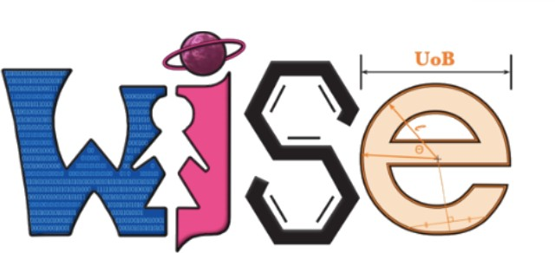

Women in Science and Engineering Science Club

Experiment at Home - Laboratory Book

Name

Group

Contents

Design a Lunar Base
…………………………………………………………3

Apple Oxidisation
…………………………………………………………8

Find your Blind Spot
……………………………………………………….14

Crack the Code
……………………………………………………….18

What is WISE?
……………………………………………………….22

A Note From our Sponsor
……………………………………………………….23

Design a Lunar Base

A lunar base is a fixed ‘home’ on the Moon. While there are no lunar bases yet to exist, NASA are aiming to have more of a sustained presence on the Moon by 2028 and the idea has been considered since the 1950s. This makes the task of designing a lunar base an important one! There are many factors to consider such as how the astronaut will live, grow food, store water, gain oxygen and go outside.
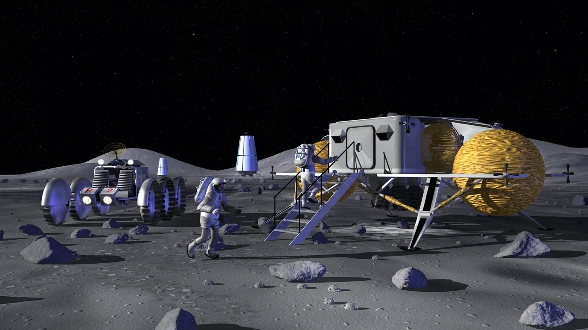

Your mission, if you choose to accept it…

Design and build a lunar base, the size of an A4 piece of paper, using all the information provided on how astronauts live in space!

Carry on reading to find out more.

How does an astronaut live on the Moon?

- Sleeping: Unlike space, the Moon does have gravity, though it is much weaker than Earth’s (less than a quarter the strength!), so astronauts don’t have to be strapped down to sleep. On the Apollo 15 mission, the first lunar exploration mission where astronauts had to learn to live on the Moon for 3 days, astronauts slept in hammocks. These were great because they could be put away during the day to save space and were comfortable!
- Staying Clean: An astronaut has to stay clean just like everyone on Earth, however on the Moon there would be no plumbing, so bathrooms need to be reconsidered. When brushing your teeth on a lunar base, there would be no sink to spit into - astronauts have to spit their toothpaste into a washcloth. Similarly, baths and showers can’t be taken in the same way either! Astronauts use special types of shampoo and soap that don’t need water - they are able to use the soap and then towel dry without rinsing it off.
- Keeping Tidy: As well as keeping themselves clean, astronauts also have to keep their home clean! To make sure that walls, floors and windows are spotless, they use wet wipes that kill germs - they also use these wet wipes for used plates and cutlery. Rubbish must also be stored somewhere on the lunar base. Just like on Earth, astronauts use bins - a dry bin and a wet bin. When these bins get full they must be taken out, but they can’t be put outside for the bin men to collect, there must be a special room to keep the rubbish away from where they live! Finally, astronauts also use vacuum cleaners with special hoses to clean hard to reach places. Vacuums are important as they keep dust out of the air filters.

What do astronauts eat?

- Growing Food: Vegetables can be grown in space! On the international space station, plants are grown in a ‘pillow’ which contains clay-based soil and fertilizer. The ‘pillow’ makes sure that water is distributed evenly throughout to prevent plants becoming too dry or waterlogged. The vegetables sit beneath a bright light which the plants need to survive.
o Advanced: Plants reflect a lot of green light and absorb red and blue light in order to photosynthesise and survive, this means that the bright light above the plants often glows pink!
- Carbs: Astronauts eat more than just vegetables, but they have to be careful with what they take! For example, if they want a sandwich for lunch they can’t use bread! Bread creates lots of crumbs which are lightweight, meaning they won’t necessarily fall to the ground as gravity isn’t as strong, if the crumbs start floating they can get into air filters and cause a mess. Instead, they use tortilla wraps! All the food taken to the Moon has to be vacuum packed, sealed in a way that no air can get in so that mold can’t grow.
- Cooking: The lunar base’s kitchen also won’t be like a normal kitchen on Earth - it is more like a ‘preparation area’. Astronauts can chop and prepare food, rehydrate their food and warm it up.

What do astronauts drink?

- Water is really heavy, so it costs a lot of money to send it to space. This means that only a limited amount of water can be transported along with the astronauts to the Moon! A water system needs to be considered. For example, on the International Space Station, there is a water system which collects moisture from people’s breath and sweat as well as collecting and filtering runoff water from sinks and even urine!

How does an astronaut get oxygen?

- Astronauts have to bring oxygen with them to the Moon but they also have to make it! Oxygen is made through a process called electrolysis, which, simply put, is where water is run through electricity in a controlled environment. The electricity can be obtained via sustainable methods such as solar panels!
  - Advanced: Water is made of oxygen and hydrogen (H2O). By running water through electricity, the oxygen and hydrogen can be separated. The oxygen is stored so that astronauts can breathe. Plus, the hydrogen isn’t wasted! It’s combined with carbon dioxide (collected from astronauts breathing outwards) to return it back to water.

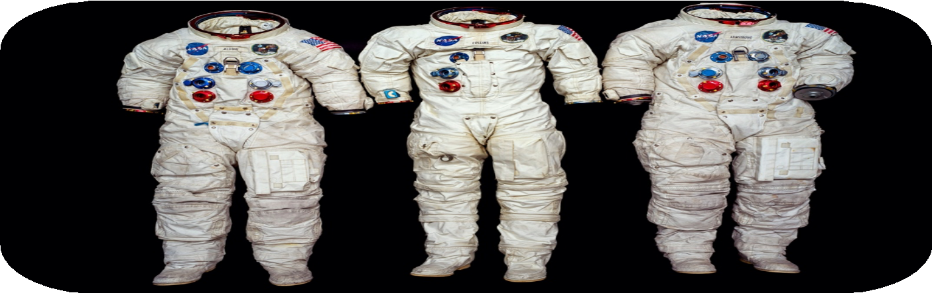
How does an astronaut go outside on the Moon?
- Remember, while astronauts wouldn’t have to wear their space suits inside the lunar base, in order to go outside they will need them in order to breath, stay grounded and be protected from the Sun’s radiation. These space suits will need to be stored somewhere.
- To be able to leave the lunar base, astronauts would need an airlock. This is a ‘doorway’ which allows people and objects to pass between the lunar base and the Moon. The airlock minimised the pressure change of the lunar base, the amount of dust entering from the Moon’s surface and the amount of oxygen lost to outside.

Remember the key information!

Q1) What is a lunar base?

……………………………………………………………………………………

……………………………………………………………………………………

…………………………………………………………………………………… Q2) Where do astronauts sleep?
……………………………………………………………………………………

……………………………………………………………………………………

…………………………………………………………………………………… Q3) How do astronauts sort their rubbish?
……………………………………………………………………………………

……………………………………………………………………………………

…………………………………………………………………………………… Q4) How do you grow vegetables in space?
……………………………………………………………………………………

……………………………………………………………………………………

……………………………………………………………………………………

Q5) What is electrolysis?

……………………………………………………………………………………

……………………………………………………………………………………

…………………………………………………………………………………… Q6) How do astronauts go outside?
……………………………………………………………………………………

……………………………………………………………………………………

……………………………………………………………………………………

Your mission….

By considering all the above information, design and build a model lunar base the size of an A4 piece of paper. You can do this with any materials that you have around the house!

Supplies:
  - A4 Paper
  - Scissors
  - PVA Glue and/or Tape
  - Pens
  - Plus, anything else you have:
    - Cardboard
    - Cups
    - Rubber bands
    - Pipe cleaners
    - Empty water bottles
    - Bubble wrap
    - Paper clips
    - Paper plates
    - Etc… get creative!

Apple Oxidation

Apples are a delicious snack but they can brown very quickly when they’re sliced. The skin of the apple protects the centre from the oxygen in the air, once cut into, oxidation occurs causing the centre to brown.

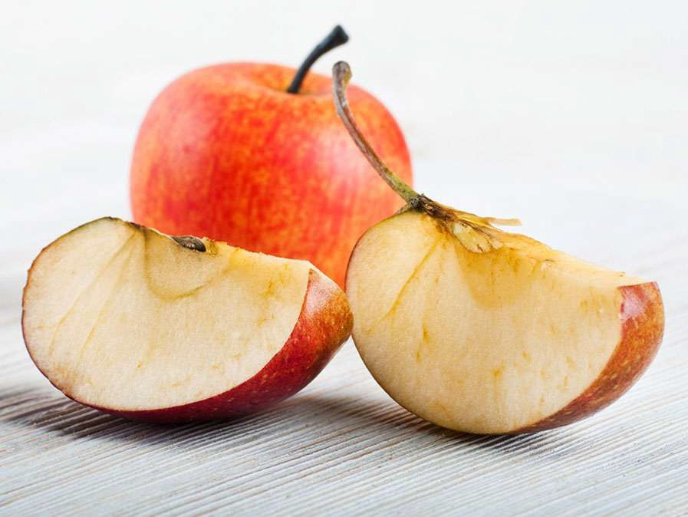
In this experiment, we’ll investigate the process of oxidation and work out whether we can prevent it!

What is oxidation?

When an apple is sliced, its skin can no longer protect it. The centre of the apple is exposed to the oxygen in the air and a chemical process called oxidation occurs. This process caused the apple to turn brown. Oxidation causes fruits such as apples, bananas, pears and peaches to spoil quickly, meaning they’re no longer edible.

How can you prevent oxidation?

Covering the fruit in ascorbic acid can prevent
oxidation. Ascorbic acid is another term for Vitamin
C. Vitamin C can be found in different citrus fruits like oranges and lemons. The mixture must be applied right after the apple is sliced – otherwise, it will not work.

Preventing oxidation is important in preserving food so that it stays edible for much longer!

Why does oxidation happen?

Apples, and all other fruit, contain an enzyme that works within the cells of the fruit to keep it alive. When the apple is cut into, these cells are damaged, and oxygen can enter them. The enzymes react with the oxygen and the apple turns brown.

Let’s find some ascorbic acids that will prevent oxidation!

Materials needed:

- Apple
- A variety of liquids:
  - Plain water
  - Salt water
    - 1/8 tsp salt, 1 cup water
  - Sugared water
    - 1 tbsp sugar, 1 cup water
  - Lemon juice
  - Apple juice
  - Honey water
    - 1 tbsp honey, 1 cup water
  - Orange juice
  - Lemonade
- A small bowl or cup for each liquid
- Labels for your liquids
- A plate
- Scissors
- Observation table

Directions:

- Pour each liquid into a cup, make sure to label each liquid with the labels provided.
- Use the observation table and write down your predictions!
- Carefully slice your apple (make sure to get supervision!).
- Save one piece of apple – this will act as the control piece.
- Place the other slices of apple into each liquid immediately.
- After three minutes, remove the apples from each liquid and place them onto your plate.
- Leave them for three minutes, record how they’ve changed in the table.
- Leave them for another three minutes, record how they’ve changed in the table.
- Were your predictions correct?

Prediction Table:

Liquid | Prediction

Observation Table:

Liquid | After Three Minutes | After Six Minutes

Draw your conclusions…

Q1) What is oxidation?

……………………………………………………………………………………

……………………………………………………………………………………

…………………………………………………………………………………… Q2) How can we prevent oxidation?
……………………………………………………………………………………

……………………………………………………………………………………

…………………………………………………………………………………… Q3) How did the control piece of apple look after the six minutes?
……………………………………………………………………………………

……………………………………………………………………………………

……………………………………………………………………………………

…………………………………………………………………………………… Q4) Which liquid was the least helpful ascorbic acid?
……………………………………………………………………………………

……………………………………………………………………………………

…………………………………………………………………………………… Q5) Which liquid was the best ascorbic acid
……………………………………………………………………………………

……………………………………………………………………………………

……………………………………………………………………………………

Find your Blind Spot

The blind spot is a point in your vision where you can no longer see clearly, it happens to everyone, due to the structure of the eye!

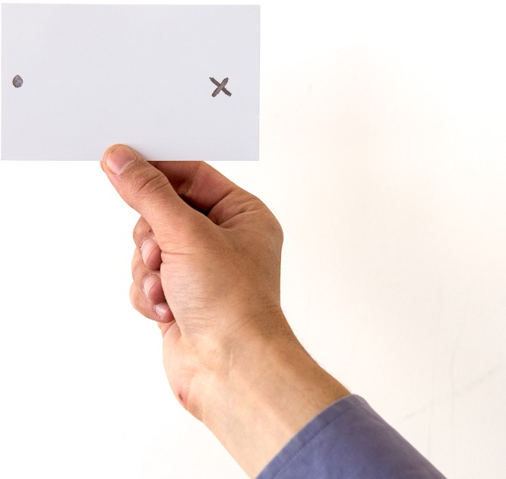

In this experiment we will find out more about the structure of the eye, what causes the blind spot and how to find your own blind spot using basic equipment at home.

What is the blind spot?

The blind spot is the region on the human retina, where the optic nerves connect to the back of the eye. There are no light receptors at this point at the back of the eye, so part of the field of vision is not perceived. This means some things can’t be seen. You don’t notice the blind spot because the brain fills in the surrounding details!

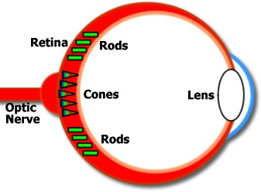

The blind spot is also called scotoma – this is a general term for any obscuration of the visual field.

Does everyone have the blind spot?

All mammals have the same blind spot! This is because the retina is inverted, ie the rods and cones are on the opposite side to the lens. This can be seen in the diagram!

However, other animals have no blind spot. The octopus eye is similar to the eye of a mammal but their retinas are right-side out which means it doesn’t have a blind spot.

Let’s find the blind spot…

Supplies:
Paper
Scissors
Pen
Ruler

Instructions:
- Using a ruler, draw two equal lines on the paper to cut along later.
- Draw a cross on the left-hand side of the rectangle.
- Draw a circle on the right-hand side of the rectangle.
- Cut out the paper strip, it should look like this:

- Hold the paper strip up to your face so that the cross is in front of your right eye.
- Close your left eye. Focussing on the cross, slowly move the paper away from your face.
- As you move the strip away from your face, you’ll notice that that you can no longer see the circle!
- The point where you can no longer see the circle is your blind spot!
- Try different lengths of paper strips, does this make a difference?

Why does this happen?

As mentioned, the blind spot occurs due to the structure of the eye! When light travels to the back of the eye, its wavelength is received by a group of cells called the retina. In the centre of the retina, is an area called the fovea, this is where blood vessels are located. There are no light receptors in the fovea – this is a natural ‘blind spot’.

Some quick questions…

Q1) What is a blind spot?

……………………………………………………………………………………

……………………………………………………………………………………

…………………………………………………………………………………… Q2) Does everyone have a blind spot?
……………………………………………………………………………………

……………………………………………………………………………………

……………………………………………………………………………………

…………………………………………………………………………………… Q3) How do different lengths of paper strips affect your blind spot?
……………………………………………………………………………………

……………………………………………………………………………………

……………………………………………………………………………………

…………………………………………………………………………………… Q4) What is a retina?
……………………………………………………………………………………

…………………………………………………………………………………… Q5) Why does a blind spot happen?
……………………………………………………………………………………

……………………………………………………………………………………

……………………………………………………………………………………

Crack the Code

Code is the building blocks of the internet, TV screens, laptops and mobile phones – without it they wouldn’t work!

For the picture on TVs to work, the device needs to receive a code telling it what to display. Each picture on the screen must be broken down into a grid – this grid is made of tiny squares called pixels. In this experiment we’ll look at how a grid creates an image.

When a video is filmed, a piece of equipment records what’s happening and turns it into an electronic signal. This signal has recorded key characteristics so that it can work out what colour each pixel on a screen would need to be to show that picture. The signal is then sent to a TV using cable, broadband or a transmitter to display the video on the screen.

Let’s see if we can decipher the pixels…

Supplies:
- Pixel grid
- Coloured pens

Instructions
- Each square in the grid represents a pixel. The grid has an X and a Y axis which is clearly labelled with letters and numbers
- Using the numbers and letters along each axis, you can find the name and number of each pixel.
- With the pixel name and number, look at the bottom of the page and find out the code.
- Using the code, look at the colour chart and work out which colour is needed for the pixel.
- Fill in the squares with the right colour to build up the picture!

For example, the top left square in the table is A2. Using the picture code, its code is 808 – A2 808. 808 is colour 8, black. This means the top left square should be left white.

Crack the code
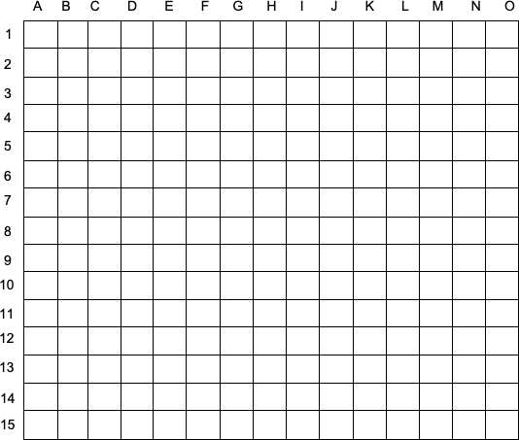

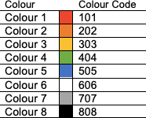
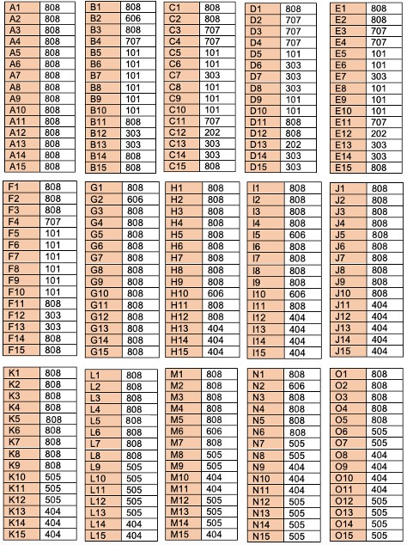
808

Some quick questions…

Q1) Briefly describe how a picture is sent to a TV screen.

……………………………………………………………………………………

……………………………………………………………………………………

……………………………………………………………………………………

…………………………………………………………………………………… Q2) How many pixels did the ‘screen’ you decoded have?
……………………………………………………………………………………

……………………………………………………………………………………

Q3) The term resolution refers to how clear an image is. What would you need to do to improve the resolution of this image?

……………………………………………………………………………………

……………………………………………………………………………………

……………………………………………………………………………………

……………………………………………………………………………………

……………………………………………………………………………………

……………………………………………………………………………………

(Hint: Think about the size and number of your pixels!)

What did you think?
Fill in our feedback form to tell us whether you enjoyed our experiments!

- Which activity did you enjoy the most?

....................................................................................................................

....................................................................................................................

....................................................................................................................

- Which activity did you enjoy the least?

....................................................................................................................

....................................................................................................................

....................................................................................................................

- What did you like about our booklet?

....................................................................................................................

....................................................................................................................

....................................................................................................................

- What have you learnt from the booklet?

....................................................................................................................

....................................................................................................................

....................................................................................................................

What is WISE?
Women in Science and Engineering is a student run society at the University of Birmingham. We hope to support and encourage women and girls so that more females head into STEM (science, technology, engineering and maths) careers!

What do our members do?
- Physics and Astronomy
- Biosciences
- Artificial Intelligence and Computer Science
- Mechanical Engineering
- Chemistry
- Liberal Arts and Natural Sciences
- Medicine
- Mathematics

There are so many career paths into STEM subjects and now is the time to join them!

How to follow a STEM path:

There’s no set path to follow, you can choose to enter STEM at any point be that high school, college, university or even after!

What next?

- Find your inspiration! What subject do you enjoy doing? Work hard at it and stay motivated.
- Apprenticeships: You can head into a STEM career by learning, getting hands on and starting an apprenticeship – this can be done before, instead of or after college!
- College/Sixth Form: Love learning and want to continue working on your favourite subject? Head to college or sixth form and master it!
- University: both college and apprenticeships can lead to getting a degree, do some research and work out what you need to get the career that you want!

A note on our sponsor…

Accenture have made it possible for us to create virtual activities!

What is Accenture?

Accenture is a leading global professional services company. This means they work across the world to help companies improve difference areas such as, solutions in strategy, consulting, digital, technology and operations. They have 482,000 people serving clients in more that 120 countries! Accenture drives innovation to improve the way the world works and lives.

They recruit students from STEM backgrounds and offer internships, apprenticeships and graduate schemes.

