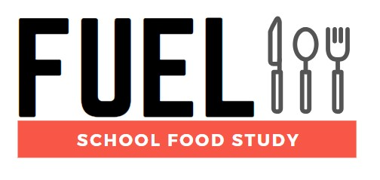

**Newsletter Issue 1 – December 2019**

**First schools on board!**



Welcome to the first issue of the FUEL Study newsletter. It has been a very exciting few months as the study has gotten well under way. Invitations were sent out to schools back in September and the team has been busy liaising with them directly to sign them up to the study.

In phase one of the study, researchers will attend schools to conduct pupil survey and dietary data collection sessions and to observe school dining and food service areas. Of the 44 schools that take part a small sample will be invited to phase two of the study in which Interviews and focus groups with staff and pupils will be conducted.

So far there are 26 schools that are interested in being involved, with 13 of them already agreeing to take part. So far over 100 surveys have been completed. The study has made a great start on its aims to recruit a total of 1,980 pupils from 44 secondary schools.

We would like to thank everyone who has been a part of the study. We know how busy you are and really appreciate you taking the time in whatever way you can. The study couldn’t have achieved what it has in such a small amount of time without your help.

The FUEL team.

Chief Investigators: Dr Miranda Pallan - Prof Peymane Adab

Researchers: Dr Emma Lancashire - Dr Marie Murphy - Ms Rhona Duff

Administrator: David Alexander

Contact us

fuelstudy@contacts.bham.ac.uk

0121 614 8072

Twitter: @FuelStudy

Address: IAHR, Murray Learning Centre, University of Birmingham, B15 2TT

For information about the study visit our [website](https://www.birmingham.ac.uk/research/applied-health/research/chronic-disease-epidemiology-and-management/fuel-study.aspx) or watch our short [video](https://biteable.com/watch/fuel-study-for-schools-2419604) (not compatible with Internet Explorer).

Institute of Applied Health logocid:image001.jpg@01D1FFB5.65BB1D20cid:image001.jpg@01D1FFB5.65BB1D20