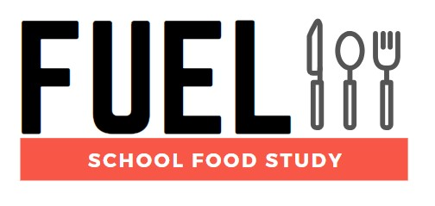

**Newsletter Issue 4 - March 2021**

**Welcome back**

Welcome to the fourth newsletter from the FUEL Study.

We hope you are all well during what we are sure is a busy time. With pupils returning to classrooms, the FUEL study can restart and will recommence data collection as soon as schools are ready for us. We are pleased to share that we are also expanding the study area to incorporate schools in the East Midlands area, as well as our current remit in the West Midlands.

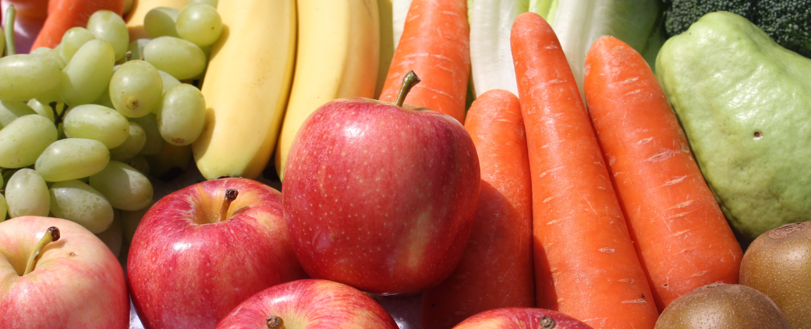

**What have we found so far?**

During the study’s hiatus, we have been busy analysing the data we had collected. We have data for 830 participants from 12 schools so far. Each participant reported their food and drink intake across a 24 hour period.

* The average fruit & vegetable intake was 3.9 portions, with only 13% of our study participants achieving the recommended 5 portions per day, and most portions being eaten outside of the school day.
* 86% of participants consumed substantially more than the recommended amount of sugar per day, with an average of 78g per pupil per day.
* The average fibre intake across a 24 hour period was 16g, below the recommend intake of 25g per day.

**CONTRAST study: Life in lockdown**

We have also been looking at the impact of the COVID-19 pandemic on young people in the CONTRAST study, in which we asked 11 – 15 year olds from across the country about their learning, eating and physical activity during the first lockdown. Some of the findings were:

* Compared with before lockdown 1, participants were more likely to eat family meals together and to help prepare meals, but over half reported snacking more during the lockdown.
* Food insecurity increased during lockdown 1 with the greatest increases seen in participants from the least affluent families.
* Sixty percent of participants reported doing less physical activity during the lockdown, compared with beforehand.
* Average weekday sleep duration increased by one hour, and sleep-related difficulties reduced during lockdown 1.

Picture child on laptop

**Tailored school reports**

Just to remind you, each school that takes part in FUEL will receive a tailored report summarising the data for their school. We can do this once we have finished collecting data from your school. If you have any outstanding data or documents to return, we would be grateful to have these so we can begin work on your tailored report. The FUEL team will be in touch to follow up on any pieces of missing data.

We would like to thank everybody for their continued support, especially through challenging times like these. We cannot wait to work with you again, and hope 2021 is a far better year for us all.

Chief Investigators: Dr Miranda Pallan - Prof Peymane Adab

Researchers: Dr Emma Lancashire - Dr Marie Murphy - Ms Rhona Duff

Administrator: David Alexander

Contact us

fuelstudy@contacts.bham.ac.uk

0121 614 8072

Twitter: @FuelStudy

Address: IAHR, Murray Learning Centre, University of Birmingham, B15 2TT

For information about the study visit our [website](https://www.birmingham.ac.uk/research/applied-health/research/chronic-disease-epidemiology-and-management/fuel-study.aspx) or watch our short [video](https://biteable.com/watch/fuel-study-for-schools-2419604) (not compatible with Internet Explorer).

Institute of Applied Health logocid:image001.jpg@01D1FFB5.65BB1D20cid:image001.jpg@01D1FFB5.65BB1D20