WOVAN Study Team Contact Information

Study team email address: WOVANstudy@contacts.bham.ac.uk

Principal Investigator -
Dr Amie Wilson, Academic Midwife, a.wilson5@bham.ac.uk Research Team:
Dr Nicole Pilarski, Postgraduate research student, Nicole.pilarski@nhs.net or nxp868@student.bham.ac.uk
Dr Victoria Hodgetts-Morton, NIHR clinical lecturer v.a.h.morton@bham.ac.uk
Dr Laura Jones, Senior lecturer in qualitative research L.L.Jones@bham.ac.uk
Professor Katie Morris, Professor in Maternal Fetal Medicine

Institute of Applied Health Research University of Birmingham
Edgbaston, Birmingham B15 2TT
Tel: +44 (0)121 414 3344

Version 1.0 16/09/2021
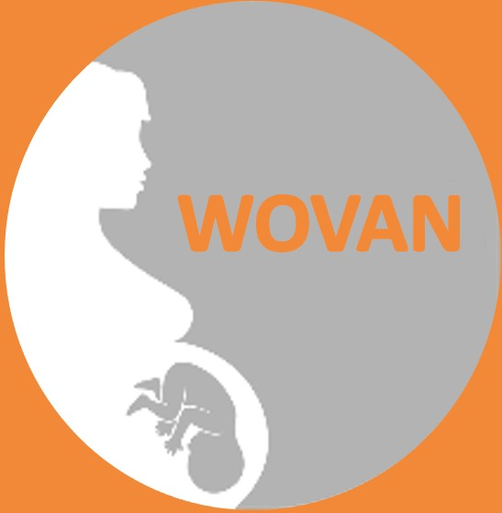
Participant Information Leaflet
Interviews
Women’s views on antibiotics at caesarean section: A study to explore women’s views on receiving antibiotics at caesarean section

Invitation to participate in the WOVAN research study.
We are inviting women who have a had a recent caesarean section to take part in a research interview regarding women’s views and experiences. Almost one in three pregnant women have a caesarean section. Most women recover quickly and without complications, however, some women develop an infection in the womb, in the scar on the skin or in the blood stream. Developing an infection makes recovery following a caesarean section more difficult and complicated. We are conducting telephone or video call interviews to help us understand more about women’s experiences with infection after caesarean and their views on using antibiotics to prevent infection.

We are looking for women who have had a Caesarean Section in the last 2 years to share their experiences.

Version 1.0 16/09/2021

Participant Information Leaflet:
This tells you the purpose of the study and what will happen to you if you take part.

What is this research study?
This is a qualitative research study. We are interviewing women who have had a caesarean section with or without a subsequent infection to improve understanding among the public and healthcare professionals about women’s experiences of recovery from caesarean section including dealing with infection and women’s perspectives on the use of antibiotics to prevent infection.

Who is funding and organising the research?
This research is funded by the University of Birmingham, the members of the research team are all affiliated with the University of Birmingham.

The researchers involved are not being paid for recruiting women into the study. Women are not paid to take part either, but their help in finding out more about the views and experiences of women in this situation is much appreciated.

Do you have any further questions?
Having read this leaflet, it is hoped that you will choose to take part in an interview. If you have any questions about the study now or later feel free to ask the research team. Their names and contact details are given on the back of this leaflet.

You may like to discuss your decision with friends or relatives.

Thank you for taking the time to read this Participant Information Sheet about the WOVAN - Women’s perspectives on the use of antibiotics at caesarean section study.

Version 1.0 16/09/2021 Version 1.0 16/09/2021

Who has reviewed the study?
This research has been peer reviewed by the university of Birmingham at the time of securing funding and has been granted ethical approval by the University of Birmingham Science, Technology, Engineering and Mathematics Ethical Review Committee on the 10th September 2021 (ERN_21- 0811).

Please keep this copy of this Participant Information Sheet. You will also be given a copy of your signed consent form to keep if you decided to participate in the research study.
More about infection and antibiotics at Caesarean Section Caesarean section (CS) is very common accounting for almost 30% of births in the UK. Unfortunately, surgical site infection after CS
affects around 9% of women (although this figure is higher when
we ask patients directly about their symptoms) we know that this can lead to women needing to seek healthcare in the community or in a hospital, treatment with antibiotics and readmission to hospital with a risk of becoming seriously unwell. In addition, healthcare professionals often talk about the broader consequences of infection such as for mother-baby bonding and breastfeeding, of prolonged hospital stays causing separation from existing children and partners, and the challenges of caring for a new baby while unwell.

Currently all women are given antibiotics at the start of a caesarean section. It is possible that giving an extra, different antibiotic after the baby is born and the umbilical cord has been cut would help to further reduce infection rates, however this is not yet standard practice.

The purpose of this research study is to understand women’s experiences of infection after caesarean section and women’s views regarding infection, and the use of antibiotics to prevent them.

Version 1.0 16/09/2021
Version 1.0 16/09/2021

About the interview
Interviews will be conducted over the phone or by online video call depending on what you prefer. Interviews will take place on a day and time that is convenient to you and the researcher.

Before the interview you will be asked to complete a short questionnaire and also to provide your contact details so that the researcher can contact you to arrange a convenient time.

The interview will be recorded. The researcher will start the interview by confirming you are still happy to take part and understand that you can stop at any time. The researcher will have some open questions to ask you but will also be guided by what you say and what you feel are important areas to discuss. We expect most interviews will last around 45 minutes although this will be guided by you. You will be able to ask questions throughout the interview.

What is involved if I take part in an interview?
An experienced researcher will conduct the interviews and
encourage you to talk about:
- Your experience of a caesarean section.
- Your experience of infection (if you have or have not had an infection).
- Your experience of receiving antibiotics at caesarean section.
- Your thoughts on new ways to help reduce and identify infection after caesarean section.
Version 1.0 16/09/2021
Are there any benefits for me from taking part in an interview? Participants may not gain any individual benefit. The trial will provide valuable information for future women having
caesarean sections.

What if I need support after the interview?
We do not anticipate that the interview will be distressing, you can pause or stop the interview at any time. If you have questions about your experiences after the interview you can contact your GP or the maternity unit where you had your baby to discuss those further or to ask questions.

Will my taking part in this study be kept confidential?
Yes, all information collected in the study will remain strictly confidential in the same way as your other medical records. Responsible members of the University of Birmingham may also be given access to data to ensure we are complying with regulations. But, apart from this, only the study organisers will have access to the data.

What will happen to the results of the research study?
The results will be reported in a medical journal. It is expected that the first results will be used to design a much larger study. Everyone who takes part will then be told the results in a newsletter that will be posted directly to them.

Version 1.0 16/09/2021

