Clinical Research Quality Manual

Purpose
The purpose of this quality manual is to explain the University of Birmingham’s (UoB) framework for conducting clinical research. This document explains how the UoB approaches quality management within the different areas of clinical research activity including clinical studies, clinical trials, human tissue collection, and sample storage/analysis for clinical trials in a UoB laboratory. This quality manual assists anyone involved in these areas to understand what systems are available to them, and what is expected of them.

Scope
This quality manual applies to all those who work in any UoB clinical research.

Implementation plan
This quality manual will be implemented in line with this document’s effective date.

Stakeholders
- UoB staff members and others working with the UoB clinical research quality management system (QMS), other relevant external standards and regulations or any other QMS referred to in this document.
- Research Governance and Ethics Team (RGT).
- Clinical Research Compliance Team (CRCT).
- United Kingdom Clinical Research Collaboration (UKCRC)-registered UoB Clinical Trials Units (CTU).
- Clinical Trials Oversight Committee (CTOC).
- Human Tissue Oversight Committee (HTOC).

Contents
Purpose 1
Scope 1
Implementation plan 1
Stakeholders 1
Background and rationale 3
The UoB’s oversight of clinical research 3
Policy on the UoB’s QMSs 5
Policy on training 8
Policy on compliance reviews 9
Policy on the CI, UoB lead, laboratory academic lead and grant holder 10
Policy on the UoB’s approval of clinical research 10
Related documents 12
References and frameworks 12
Abbreviations and definitions 13

Background and rationale
With its broad portfolio of clinical trials and clinical studies, the UoB is one of the leading centres for clinical research in the United Kingdom (UK). In order to support a high-quality standard for all clinical research, the UoB has developed a QMS that includes this quality manual. See the UoB Clinical Research Definitions (UoB-CRG-POL-002) for differentiating between a clinical trial and a clinical study.
A QMS is a structured programme of procedures and policies that describes how relevant tasks should be performed; a QMS should also encapsulate any applicable standards and/or regulatory requirements. Adherence to the UoB’s QMS ensures that participants’ rights and wellbeing are protected, that data is credible, and that the research is conducted in compliance with the protocol, applicable regulations, international standards, and local policies.
The UoB’s Clinical Research QMS embeds the principles and standards of Good Clinical Practice (GCP). GCP is a set of internationally recognised ethical and scientific quality requirements for designing, conducting, recording and reporting clinical trials that involve the participation of human volunteers. Additionally, the UoB QMS incorporates the GCP in the Laboratory standard. Adherence to this standard ensures that any sample-analysis data produced by a laboratory are accurate, reliable, and correctly reported, and that participant safety is maintained. The UoB’s QMS also details the standard to be followed when clinical laboratory research involves the use of human tissue.
This quality manual must be used in conjunction with other policies and processes put in place by the UoB, for example the UoB’s health and safety policies.

The UoB’s oversight of clinical research
In its role as a sponsor/institution for clinical research, the UoB has set up an infrastructure to maintain appropriate oversight. The UoB has a number of committees, groups and teams, as described below, who are fully committed to delivering high-quality clinical research. An overview of the UoB’s Research Governance Framework is outlined in Figure 1.

Clinical Trials Oversight Committee (CTOC)
The CTOC oversees clinical research activities carried out by the UoB either in its role as a sponsor, co-sponsor, or host institution, or when in partnership with other organisations. This includes Clinical Trials of Investigational Medicinal Products (CTIMPs), clinical research conducted through the UoB’s CTUs, and any clinical research where a UoB REC (Research Ethics Committee) has stipulated that the research must be conducted in accordance with the UoB Principles of GCP for Clinical Research (UoB-GCP-POL-001). Through the Research and Knowledge Transfer (R&KT) Executive Committees, the CTOC reports to both the College of Medical and Dental Sciences (MDS) Board, and the College of Life and Environmental Sciences (LES) Board. The CTOC also reports to the Pro-Vice Chancellor for R&KT through the UoB’s Research Governance, Ethics and Integrity Committee (RGEIC).
See CTOC Terms of Reference for more information.

Human Tissue Oversight Committee (HTOC)
The HTOC oversees all of the UoB’s clinical research activities involving the use of human tissue and provides support for their related quality assurance and risk- management processes. The HTOC is responsible for ensuring that the terms of the UoB’s Human Tissue Authority (HTA) licences are being met. Additionally, it oversees GCP compliance in the UoB’s laboratories that analyse clinical trial samples, and it also oversees compliance with Good Manufacturing Practice (GMP) standards in the GMP Manufacturing Unit. The HTOC reports both to the MDS College Board and the LES College Board through the R&KT Executive Committees, and the Pro-Vice Chancellor for R&KT through the UoB’s RGEIC.
See HTOC Terms of Reference for more information.

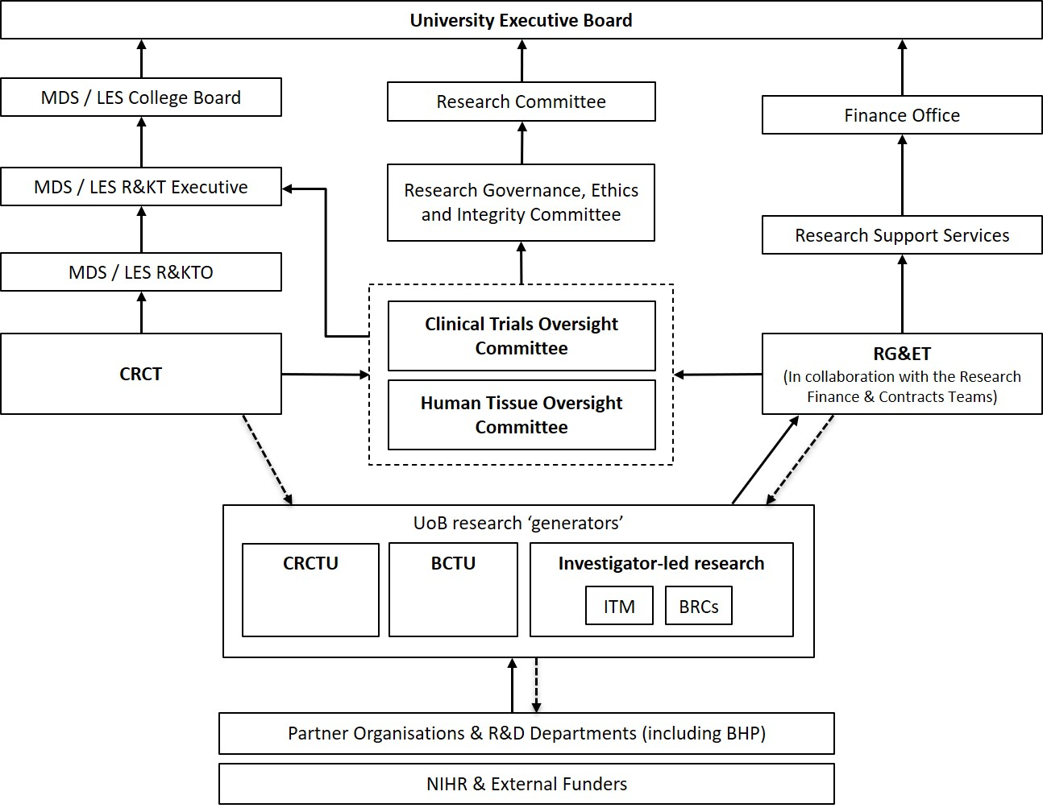

Figure 1. The UoB’s Research Governance Framework. Solid line denotes reporting pathway and dotted line denotes compliance review and guidance/training pathways. See abbreviation and definition table below.

Clinical Research Compliance Team (CRCT)
The CRCT is part of the MDS R&KT Office. The CRCT has three core areas of focus: (1) developing and maintaining the QMS, (2) conducting compliance reviews, and (3) providing training and support. The CRCT cover all of the UoB’s clinical research activity, including any involving the use of human tissue.
The CRCT works closely together with the Research Governance Team & Research Ethics Team (RG&ET) to ensure new clinical research projects are set up in accordance with the UoB’s QMS. For independent chief investigator (CI)-managed CTIMPs, the CRCT can provide a service to perform on-site monitoring as per the trial-specific monitoring plan; it is expected this is suitably costed as part of the grant application process. The CRCT reports to the CTOC and the HTOC, and liaises with UoB staff where issues are noted, to ensure proper corrective and preventative action plans are put in place.
See the CRCT webpages for more information.

Research Governance Team & Research Ethics Team (RG&ET)
The Research Governance Team (RGT) and the Research Ethics Team are two teams located within the UoB’s Research Support Group. These two teams are led by the Head of Research Governance & Integrity, and are collectively known as the Research Governance & Ethics Team (RG&ET). They are responsible for the UoB’s research sponsorship processes and the establishment of sound governance arrangements for any UoB-sponsored research. The RG&ET also oversees projects that are sponsored or co-sponsored by the UoB, and manages the UoB’s ethical-review process.
The RG&ET makes the initial decision on sponsorship, referring to the CTOC/HTOC as required. Where sponsorship is agreed, the RG&ET provides support to a clinical research project as the sponsor’s representative. In this role it manages the process of insurance referrals, and it can provide support for e.g. developing a site agreement, signposting researchers to other available resources e.g. the CRCT, as appropriate.
See the RG&ET for more information.

Research Support Services (RSS)
Research Support Services (RSS) provide a range of pre- and post-award support services to the university’s research community (including clinical research). This includes, but is not limited to, the Research Development Support Team, Research Grant Set-up and Support Team, Research Finance Team, and Research Contracts Team.
See the RSS for more information.

Policy on the UoB’s QMSs
The UoB’s overarching clinical research QMS (hereafter referred to as UoB QMS) has been designed to cover clinical research activity (including work with human tissue) carried out at, or conducted by, the UoB. See UoB QMS to access all related documents. Within the UoB there are many other areas of activity that work with written processes/policies (e.g. relating to GMP, teaching, and animal research). These areas of activity fall outside of the remit of the clinical research QMS and are managed and maintained independently of it. Other areas/departments may choose to refer to (parts of) the UoB QMS for clinical research within their own documentation.
In this quality manual and in any other documents referring to this quality manual, it can be taken that the UoB QMS is a collection of policies, standard operating procedures (SOPs) and where applicable, mandatory quality control documents (QCDs), that must be adhered to. The UoB QMS reflects four levels as shown in Figure 2 and are described below.
Note: the UoB QMS is a live system and is continuously under review and development. In the event where two documents present conflicting statements, the document with the latest effective date (i.e. most recently issued) is deemed to supersede the statement in the opposing document (unless informed otherwise by the CRCT). Where any conflicting statements are identified, these should be reported to the CRCT (crct@contacts.bham.ac.uk). Similarly, if a change to a process is required, a request should be made to the CRCT.
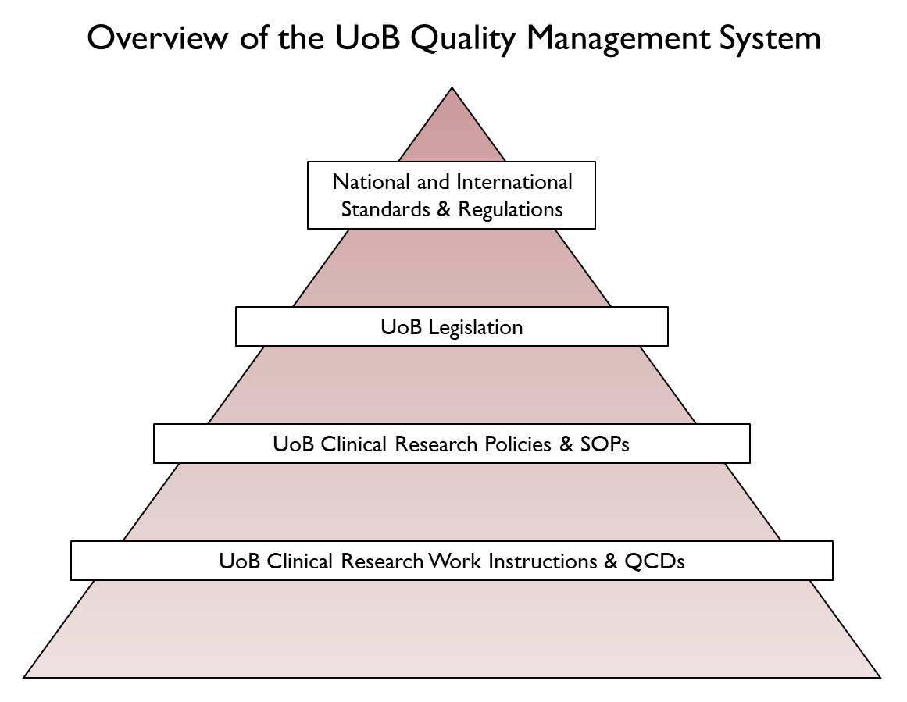
Figure 2. Overview of the UoB QMS. See abbreviation and definition table below.

Level 1: national and international standards and regulations
Clinical research (in particular, clinical trials) is governed by regulatory requirements, internationally accepted standards and governance frameworks, all with the ultimate aim to ensure participants’ safety and data quality. Any UoB staff member involved in clinical research must familiarise themselves with, and adhere to, any applicable regulations, standards and governance frameworks.
The development and maintenance of the UoB QMS is informed by (but not limited to) the following regulations, standards and governance frameworks (and subsequent amendments):
- UK Policy Framework for Health and Social Care Research (v3.3 07-Nov-2017)
- The Medicines for Human Use (Clinical Trials) Regulations 2004 (UK SI 2004 No. 1031)
- The Medical Devices Regulations 2002 (UK SI 2002 No. 618)
- Data Protection Act 2018
- Mental Capacity Act 2005
- Human Tissue Act 2004
- Human Tissue Authority (HTA) Codes of Practice
- International Council on Harmonisation (ICH): Guidelines for Good Clinical Practice (GCP) E6(R2)
- European Medical Agency - Reflection paper for laboratories that perform the analyses or evaluation of clinical trial samples (PDF - 136 KB).

Level 2: UoB legislation
The University's legislation addresses matters of institutional governance and organisation. It consists of the charter, statutes, ordinances and regulations, and codes of practice. All members of staff and students are subject to the legislation. These also inform the development and maintenance of the UoB QMS, and include (but are not limited to) the codes of practice and policies listed below.
- UoB Code of Ethics (PDF – 639 KB). This code of practice is designed to provide an accessible, overarching guide to ethical conduct of activities at the UoB. For research, staff must be honest, accountable and lawful in respect of their own research, as well as that of their students, and others working with them on research. Responsible ethical conduct is expected in all aspects of research including applying for funding, experimental design, generating and analysing data, using equipment and facilities, publishing results, and acknowledging the direct and indirect contribution of colleagues, collaborators and others.
- UoB Code of Practice for Research (PDF – 572 KB). This code of practice provides a framework for the governance of all research throughout the university. The university is committed to research excellence and to the rigorous pursuit of new knowledge. As such it is committed to maintaining the highest standards of scholarly and scientific integrity in its research. It expects all researchers to work to these standards.
- UoB Data Protection Policy (PDF – 639 KB). This policy sets out the university’s requirements as data controller when processing personal data. It is designed to protect the accuracy, integrity, and confidentiality of personal data and to ensure that individuals are able to exercise their rights. All data users must comply with this policy when processing personal data on behalf of the university.
- UoB Information Security and Management Policy (PDF – 199 KB). This policy aims to maintain and improve the security of UoB systems, and the quality of UoB data. It aims to do this by improving the data capability and awareness of UoB staff, students, and other users of the university’s data or computing and networking facilities, and ensuring that they are supported by appropriate tools and processes.

Level 3: UoB clinical research policies and SOPs

Policies
Policies are developed to describe the UoB’s approach to areas that are regulated; they explain why the UoB has its procedures. Where regulatory requirements are not explicitly prescriptive (e.g. they do not detail an implementation method), a policy may be developed to specify the way in which the UoB will meet the requirements. A policy may also be developed when the UoB’s position on an issue or area is still undetermined, but that issue or area would normally be documented within the UoB QMS.
This quality manual collates policies relating to the UoB QMS and its development. The development of the UoB QMS is led by the CRCT. This quality manual, and any other policies that form part of the UoB QMS, are approved by the CTOC and HTOC. This quality manual, and any other policies outside this quality manual that form part of the UoB QMS, have the code ‘POL’.

SOPs
A SOP is a set of detailed written instructions designed to encourage best practice and help users standardise the performance of specific functions. It defines tasks, allocates responsibilities, details processes, indicates documents and templates to be used, and cross-references to other work instructions, guidance or policy documents. SOPs provide standards against which the UoB may be audited or inspected. Where applicable, SOPs will include instructions from relevant regulations, standards, guidelines, and any other pertinent policies. By adhering to a SOP, the user will be compliant with all applicable requirements.
The development of SOPs within the UoB QMS is led by the CRCT. Expert advice is requested as appropriate, and SOP review is performed by experts in the field. SOPs are approved by the CTOC and/or the HTOC, as per the UoB QMS Management Plan. SOPs as part of the UoB QMS have the code ‘SOP’.

Level 4: UoB clinical research QCDs & work instructions

QCDs
QCDs are tools that are included in a QMS to help the user adhere to the SOPs. Examples are template documents, checklists and forms. On occasion it may be that these tools are embedded into the related SOP. The QCD may include detailed instructions on how to work with the tool (e.g. steps to follow when developing an annual report) as well as the tool itself (e.g. the annual report template). The use of QCDs may be optional or mandatory; this will be detailed in the QCD and the related SOP. QCDs are developed and reviewed by experts in the field, ensuring best practice is promoted. Where applicable, QCDs will include instructions from relevant regulations, standards, guidelines and any other pertinent policies. By utilising the QCDs, the user will be compliant with all applicable requirements.
The development of QCDs within the UoB QMS is led by CRCT. Expert advice is requested as appropriate. QCDs are reviewed and approved by a senior member of the CRCT. For mandatory QCDs, approval will also be sought from the CTOC and/or the HTOC as per the UoB QMS Management Plan. QCDs that form part of the UoB QMS have the code ‘QCD’.

Work instructions
Work instructions are guidance documents and can be used by teams to help them successfully implement processes. Work instructions can be used to reflect current practices, and to help ensure consistency in teams where multiple people are performing the same activity. Work instructions do not directly form part of the UoB QMS. The development of work instructions is optional, and is expected to be managed internally by individual teams.

Set up of QMSs in the UoB
As described above, the overarching UoB QMS has been designed to cover clinical research activity (including work with human tissue) at, or conducted by, UoB. However, the two UKCRC-registered UoB CTUs, the Birmingham Clinical Trials Unit (BCTU) and the Cancer Research UK Clinical Trials Unit (CRCTU), each have their own QMS covering the same key processes; this is a requirement of their UKCRC registration, and includes further instructions relating to local management and oversight. It is anticipated that in some cases research teams or laboratories working outside a UoB CTU may also have their own QMS. Where this is the case, the requirements set out in the UoB’s QMS will need to be adhered to as a minimum, and the development and management of the local QMS will be in accordance with the QMS Development and Management SOP (UoB-QMS-SOP-001).
Where the UoB (co-)sponsors a clinical research project that is to be (partially) managed outside of the UoB (e.g. international trials or trials managed by a non-UoB UKCRC-registered CTU), there must be a clear agreement as to which QMS will be adhered to. Where an external QMS is used, it must be reviewed against the UoB QMS. This is to ensure that aspects relating to compliance with regulations, and Principles of GCP, are covered appropriately. This review must be conducted by the CI or their team. The CRCT will provide support where resources allow (it is recommended to contact CRCT as early as possible). Where the QMSs are consistent with each other, the check must be documented and filed in the study/trial master file (S/TMF). Where differences are noted, these must be discussed with the CRCT.
The CRCT will review the compliance of researchers and/or CTUs with any applicable international standards, guidelines, regulations and local QMS documents relating to clinical research. See also ‘Policy on Compliance Reviews’ below.
The two UoB HTA-licensed research tissue banks, the Human Biomaterial Resource Centre (HBRC) and the Dental Research Tissue Bank (DRTB), each have their own QMS covering their licensed activities. Where additional activity is undertaken for clinical research the UoB SOPs, will need to be adhered to as a minimum standard, and the development and management of the local QMS will be in accordance with the QMS Development and Management SOP (UoB-QMS-SOP-001).

Policy on training
High-quality clinical research is underpinned by continuous staff training and development. As per the UoB Principles of GCP for Clinical Research (UoB-GCP-POL-001), individuals involved in managing and conducting a research project are to be qualified by education, training and experience, or otherwise competent under the supervision of a suitably qualified person, to perform their tasks.
Staff training, including GCP training, should be appropriate and proportionate to the type of research undertaken, and should cover the relevant legal and contractual requirements commensurate with their roles and responsibilities. The scope and format of the (re)training, together with its evidence, should be documented (see Training SOP (UoB-TRN-SOP-001)).
Staff will have training in all policies, SOPs, QCDs and area-specific work instructions that are applicable to their role. In addition, staff will receive relevant training on the protocol and other project-related documents to a level that enables them to perform their delegated duties appropriately.
Training and retraining needs will be reviewed on an ongoing basis as per the Training SOP (UoB-TRN-SOP-001). For example, training may be updated when legislation has changed, new policies or practice have been implemented, different research activities are to be undertaken, or a significant period of time has elapsed since research activities have been conducted. Refresher training may also be required at periodic intervals, as required by local or external policy e.g. local NHS Trust site policy. In addition, staff may be required by the CTOC and/or the HTOC to undertake targeted (re)training following research governance and compliance reviews.

GCP training
The UK Clinical Trials Regulations (Medicines for Human Use (Clinical Trials) Regulations 2004, as amended) state that no person shall conduct a clinical trial otherwise than in accordance with the conditions and principles of GCP (Regulation 28) and that each individual involved in conducting a trial shall be qualified by education, training and experience to perform their tasks (Schedule 1, Part 2, 2). It therefore follows that anyone involved in a CTIMP must receive training in GCP that is commensurate with their roles and responsibilities.
Training should be tailored accordingly, as discussed in the above section. As a minimum, anyone involved in the day-to-day (site) management of a CTIMP (e.g. chief investigator, research nurse, trial coordinator) are required to complete the National Institute for Health Research (NIHR) GCP training, and must complete the GCP refresher training every three years. It is acknowledged that where someone's involvement is entirely within their professional expertise (e.g. a practice nurse taking a blood sample), and all other protocol activities are undertaken by a member of the research team, then no GCP training may be required. However, this should be reviewed as part of the risk assessment for a trial.
For other types of clinical research, there is no legal requirement for research to be conducted in accordance with the conditions and principles of GCP. However, it is still vital that such research is conducted in a manner that provides public assurance that the rights, safety and well-being of research participants are protected and respected, and that the integrity of the research data is maintained. As such, staff are to be qualified to perform their tasks (as described above and in the UoB Principles of GCP for Clinical Research (UoB-GCP-POL-001)) but are not required or expected to undertake GCP training unless required by local or external policy.
This policy has been written in line with the Joint Statement on the Application of GCP to Training for Researchers.

GCP in the laboratory training and working with human tissue
Like the above, laboratory staff working with clinical trial samples will require GCP in the Laboratory training commensurate with their role and responsibilities and refreshed at least every 3 years.
For those researchers seeking the UoB‘s sponsorship for clinical trials and studies involving human tissue samples, evidence of specific training on the use of human tissue in research will be required (such as the completion of the Health Research Authority (HRA) online Human Tissue training or Medical Research Council (MRC) online Human Tissue training).

Training opportunities
The CRCT offer a range of clinical research training. This includes training on GCP in the Laboratory and training on the use of human tissue, which are both tailored to the specific UoB clinical research environment/UoB QMS, and are also in line with applicable regulations, standards and governance frameworks. See CRCT Training and Workshops for more details on the training available.
Additionally, the RG&ET provide training on research integrity, ethics and governance and the Library Services Research Skills Team offer a range of training opportunities for research staff e.g., on research data management.
UoB staff are also encouraged to access any appropriate training provided by the NIHR and the West Midlands Research Training Collaborative (WMRTC). See CRCT Training and Workshops for all other training opportunities.

Policy on compliance reviews
It is expected that for each area governed by its own guidelines, standards and/or regulations, a system of quality checks will be implemented by the researcher or team. For clinical research, compliance reviews will be conducted in accordance with the Compliance Review SOP (UoB-CPR-SOP-001). This SOP describes the processes for ensuring quality in clinical research projects including the approval of vendors, and the management and implementation of compliance programmes (such as an audit).
There may also be other systems in place at a school, college or UoB level to ensure adherence to any applicable regulations. Some examples are listed below.

Internal Audit Service
The UoB Internal Audit Service follows its own processes and is responsible for performing a programme of audits across all areas of the UoB. It focuses on the controls that departments have put in place to ensure adequate governance, risk management, and quality, in addition to their adherence to regulations, policies and procedures.

CRCT
The CRCT takes on certain duties relating to the sponsor’s/institution’s oversight of clinical research activity. This includes the management and delivery of the UoB’s audit programme, and its sponsor support visit (SSV) programme for clinical research. The CRCT carries out these activities in accordance with the Compliance Review SOP (UoB-CPR-SOP-001).

Audit programme
The CRCT’s audit programme covers clinical research activity within the UoB including trial audits, audits of the UoB’s two CTUs, the two HTA-licensed tissue banks, GMP areas, laboratories, external vendors, and ‘for cause’ audits. The audit programme is approved by the CTOC and the HTOC, and details of an audit are reported to the CTOC and/or the HTOC (as appropriate). The CRCT uses Finding Classification Grid (UoB-CPR-QCD-001) for the classification of audit findings on clinical research, which is based on the Medicines and Healthcare products Regulatory Agency (MHRA)’s grading system.
It is expected that other departments (including, but not limited to, the UoB’s CTUs, HTA-licensed tissue banks and GMP facilities) will have their own internal audit programme. These programmes will be setup and conducted in accordance with the Compliance Review SOP (UoB-CPR-SOP-001), and approved locally by appropriate senior management.

Sponsor support visit (SSV) programme
The CRCT conducts SSVs for projects where the UoB is the sponsor, or where the UoB provides institutional oversight for any clinical research project not being managed within a UoB CTU. During an SSV, the CRCT has discussions with the research team and reviews the project, including its key processes and documents. This covers areas such as participant consent and enrolment, collection and processing of study data, and tissue-sample management, as applicable. The SSV provides an opportunity to evaluate the research project against applicable SOPs, which allows the CRCT to provide feedback to the research team (including highlighting areas where further work is needed to ensure adherence to applicable regulations and standards). In addition, the SSV process allows best practice to be shared between research teams. The SSV programme is approved by the CTOC and the HTOC, and where necessary any issues identified during an SSV are reported to them.

Policy on the CI, UoB lead, laboratory academic lead and grant holder

CI (UoB principal investigator)
Any researcher who has a contract with the UoB can take on the role of CI for a clinical study and/or clinical trial that is not a CTIMP (‘non-CTIMP’). By doing so, they take on responsibility as assigned to the CI in the UoB Code of Practice for Research (PDF – 572 KB) (see section 3 ‘Integrity and Accountability’). Please note in the UoB Code of Practice for Research, the CI is referred to as the Principal Investigator (PI). For the purposes of the UoB QMS, the PI as defined in the UoB Code of Practice for Research is referred to as the ‘UoB PI’, which differs from the clinical research term of ‘PI’. See abbreviations and definitions table below.
For HRA-approved clinical research, the CI also takes on responsibilities as assigned to the CI in the UK Policy Framework for Health and Social Care Research (see section 9 ‘Responsibilities’). For CTIMPs, the CI must be an authorised healthcare professional (doctor, dentist, nurse or pharmacist). The CI also takes on the CI’s responsibilities as described in the UK Policy Framework for Health and Social Care Research and the UK Clinical Trials Regulations (Medicines for Human Use (Clinical Trials) Regulations 2004, as amended).
For HRA-approved clinical research, the RG&ET (see also ‘the UoB oversight for clinical Research’ section above) has developed a ‘CI Declaration Form’ that summarises these responsibilities. The CI will be asked to sign this declaration, thereby confirming that they will take on the responsibilities assigned to them. In the event that the CI is external to the UoB, see ‘Policy on the UoB’s approval of clinical research’ below.
Where a clinical research project is sponsored externally, the RG&ET will need to ensure that appropriate insurance cover for the CI can be put in place. Where this occurs, the CI will need to liaise with the RG&ET to inform them about their role in the externally sponsored project.

UoB lead
For a clinical research project where the CI is located outside the UoB, a UoB lead is also required. The UoB lead is a (senior) person in the UoB who will take responsibility for the conduct and delivery of those aspects of the project that are either carried out at, or managed/overseen by, the UoB. Normally this would be an academic researcher but, in some cases, it may be a senior member of a UKCRC-registered UoB CTU (where appropriate).

Laboratory academic lead
Where clinical research samples are analysed in a UoB laboratory, a laboratory academic lead (LAL) will be appointed by the CI. The LAL will lead the laboratory-based research and they will be responsible for maintaining the appropriate laboratory standard (see Laboratory Set-up and Management SOP (UoB-CRL-SOP-001)).

Grant holder
Normally, the principal grant holder for a clinical research project will be expected to act as CI. However, where the principal grant holder is not appropriately qualified/trained to act as CI on a clinical research project (e.g. is a statistician, or other member of the clinical research team who is not clinically qualified) then an appropriately qualified/trained individual must be identified to act as CI. The grant holder may take on the role of the UoB lead, where the CI is external to the UoB.

Policy on the UoB’s approval of clinical research
All clinical research should be setup in accordance with the Project Setup SOP (UoB-SET-SOP-001). Where clinical research falls within the UK Policy Framework for Health and Social Care, it requires a designated sponsor. For research projects that require sponsorship, the RG&ET is responsible for making and confirming sponsorship decisions on behalf of the UoB. The RG&ET is also responsible for the operation of the university’s internal ethical review processes, and the co-ordination of applications requiring further review by an internal REC. Additionally, the RG&ET processes any requests for clinical trial insurance, and maintains the sponsor’s oversight of any projects.
The CRCT offers set-up support to staff who are in the process of setting up a new clinical research project. The CRCT can review the draft documentation and provide feedback, to help ensure the documents satisfy the requirements of the REC and/or sponsor.

UoB as the sponsor

Internal CI
The UoB is strongly supportive of clinical research and is prepared to act as the sponsor for clinical research under the UK Policy Framework for Health and Social Care Research, and the Medicines for Human Use (Clinical Trials) Regulations (where applicable). The RG&ET will make the initial decision on sponsorship. The RG&ET will liaise with the CI, with an aim to resolve any potential hurdles to sponsorship. The RG&ET may refer any issues to other experts e.g. the CRCT and the CTOC.
Where the UoB accepts the role of sponsor, the RG&ET will ask the CI to confirm their acceptance of the CI’s responsibilities, and the associated sponsor’s duties delegated to them, via the CI Declaration Form. These responsibilities are also stated within the UoB QMS.
Where a UoB CTU takes on (part of) the management of a clinical research project it is expected that the CI’s responsibilities, along with their delegated sponsor’s duties, will be further delegated to staff members within the CTU, as described in the CTU’s QMS. All delegation of duties must be documented (see Clinical Trial Task Delegation Log (UoB-SPO-QCD-001)).

External CI
Where the UoB is sponsors and manages a clinical research project, but the appointed CI is employed elsewhere, arrangements must be agreed between the UoB, the CI and their employing institution stipulating the CI’s duties. In some exceptional circumstances this may take the form of a formal co-sponsorship arrangement between the UoB and the CI’s employing institution. However, more typically, the UoB will act as the sole sponsor to ensure clarity of study/trial-management functions. As such, an “External Chief Investigator Agreement” will be negotiated between the UoB, the CI and their employer.

External UKCRC-registered CTU
Where an external UKCRC-registered CTU takes on (part of) the management of a clinical research project, the following must be clearly defined and documented (e.g. within the contractual agreement between the UoB and the external UKCRC-registered CTU).
- A clear description of the division of responsibilities and duties between the UoB and the external UKCRC- registered CTU; typically, this will be between the internal UoB CI and the CTU.
- A clear agreement as to what QMS will be adhered to. Where the CTU’s QMS is used, the UoB lead/CI and their team must review the CTU’s QMS against the UoB’s QMS. Where these are consistent with each other, the outcome of this check will be documented and kept in the S/TMF. Where differences are noted, these must be discussed with the CRCT.

UoB as a co-sponsor
In exceptional cases, the UoB may share the sponsor’s responsibilities with another institution acting as co-sponsor. Where this happens the UoB and the co-sponsor each take responsibility for certain aspects of a clinical research project. In this case a co-sponsorship arrangement will be put in place that specifies each co-sponsor’s responsibilities. Situations where co-sponsorship may be considered are as follows:
- the design of the study/trial has been carried out by one party, but coordination will be by the other
- a collaborating partner is better resourced to conduct a specific aspect of a study/trial, such as the statistics
- the CI is based at another institution (see below).
Where the UoB acts as a co-sponsor the RG&ET will initiate regular contact with the other co-sponsor to ensure appropriate oversight is maintained. Contact should occur at least annually, and the RG&ET will maintain documented evidence of the items discussed. The UoB will not take on a joint sponsorship role, as there is no clear division of responsibilities in this type of sponsorship.

UoB as coordinating centre
The UoB’s two CTUs have expertise in the design, management and conduct of clinical research. The UoB recognises that the expertise and experience of its CTUs should be available to support medical research generally by working in collaboration with other members of the clinical research community, and in particular by managing or hosting clinical research on behalf of an external, non-commercial sponsor.
Although the UoB may act as a coordinating centre for non-CTIMPs and studies, it would not normally permit a research team operating outside of its own CTUs to act as a coordinating centre for regulated clinical trials or surgery trials (i.e. CTIMPs or, of medical devices). Occasionally exceptions may be made, and these will be documented in writing in the form of a letter from the university’s Head of Research Governance and Integrity.
In the context of international clinical research sponsored by another institution, the UoB may take on the role of the UK national coordinating centre. In order to undertake the role of a coordinating centre for an externally sponsored clinical research project the UoB requires the following to be in place.
- A clear definition of the delegated duties to be carried out by the UoB.
- A clear agreement as to what QMS will be adhered to; typically this will be the UoB QMS and/or UoB CTUs’ QMS. Where an external sponsor’s QMS is to be used, the UoB’s CTU/research team must review the external sponsor’s QMS against the UoB QMS. Where these are consistent with each other, the outcome of the check should be documented and kept on file in the UoB CTU or with the research team. Where differences are noted, these must be discussed with the CRCT.
- A clearly identified UoB lead, taking responsibility for the activities of the UoB CTU/research team acting as a coordinating centre. This may be a clinical investigator or a senior member of the CTU’s management team.
- Adequate resources within the UoB CTU/research team to carry out the delegated duties.
- A clear definition of the level of support to be provided by the sponsor, particularly in terms of the information and documentation required to register and conduct the clinical research, the sourcing and supply of any IMPs, pharmacovigilance assessment, pharmacovigilance reporting (where appropriate), and financial support for the costs of providing the activities of the coordinating centre.
- An appropriate contractual agreement governing the above, and a procedure to oversee that the terms contained in the contractual agreement are met.

UoB as a site
Although the UoB may act as an investigator site for non-CTIMPs and studies, it would not normally act as an investigator site for regulated clinical trials or surgery trials (i.e. CTIMPs or, of medical devices). Occasionally exceptions to this may be made and these will be documented in writing in the form of a letter from the university’s Head of Research Governance and Integrity. This means that for CTIMPs, regulated device trials and surgery trials participants cannot be recruited, treated or receive other interventions on the university’s premises without express written permission from the Head of Research Governance and Integrity.

Related documents
- UoB-CPR-QCD-001 Finding Classification Grid
- UoB-CPR-SOP-001 Compliance Review
- UoB-CRG-POL-002 UoB Clinical Research Definitions
- UoB-CRL-SOP-001 Laboratory Set Up and Management
- UoB-GCP-POL-001 UoB Principles of GCP for Clinical Research
- UoB-QMS-SOP-001 QMS Development and Management
- UoB-SET-SOP-001 Project Setup
- UoB-SPO-QCD-001 Clinical Trial Task Delegation Log
- UoB-TRN-SOP-001 Training
Note the UoB QMS documents can be found on the CRCT website. Internal work instructions can be obtained from the CRCT (crct@contacts.bham.ac.uk) and/or from the RGT (researchgovernance@contacts.bham.ac.uk).

References and frameworks
- CRCT Training and Workshops, including other training opportunities e.g., from the NIHR and WMRTC: https://www.birmingham.ac.uk/research/activity/mds/mds-rkto/governance/training-and-workshops.aspx
- Data Protection Act 2018: https://www.legislation.gov.uk/ukpga/2018/12/contents/enacted
- European Medical Agency - Reflection paper for laboratories that perform the analyses or evaluation of clinical trial samples: http://www.ema.europa.eu/docs/en_GB/document_library/Regulatory_and_procedural_guideline/2012/05/WC500127124.pdf
- HRA online human tissue training: https://www.hra.nhs.uk/planning-and-improving-research/learning/e-learning/
- HTA Codes of Practice: https://www.hta.gov.uk/guidance-professionals/codes-practice-standards-and-legislation/codes-practice
- Human Tissue Act 2004: https://www.legislation.gov.uk/ukpga/2004/30/contents
- ICH: Guidelines for GCP E6(R2): https://www.ich.org/page/efficacy-guidelines
- Mental Capacity Act 2005: https://www.legislation.gov.uk/ukpga/2005/9/contents
- MRC online human tissue training: https://byglearning.com/mrcrsc-lms/course/index.php?categoryid=1
- NIHR GCP training: https://www.nihr.ac.uk/health-and-care-professionals/learning-and-support/good-clinical-practice.htm
- The Medical Devices Regulations 2002 (UK SI 2002 No. 618): https://www.legislation.gov.uk/uksi/2002/618/contents/made
- The Medicines for Human Use (Clinical Trials) Regulations 2004 (UK SI 2004 No. 1031): https://www.legislation.gov.uk/uksi/2004/1031/contents/made
- UK Policy Framework for Health and Social Care Research (v3.3 07-Nov-2017): https://www.hra.nhs.uk/planning-and-improving-research/policies-standards-legislation/uk-policy-framework-health-social-care-research/
- UoB Clinical Research Oversight Committees: https://www.birmingham.ac.uk/research/activity/mds/mds-rkto/governance/oversight-committees.aspx
- UoB Code of Ethics: https://www.birmingham.ac.uk/Documents/university/governance/Code-of-Ethics/Code-of-Ethics-Approved-by-Council-April-2018.pdf
- UoB Code of Practice for Research: https://www.birmingham.ac.uk/Documents/university/legal/research.pdf
- UoB Data Protection Policy: https://www.birmingham.ac.uk/Documents/university/legal/data-prot-policy.pdf
- UoB Departments:
- CRCT: https://www.birmingham.ac.uk/research/activity/mds/mds-rkto/governance/index.aspx
- Internal Audit Service: https://intranet.birmingham.ac.uk/finance/internal-audit/index.aspx
- RG&ET: https://intranet.birmingham.ac.uk/finance/rss/ethics-and-governance/index.aspx
- RSS: https://intranet.birmingham.ac.uk/finance/rss/index.aspx
- UoB Information Security and Management Policy: https://intranet.birmingham.ac.uk/it/documents/public/information-security-and-management-policy.pdf
- UoB Library Services Research Skills Team training opportunities: https://intranet.birmingham.ac.uk/as/libraryservices/library/research/workshops-and-training/workshops-for-research-staff.aspx
- UoB QMS: https://www.birmingham.ac.uk/research/activity/mds/mds-rkto/governance/qms.aspx
- UoB research integrity, ethics and governance training courses: https://intranet.birmingham.ac.uk/finance/rss/ethics-and-governance/research-integrity/training.aspx

Abbreviations and definitions
Term | Description
BCTU | Birmingham Clinical Trials Unit
BRC | Biomedical Research Centre
Chief investigator (CI) | The person who takes overall responsibility for the design, conduct and reporting of a study if it is at one site. If the study involves researchers at more than one site, it is the person who takes primary responsibility for the design, conduct and reporting of the study, whether or not that person is an investigator at any particular site.  Note that for CTIMPs the chief investigator must be an authorised healthcare professional.
CRCT | Clinical Research Compliance Team
CRCTU | Cancer Research UK Clinical Trials Unit
CTIMP | Clinical Trial of an Investigational Medicinal Product
CTOC | Clinical Trials Oversight Committee
CTU | Clinical Trials Unit
DRTB | Dental Research Tissue Bank
GCP | Good Clinical Practice
GMP | Good Manufacturing Practice
HBRC | Human Biomaterial Resource Centre
HRA | Health Research Authority
HTA | Human Tissue Authority
HTOC | Human Tissue Oversight Committee
ICH | International Council on Harmonisation
ITM | Institute of Translational Medicine
LAL | Laboratory academic lead
LES | College of Life and Environmental Sciences
MDS | College of Medical and Dental Sciences
MHRA | Medicines and Healthcare products Regulatory Agency
MRC | Medical Research Council
NIHR | National Institute for Health Research
Principal investigator (PI) | An individual responsible for the conduct of the research at a research site. There should be one PI for each research site. In the case of a single-site research project, the chief investigator and the PI will normally be the same person.
QCD | Quality control document
QMS | Quality management system
R&D | Research and development
R&KT | Research and Knowledge Transfer
REC | Research ethics committee
RG&ET | Research Governance & Ethics Team
RGEIC | Research Governance, Ethics and Integrity Committee
RGT | Research Governance Team
RSS | Research Support Services
S/TMF | Study/trial master file
SAF | Self-assessment form
SOP | Standard operating procedure
SSV | Sponsor support visit
UK | United Kingdom
UoB | University of Birmingham
UoB lead | The UoB lead is a (senior) person in the UoB who takes responsibility for the conduct and delivery of those parts of the study that are either carried out at, or managed/overseen by, the UoB. Normally this would be an academic researcher, but in some cases it may be a senior member of a UKCRC-registered UoB CTU.
UoB principal investigator (PI) | The primary researcher who takes responsibility for the conduct and delivery of those parts of the research that are either carried out at, or managed/overseen by, the UoB.
WMRTC | West Midlands Research Training Collaborative
See also the Glossary of Terms.

