IDTP
Completing the application
Click on the 'Apply Now' button and you will be directed to an application specifically designed for the IDTP programme. You will create a personal account with the University application system. You must submit the following:
A detailed CV, including your nationality and country of birth;
A personal statement highlighting your research experience/capabilities and information on which subjects in life sciences you envisage doing a PhD
A document listing your top two preferred choices of optional modules outlined in the programme modules information section
Copies of your degree certificates with transcripts;
Names and addresses of two referees;
Evidence of your proficiency in the English language;
Evidence of funding - This can be a letter from your sponsor or evidence that you have started to apply for funding, if eligible.
UoB PGR application portal:
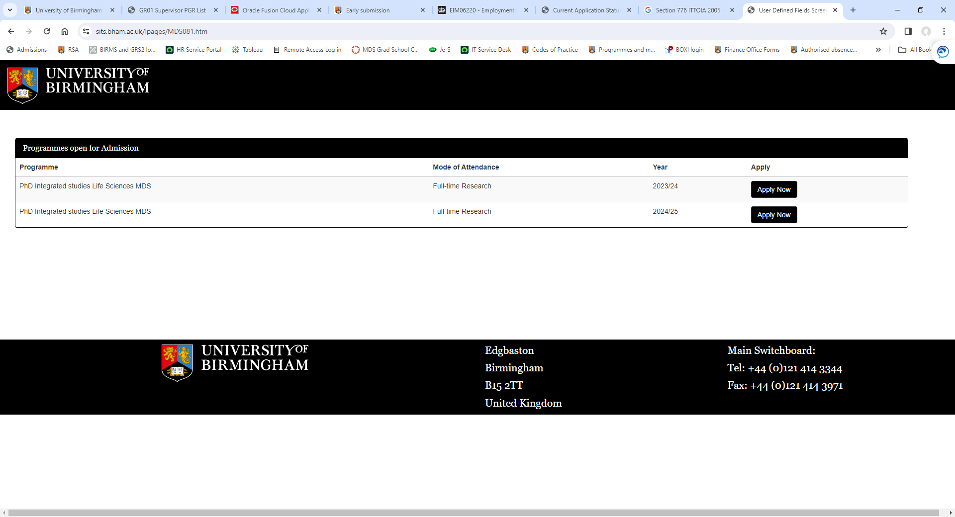
Click on ‘apply now’ 2024/25

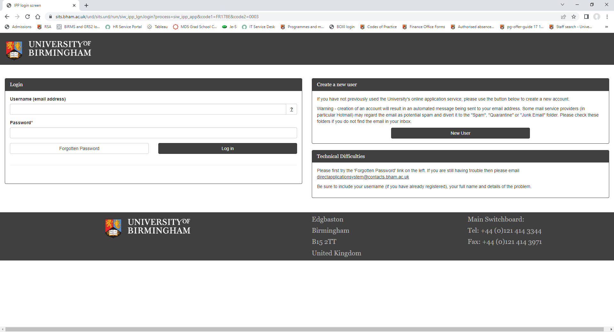
Follow the instructions to ‘create a new user’

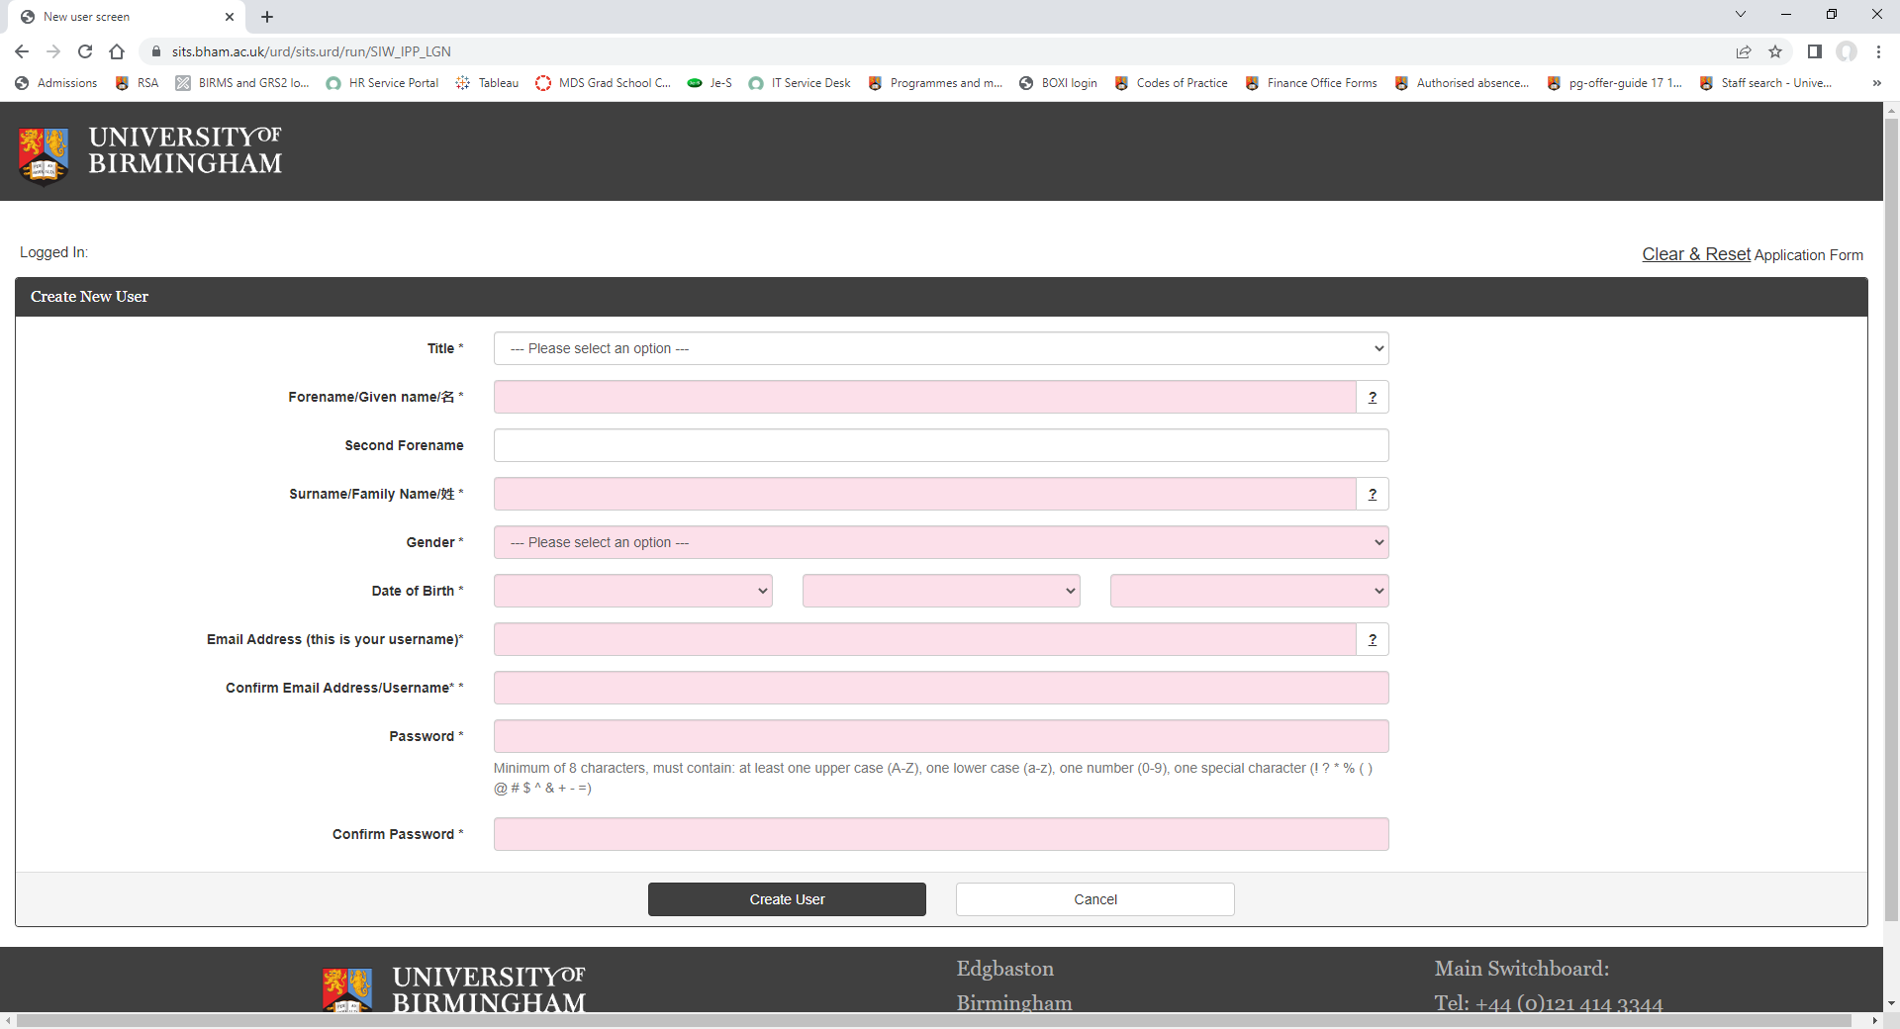
Complete personal details to create a new user profile

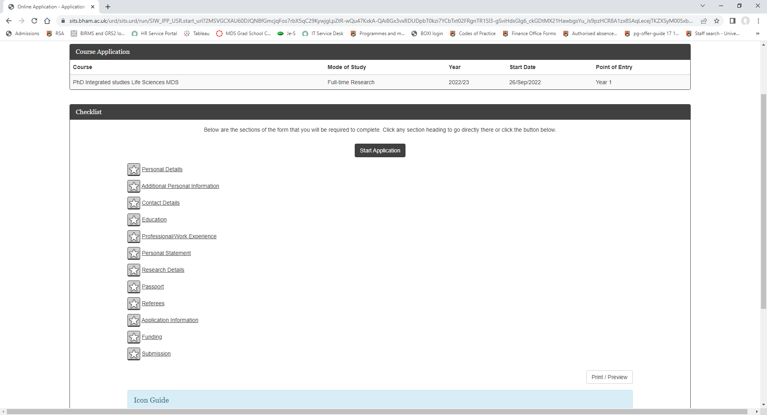
Once your user profile is created, the next screen you will see is the ‘start application’ screen. You will need to complete all of the sections before submission of your application can take place.
The portal will show you where information is still outstanding or if all has been provided:
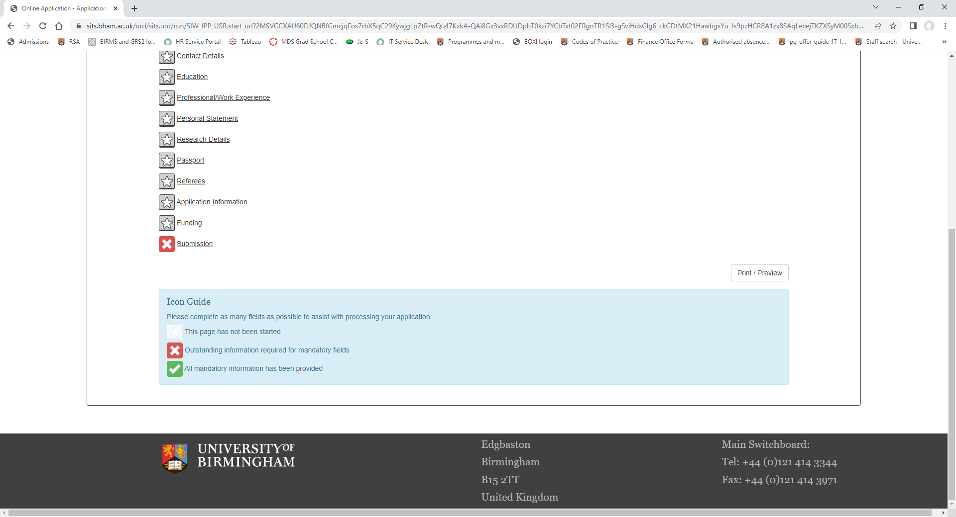

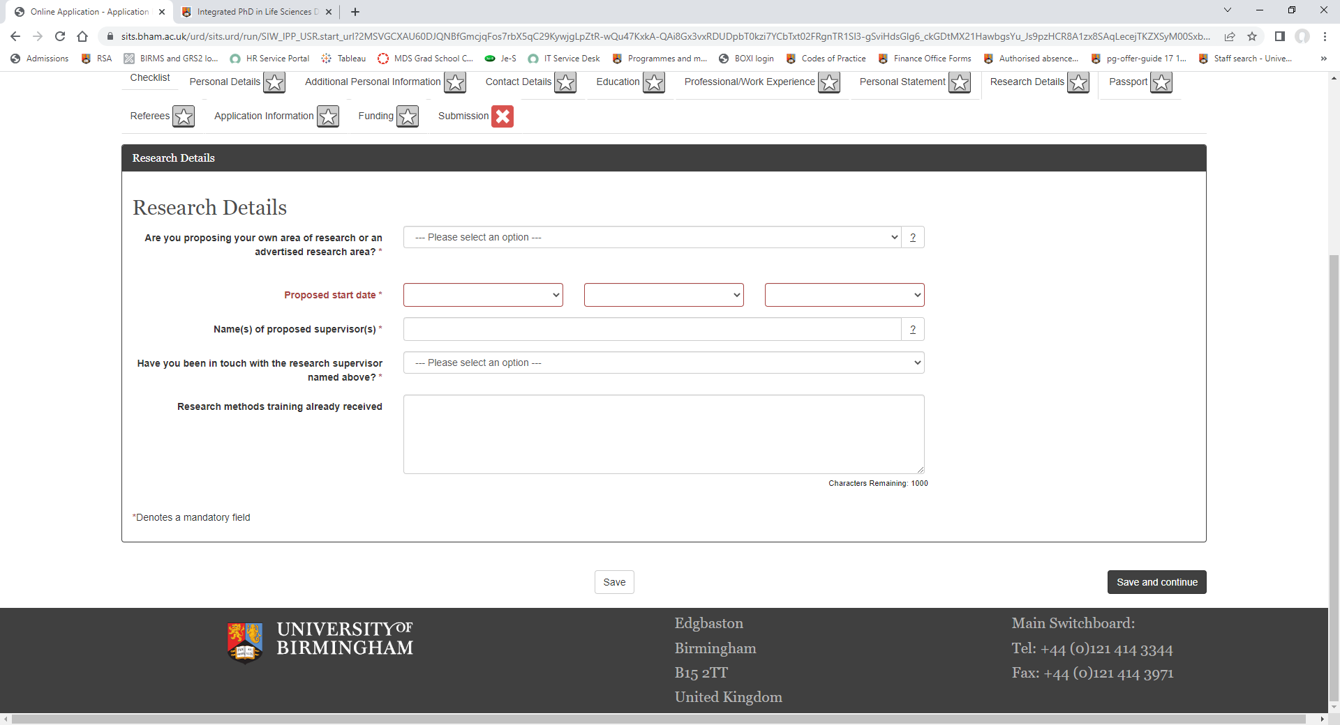
A research proposal is not required for the idtp application. Instead you will be asked to provide details of your area of research and any supervisors you have been in touch with. If you haven’t had prior contact, that is fine, please indicate Dr Helen McGettrick under ‘name of proposed supervisors’
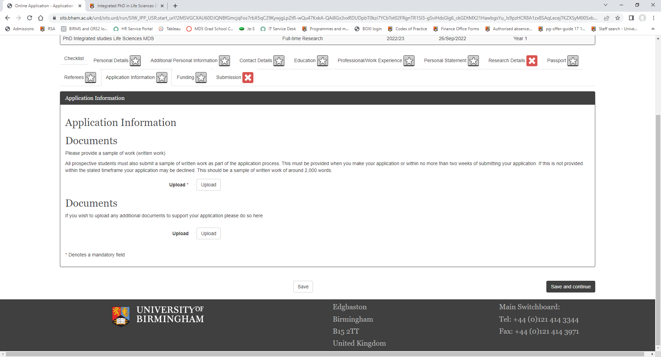
‘Application Information’ is where you will need to provide:
1) the document listing your top two preferred choices of optional modules outlined in the programme modules information section
2) your CV and
3) personal statement
4) Evidence of funding - This can be a letter from your sponsor or evidence that you have started to apply for funding, if eligible.
You will also need to submit an example of your written work from your previous degree(s) eg: an essay.
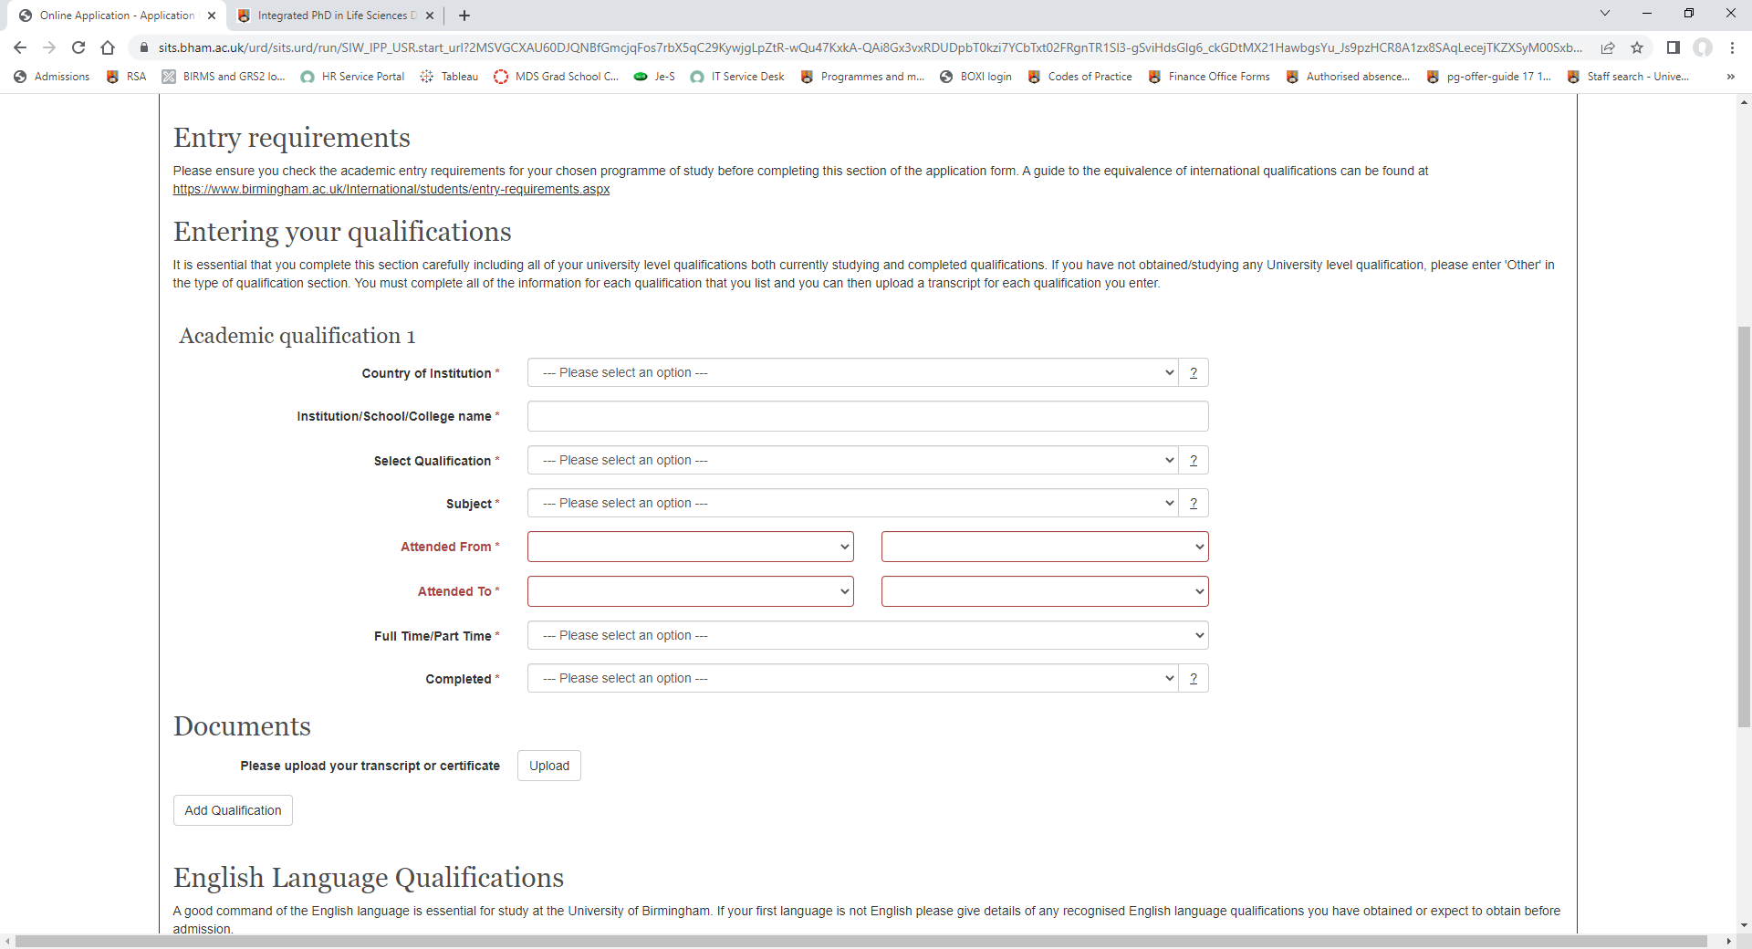
‘Education’ is where you will need to provide details of your qualifications, both currently studying and completed qualifications. You will alsp upload your degree certificates and transcripts to this page. If you will also upload to this page e details of any recognised English language qualifications you have obtained or expect to obtain before admission.
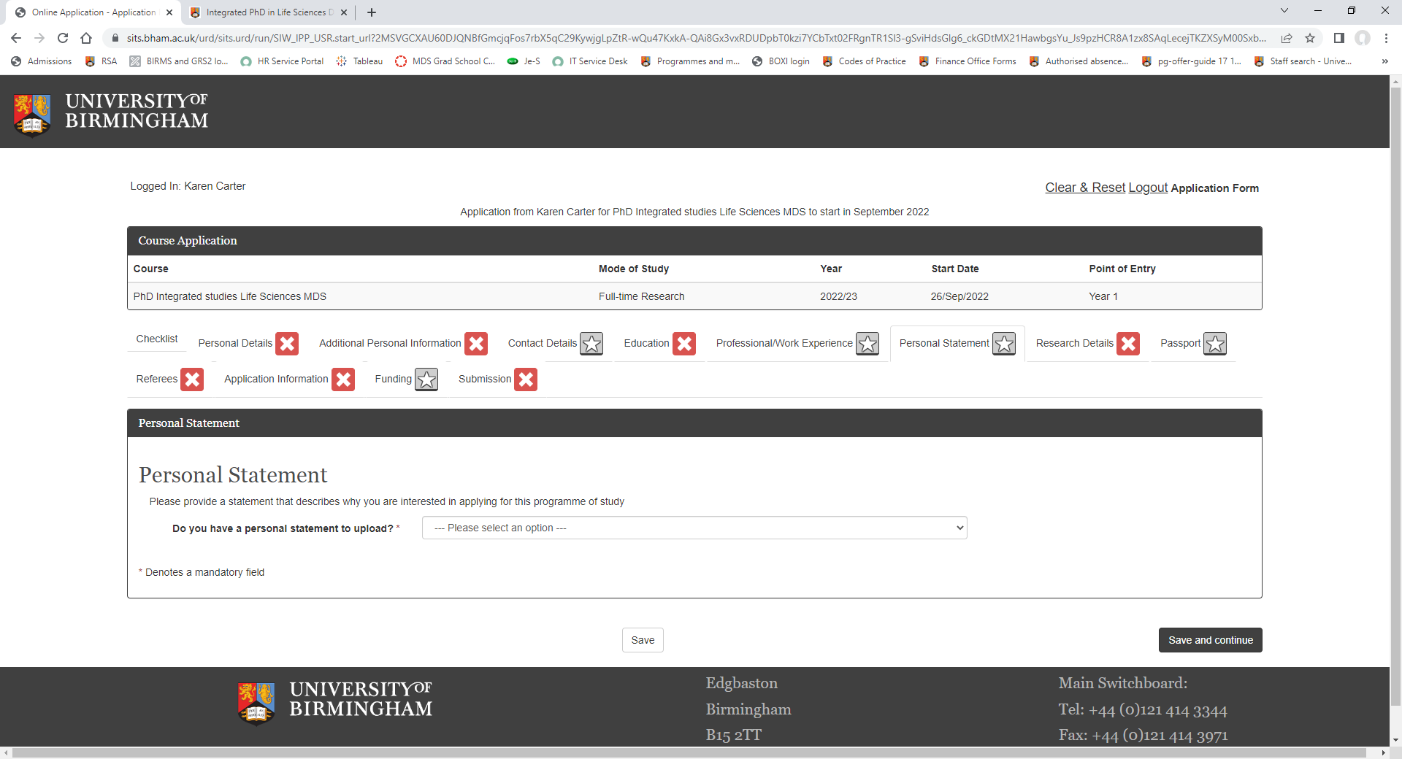
‘Personal statement’ is the page where you upload a statement that describes why you are interested in applying for this programme of study
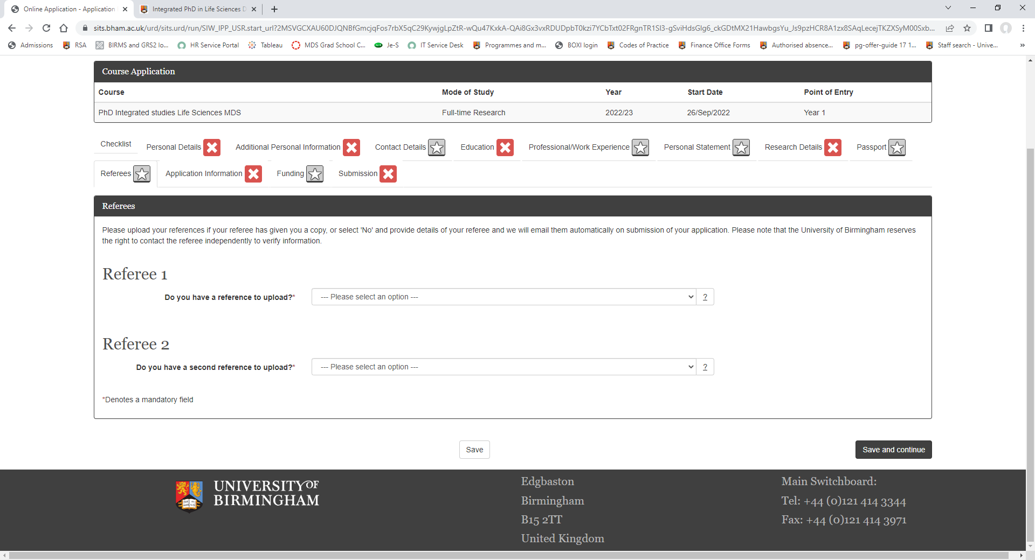
‘Referees is the page you will provide Names and addresses of two referees and we will email them automatically on submission of your application. Alternatively, if you have a copy of your references you can upload to this page.
If you have any queries, please contact idtp@contacts.bham.ac.uk

