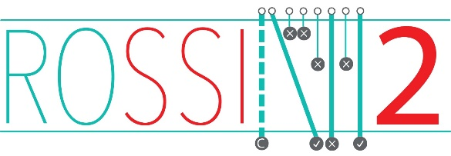
ROSSINI 2: Reduction Of Surgical Site Infection using several Novel Interventions
A phase III, multi-arm, multi-stage (MAMS), pragmatic, blinded (patient and outcome assessor), multicentre, randomised controlled trial (RCT) with an internal pilot, to evaluate the use of several in-theatre interventions, alone or in combination, to reduce SSI rates in patients undergoing abdominal surgery.
GP LETTER
Version 2.0, 12th July 2022

Patient Name:
Date of Birth:
NHS Number:

Dear Dr
Your patient, named above, has given their consent and subsequently been enrolled in the ROSSINI 2 trial.

The ROSSINI 2 trial is a multi-arm, multi-stage (MAMS) pragmatic, multicentre RCT exploring the use of several in-theatre interventions to reduce surgical site infection (SSI) in patients undergoing abdominal surgery. This multi-arm, multi-stage (MAMS) trial has the opportunity to ‘drop’ interventions (e.g. combinations showing a lack of benefit) and ‘introduce’ interventions (e.g. combinations based on new, available evidence) at specified time points. MAMS trials aim to answer multiple questions simultaneously under one trial.

Patients who agree to take part (after provision of a patient information leaflet) are then randomised in theatre around the time of induction of anaesthesia on the day of surgery and after eligibility has been confirmed.

Follow-up is according to a predetermined schedule, using specific collection tools to collect blinded data. Your patient will have clinical follow-up before they are discharged from hospital as an inpatient and then roughly 30 days post-surgery as an outpatient and, if applicable, every 30 days until the SSI has resolved.

ROSSINI 2 was developed by the West Midlands Research Collaborative and the University of Birmingham Clinical Trials Unit. The University of Birmingham Clinical Trials Unit are acting as the coordinating centre. The study is funded by NIHR Health Technology Assessment Programme. The trial has been approved by Wales REC 6.

Due to the blinded nature of the trial we are unable to inform you which arm your patient has been randomised to. This information will be made available upon request at the end of the trial. If for any reason you have a safety concern regarding this patient’s involvement in ROSSINI 2, please contact the ROSSINI 2 trials team.

If you require any further information about the ROSSINI 2 trial, please contact the ROSSINI 2 Trial Office at the University of Birmingham Clinical Trials Unit where you can also request a copy of the Patient Information Sheet. Please file this letter in the patient’s notes. We would appreciate being notified if they are no longer one of your patients.

Many thanks,

Name:
Position:
Contact Details:

ROSSINI 2 Trial Office, Birmingham Clinical Trials Unit (BCTU), Public Health Building, University of Birmingham, Edgbaston, B15 2TT.
Tel: 0121 415 8840
E-mail: rossini2@trials.bham.ac.uk.

