Recommendations from participatory research inquiry on urban nature

Centre for Urban Wellbeing (CUWb) and Birmingham Voluntary Services Council (BVSC) Research
September 2024

Background: Community Based Participatory Research

A ‘community of inquiry’ on urban nature in Birmingham was developed, responding to calls from the UK Government’s DEFRA Green Spaces Inquiry 2024 for more knowledge on:
- how people engage in collective environmental action
- how we can upskill local authority staff to support equitable access to green spaces
- how can we scale up local deliberative community action to improve green spaces
The CUWb Community Researchers panel co-designed and delivered research on cultural and social barriers to accessing urban green spaces, commissioned by Natural England. This involved 32 qualitative interviews with residents in Winson Green, Lozells, Newtown, Handsworth and Bartley Green.
We conducted focus groups with 10 environmental and community organisations across the West Midlands region to identify actions already been taken to address these barriers. These groups were invited to our Urban Green Room event at the Birmingham Settlement Nature and Wellbeing Centre in June 2024, with 250 participants and over 30 organisations attending on the day.
We collaboratively analysed the qualitative data to develop key themes and presented these to a policy panel. Here we present qualitative research data and joint recommendations arising from this workshop in September 2024.
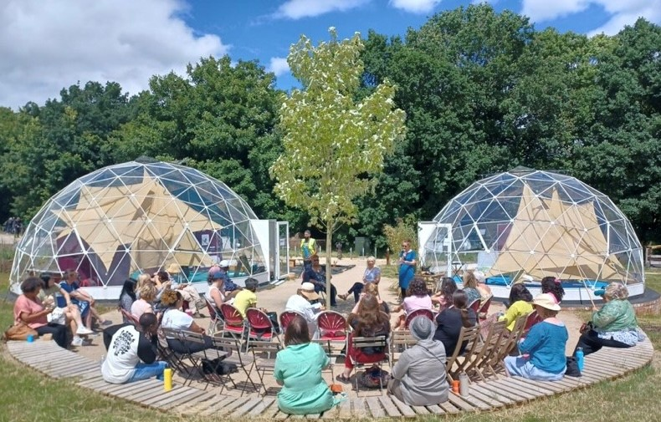
Urban Green Room, Birmingham Settlement Neighbourhood Futures Festival, June 2024

Research Themes:
Finding a shared language to relate with nature

We identified the following themes arising from the research, as a basis for community discussion, policy advocacy and action research:


Redefining nature access
Making time for nature
Cultivating nature belonging
Kinship with nature
Valuing nature connection
Taking action with nature

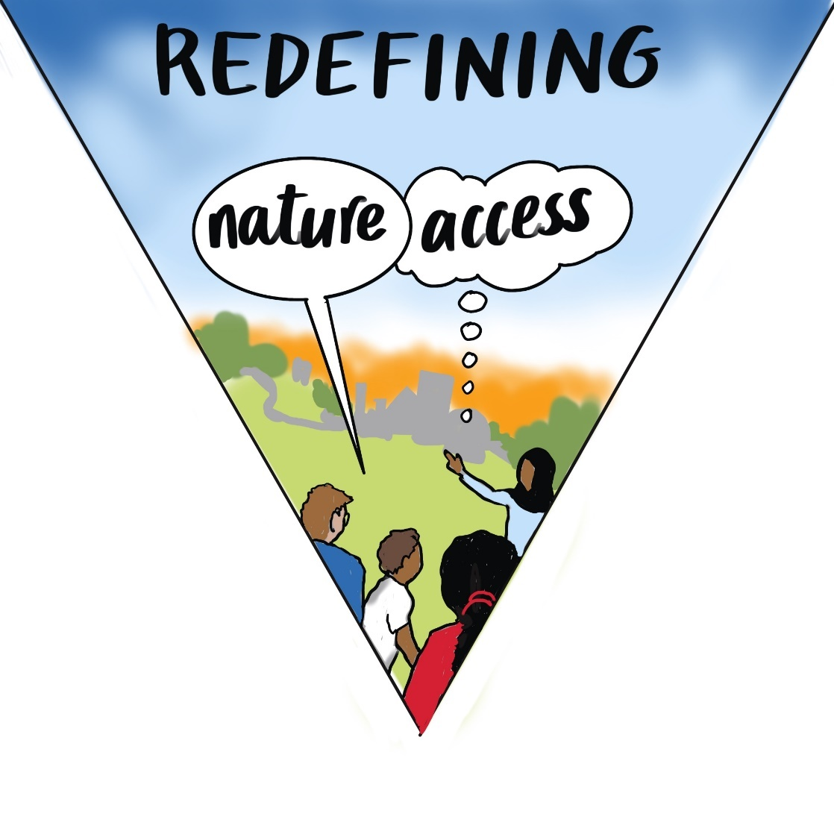
Challenge: Perception that ‘top-down’ definitions of nature are not inclusive​.
What the Community Research Panel discussed: “the language that even we’re using now about nature does not relate to the people that come from his part or my part of the world. It’s like two different worlds […] Sometimes, for people in certain urban areas, their priorities are not what’s growing down the road, their way of thinking is, “Can I afford to pay my bills this week? Are the council going to come and fix my roof? Are my kids safe kicking the ball out the front or even down the park?” That’s what you’re focused on, you’re not thinking, “I could do with a weekend retreat.”
“I think the infrastructure the people are made to live in influences the way they think about themselves and their environment.”
How could we respond? Focus on nature connection, and language that speaks to rather than alienates people​, acknowledging their specific situations and opportunities available to them to incorporate nature into daily life.

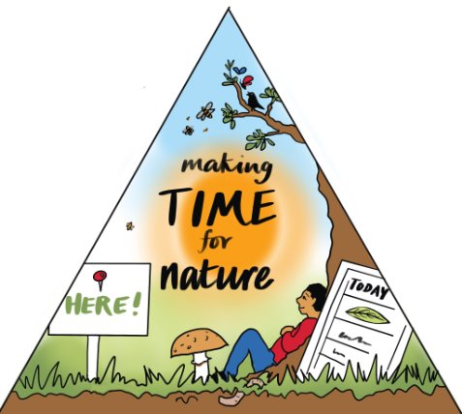

Challenge: Research with environmental organisations identified a need to re-imagine nature activity not as a leisure pursuit but part of everyday life (e.g. trip to hospital, in front yard).
​What the Community Research Panel discussed: “when you look at children, they automatically know what to do in nature. They’re jumping in puddles, they’re touching leaves, they just know instinctively what to do.”
“it might not be what someone might traditionally think of as connecting with nature, I don’t know, like it might not be going for a walk in a country park, it might not be doing gardening but it could be something vaguely connected to that or crafts in nature, anything like that. Food is a really great way to get people interested, it’s something universal.”
How could we respond? There is a need to focus initiatives on the ways people engage with nature through their everyday lives and to recognised inequalities in spare time. For example, noticing nature and being aware of nature, such as listening to bird songs on the way to the bus.

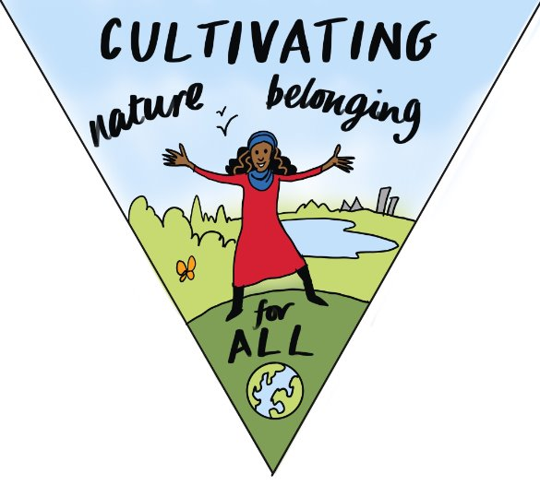
Challenge: People feel excluded where visitors and staff are predominately white, which gives them feelings of intimidation and not knowing ‘how to follow norms’ in these areas.

What the Community Research Panel discussed: “I was thinking about how important memory is, especially for kind of first and second generation migrants you know, their homeland and imagination […]how do we bring back that long memory and then certain things that they saw that gave them great joy that’s still there inside them.”
“Something that kind of resonates with me is I’ve been to a lot of nature reserves where you go into a bird hide and it feels like you’re not very welcome, I can only imagine that people that aren’t white going into those spaces feel even more intimidated… it feels like it’s a private club that you shouldn’t be part of sometimes. “​
How could we respond? A need to cultivate feelings of autonomy, build on community strengths and memories and acknowledge diverse life experiences. Community organisations providing a stepping stone approach to accessing nature to develop people’s confidence.

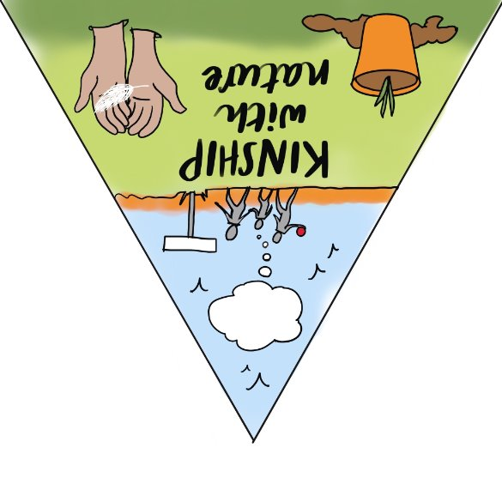

Challenge: Some people see nature as inseparable from human wellbeing. Where aspects like ancestry, family, intergenerational knowledge and commitments, emotional ‘yearning’ for nature are ignored, this perpetuates a sense of separation.​
What the Community Research Panel discussed: “This means something to me. This feels good in a way I can’t quantify.”
“when given the right setting, connecting to nature will come quite naturally to us as humans […]But I’m not sure what creating that right setting would always look like.”
“somebody once said to me a chance encounter with nature is like a chance encounter with an old friend, it lifts the spirits.”
“[we] need to go back to sort of historical stories, I mean, ancestral stories and things like this because the society that we live in makes us think that that locked-offness [from nature] is normal.
How could we respond? Sharing of folklore, storytelling and wisdom from diverse communities​. ​Need to solve environmental deprivation at the ‘heart of the city’​.

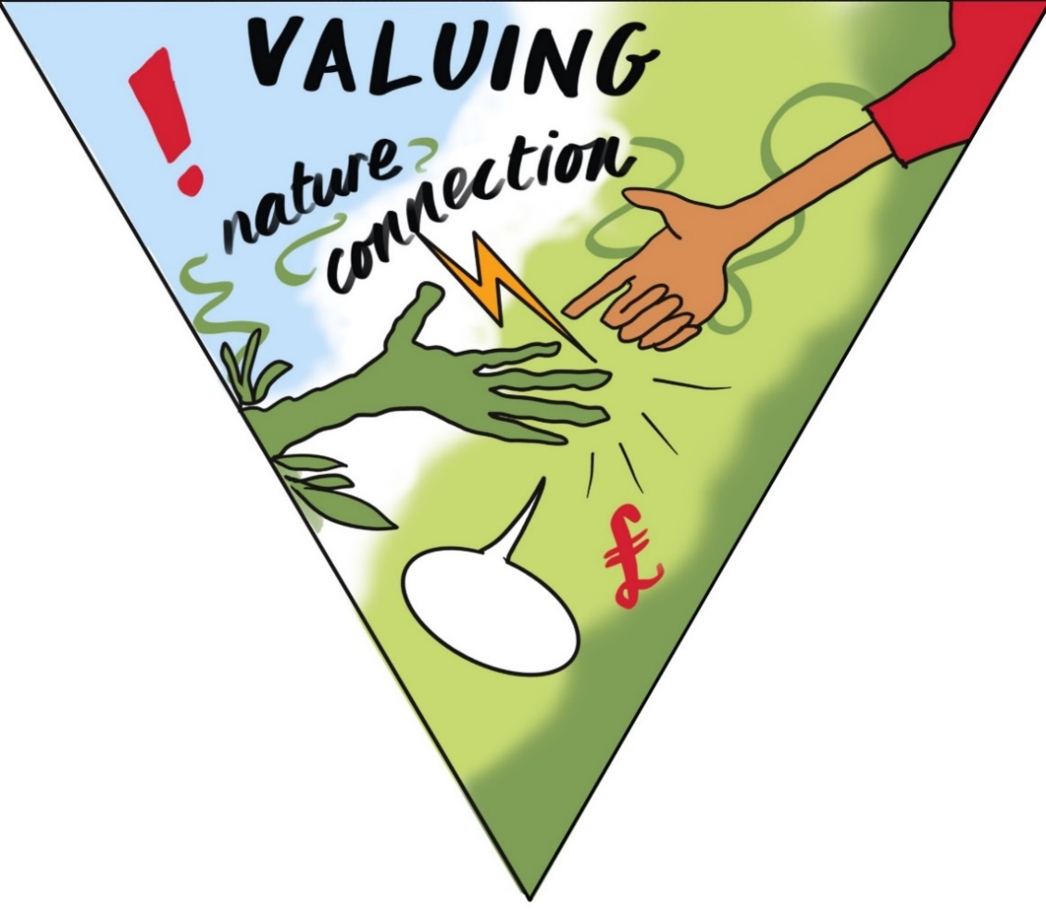
Challenge: Risk of intrinsic worth being lost in valuing nature as a service or resource for the betterment of human wellbeing, societies, economies, or are their benefits to attracting private finance to nature or ecosystem projects. How can we avoid greenwashing and green gentrification and give nature a voice?
What the Community Research Panel discussed: “I was really struck with the idea of nature having to have a monetary value in order to be worth something because for me, kinship with nature is about the fact that we are all connected to each other and to the natural world. And if we block that off, then we’re losing part of ourselves”
“in just recognising people in the red zone [mapped as environmentally deprived] areas are just dealing with survival, bottom line, survival. It is seen as luxury to live in an area like this, seen as luxury to have that. And I think I’ve said before, there is a very, in those areas, there’s a very strong counter-narrative which is ‘concrete is king’. And that’s the other thing to fight against.”
“the centre of Birmingham is the heart of Birmingham and if that’s sick, everything around it is also sick.”
How could we respond? Structural changes are needed, build on positive examples where developers, planners, community members are working together to change what we value, how we value it and make urban spaces inclusive. Change the culture so that nature is seen as a necessity not a luxury.

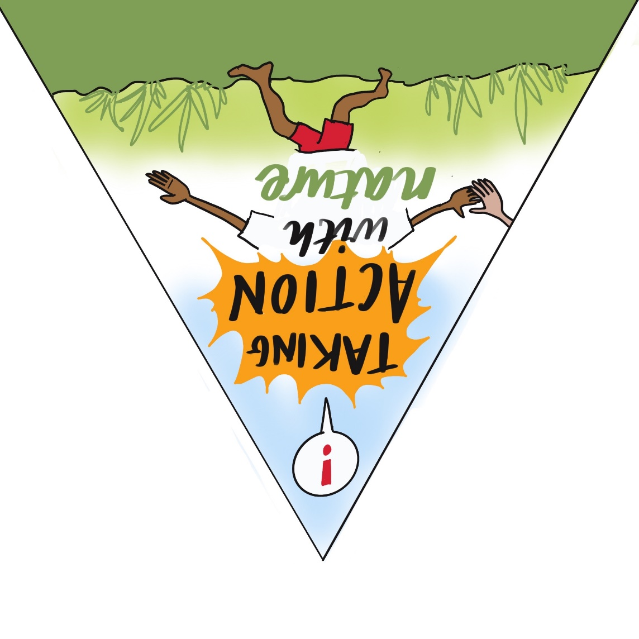
Challenge: Economically excluded areas and communities are being left behind in terms of environmental justice, and the urgent crisis of climate inaction is not being addressed – strategies are inadequate to the challenges ahead.
What the Community Research Panel discussed: “We can never stop asking, we’ve got to keep asking and checking. But we know enough now to just get on with it and do this at scale, at pace.”
““I really don’t think we appreciate the size of what we’re trying to achieve.”
“When we try to sit in a room and communicate, it all becomes very awkward. But if we actually just, like you said, just went out into a green space with no agenda and no list of things that we wanted to do, it would happen, it happens. And the other thing it does, it joins us together. So, where there isn’t kinship between people, that kinship takes over because it sort of takes away all the barriers when you’re in a natural environment together.”
How could we respond? Need to focus on underserved areas to make access to nature easier, inspire value of nature, give people autonomy over caring for nature in their area, acting as stewards for nature assets. It is essential not to frame these problems as personal but to understand better how to better engage in effective action collectively, with nature, and at scale.

Community Researcher Panel
Recommendations for action

Barriers to overcome

Personal energy levels – recognising that activism, influencing, volunteering can be emotionally demanding.
Lack of knowledge and experience of green financing structures and initiatives limits what we perceive to be possible.
Ensuring action appeals across generations.
Finding resource and methods to scale up local action fast and far, with the sense of urgency necessary.
Lack of power devolved to local people to make choices about public spaces in their neighbourhoods.
Need to better understand (personal, policy) constraints and motivations for investing in nature.

Long term goals

Birmingham City Council is committed to delivering the City of Nature plan in its entirety.
Natural England is working with Community Researchers, Leaders and Organisations to help enable more people to access nature for their enjoyment, health and wellbeing.
WMCA work create locally led work with the support of larger institutions, such as creating a network of projects and groups funded through the Community Environment Fund.
Longer term and transformed funding landscape for community and voluntary sector organisations, to invest in people (community), and place (infrastructure).
Co-ordinate and support existing current environmental work in the city and region, pooling research results of smaller scale initiatives to lobby for funding and influence policy.
Address the root causes of barriers to accessing urban green spaces including poverty and provide more opportunities to develop kinship or nature connectedness for people living in areas of Birmingham identified as environmentally deprived.
Rediscover our relationships with nature.
Identify land opportunities regionally for creating new green spaces, develop a nature inspired building scheme for one neighbourhood to inspire a community in a specific area, ensure social housing is more environmentally sustainable by using creative nature-inspired architects.

Quick wins

Creating relationships with community groups to connect them to large funding opportunities, through City of Nature Alliance.
Advocate for the importance of valuing nature across sectors (e.g. health, planning, education, transport) for health and wellbeing, and signposting to relevant research findings.
Use arts to share stories of nature connection, take individuals to green spaces rather than expect them to go alone. Connect someone else to nature
Acknowledge own privileges around kinship and nature connection, to more genuinely understand the perspectives of people different to ourselves, recognising where we do have power to influence and accelerate change.
Share the research results with Birmingham Open Spaces Forum, 135 Friends of Parks groups, Women’s Institute, faith organisations, more widely within Natural England, City of Nature Alliance.
Introduce more children and adults to seed sowing and growing, through organisations such as Patchwork Meadow.
Use social media to communicate the inequalities between environmentally deprived and privileged areas of the city, and work together to reach a national audience.

Call to action

Whether it is tackling environmental deprivation, inequitable access to green space, the quality and affordability of housing or public spaces, climate action or adaptation, or creating urban environments which support mental and physical wellbeing, community-based research can inform collective action.
The words we use, the stories we tell and the conversations we have on these issues shape what matters, how problems are framed, and who counts in addressing urban wellbeing inequalities - the inequalities which drive unequal opportunities, human-environment relations and social outcomes.
We work with community groups, community and voluntary service organisations, civil society, public bodies and policy makers to develop new knowledge, experience and practices aimed at reducing wellbeing inequalities. Please get in touch if you share our goals and want to get involved: urbanwellbeing@contacts.bham.ac.uk
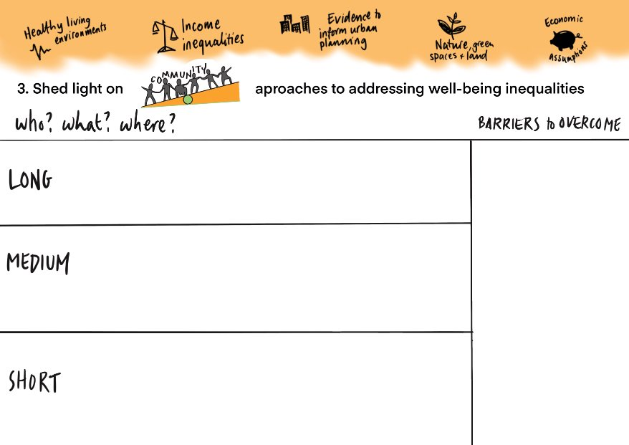

Acknowledgments:

We are grateful to the Community Researcher Panel and participants at our workshop in September 2024. We are thankful to the following keynote speakers at the Urban Green Room event: Dr William Bird, Beth Collier, Imandeep Kaur, Charlotte Garner, Martin Holcombe, Mike Webb. We gratefully acknowledge funding from the Research England QR Policy Support Fund at University of Birmingham.
The views expressed here are solely those of the authors, and do not necessarily reflect the views of the authors’ employers institutions or other parties or organisations referred to in this document.
Illustrations credit: Think Big Picture.

