Focus Group Pupil Participant Assent Form V2 12-09-2025
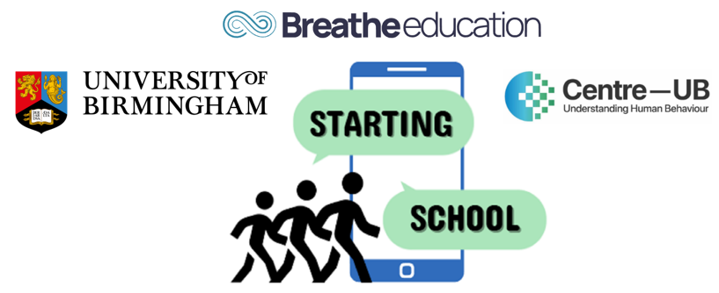

STARTING SCHOOL Study: SmarTphones and Adolescent Risk and resilienT factors for wellbeing when transitionING SCHOOL
PUPIL PARTICIPANT FOCUS GROUP ASSENT FORM
If you agree to take part in this study, please read the following statements, and write your initials in the boxes on the right-hand side:
Statement: | Initials:
I confirm that I have read and understood the Focus Group Pupil Information Letter dated 12/09/2025 (Version 2) and have had a chance to ask questions about it.
I understand that I’m being asked to take part in a group discussion that could last up to 60 minutes. We’ll talk about what I think and feel about smartphones and social media.
I understand that it’s my choice whether I join the focus group. If there’s a time during the focus group I don’t want to talk or answer a question, I don’t have to. If I want to leave the focus group for any reason, I can.
I understand that after taking part, I can choose to stop being in the study at any time. I don’t have to give a reason, and it won’t affect my rights in any way. However, I know that anything I say in the focus group can’t be removed and will still be used in the study.
I understand that the focus group will be audio-recorded, and that what I say might be written down and used in the study, but my name won’t be used.
I understand that the recording of our talk will be safely shared between the company that turns to audio recording into text and the University of Birmingham, and they’ve agreed to keep it private. I agree to what I say in the discussion will be recorded in text and shared with the University.
I understand that my answers will be kept private, and only the research team will see my personal information. I know that if I, or someone else in the group, says something that makes the researchers worried about someone’s safety, they might need to tell a teacher to help keep us safe.
I agree to take part in the Starting School Study.
Name___________________________________________________________
School _________________________________________________________
Year __________________________________________________________
Signed __________________________________________________________
Date ____________________________________________________________

Please return this form to your class teacher within 1 week:
Starting School Study Project Manager
School of Sport and Exercise Rehabilitation Sciences
University of Birmingham
B15 2TT
This project is funded by the Centre for National Training and Research Excellence in Understanding Behaviour (Centre-UB). The views expressed are those of the project investigators and not necessarily those of Centre-UB or the University of Birmingham.
Thank you for considering taking part in the Starting School Study

