Focus Group Pupil Participant Information Letter V2 12-09-2025
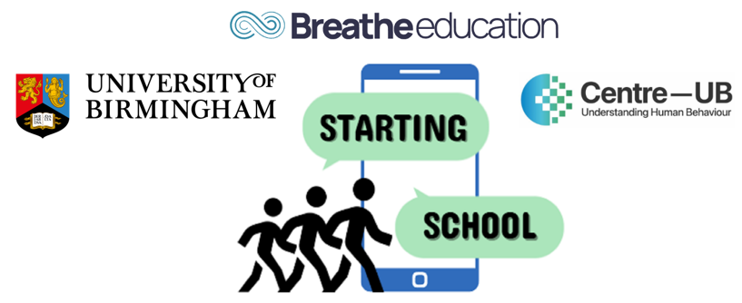
STARTING SCHOOL Study: SmarTphones and Adolescent Risk and resilienT factors for wellbeing when transitionING SCHOOL
Hi again! Thank you for reading our flyer about taking part in an online survey. This leaflet is about taking part in a focus group discussion. We would love you to think about joining!
What will I be asked to do?
You’ll take part in a focus group with 4–6 other pupils from your class. You’ll talk about your smartphone and social media use. Some topics might include:
- How you use your smartphone and social media
- How you use your phone to talk or interact with others
- Rules your parents/carers or school have about phone use
- How using smartphones and social media might affect your feelings and wellbeing
The goal is to understand what influences how pupils use phones and social media, and how this changes from primary to secondary school.
When will I take part?
- During lesson time at school
- In a classroom or open area with a researcher
- The discussion will take about 60 minutes and will be voice recorded
Do I have to take part?
- No. It’s your choice.
- We will ask if you agree before the focus group.
- Your parents/carers can also say no by sending back a letter or emailing the study team.
- You can skip any question you don’t want to answer.
Can I stop once the focus group has started?
- Yes. You can leave the focus group at any time.
- But anything you’ve already said before you stopped will still be used.
- We would only remove something you said if it made us worried about your safety or someone else’s. In that case, that part of the recording will be deleted before it is written down or used in the study.

Could it be harmful?
- We don’t think it will hurt you.
- If you feel upset or uncomfortable for any reason, tell a teacher, your school wellbeing officer, or your parent/carer.
Why take part?
- You’ll help us learn how kids use smartphones and how it affects wellbeing.
- This could help schools and the government make better rules about phone use.
What will happen to my information?
- Your answers will be kept safe and private.
- Your name will not be used in any reports.
- Only researchers will know what you said.
- The discussion will be recorded and stored safely.
- After the study, the information will go to a special research library, but it will still not include your name.
Confidentiality
- Your information will be kept secret.
- Other pupils won’t know what you say.
- BUT if we are worried about your safety or someone else’s, we might tell a teacher to help.
What happens next?
- Sign and return the assent form if you want to take part.
- Contact us with questions: 0121 414 9286 or startingschoolstudy@contacts.bham.ac.uk
Thank you for thinking about taking part in the Starting School Study!

