Parent Opt-Out Consent Form V2 12-09-2025

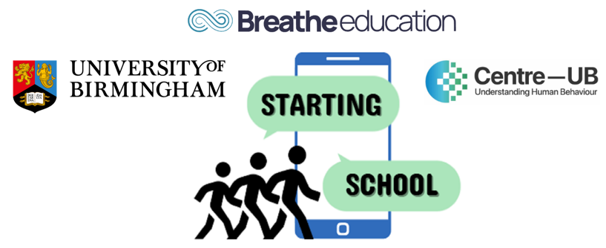
STARTING SCHOOL Study: SmarTphones and Adolescent Risk and resilienT factors for wellbeing when transitionING SCHOOL

PARENT OPT-OUT CONSENT FORM
(TO RETURN WITHIN 1 WEEK)
Please only complete this if you do not want your child to take part:
Please initial the boxes below:
I confirm that I have read and understood the Parent Information Letter dated 12/09/2025 (Version 2)
I am not willing for my child to take part in the Starting School Study
Name of child ____________________________________________________
School _________________________________________________________
Class/Tutor Group ________________________________________________
Signature of parent/carer ________________________________________
Date ___________________________________________________________
Please complete opt-out within 7 days of receiving the information letter
WAYS YOU CAN CONFIRM OPT OUT:
- Sign this form and hand it in to your child’s school by hard copy
- Sign this form and email it to us at startingschoolstudy@contacts.bham.ac.uk

If you have a question or would like to speak to someone, please contact us:
Starting School Study Project Manager  School of Sport, Exercise and Rehabilitation Sciences, University of Birmingham, B15 2TT | Email startingschoolstudy@contacts.bham.ac.uk  Phone: 0121 414 9286
This project is funded by the Centre for National Training and Research Excellence in Understanding Behaviour (Centre-UB). The views expressed are those of the project investigators and not necessarily those of Centre-UB or the University of Birmingham.

