Primary School Information Sheet (Wave 1) V2 12-09-2025
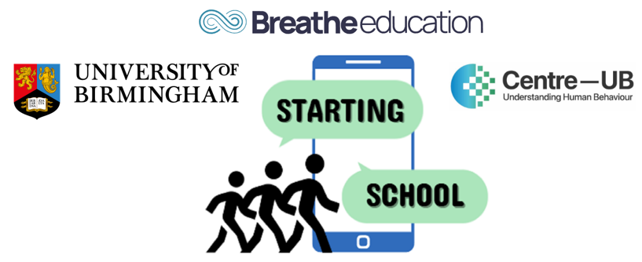
STARTING SCHOOL Study: SmarTphones and Adolescent Risk and resilienT factors for wellbeing when transitionING SCHOOL
This is a PhD project funded by the Centre for National Training and Research Excellence in Understanding Behaviour (Centre-UB) undertaken by Jacquelynn Ennis, a postgraduate researcher at the University of Birmingham, under the supervision of Dr Victoria Goodyear, Dr Miranda Pallan, Dr Amie Randhawa and Dr Paul Patterson.
What is the aim of the study? To understand the relationship between adolescent smartphone use and mental wellbeing during the transition from primary to secondary school.
Who will be involved in the study?
- Pupils in year 6
What will the study involve?
- Pupils will complete an online survey that will include the following topics; smartphone and social media use, mental wellbeing, anxiety and depression (for example, ‘over the past 2 weeks how often have you felt worthless, sad, or empty’) social connectedness, school connectedness and smartphone addiction. The survey will also ask pupils their age, gender, ethnicity and postcode. We are asking this information to understand more about the different factors influencing adolescent smartphone and social media use.
- Form tutors (or equivalent class teacher) will submit information about each of their pupils including whether the pupil is eligible to free school meals, if they are registered as having a special educational need and if English is an additional language. We are asking for this information in order to understand more about pupil characteristics.

Where will the study take place?
- Pupils will complete the online survey during a timetabled lesson in the presence of the class teacher and a member of the research team. Tablets will be provided for students to complete the survey. The survey will take up to 30 minutes to complete.
Are there any further research activities? Your school may be invited to take part in additional data collection activities in the form of focus group discussions. If selected, one focus group will be completed with Year 6 pupils at your school. The discussions will take place in your school, last approximately 60 minutes, will be led by a member of the research team and will be voice recorded. The discussions will focus on phone use, smartphone-aided interaction with schoolmates and non-school friends and mental wellbeing. If you are interested in taking part in a pupil focus group discussion, please contact the research team.
What are the benefits to taking part? This study will offer your school the opportunity to play a key role in the development of new guidelines regarding phone and social media use in schools and mental health. You will be provided with free access to resources and materials developed from this study and can request a summary of findings related to pupils’ uses of smartphones and social media use specific to your school that can be used to inform your school’s phone/media and mental health policies and practices.
Will the school be provided with compensation for taking part? Your school will be entered into a prize drawing for a £400 voucher. All participating schools will receive a tailored report summarising their own findings of their pupils’ smartphone habits. Additionally, the research team will provide workshops for pupils, parents and teachers about digital literacy and healthy smartphone use.
Schools that facilitate a pupil focus group will receive £150 pound vouchers and participating students will each receive a £5 voucher.
What are the risks to taking part? This study is an observational study about current phone/media use and mental wellbeing, and therefore any risk or harm to participants is not expected as a direct result of the research. There is a small possibility that the collecting of data related to mental health may be a sensitive issue for some participating pupils. We have therefore put in place the following measures to mitigate any potential risks to your pupils:
- Within the pupil leaflet and at the end of the survey, pupils will be provided with internet links signposting to further mental health support and information
- At the end of the survey pupils will be provided with the option to complete a mood-elevation task; this is an evidence-based strategy to support mental wellbeing
- The research team will work closely with the wellbeing team (or similar) in your school and follow your school’s safeguarding protocols and procedures

Will information be kept confidential? All information that is collected about your school, teachers and pupils will be kept strictly confidential. This means that your schools’, teachers’ and pupils’ names will be removed from any reporting of the findings. All information will be stored electronically and securely. Only the research team will have access to the data. There may be some instances whereby confidentiality may need to be broken, and this is in the event that a participant in the study identifies a safeguarding concern. If this occurs, the researcher will inform the Designated Safeguarding Lead (DSL) so that they take appropriate action in line with the school’s safeguarding policy.
For example, if a pupil’s survey suggests possible depression, the researcher will send two secure emails to the school’s Designated Safeguarding Lead (DSL): one with the issue and a mental health resource pack, and one with the pupil’s name and score in a protected file. The research team will request confirmation within 24 hours and follow up by phone if needed.
Can I withdraw my school from the study? Yes. You can withdraw your school from the study. All participants also have the right to withdraw, and parents can withdraw their child from the study. If pupils withdraw while they are completing the survey, they can select an alternative task to complete on the tablet so that their withdrawal is not known to other pupils. If the school and/or any of the participants withdraw within 4 weeks of the last point of data collection, all documents and data generated related to the school or a specific individual will be destroyed. The contract, consent and assent will not be destroyed to ensure we remain within legal processes.
If your school participates in the pupil focus group, pupils taking part in a focus group discussion may withdraw at any time. However, any contributions made before their withdrawal may still be included in the study, as it would not be possible to identify individual speakers from the group recording.
What will happen with the results of the study? The results will be presented in academic journal papers and at national and international conferences. We will produce blogs, podcasts, videos and infographics targeted at pupils, parents and the wider public to raise awareness and understanding of the relationship between phone/social media use and mental wellbeing, and these will be made available on our website and sent to your school during and at the end of the study.

What is expected of the school?
- The main role of the school is to facilitate the dissemination of documents to parents, pupils, and school staff and to arrange time during the school day for the data collection activities (online survey completion by pupils and school staff).
- For parents, we are asking for opt out consent and this means that parents will only be required to return a letter or contact the school/research team if they do not wish for their child to take part.
- We ask that teachers monitor the pupil participants behaviours, and if necessary, provide appropriate forms of support e.g. through the school’s wellbeing or safeguarding team.
- To facilitate these processes, we ask you to nominate a member of staff to act as a liaison person between the school and the research team.
If you agree for your school to participate, please sign and return the attached school contract as soon as possible. PLEASE RETURN CONTRACT TO startingschoolstudy@contacts.bham.ac.uk or write to:
Starting School Project Manager
University of Birmingham
B15 2TT
If you have a question or would like to speak to someone, please contact us 0121 414 9286
This project is funded by the Centre for National Training and Research Excellence in Understanding Behaviour (Centre-UB). The views expressed are those of the project investigators and not necessarily those of Centre-UB or the University of Birmingham.
Thank you for considering being involved in the Starting School Study

