Secondary Parent Information Wave 2 Letter V1 14/03/2025
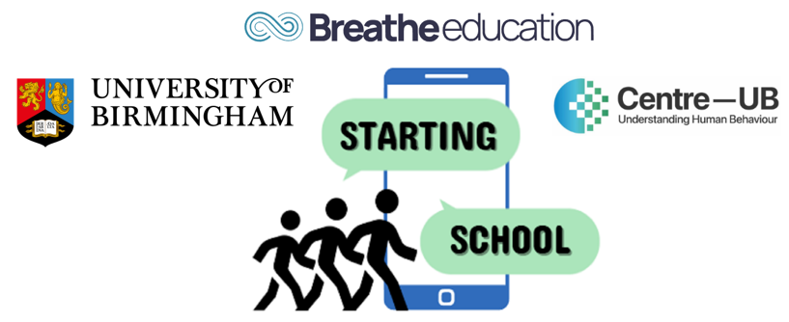

STARTING SCHOOL Study: SmarTphones and Adolescent Risk and resilienT factors for wellbeing when transitionING SCHOOL
This is a PhD project funded by the Centre for National Training and Research Excellence in Understanding Behaviour (Centre-UB) undertaken by Jacquelynn Ennis, a postgraduate researcher at the University of Birmingham, under the supervision of Dr Victoria Goodyear, Dr Miranda Pallan, Dr Amie Randhawa and Dr Paul Patterson.
This document provides information for the Parents/Carers of children who have been invited to participate in the study. Further information about the study can be accessed on our website [insert website address].
What is the aim of the study? To understand the relationship between adolescent smartphone use and mental wellbeing during the transition from primary to secondary school.
What will my child be asked to do? Your child will be asked to complete an online survey during a timetabled lesson in the presence of the class teacher and a member of the research team. The survey will take up to 30 minutes to complete. The survey will ask your child questions about their mental wellbeing, anxiety and depression, social and school connectedness, and smartphone and social media use. Example survey questions include:
- ‘Over the past 2 weeks have you felt useful, relaxed, optimistic, bad about yourself?’
- ‘Over the last 2 weeks how often have you felt worthless, sad or empty?’
The survey will also ask your child for their age, gender, ethnicity and postcode so that we can understand more about the differences in adolescent smartphone use.
Your child may also be invited to take part in a focus group discussion about smartphone and social media use, smartphone-based interactions with school friends and others and mental wellbeing. This will take place with 5 other members of their class, during lesson time in a classroom and with a member of the research staff. The focus group will last up to 60 mins and will be recorded using a voice recorder.
IMPORTANT:

IF YOU ARE HAPPY FOR YOUR CHILD TO TAKE PART: You do not need to do anything.

IF YOU DO NOT WANT YOUR CHILD TO TAKE PART: Please complete the parent opt-out consent form either online [add link], or by filling in the form at the end of this document and either return it to your child’s school via hard copy or email or by emailing it to us at [add study email]. You will need to do this within 7 days of receiving this letter

What are the benefits to taking part? Your child’s participation will help improve the health and wellbeing of future primary and secondary school pupils during transition by informing school and national policy and guidance relating to smartphone and social media use.

What are the risks to taking part? Any risk or harm to your child is not expected as a direct result of the research. There is, however, a small possibility that survey questions may be a sensitive issue for your child. We have therefore put in place measures to reduce risk and to ensure your child is well supported. For example, we will
- Provide your child with information about mental health and how to access support
- Observe closely, any signs of distress during the lesson and provide follow up support promptly by informing your child’s teachers that a safeguarding issue has been identified
- Screen the survey data within 2 weeks and if your child scores highly on questions related to depression, we will feed this back to the school so that the school can action the appropriate support for your child, in accordance with their guidelines and safeguarding/welfare policy.

What if I do not want my child to take part? Your child does not have to take part in any part of the study. Your child will be provided with an alternative educational task to complete during the research lesson if you do not want them to take part. Their withdrawal will not be known to others in the class.
FURTHER INFORMATION FOR PARENTS
Why is this research needed? In the UK, early adolescence brings two big changes: starting secondary school and getting a first smartphone. Moving from primary to secondary school is a time of major transition. Young people face new academic pressures and a whole new social environment. For some, this can increase the risk of mental health challenges. An estimated 1 in 5 young people aged 11–16 have a probable mental health disorder.
At the same time, nearly all young people have a smartphone by age 12. While smartphones can help adolescents feel more connected to friends and their school community, the benefits depend on how they use them. This research aims to understand how smartphones affect pupils' experiences during this important transition. We want to find out which types of phone use support connection and wellbeing and which might be harmful, especially for those who may be more vulnerable.

Additional information collected about your child: Your child’s form tutor (or equivalent class teacher) will submit information about all pupils in your child’s class. The form tutor will be asked to provide information on whether your child is eligible to free school meals, if English is an additional language, and if they are registered as having any special educational needs. We are asking for this information in order to understand more about the relationship between different pupil characteristics and smartphone / social media use. If you do not want your child to participate in this study, we will not collect data from the form tutor on your child.
Our aim is to collect data during the transition from primary to secondary school to better understand how phone use changes over time. If your child took part in the study last year while in primary school, they will be asked whether their previous responses can be compared with their responses from this year.
Will information be kept confidential? All information that is collected about your child will be kept strictly confidential. This means that your child’s name will be removed from any reporting of the findings. All information will be stored electronically and securely, and only the research team will have access during the study. Your child’s individual responses will not be shared outside the research team, except that a teacher may be alerted if responses suggest your child could benefit from mental health support. After the study, your child’s information will remain confidential, with all identifying information removed before it is securely archived, used only for non-commercial research and education, and any results shared publicly will never identify your child or school. For further information on how we store data, please read our full Parent Privacy Notice, which can be accessed on our website, under the heading “Participant Information”.

What happens if I change my mind about my child taking part: If you agree for your child to take part and you change your mind during the study, you can let us know at any time either by email or telephone or by contacting the school. If you wish for your child’s data to be removed, you can request this up to 4 weeks after your child has completed the survey. The exception to this is if your child takes part in a focus group discussion. If you withdraw your child from the study after they participate in a focus group, their data will remain in the study and be included in the analyses as it is not possible to separate and remove their data from a focus group discussion.
What if I my child does not want to take part? Your child does not have to take part if they don’t want to and this is stated clearly in their pupil information leaflet. Before starting the survey questions, your child will read a question on the tablet, asking them whether they want to complete the survey. If they click “no” they will be directed to an alternative educational task to complete, so that their withdrawal is not known to others in the class.
What will happen with the results of the study? The results will be presented in academic journal papers and at national and international conferences. We will produce blogs, podcasts, videos and infographics targeted at pupils, parents and the wider public on the study findings and these will be made available on our website and sent to your school.
If you would like to speak to someone about the study, email startingschoolstudy@contacts.bham.ac.uk,or contact us at 0121 414 9286 or by mail:
Starting School Study Project Manager
School of Sport, Exercise and Rehabilitation Sciences
University of Birmingham
B15 2TT
This project is funded by the Centre for National Training and Research Excellence in Understanding Behaviour (Centre-UB). The views expressed are those of the project investigators and not necessarily those of Centre-UB or the University of Birmingham.
Thank you for considering your child taking part in our study
We can provide copies of the information leaflet and the consent form in another language on request. Please contact your child’s school so that they can inform a member of the Starting School’s Study team.

