Canvas and document accessibility quick reference

For all new content added to Canvas
Including Canvas pages, new quizzes or quiz questions, new discussion topics, new assignment portals and information.
Use the Canvas accessibility checker
The Canvas Accessibility Checker makes it possible for you to check the accessibility of your Canvas content as you create it.
In the Rich text content editor when editing content select the ‘Check Accessibility’ icon and follow the instructions on screen

Key areas to consider when adding content to Canvas:
- Use the default size (12pt) when editing in Canvas. This is accessible.
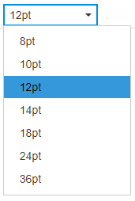
- Clearly written section headings will help all users navigate pages.
- Don’t create section headings by changing font sizes. Use Heading styles
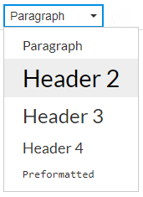
- Canvas makes all page titles ‘Header 1’.
- Use ‘Header 2’ for section headings.
- Use ‘Header 3’ for sub-sections.
- Use ‘Paragraph’ for all other text.
- Make web links descriptive (e.g. ‘Contact us’). Avoid 'click here'.
- Provide alternative text for images which further understanding. You will be prompted when uploading an image in Canvas to provide alternative text:
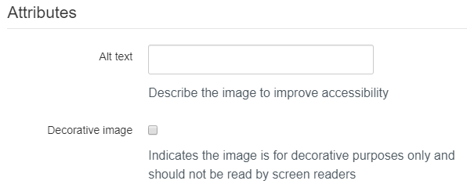
- If your image is ‘decorative’ and provides no additional information, mark it as such.
- Only use coloured text or coloured backgrounds when necessary and never rely on colour to convey meaning.
- For lists (bullet points and numbers) use the inbuilt editor tools.

‘Office File format’ documents uploaded to Canvas

Use in-built document accessibility checkers
- Designing documents to be accessible from the beginning helps to ensure that they can be easily accessed by everyone.
- Providing original versions of documents helps users to re-format the document to best suit their needs.
- PDF documents are not accessible by default.
- If you plan on converting Office documents to PDF run accessibility checks before converting. Any accessible features embedded in the original will be carried across from one format to another.

Microsoft Office Accessibility Check
Office programmes allow you to quickly review your document before sharing. For the versions in widest use across the University:
- Select File > Check for issues > Check accessibility to open the Accessibility Checker and follow the instructions
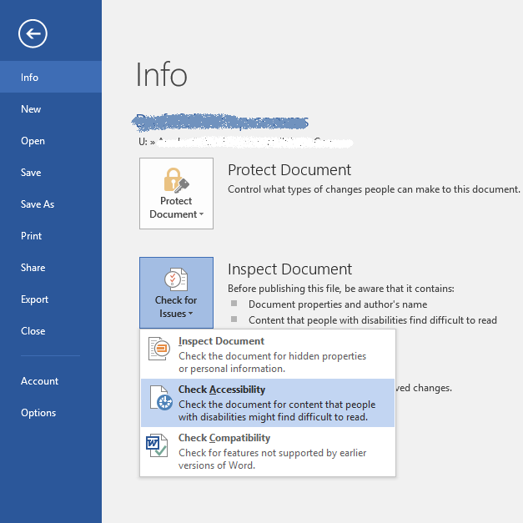

Adobe Acrobat Accessibility Check
- There is no accessibility checker in Acrobat Reader.
- Best practice is to run accessibility checks on your original document before converting to PDF.
Users of Adobe Acrobat Pro (not widely available across the university) can check the accessibility of documents directly when creating pdf documents.
Select Tools > Accessibility to open the Accessibility Checker. Run Full Check > Select Start Checking

Key areas to consider when creating and checking documents:
- Use an accessible ‘sans serif’ font such as Arial, Verdana or Calibri
- Don’t create section headings by changing font sizes. Use Heading styles 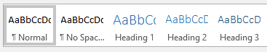
- Clearly written headings will help all users navigate pages.
- Use ‘Heading 1’ for page titles
- Use ‘Heading 2’ for section headings.
- Use ‘Heading 3’ for sub-sections.
- Use ‘Normal’ for all other text.
- Provide alternative text for images.
- Only use coloured text or coloured backgrounds when necessary and never rely on colour to convey meaning. Colour contrast checkers can help check that the text colour can be read on the background colour.
- For lists (bullet points and numbers) use the inbuilt tools.
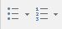
- Avoid text boxes, except when used in PowerPoint. Set the correct reading order for tab control and screen reader access.
- Use understandable file names.

