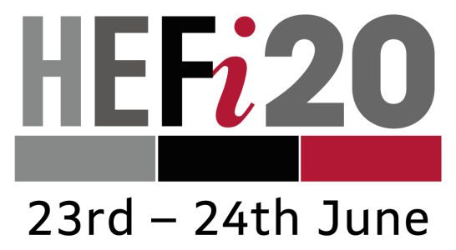

Next Generation University Teaching: New Challenges and New Rewards
University of Birmingham
Session Proposal Form

Proposals should be sent electronically to hefi@contacts.bham.ac.uk by 5pm on 28th February 2020
The call for proposals for HEFi20 is open to internal and external colleagues interested in exploring the challenges and rewards of teaching in a contemporary university. Within the conference theme, we welcome submissions that seek to tackle the following challenges:
- Reclaiming the teaching space. How can we respond to the changing expectations of stakeholders whilst retaining the unique experience of teaching and learning in a higher education context?
- Tackling inequalities. How do we ensure that teaching is optimal for all students and staff?
- Disrupting the curriculum. How can we challenge traditional curriculum structures to support creativity and innovation in teaching and learning?
- Future of the university. How should we position ourselves to ensure that next generation university teaching will meet the challenges of the 4th Industrial Revolution and the lifelong learning agenda?

Name(s)
Department and Institution
Contact email
(lead presenter)
Session title
Session format (select appropriate) | 10 minute Presentation | ☐ | Poster | ☐
Audience this session/poster is relevant to (max. 50 words)
By the end of the session, participants will…
(max. 50 words)
Session/poster abstract
(max. 150 words)

References
Key texts mentioned in the outline, please use the Harvard referencing system
Session audiovisual/other requirements
(Standard lectern PC, projector, network and WiFi will be available)

Higher Education Futures Institute, University of Birmingham
Old Gym Building
Edgbaston; Birmingham B15 2TT
https://www.birmingham.ac.uk/university/hefi/index.aspx

