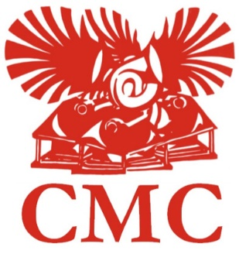
Ways of Reading: An Interactive Magazines Workshop for PGs and ECRs

Application Form

Please complete this form and return to Emma West (e.west@bham.ac.uk)

Name

Career stage (delete as appropriate) | Postgraduate taught  Postgraduate research  Early-career researcher*
Department/discipline

Institution

Email address

Why is the magazines workshop relevant to your research and/or teaching? What are you hoping to gain from the workshop and what will you bring to it?
(250 words)

If successful, which magazine would you like to close read in the morning session? | Please assign numbers in order of preference, with 1 being the magazine you would most like to read and 4 the magazine you would least like to read.  BLAST  Coterie  Form  Rhythm
We hope to make a contribution towards travel expenses, to be claimed after the event. If you wish to claim expenses, please give a rough estimate of travel costs.

*As per the AHRC’s guidelines, we define an early-career researcher as someone within 8 years of finishing their PhD, excluding any career breaks.

