Our Digital Reading Activity
Names:

1. Theme/Perspective

What is the theme of your activity? Some suggested themes/perspectives for your writing are given below. Please tick or add your own idea as appropriate.

Gender
Power
Childhood
Social Class
Setting and Environment
Poverty
Feminist Reading
Marxist reading
Post-colonialism
Time

Other:

2. Writing Task Question

Please write your question below. The question chosen can be suggested by your teacher or decided individually. Here are some examples:

- How does Dickens present Scrooge as an outsider to society?
- Consider how social class and culture is presented in Jane Eyre.

3. Background Statement (up to 200 words)

Please provide a brief paragraph that explains why you have chosen your theme and how it links to what you are studying in English (KS3 class novel, GCSE, A Level NEA etc.).

4. CLiC Analysis Tab(s)
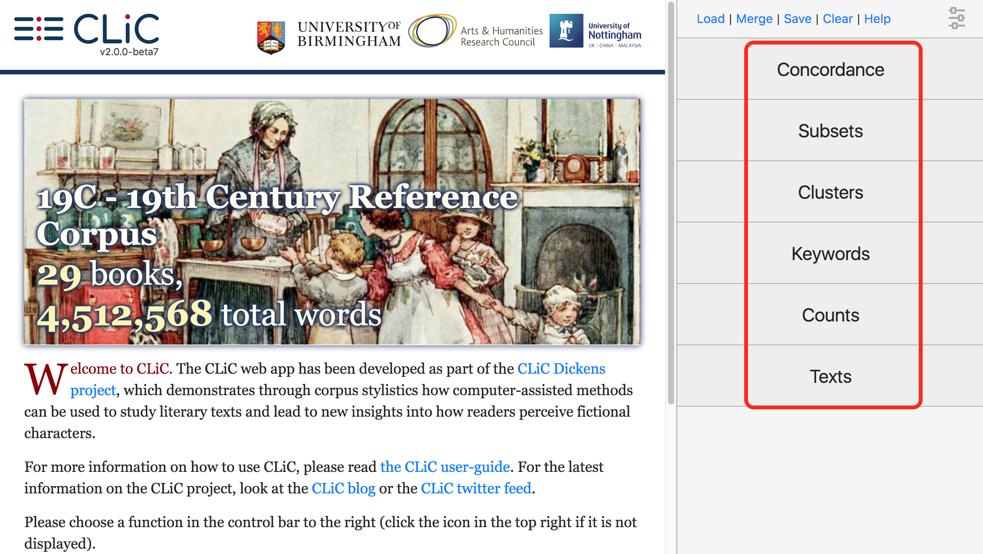
Please choose at least one CLiC tab which your Digital Reading Activity makes use of:

Concordance
Subsets
Clusters
Keywords
Counts
Texts

5. Step-by-Step Instructions (up to 200 words)

Describe how you used CLiC to find the information for your writing. Which tabs did you use and how did they help? It may be useful to support your instructions with screenshots, which you can insert into this Word document. (Please also upload as separate files.) You can find examples of step-by-step instructions in the Activity Competition Guidance Booklet.

6. Key Writing Task (up to 500 words)

Write down the answer to your chosen question below.

7. References

Did you use any other resources such as BBC Bitesize, any reference books or the suggested reading in the CLiC Activity Book? Please provide the sources of any material you used in your research, including images! (Ensure that you only use images for which you have the permission to reproduce them!)

Please hand this form to your teacher to upload to the activity competition online submission system via Birmingham.ac.uk/clic-competition
If you want to participate in the Digital Reading Survey, please go to Birmingham.ac.uk/clic-reading-survey to fill that out first.

