IAA USING LITERATURE FOR DIVERSIFYING AND DECOLONIZING THE SOVIET HISTORY

Supporting materials for teaching and studying A-level History through literature

Narine Abgaryan

Three Apples Fell from the Sky (2020)
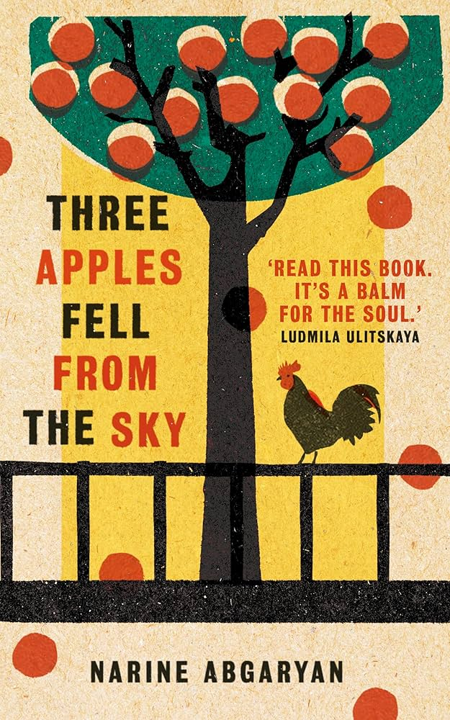

© Cover of Three Apples Fell from the Sky by Narine Abgaryan, https://www.simonandschuster.co.uk/books/Three-Apples-Fell-from-the-Sky/Narine-Abgaryan/9781786077318
Christoper Crowson
University of Birmingham
2025

Suggestions for how to use the materials

Section 1
Material in this section can be linked to the following topic on the AQA A-level History syllabus:
- ‘The consolidation of Bolshevik authority, the ending of involvement in the First World War and Foreign relations and attitudes of foreign powers’.
Use this section to allow pupils to get to grips with the novel and its background/context.
Three Apples Fell from the Sky is loosely based on the tumultuous events that took place in Armenia in the twentieth century, but it is important that pupils understand that it is a fictional work with fictional characters.
This section includes opportunities to:
- reflect on the usefulness of literary representations when studying history.
- engage with authentic materials (a Russian-language map from the Soviet era; Armenian-language propaganda posters)
- understand the historical context of early Soviet Armenia; how Soviet power extended to lesser-known republics such as Armenia; and how the early USSR interacted with neighbouring powers such as Turkey.

Section 2
Material in this section can be linked to the following topic on the AQA A-level History syllabus:
- ‘Economic and social developments during the Bolshevik consolidation, the Red Terror, Lenin’s Russia, ideology and change’.
This section deals with the persecution of the noble classes following the Bolshevik revolution.
Exercises are based on short extracts from Abgaryan’s novel and guide pupils to continue thinking about in what ways literature is a useful resource when studying history and how it differs from more conventional sources of historical information.
This section includes opportunities for pupils to undertake independent research into Armenian history (e.g. link to Britannica article on the medieval kingdom of Cilicia in question 6 – intended for interested pupils to explore in their free time).

Section 3
Material in this section can be linked to the following topic on the AQA A-level History syllabus:
- ‘the impact of the war on the Soviet Union: Operation Barbarossa, the USSR under occupation and the fight-back’.

This section deals with the “Great Patriotic War” (WW2). It looks primarily at the Armenian contribution to the war effort and defence of the Soviet Union, a less-studied aspect of the history of this period. These materials provide an opportunity for pupils to perhaps explore the role which other ‘minor’ nationalities played during the war.
This section collates information from a range of sources and involves a significant amount of reading. Teachers may want to break this section into smaller sections.
This section provides further opportunities for pupils to reflect on the role that literary texts play in the study of history and to get them thinking on whether novels such as Three Apples Fell from the Sky are useful in this regard.

Section 1: ABOUT THE NOVEL – GENERAL CONTEXT

INFORMATION ON THE AUTHOR
Narine Abgaryan is an Armenian novelist, writer and blogger who was born in the town of Berd, Tavush province, in northeastern Soviet Armenia in 1971. She graduated from Yerevan’s Brusov State University of Linguistics with a diploma as a Russian language and literature teacher. In 1993 she moved to Moscow and has lived there ever since. Her novel, Three Apples Fell from the Sky, originally written in Russian, has been translated into 12 languages and won the prestigious Leo Tolstoy Yasnaya Polyana Award in 2018 (Narine Abgaryan, no date).
Question
- Abgaryan has written all her novels in Russian, not just Three Apples Fell from the Sky. Why do you think Abgaryan may have decided to write her novels in Russian despite the fact that she grew up in Armenia with Armenian as her native language?

GENERAL OUTLINE OF THE NOVEL
Three Apples Fell from the Sky is a fictional novel set in the fictional village of Maran. The village’s geography resembles the landscape of northeastern Armenia, the region from which Abgaryan hails.
The tale begins with its protagonist, Anatolia, on her deathbed. Although she has no other intention but to die peacefully, we come to learn that life is far from over for her.
Maran, like other historical Armenian lands, has a history rife with tragedy. Before Anatolia was born, the unknown narrator speaks of a devastating earthquake which tore the village apart. When she is a young girl, a horrific famine grips Maran and kills off much of the village’s population. Later, when she is already an adult, a terrible war begins, eliminating most of the village’s men and boys.
The tragic circumstances that befall Maran reflect the sorrowful events which took place throughout her own life as well. At present, Anatolia is the only surviving member of her family and over the course of the novel we learn that she was the victim of an abusive marriage and her beloved village library, where she worked, was destroyed during the war – what could she possibly have to look forward to in her future?
The novel is split into three parts and an epilogue. All parts are told by the same unnamed narrator.
Although the tale begins and ends with Anatolia’s story and revisits her at certain points in the middle of the novel, the narrator tells the story via a variety of different characters. The story of Maran and its inhabitants are always the focal point of the novel. Moreover, the novel also focuses very heavily on representing Maran’s women and seeing the events which unfold in the village through their eyes.
It is also important to note that other than a couple of references to the Tsarist era and the Bolshevik revolution, there is never any explicit reference to the story being set during the Soviet era. As explained in an article reviewing the novel in the Armenian Mirror-Spectator (a newspaper serving the Armenian diaspora in the USA), “while it is true that a work cannot be disengaged from its historical and social context, one couldn’t say that Three Apples Fell from The Sky is immersed in a specific historical moment” (Sarafian, 2022).
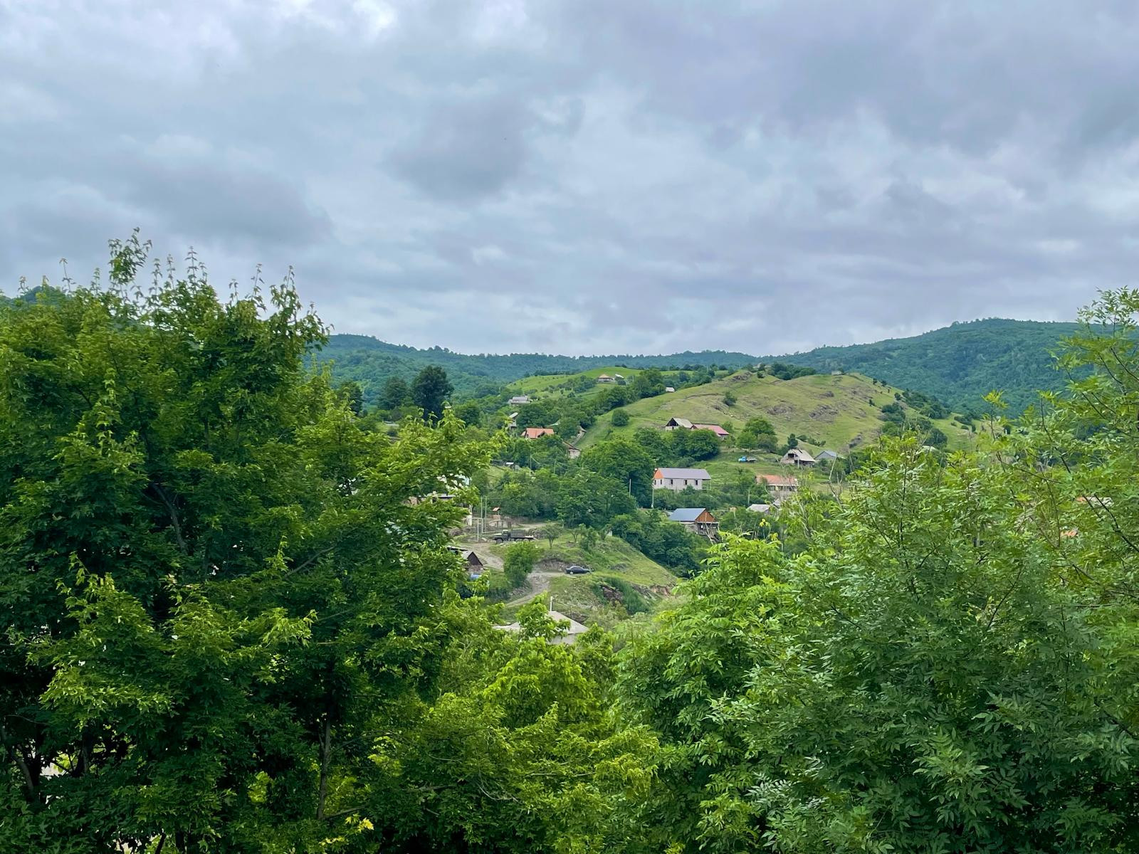
The mountains of northeastern Armenia, the region from where Abgaryan hails and the geographical inspiration of Maran. Christopher Crowson, 2025.
Questions
- Can fiction be a reliable primary source when studying history? Why/why not? If not, what other possible uses might it have for those studying the history of a certain place at a certain time?
- Why do you think the author focuses on multiple characters? Why was it more important for her to focus on the community rather just one individual inhabitant of Maran?
- What are the advantages and disadvantages of using fiction to learn about the Soviet Union and the lives of its citizens? What can fiction do that non-fiction cannot?

Exercise 1: Look at the below map of the Armenian Soviet Socialist Republic and locate the town of Berd (in Russian – Берд) in northeastern Armenia – Abgaryan’s hometown. Then read/watch the extracts that follow to learn more about the period in which Armenia became incorporated into the Soviet Union and complete the timeline exercise that follows.

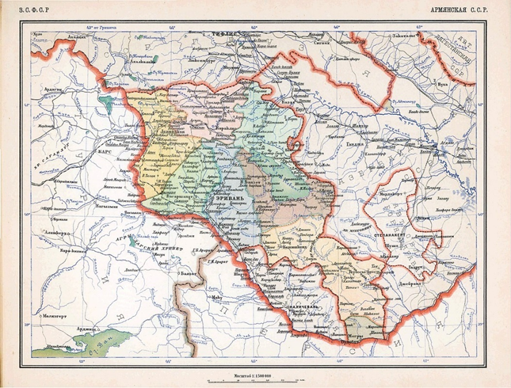

Map of the Armenian Soviet Socialist Republic in Russian (Карта Армянской СССР, 1928)

Extract 1: History of Modern Armenia (https://www.britannica.com/place/Armenia/Modern-Armenia)
“In 1916 the Armenian regions of the Ottoman Empire fell to the Russian army, but in March 1918 the Soviet Union (having succeeded Russia) was forced by the Treaty of Brest-Litovsk to cede all of Ottoman Armenia and part of Russian Armenia to the now moribund Ottoman Empire, though some Armenians continued to hold out against the advancing Ottomans. On April 22, 1918, Armenia, Georgia, and Azerbaijan formed the Transcaucasian Federal Republic, but their basic diversity soon caused them to split into separate republics; Armenia declared independence on May 28. Although short-lived, this Armenian republic was the first independent Armenian state since the Middle Ages. On June 4 Armenia was forced to sign the Treaty of Batum with the Ottoman state, acknowledging the pre-1878 Russo-Turkish frontier along the Arpa and Aras rivers as its boundary, but after the Allied victory in World War I the Armenians reoccupied Alexandropol (now Gyumri) and Kars. A short war ensued with Georgia for the possession of the cities of Borchalu (modern Marneuli, Georgia) and Akhalkʿalakʿi and with Azerbaijan for the Karabakh region; despite temporary military success, these areas were destined to remain outside Armenia. On January 15, 1920, the Allies recognized the de facto existence of the three Transcaucasian republics. U.S. Pres. Woodrow Wilson hoped to persuade the United States to accept a mandate for an independent Armenia, but the Senate refused the responsibility (June 1, 1920). On August 10 Armenia, now recognized de jure, signed the Treaty of Sèvres, by which the Ottomans recognized Armenia as a free and independent state. On November 22 Wilson, as instructed, announced projected boundaries that ceded to Armenia most of the provinces of Erzurum, Trabzon, Van, and Bitlis. Already in the summer of 1919, however, the new Ottoman Turkish government of Ankara, under Mustafa Kemal (Atatürk), had repudiated Constantinople’s treaties with Armenia. In September 1920 the Turks attacked, seizing Kars and Alexandropol by November 7. By the Treaty of Alexandropol on December 2, 1920, Armenia renounced all pre-1914 Turkish territories and Kars and Ardahan, recognized that there were no Armenian minorities in Turkey, and accepted that the region of Nakhichevan should form an autonomous Turkish state.
That same day a new Armenian government at Yerevan, a coalition of communists and Dashnaks, proclaimed Armenia a Soviet republic. The Dashnaks were soon driven from the government, provoking an abortive revolt in February 1921. In March 1922 Armenia joined Georgia and Azerbaijan to form the Transcaucasian Soviet Federated Socialist Republic, which joined the U.S.S.R. on December 30, 1922. Nakhichevan, a largely Muslim region, was awarded to Soviet Azerbaijan, as was Nagorno-Karabakh, an overwhelmingly Armenian district. In 1936 Armenia, Georgia, and Azerbaijan became separate union republics of the Soviet Union.”

Extract 2: The Armenians: From Kings and Priests to Merchants and Commissars, Razmik Panossian (Columbia University Press, 2020).
“The Bolshevik revolution and the withdrawal of the Russian army from the South Caucasus created an imperial power vacuum in the region, including Russian Armenia. Ottoman forces tried to fill this vacuum by advancing on Armenia and hoping to reach Baku (the modern-day capital of Azerbaijan). But the Ottoman empire itself was on the losing side in the First World War and eventually had to cease hostilities short of achieving its aim of occupying eastern Armenia and controlling Azerbaijan. In the subsequent two-year hiatus of imperial power struggles between the Russians and the Ottomans in the South Caucasus, three independent republics emerged in the region between 1918 and 1920: Georgia, Azerbaijan and Armenia… By early 1918 the Russian army had mostly withdrawn from the Ottoman front. Article 4 of the Brest-Litovsk Treaty (signed on 3 March 1918) formalised this arrangement, once again transferring the Armenian-populated regions of Kars and Artahan (as well as Batum) to Turkey. Armenian units fighting alongside the Russian army were to be demobilised, and the pre-1878 border between the two empires was to be the new frontier. Armenians and the other peoples south of the Caucasus were left alone to fend for themselves. On 12 March 1918 Erzerum fell to the Turkish forces, Van followed on 7 April and Kars on 25 April. In this way the battle for Ottoman Armenia came to an end. There remained, however, the struggle for Russian Armenia. In the absence of Russian administration, the political vacuum in the South Caucasus was briefly filled by the Transcaucasian Federative Republic. The regional (non-Bolshevik) Seim (sitting in Tiflis), comprising Georgian, Azerbaijani and Armenian delegates, formally declared its independence on 22 April 1918—much to the chagrin of the Armenians who opposed any kind of formal separation from Russia. But in the end they too had to agree to it in order to have some sort of formal structure that could oppose the Turkish advances. However, the Federation did not have the strength to deal with the Turkish onslaught, nor did it have the internal unity necessary to continue its existence. It fell apart in less than five weeks as Turkish forces crossed the borders agreed at Brest-Litovsk and advanced toward Yerevan, Baku and the southern parts of Georgia. It had become obvious that the Federation was unworkable owing to the fundamentally differing interests of the Georgians, the Azerbaijanis (Tatars) and the Armenians. The Georgians wished to ally with the Germans, the Azerbaijanis with the Ottoman Turks and the Armenians—in the absence of Russia—with the Allied forces led by Britain and France and supported by the United States. Hence the leadership of each of the three peoples decided to follow a separate path. Georgian delegates (mostly Mensheviks) in the Seim proclaimed the independence of their country on 26 May, dissolving the Federation. The following day the Muslim National Council decided to do the same for Azerbaijan (although Baku was still ruled by the Bolsheviks), formally announcing independence on 28 May. With no other choice the Armenian National Council—led by Dashnaks —had to declare the independence of Armenia as well (in Tiflis!). Thus on 28 May 1918 the ‘inglorious birth’ of an independent Armenia took place, ‘a mangled bit of land that, for a lack of a better term, [was] called a republic’. It did not even comprise all the territories on the Russian side of the 1828 Ottoman-Russian frontier (let alone of the 1878 border)—lands west of Yerevan, the city of Alexandropol (Leninakan/Gyumri) and the north-south railroad (Alexandropol-Julfa), remained under Turkish occupation” (pp. 242-243).
“By late 1920 Communist Russia was eager to assert its influence on all three South Caucasian republics. Soviet representative to Armenia, Boris Legran, was insisting that Armenia accept Soviet rule (Azerbaijan was Sovietised on 27–8 April 1920).Meanwhile Turkish forces—now reorganised under Mustafa Kemal (Ataturk)—once again were on the attack to subdue Armenia and to expand the frontiers of Turkey eastwards; on 6 November Alexandropol had fallen again to the Turkish 15th army corps (commanded by General Kiazim Karabekir) and Yerevan was under threat. Moreover, Kemalists and the Moscow government were engaged in friendly negotiations while the Soviets supported (in arms and gold) Kemal’s ‘national liberation’ struggle against Western encroachment in Turkey (viz.in opposition to the Sèvres Treaty of 10 August 1920). Finally Western powers, which had promised much to Armenia, were nowhere to be seen. Given these circumstances Armenia was caught, in the words of Simon Vratsian, the last Prime Minister of the independent republic, between the ‘Bolshevik hammer and the Turkish anvil’. On 2 December 1920 the Dashnak-led government resigned and Armenia was declared an ‘independent socialist republic’. On 4 December the Communist Military Revolutionary Committee of Armenia assumed power and on 6 December Red Army units entered Yerevan. Henceforth, in its policies and structures Armenia was further integrated into the Russian Soviet Federated Socialist Republic (RSFSR), particularly in the second half of 1921. On 12 March 1922 it became part of the Federative Union of Soviet Socialist Republics of Transcaucasia. This in turn became a single federated republic on 13 December 1922. Two weeks later the Transcaucasian Federal Socialist Republic entered the USSR as one of its seven constituent republics when the latter was established on 30 December 1922. After a short break of two-and-a-half years Armenia was once again under the firm control of much larger imperial powers” (p.245).
“Armenia was Sovietised in December 1920. It joined the USSR as a constituent part of the Transcaucasian Federal Soviet Socialist Republic at the Soviet Union’s inception in December 1922. The December 1936 Constitution of the USSR granted Armenia the status of a separate Soviet Socialist Republic—the smallest of the then 11, later 15, Union republics” (p.266).

Extract 3: The Sovietisation of Armenia (video)
https://www.youtube.com/watch?v=RHj-hao3aI8&ab_channel=ImperatorArmenator
https://www.youtube.com/watch?v=nmO6JQZcZmI&ab_channel=ImperatorArmenator

Task: The events listed below have been jumbled up into random order. Based on what you have read and watched, place them into the correct order to create a timeline of the period. For each event, write down briefly how the event was significant to the formation of Soviet Armenia.
- Formation of the Transcaucasian Federated Socialist Republic
- Treaty of Sèvres
- Treaty of Brest-Litovsk
- Armenian Genocide
- Proclamation of Armenia as a Soviet Republic
- World War One
- Treaty of Alexandropol
- Reestablishment of the Armenian Soviet Republic
- October Revolution
- Creation of the First Armenian Republic

Question for discussion: Does learning about Armenia, which would eventually become the USSR’s smallest Republic, and how it was incorporated into the USSR change what we understand about the early years of the Soviet Union?

Exercise 2:

Abgaryan’s novel foregrounds the lives of women in Maran. Read the texts below and look at how women are represented on the political posters from early Soviet Armenia provided. What do you learn from these resources about the lives of women in Soviet Armenia?

Resource #1: Exploring the Legacy of Soviet Armenia:
Interview with great aunt who lived through Soviet period: https://tiss.aua.am/2021/02/09/exploring-the-legacy-of-soviet-armenia-2/

Resource #2: Women’s rights in Armenia, Social Watch Website
“During the Soviet Era equal rights for men and women in work, educational, social and economic life were declared, the State guaranteed free and obligatory school education, free and accessible University Education, free and accessible medical services, paid 24 days’ vacation, allowances, prenatal and post-natal vacation etc. In 1920 the right to abortion was legalized and medical care in this field guaranteed.
Despite these advances women in Soviet Armenia carried a double load and faced structural discrimination.
Although the Armenian Constitution states that men and women are equal, strong mechanisms to bring this about in the daily life of Armenian society were non-existent.”
https://www.socialwatch.org/node/11600#:~:text=During%20the%20Soviet%20Era%20equal,the%20most%20fundamental%20human%20rights.

Resource #3: Gender equality: history must be honoured, Social Watch Website
“In spite of this apparent progress, women in Soviet Armenia had to carry a double burden and suffered structural discrimination. Women worked outside and also inside the home, cooking and cleaning, doing the laundry and obtaining food on the way to or from work. This double burden was made heavier in the absence of infrastructure support and lack of technology, which ensured these daily tasks were more time-consuming than necessary.
During this time no women held a top position in the power hierarchy, in either the Government or Parliament. Moreover, although it was stated that women and men had to be paid equally, in fact women were employed in all the low-paid jobs.”
https://www.socialwatch.org/es/node/12059#:~:text=In%20spite%20of%20this%20apparent,day%2Dto%2Dday%20life.

Resource #4: Soviet posters
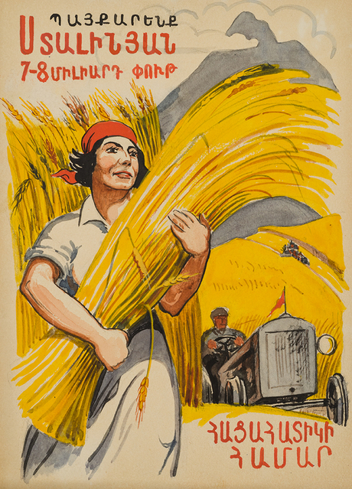

“Let’s fight for 7-8 billion poods of Stalin’s grain”. Pre-WW2 Soviet Armenian political poster shows a woman as a central figure in the USSR’s drive for grain during the intensive collectivisation and industrialisation period (Պայքկարենք Սնալինյան 7-8 միլիարդ փուդ հացահատիկի համար, no date).
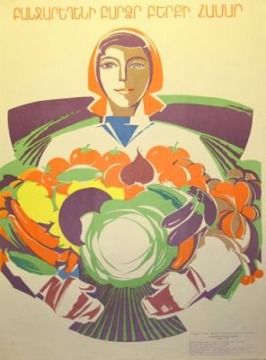

“For a high vegetable harvest”. Again, this Soviet Armenian poster shows a woman at the centre of agricultural production. What does this tell us about the place of women in Soviet Armenian society? (բամջարեղենի բարձր բերքի համար, no date).

Creative task: Imagine that you are a Soviet Armenian woman living in a rural area such as Maran and that you are writing a letter to a family member who lives in the Armenia’s capital, Yerevan. What are your daily activities/concerns? How does life compare to the men in the village? Are you grateful for the arrival of Soviet power in Armenia?
You may want to refer particularly to Resource 1, Exploring the Legacy of Soviet Armenia, where the writer interviews her great aunt, who grew up in rural Soviet Armenia.

Section 2: PERSECUTION OF THE ARMENIAN NOBLE CLASS FOLLOWING THE BOLSHEVIK TAKEOVER

Read these passages from Narine Abgaryan’s Three Apples Fell from the Sky and answer the questions that follow.

“[Vano’s] mother was a sister of Arshakbek, who had been forced to flee the new regime that overthrew the tsar at the beginning of the last century. Her grandfather, Levon-bek, descended from the eastern branch of the noble line of the Lusignans, and was always proud to bring up his distant ancestor, Levon the sixth Lusignan, who was the last king of Cilicia, a knight of the Order of the Sword, and the seneschal of Jerusalem” (p.130).
“She suffered tremendously from being separated from her brother, who was forced to escape the new regime… She wasn’t persecuted but she was cautious, never again appearing at the family’s estate, which by that time had been looted and nationalised, and she took the portrait of her crowned ancestor from the wall and stored it away in the attic, irately rejecting her husband’s proposal of burning it in a bonfire to be safe.
‘I’m not going to destroy my only memory of my grandfather,’ she said….” (p.131)
“Vano’s mother took her husband’s surname in order to cover her tracks definitively and not let her noble origins make the new regime nervous. This was an unprecedented occurrence in Maran since local young women did not change their surnames when they married, remaining an integral part of their own kin rather than renouncing them. The villagers piously kept Vano’s mother’s real surname a secret but among themselves they called her husband ‘Melikants-son-in-law’, since melik means ‘prince’” (pp.132).

Questions
- Based on the description of Vano’s mother’s and Arshakbek’s lineage, why do you think Arshakbek “had been forced to flee the new regime that overthrew the tsar”?
- What do these extracts help you to understand about the personal impact that the revolution and its ensuing persecutions had on the new citizens of the Soviet Union?
- The Armenian Kingdom of Cilicia (Little Armenia) was an Armenian kingdom located in Southern Anatolia (southeastern Turkey on a modern map) in the Medieval period and Levon the sixth Lusignan was a real ruler of the kingdom. Read more here if interested. Along with the mention of the overthrow of the Tsar and the persecution of the noble classes, this is another example of Abgaryan blending fact with fiction in her novel. Why do you think the author adds some historical references if the novel is otherwise based on fictional characters in a fictional place?

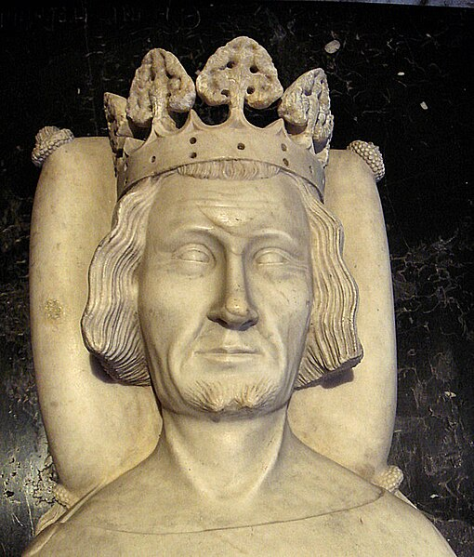
A bust of Levon the sixth Lusignan, the final king of the Armenian Kingdom of Cilicia, at his final resting place of the Basilica of Saint-Denis, Paris, France (PHGCOM, 2007).

Exercise 1: Below you will find extracts from an article which discusses the persecution of the nobility in the former Russian empire following the Bolshevik revolution.
Read the extract and compare it with the above extracts from Three Apples Fell from the Sky and prepare to discuss the following questions:
- How does the novel differ from historical accounts detailing the persecution of the former noble class in the Soviet Union?
- What do we learn from the novel that we don’t usually learn from historical accounts?
- Can literary representations complement historical accounts when trying to understand the history of a certain place at a certain time?

Michael Scammell, “The Russian Nobility Under the Red Terror,” New York Review (March 7, 2013)
“About a year after the start of the revolution, the Soviet official Grigory Zinoviev announced that as part of a campaign of class warfare being launched against “counterrevolutionaries,” 10 percent of Russia’s population (ten million people) would have to be annihilated. “Do not look in the file of incriminating evidence to see whether or not the accused rose up against the Soviets with arms or words,” said Martin Latsis, his colleague and boss in the Cheka: “Ask him instead to which class he belongs, what is his background, his education, his profession. These are the questions that will determine the fate of the accused. That is the meaning and essence of the Red Terror.” This chilling expression of class warfare in its purest form took a heavy toll on the nobility, though a considerable number of the ten million survived the Red Terror (and the many persecutions that followed in later years) and stayed on, either by sheer luck or by keeping a low profile and either resisting the temptation to emigrate or not having the means to do so.”
“[The nobility’s] first great ordeal came in the aftermath of the revolution itself, when revolutionary forces invaded the palaces of the nobility and terrorized their families with murder, rape, and violence, while confiscating huge quantities of money, paintings, and furniture. Enraged peasants, whipped into a frenzy by the Bolsheviks, ran riot in the nobility’s country mansions, also looting and raping, and, according to Smith, making a beeline for their lavishly stocked wine cellars. A grim paragraph [in Douglas Smith’s nonfiction history book Former People: The Final Days of the Russian Aristocracy] about the Obolensky family sums up the results for the worst-hit of the victims:
“Prince Vladimir Obolensky was killed at his estate in early 1918; later that year his older brother Alexander was shot at the Fortress of Peter and Paul in Petrograd. Prince Mikhail Obolensky was beaten to death by a mob at a railroad station in February 1918. Prince Pavel Obolensky, a cornet in the Hussars, was shot by the Bolsheviks in June 1918 and left for dead…. Princess Yelena Obolensky was killed at her estate in November 1918; her dead body was burned along with her manor house. Many more Obolenskys suffered similar horrific fates; they included seven members of the family who perished in Stalin’s prisons years later.”

Creative task: Following the Soviet takeover of Armenia, Vano’s mother had to be ‘cautious’ and never again appear at her family’s estate. She also went against societal conventions, taking on her husband’s last name after marriage. Imagine you are a member of the Armenian noble class around the time following the Soviet takeover of Armenia, what actions may you have to take to ensure safety from persecution from the new government? Write a letter to a family member abroad detailing what you have had to do following the arrival of Bolshevik power in Armenia.

Section 3: ARMENIA AND THE GREAT PATRIOTIC WAR

In the following extracts from Three Apples Fell From the Sky, we can see inexplicit references to the Second World War (or the Great Patriotic War [Великая отечественная война], as it is known in Russia and some other post-Soviet states, including Armenia).

“Tigran went to a military academy after high school and rose to a senior rank by the age of twenty-five. He had been planning to marry, but the war started so he didn’t get around to it and then the regiment he commanded was surrounded and there was no news at all from Tigran for eight long years. Valinka cried her eyes out and prayed every hour of every day, wearing down the threshold at the old chapel; Vano had serious problems with his veins, and his feet ached and burned, but the old man endured without saying anything… Valinka knitted sweaters and patterned socks to send to the front, placing in each anonymous package a peacock and a tiny figure of the Holy Mother of God that Vano had carved. The packages had no return address, so they went off and didn’t return the way other correspondence came back to Maran homes in lieu of death notices.
Vano remembered right down to the last detail the spring of the year the war had ended, just as clearly and completely as he recalled the day Tigran was born… By some wonder, despite not walking at all and barely being able to hold up his head during his last winter, the peacock had made his way to the kitchen, where he was scratching his beak at the door in an attempt to open it, and calling for help. Vano picked him up and went out on the veranda at the very same moment the gate opened, letting his grandson, who was skinny and scar-riddled but very much alive, into the yard. The peacock died that same evening, in Tigran’s arms, during his story of how he had been surrounded, how he had miraculously escaped from captivity and spent that entire time as a partisan in the woods, and how his leg had been wounded and his thigh had to be cauterised without anaesthesia so an infection wouldn’t spread, and how there was a deep, ugly scar that had frozen a muscle and didn’t allow him to bend his leg fully. In the middle of his grandson’s story, Vano distinctly sensed light breathing from up high and then the heavens themselves descended down below the mountains, opened the windows wide, swept into the house, intertwined their hands to form a cradle, and placed the tsar bird’s sparkling soul inside before soaring upward, leaving behind the light aroma of cinnamon and almond, and something else elusive and incomprehensible but eternally beautiful.” (pp.139-140)
“[Tigran] became both the only man from Maran to return from war alive and the last of the young to leave the village of old people” (p. 141).

Although WWII is not referenced explicitly here, we can assume that Abgaryan does indeed allude to this war for the following reasons:
- The Second World War/Great Patriotic War plays an important role in Armenian collective memory.
The Great Patriotic War, or Հայրենական Մեծ պատերազմ (Hayrenakan Mets paterazm) in Armenian, began 22 June 1941 when Nazi Germany launched Operation Barbarossa and invaded the Soviet Union. It is important to note here that the Soviets were only dragged into the Second World War almost two years after it had begun in the rest of Europe when Germany invaded Poland and Great Britain declared war on Germany (September 1 and 3, 1939, respectively).
Although the war on the Eastern Front within Soviet territory almost exclusively took place in the westernmost regions of the Soviet Union (the Baltic states, Belarus, Ukraine and Western Russia), the distant Armenian Republic made a significant contribution to the Soviet war effort. Every fifth resident of the Armenian Soviet Socialist Republic went to the front and Armenian troops, who fought in all branches of the Soviet Armed forces, participated in all major battles and operations in the war against Nazi Germany (Every fifth resident of the Republic of Armenia went to the front ..., 2020). Out of the 300,000 troops who went to fight from the Armenian SSR, 200,000 were killed, meaning that 14% of the Republic’s total population of approximately 1.3 million citizens was lost in the war (Shakarian, 2022). This is comparable to the proportion of the total population which was killed in Russia and Ukraine at 13% and 16% respectively, despite being front-line Republics unlike Armenia (2022). Therefore, in a tale about life in the Armenian SSR, it is likely that the “war” in question is the Great Patriotic War.
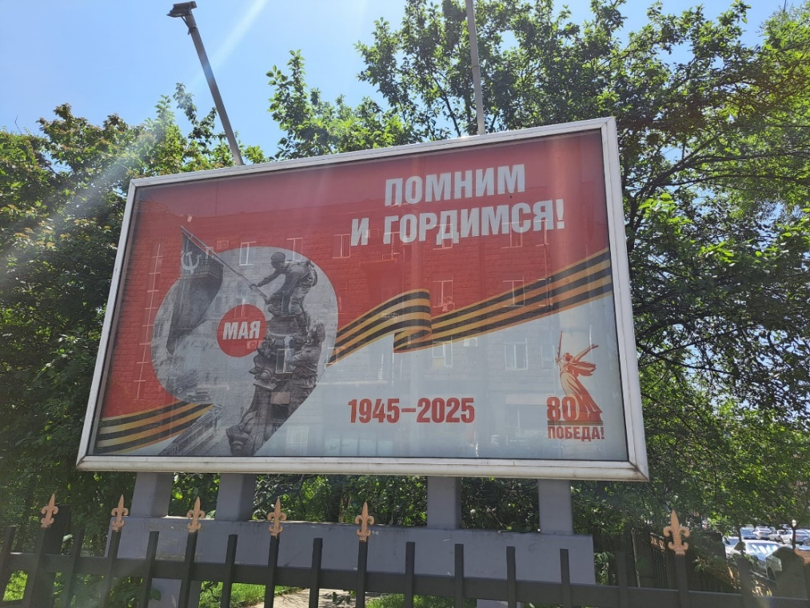

A billboard in Yerevan in May 2025 commemorating 80 years since the defeat of Nazi Germany. Interestingly, even 35 years after Armenian independence, the billboard reads ‘We remember and we are proud!’ in the Russian language.

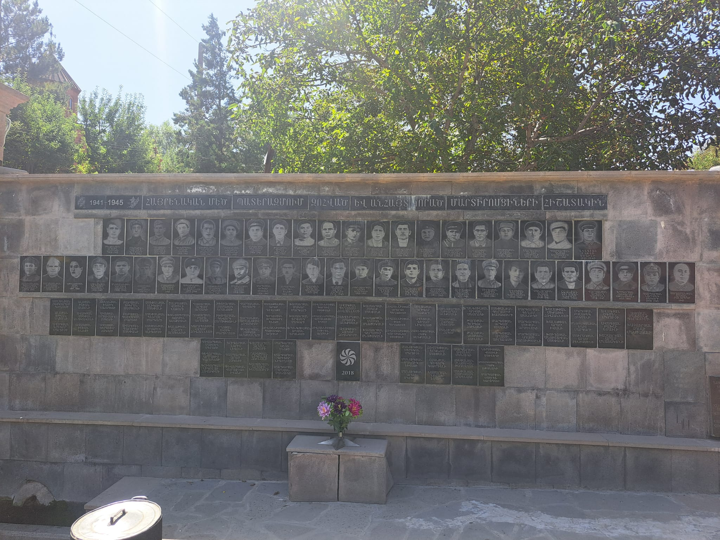

A memorial to the men who fell during World War Two in the remote mountain village of Martiros, Vayots Dzor province, Armenia. It reads “In commemoration of those from Martiros who were sacrificed and went missing in the Great Patriotic War” in the Armenian language. As the village’s population was just 1876 in 1939, one could say the war claimed the lives of an entire generation. Martiros is by far not the only Armenian village to have sacrificed so many of its young men.

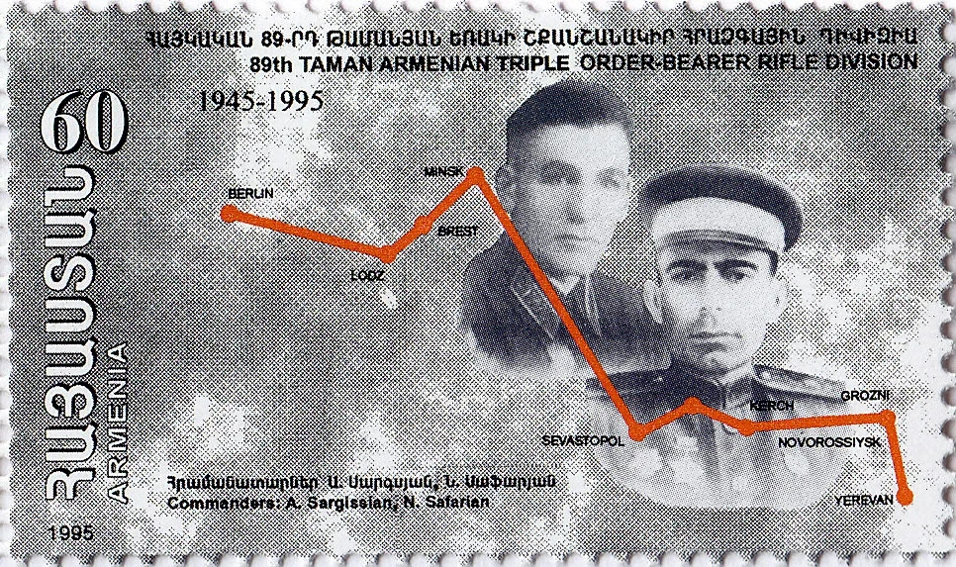
A stamp from the newly independent Republic of Armenia commemorating 50 years since the end of the Great Patriotic War. The stamp pays tribute to the 89th Taman Rifle Division, a Soviet unit predominately made up of ethnic Armenians who participated in several major battles on the Eastern front. Featured are notable commanders Andranik Sargissian and Never Safarian (“Every fifth resident of the Republic of Armenia went to the front…”, 2020).
After being formed in Yerevan in December 1941, the Taman Division fought from the foothills of the Caucasus all the way to Berlin. They were even one of the first Soviet units to storm and seize the German Reichstag, a former parliamentary building that was of extreme symbolic value to Stalin. Watch this short video recounting the legendary division’s participation in the battle of Berlin and their performance of the Քոչարի (Kochari), a traditional Armenian folk dance, outside the Reichstag upon hearing news of the final victory over Nazi Germany (“Every fifth resident of the Republic of Armenia went to the front...”, 2020).

- It is implied that Tigran is fighting on a cold, far-away front
Tigran’s grandmother, Valinka, “knitted sweaters and patterned socks to send to the front, placing in each anonymous package a peacock and a tiny figure of the Holy Mother of God that Vano had carved.” The fact that Valinka is sending packages filled with warm clothing to her grandson suggests that he is off fighting on a distant front in a cold climate. Indeed, as mentioned earlier, most of the fighting on the Eastern Front took place far away from the borders of the Armenian Republic and many of its most significant battles (Moscow, Stalingrad, Kharkiv) occurred during the notoriously harsh winters which are common to Western Russia, Belarus and Ukraine.
The closest the Germans got to the borders of the Armenian SSR was in 1942 during the Caucasus campaign, named after the mountain chain which dominates Southern Russia, Georgia and parts of Azerbaijan. Intending to ultimately capture the vast oil fields of Baku in the Azerbaijani SSR and deliver a decisive blow to the Soviet war effort, Hitler launched operation Eidelweiss in July 1942. Despite initial success, the offensive eventually ground to a halt due to ferocious Soviet resistance, the unforgiving mountainous terrain and logistical issues. The German advance stopped November 2, 1942, 5 miles outside of Ordshonikidze (modern day Vladikavkaz); about 150 miles from the northern border of the Armenian SSR, thereby marking the furthest point to the southeast reached by the German military and closest the Eastern Front got to Armenian territory. November 4 all German offensives in the region were suspended and the Soviets succeeded in continually pushing German forces further and further out of the southern regions of the Russian Soviet Federative Socialist Republic (Chen, 2012). As a result, if Tigran was a Red Army soldier as it is supposed, he would indeed be fighting away on a distant front.
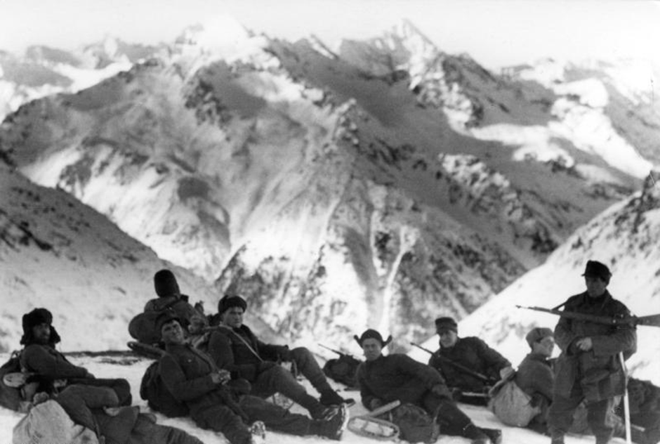
German Gebirgsjäger (mountain troops) resting in the mountains of the North Caucasus, Russia, December 1942 (Poetsch, 1942).
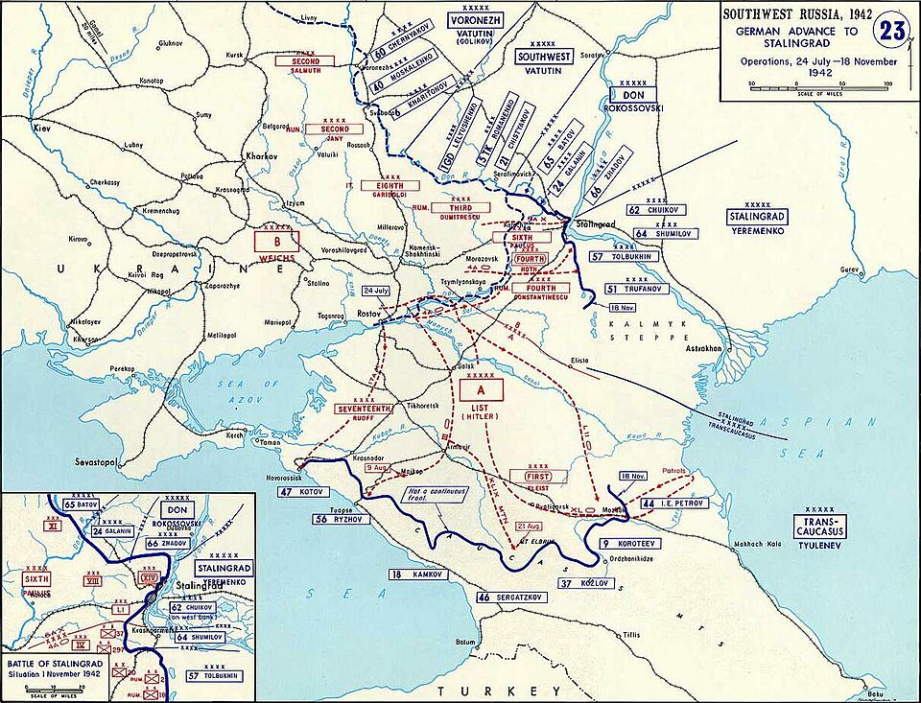
German gains in southern Russia and the Caucasus region of the USSR in the latter half of 1942. German forces made it no further than the southern Russian city of Ordshonikidze, still hundreds of miles from the Armenian SSR (WW2 Map 23 July 1942 November 1942, 2023).

If you are interested in learning more about the Caucasus campaign and introducing yourself to some Russian language media, watch this documentary from Starmedia, a Russian language media company that releases historical documentaries on Youtube. Turn on subtitles in English with the closed captions tool.
https://www.youtube.com/watch?v=3f_P5HpW8vY&ab_channel=StarMediaEN

- During the war, Tigran “had had been surrounded… miraculously escaped from captivity and spent that entire time as a partisan in the woods”
The Great Purge of 1936-1938, a period of mass repression in the Soviet Union in which many top Soviet military leaders and high-ranking officers were eliminated, was certainly a contributing factor to the Red Army’s initial failures following Operation Barbarossa.
Read here to get more information on the Great Purge: https://www.britannica.com/event/Great-Purge
Soviet forces performed very poorly at the outset of the Great Patriotic War. They suffered monstrous defeats at the hands of the Germans and within the first five months of the war, the Soviets had lost an astonishing 4.5 million men (Kirchubel, 2013, 96). To put this figure into perspective, the total number of British troops who were killed throughout the entirety of the war stands at 380,000 (The Fallen, no date).
Read here to find out more about Operation Barbarossa: https://www.britannica.com/event/Operation-Barbarossa
As a result of the Soviet’s poor preparation, in the first months of the war, it was not uncommon for German forces to overwhelm their Soviet counterparts, sometimes capturing entire army groups in mass encirclements. Some of the most major encirclements from this stage of the war include the Battle of Bialystok-Minsk (330,000 captured), the Battle of Smolensk (340,000 captured) the Battle of Kiev (665,000 captured) (Citino, 2021). Given the frequency of such operations and the sheer number of troops taken prisoner, one could imagine that Tigran was among those who were captured towards the beginning of the war.

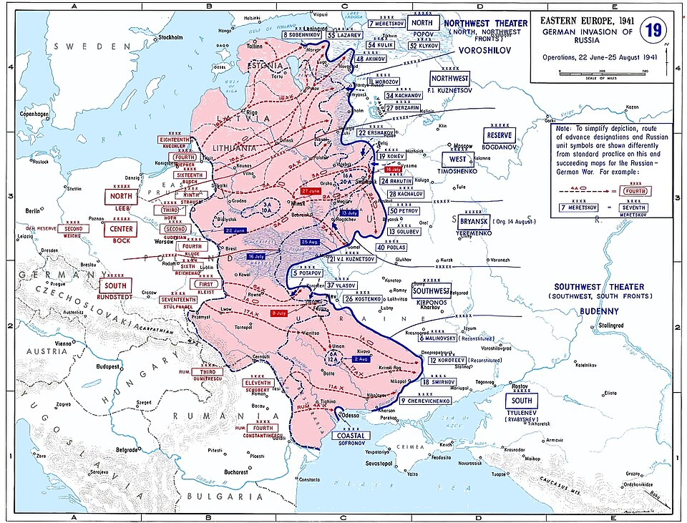
This map shows German advances into the USSR from the start of Barbarossa (22 June) to 25 August 1941. Kiev is yet to be conquered, however, within it a month most of its Soviet defenders will have been surrounded and taken prisoner in what was the largest encirclement of troops in all history (Invasion 1941, no date).

The Soviet Partisan War was a major aspect of the war on the Eastern Front. Red Army troops who escaped encirclement or German captivity like Tigran, as well as ordinary peasants and workers joined the ranks of the партизаны (Russian for partisans/resistance fighters) to harass German forces from behind the front line. Employing guerilla tactics, partisan units made use of the vast swamps and forests of Belarus and western Russia as a base from which they would launch ambushes and assaults (Von Geldern, no date). As the notion of fighting as a “partisan in the woods” is heavily embedded in the Soviet collective memory of the Great Patriotic War, it is safe to assume that Tigran was indeed a Red Army soldier.

Иди и смотри, Come and See
Click the link to watch the world-renowned Soviet film from 1985 entitled Иди и смотри (Come and See). This brutal anti-war film follows a young Belarusian lad who joins the partisans during the Nazi occupation of the Belarusian SSR.
Content warning: This film is very graphic in places, so viewer discretion is advised.
https://www.youtube.com/watch?v=zjIiApN6cfg&t=671s&ab_channel=Mosfilm

The Novel’s confusing chronology
Despite this evidence supporting the idea that Tigran fought in the Great Patriotic War, the seemingly ever-shifting chronology of the novel’s storyline, as well as other pieces of contradictory information make it more difficult to definitively conclude that this is the case.
Earlier in the novel there is mention of a war whose action came very close to the village.
“First, vague news started coming from the valley about fire exchanged on the eastern borders… Judging from urgent reports about battles, what was happening on the borders – first the eastern, then the southwestern – was unspeakably awful…” (p.43)
“And then war came to the valley. It swept in like a fanged whirlwind that pulled buildings and people into its horrendous maelstrom. The only road leading to Maran, which snaked along the slope of Manish-kar, was covered in ruts, the vestiges of mortar shelling. The village was plunged into pitch-black darkness, hunger, and cold for long years. Bombing broke off electrical power lines and knocked out windowpanes so people had to stretch plastic film over the frames because there was nowhere to buy new glass. And what was the point of putting it in anyway if the next shelling would inevitably turn it into a pile of shards? The bombing became particularly merciless during the sowing season, intentionally not allowing work in the fields; meagre harvests from kitchen gardens didn’t last long. The forest teemed with enemy scouts who spared nobody, not even women or the elderly, and there was nowhere to find firewood to heat the stove and at least shake off the excruciating cold. People first had to use wooden fence pickets as kindling, then attic roofs and sheds, and they later began taking apart verandas… The Maranians had grown long accustomed to the shelling thus paid it no attention when they went about their endless list of daily tasks” (p.45)

As we saw above, the Great Patriotic war took place hundreds of miles to the north of the Armenian SSR, not to its eastern nor southwestern borders. During the Great Patriotic War, Armenian villagers in the Armenian SSR would not have had to worry about windowpanes being knocked out from enemy shelling or the forest teeming with merciless enemy scouts.
These descriptions of war are more reminiscent of the battles which would have taken place during the Caucasus campaign of the First World War (1914-18) or the ensuing Turkish-Armenian War (1920) or Armenian-Azerbaijani War (1918-20), in which historic Armenian lands were embroiled in conflict.
Read here to learn more about the Caucasus front in World War One, where the Russian empire clashed with the Ottomans.
https://encyclopedia.1914-1918-online.net/article/caucasus-front-1-2/

Read this fascinating article to understand more about Armenia’s conflicts with Azerbaijan and Turkey as well as Britain’s important but little-known role in Armenian politics and diplomacy just after the end of the First World War.
https://historyreclaimed.co.uk/from-ararat-to-albion-the-interwoven-histories-of-britain-and-armenia-1918-20/

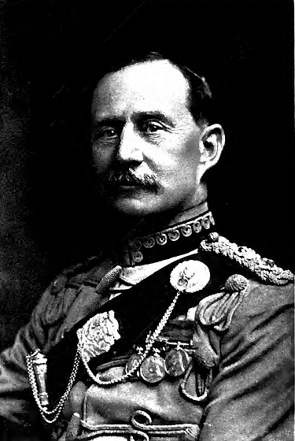

Major-General Lionel Charles Dunsterville. Leader of the so-called 'Dunsterforce' who fought alongside Armenian troops in the battle of Baku against Ottoman and Azerbaijani forces in 1918 (LC Dunstervile, 1920).

For the reader, there is confusion in the timeline as the narrator does not make any distinction between these wars. Abgaryan simply refers to both of these events as “the war”. Moreover, both these wars appear to have lasted for a total of eight years, leading us to believe that they are indeed the same war.
“For eight long, unbearable years, the war reaped a harvest of restless souls around the world, but one day it sputtered out and retreated, howling and limping and licking its bloody paws. There still wasn’t enough fuel, but little by little life began turning itself around and reverted to its normal course, albeit painfully slowly. Those changes didn’t touch Maran, though, since for some reason nobody had any intention whatsoever of remembering the village” (p.51)
“The regiment he commanded was surrounded and there was no news at all from Tigran for eight long years” (p.139)

Although it is true that the latter quote does not necessarily mean that the war lasted eight years but perhaps only the time when Tigran was demobilised from the Soviet Army, the lack of distinction between these wars may lead the reader to believe that it was indeed one and the same war. To make matters more confusing, towards the end of the novel, when Tigran is now a father and is living “up north” (most likely Russia) with his “northern wife” (most likely Russian), Nastasya, they have this interaction with a fellow Maranian when on holiday in Maran:
“Mukuch Nemetsants, a grey-haired, brown-eyed old man of gigantic height embraced Tigran and then extended a hand to her.
‘Hello, my dear,’ he said.
‘Why do they call you Nemetsants?’ Nastasya asked, squeezing his withered hand.
‘Because my grandfather came back from the world war with a German bride, and we call German nemets here, like they do in Russia, and so, well, they started calling us Nemetsants in my grandmother’s memory…
‘My great-grandfather fought in that war too, you know, and he also came back with a German wife,’ she said” (p.180).
Nastasya, who is most likely from Russia and Mukuch, an Armenian speak about their grandfathers fighting in “the world war” and bringing back German wives, therefore, suggesting that they were Red Army soldiers in the Great Patriotic War. However, if we remember from earlier, Tigran “had been surrounded” and became a “partisan in the woods” on a cold, distant front, thereby suggesting that Tigran was also a soldier of the Great Patriotic War, meaning that he and Nastasya’s great-grandfather would have fought in the same war…
It goes without saying that the chronology of events in the novel truly are confusing and the timeline of events extremely blurred. Even after serious analysis, the reader cannot be sure of the specific historical period in which certain events take place.
Therefore, although it is evidently useful to try and pin down the exact historical period in which the novel is set when trying to understand the history of Armenia and Armenians in the USSR, when it comes to analysing the storyline of Three Apples Fell from the Sky, as we have seen above, trying to tie every event in the novel with a specific episode in history merely leads to confusion and questioning of its historicity.
However, it is important to keep in mind the author’s intentions for the novel. On one hand, it is true that Three Apples Fell from the Sky is a historical novel which tries to capture the atmosphere of an Armenian village during the tumultuous twentieth century. On the other hand, one must remember that the places and people in the book are almost entirely fictional and that there is an enormous emphasis on with “community, courage and the irresistible joy of everyday friendship” rather than explicitly telling the history of the Armenian SSR.
Let’s look back some of the extracts we have already examined and find some quotes which demonstrate to us how the book is useful when trying to understand life in the Armenian SSR.
“Tigran went to a military academy after high school and rose to a senior rank by the age of twenty-five. He had been planning to marry, but the war started so he didn’t get around to it and then the regiment he commanded was surrounded and there was no news at all from Tigran for eight long years. Valinka cried her eyes out and prayed every hour of every day, wearing down the threshold at the old chapel; Vano had serious problems with his veins, and his feet ached and burned, but the old man endured without saying anything” (p.139)
“One day [the war] sputtered out and retreated, howling and limping and licking its bloody paws. There still wasn’t enough fuel, but little by little life began turning itself around and reverted to its normal course, albeit painfully slowly. Those changes didn’t touch Maran, though, since for some reason nobody had any intention whatsoever of remembering the village” (p.51).

Questions:
- What impact does the confusing chronology/timeline have on the historicity of the novel? Does it render the novel completely useless as a resource when studying Soviet history or does it require a change in perspective?
- What is included in these extracts above that would not be found in history books and why can it be useful for us, historians, to analyse such materials when trying to understand the history of a certain place?
- What kind of life did the average villager in the Armenian SSR lead? From the above extracts, try to imagine what was important to them, whether they led a hard or an easy life, and to what extent external influences (such as war) had an impact on life in the village. Pretend that you are a Maranian and that you are writing a letter to a family member who lives in a different town in Armenian SSR during wartime. How do you occupy your days, who do you spend your time with and how is the war impacting your daily life.

“Little by little life began turning itself around and reverted to its normal course, albeit painfully slowly. Those changes didn’t touch Maran, though, since for some reason nobody had any intention whatsoever of remembering the village” (p.51).
This quote captures the essence of the novel well. Maran, the fictional village in the Armenian highlands, inhabited by fictional characters could be perceived as a portrait of one of the many remote Armenian mountain villages which existed in Soviet Armenia, on the periphery of the Soviet empire. Despite the changes brought about by Soviet power and wars being waged near and far, life continued to trundle on for ordinary people in these ordinary villages. Although it is interesting to try and tie certain moments in the novel to specific historical events, the occurrence of major historical events and the decisions made by history’s big players are secondary in the novel. Instead, it is the individual portraits of history’s forgotten voices which stand out here. Monumental events, such as changes in regime or world wars, seem to blur into one distant memory for the Maranians. This gives the reader the impression that Maran has been untouched by the passage of time and that even the impressive might of Soviet central power could not exert a profound enough influence on general life in the village. Community life is what is most important to the Maranians, and thus what is important to the narrator. This is what makes Abgaryan’s novel so powerful and useful; Three Apples Fell from the Sky gives the reader unique access to a world which would normally be closed off. Through this tale, we are given unique insight into the lives of forgotten people in a forgotten village on the periphery of the Soviet Union’s territory. By reading such novels, we obtain an idea of what life was like in such settlements and learn that the villagers, just like us, have hopes, fears and superstitions, despite living in a completely different place during a completely different time.
Questions
- When studying history, we often focus on groups of people (nations, political parties, religions, social classes, etc.) or prominent individuals (kings, presidents, clergymen, writers etc.). We very rarely consider the histories of ordinary individuals. What is the value in learning about ordinary individuals from history?
- Draw a table and list how it useful to consider i) groups of people, ii) prominent individuals from history and iii) ordinary individuals when studying history. If you believe there is no use in considering any of the above, justify your reason in a brief paragraph.

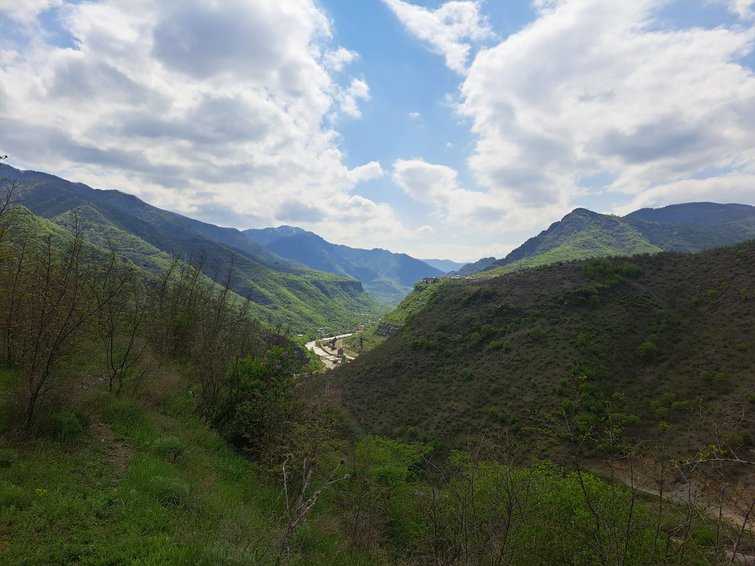

The Alaverdi region of northeastern Armenia – mountainous, rural and almost untouched by the course of time and the region's ever-shifting geopolitics.

Dashnaks – an abbreviation of Hay Heghapokhakan Dashnaktsutyun (Հայ Յեղափոխական Դաշնակցութիւն) or the Armenian Revolutionary Federation (ARF). The ARF is a political party which was founded in Tiflis (modern-day Tbilisi, Georgia) in the Russian empire in 1890. Its members sought to obtain ‘political and economic freedom in Ottoman Armenia through rebellion. It soon emerged as the leading revolutionary-political party for the Armenian people.
The Seim – the name of the Transcaucasian Federative Republic’s parliament.

