IAA USING LITERATURE FOR DIVERSIFYING AND DECOLONIZING THE SOVIET HISTORY

Supporting materials for teaching and studying A-level History

Svetlana Alexievich

The Unwomanly Face of War (1985) | Second-Hand Time (2013) | Boys in Zinc (1991)

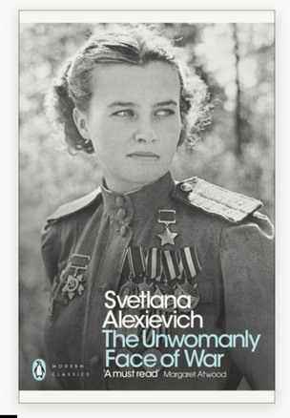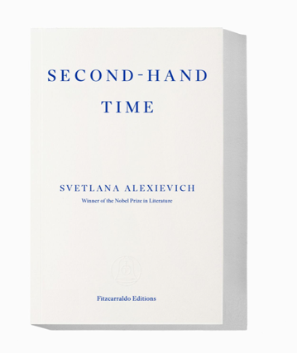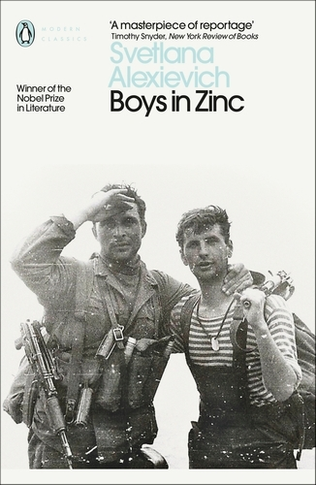

© A screenshot of The Unwomanly Face of War book cover by Svetlana Alexievich, https://www.penguin.co.uk/books/295606/the-unwomanly-face-of-war-by-alexievich-svetlana/9780141983530

© A screenshot of the Second-Hand Time book cover by Svetlana Alexievich, https://fitzcarraldoeditions.com/books/second-hand-time/

© A screenshot of the Boys in Zinc book cover by Svetlana Alexievich, https://www.penguin.co.uk/books/295485/boys-in-zinc-by-alexievich-svetlana/9780241264119

Dr Olga Kenton
University of Birmingham
2025

These supporting materials are designed to enrich A-level students’ understanding of history and critical thinking using creative nonfiction literature and historical resources. They provide educators and students with innovative approaches to engage with historical content dynamically and interactively.

Topics included:

- Oral history
- Genres that intersect with oral history
- Personal testimonies as historical document
- Role and approaches of historians and writers in collecting people’s own stories
- “Big history” vs “little history”
- Second World War (1939-1945)
- Great Patriotic War (1941-1945)
- Molotov-Ribbentrop Pact
- Stalin’s Era
- Stalin’s repressions (Great Purge)
- Civilians in wartime
- Women’s Roles in the Soviet Military during the Second World War
- Soviet communal apartments
- Khrushchev Era
- Khrushchyovkas
- Gorbachev Era
- Perestroika
- Homo Sovieticus
- Soviet Identity
- Soviet Afghan War (1979-1989)
- Svetlana Alexievich

About the author

Svetlana Alexievich

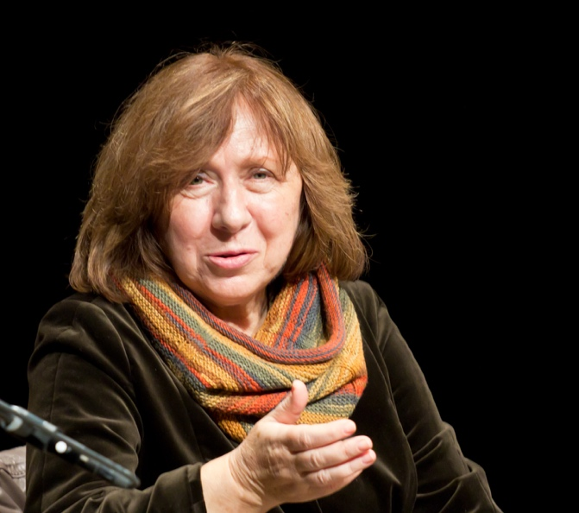

Source: Elke Wetzig, “Swetlana Alexijewitsch 2013,” Wikipedia.org., 14 October 2013, www.en.wikipedia.org/wiki/Svetlana_Alexievich#/media/File:Swetlana_Alexijewitsch_2013.jpg, CC BY-SA 3.0

Svetlana Alexievich was born in Ivano-Frankivsk (formerly, Stanyslaviv – See the map below) in 1948 and has spent most of her life in the Soviet Union and present-day Belarus, with prolonged periods of exile in Western Europe. Starting out as a journalist, she developed her own non-fiction genre which brings together a chorus of voices to describe a specific historical moment. Her works include The Unwomanly Face of War (1985), Last Witnesses (1985), Boys in Zinc (1991), Chernobyl Prayer (1997) and Second-hand Time (2013). She has won many international awards, including the 2015 Nobel Prize in Literature for ‘her polyphonic writings, a monument to suffering and courage in our time’.

Source : “Svetlana Alexievich,” FitzcarraldoEditions.com, n.d., https://fitzcarraldoeditions.com/authors/svetlana-alexievich/

[1]

- Study the map provided below and see if you can find Ivano-Frankivsk on it.
- In which country is it located now?

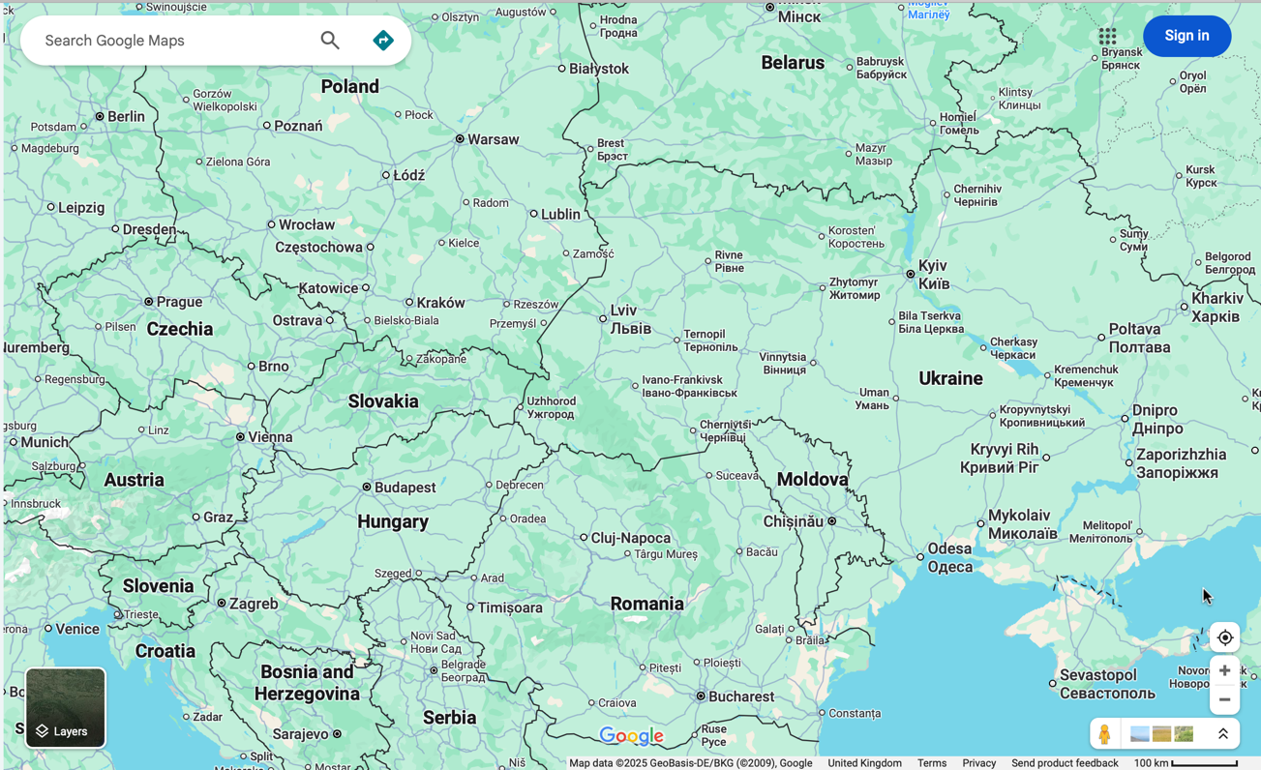

Image 1. A screenshot of Google Maps page. Google Maps, August 21, 2025, https://www.google.com/maps/@48.911802,23.8560726,6z?entry=ttu&g_ep=EgoyMDI1MDgxOS4wIKXMDSoASAFQAw%3D%3D

[2]

Polyphonic writing (Polyphony in literature)

The term ‘polyphony’ was borrowed from musical terminology. In music, polyphony is ‘a synchronous interaction and development within the work of several independent melodic lines or voices’ (DeVoto). However, in literature, polyphony is described as a feature of narrative texts in which more than one voice can be heard, or to put it simply ‘many-voiced’ (Aczel).

Further, you will find various extracts from books by Svetlana Alexievich. When you read them, try to pay attention to the multiple voices in the texts and consider why it was important for the author to present her works in this way.

You might find that the section ‘About the Book’ helps you better understand the concept of multiple voices.

Sources:
DeVoto, Mark. “Polyphony,” Encyclopedia Britannica, accessed 21 August 2025), https://www.britannica.com/art/polyphony-music.

Aczel, Richard. “Polyphony,” in Routledge Encyclopedia of Narrative Theory, (London: Routledge, Taylor & Francis Group, 2010), ProQuest Ebook Central, accessed 21 August 2025, https://www.proquest.com/encyclopedias-reference-works/polyphony/docview/2137930846/se-2

Discussion before the reading.

Below, there is a list of question to discuss before you proceed with reading extracts from Svetlana Alexievich’s books. You might also find that Glossary helps you understand some unfamiliar terms.

- What is history?
- What is oral history?
- What do you know about genres such as literary journalism, life writing, ethnographic narratives, and creative nonfiction?
- What do you know about genres such as documentary fiction or document novel? How are they related to genres such as literary journalism or ethnographic narratives?
- From history perspective, could such genres (literary journalism, creative nonfiction, documentary fiction) be considered a reliable source?
- To what extent can personal testimonies be considered valid historical sources?
- What are advantages and disadvantages working with personal testimonies?
- What do we need to consider when reading creative nonfiction or documentary fiction?
- How might combining multiple voices in a single book impact our understanding?
- How does oral history intersect with life writing, literary journalism, and other genres mentioned above?

About the book

Second-Hand Time
by Svetlana Alexievich, translated by Bela Shayevich

© A screenshot of the Second-Hand Time book cover by Svetlana Alexievich, https://fitzcarraldoeditions.com/books/second-hand-time/

Second-hand Time is the latest work from Svetlana Alexievich. Here she brings together the voices of dozens of witnesses to the collapse of the USSR in a formidable attempt to chart the disappearance of a culture and to surmise what new kind of man may emerge from the rubble. Fashioning a singular, polyphonic literary form by combining extended individual monologues with a collage of voices, Alexievich creates a magnificent requiem to a civilization in ruins, a brilliant, poignant and unique portrait of post-Soviet society out of the stories of ordinary women and men.

Source: Fitzcarraldo Editions, “Second-hand Time,” Fitzcarraldo Editions.com, n.d., https://fitzcarraldoeditions.com/books/second-hand-time/

Book Review:

Nobel Prize–winning (2015) Russian writer Alexievich (Voices from Chernobyl, 2005, etc.) presents a rich kaleidoscope of voices from all regions of the former Soviet Union who reveal through long tortuous monologues what living under communism really was like. For a new generation of Russians born after World War II, the era of Mikhail Gorbachev, perestroika and glasnost, the attempted putsch of the government, collapse of the Soviet Union, and subsequent economic crises of the 1990s under Boris Yeltsin heralded a sense of freedom and new possibility, yet many Russians were left disillusioned and angry. What was socialism now supposed to mean for the former Homo sovieticus, now derogatively called a sovok ("dustbin") [sic – dustpan]?

Source: “Secondhand Time. The Last of the Soviets,” Kirkus Reviews, 15 April 2016, https://www.kirkusreviews.com/book-reviews/svetlana-alexievich/secondhand-time/

Svetlana Alexievich on history and writing:

“History’s sole concern is the facts; emotions are outside of its realm of interest … But I look at the world as a writer, and not strictly an historian. I am fascinated by people.”

Source: Bela Shayevich, “Svetlana Alexievich builds individual voices into a mighty chorus,” The Guardian, 8 October 2015, https://www.theguardian.com/books/booksblog/2015/oct/08/svetlana-alexievich-builds-individual-voices-into-a-mighty-chorus

Questions for discussion:

- Svetlana Alexievich uses the stylistic method of combining multiple voices across all her books (they are also known as Voices of Utopia). In your opinion, how does this “kaleidoscope of voices” impact our understanding?
- Svetlana Alexievich says, ‘I look at the world as a writer, and not strictly an historian’. In your opinion, how do historians and writers view history and the world? What is the difference between writing about events as a writer and as a historian?

Exercise 1

Topics: Stalin’s repressions (Great Purge), civilians in wartime.

Task: Read the extract from Second-Hand Time provided and complete the activities suggested below the text.

THE STORY OF A CHILDHOOD Maria Voiteshonok, writer, 57 years old

I’m an osadnik. I was born to an exiled Polish osadnik officer (‘osadnik’ is Polish for ‘settler’. They received land in the Eastern Borderlands* after the Polish-Soviet war of 1921). Then, in 1939, in accordance with a secret protocol in the Molotov-Ribbentrop Pact, Western Belarus became part of the USSR and thousands of osadnik colonists and their families were resettled to Siberia for being ‘dangerous political elements’ (as specified in a note from Beria to Stalin). But this is Big History. I have my own little history… […]

I don’t know when my birthday is… or even what year I was born… With me, everything is approximate. I never found any documents. I exist, but I don’t. I don’t remember anything, but I remember everything. I think my mother was pregnant with me when they were leaving. Why do I think that? Because train whistles always upset me… and the smell of railway sleepers… […]

The Altai Krai. The town of Zmeinogorsk, on the banks of the Zmeyevka River… The exiles were unloaded outside of town. Next to the lake. We moved into the dirt. Into mud huts. I was born underground, and it’s where I grew up. The soil has always smelled like home to me. Water’s dripping from the ceiling – a clump of dirt falls down and bounces toward me. That’s a frog. But I was little, I didn’t know that you were supposed to be afraid of these things. I slept with two little goats on a warm spread of goat droppings… My first word was ‘b-a-a-a’… The first sound I made, instead of ‘ma’… or ‘mama.’ My older sister Vladya recalled how surprised I was when I learned that goats don’t speak like we do. I was confused, I thought they were our equals. […] In winter, we’d go dormant like the trees, hibernating from hunger.

[…] In the evenings, I would see the blackened people marching. Black clothes, black faces. They were exiles coming home from the mines…[…] I can’t remember anything about the winter… In winter, I would never leave our mud hut. Day was the same as night. Nothing but twilight. Not a single spot of colour… Did we own anything other than bowls and spoons? No clothes… For clothes, we would wrap ourselves in rags. Not a single spot of colour. Shoes… What did we have by way of shoes? Galoshes, I remember galoshes… I had galoshes, too, they were big and old, like Mama’s. They had probably been hers… I got my first coat in the orphanage, as well as my first pair of mittens. A little hat.

When I was in the orphanage… In the orphanage, they kept osadnik orphans until the age of fourteen, then they would send them off to work in the mines. By the time they were eighteen, they’d all have tuberculosis… just like Vladya… That was our destiny. Vladya told me that somewhere far away, we had a home. But it was very far away. Aunt Marylya was still out there, our mother’s sister… an illiterate peasant. She went around asking about us. Strangers wrote letters on her behalf. I still can’t understand it… How? How did she do it? A notice came to the orphanage to send me and my sister to such and such an address. To Belarus.

*The Eastern Borderlands or the Eastern Kres, from the Polish word for ‘border’, refers to the territory covered by present-day Western Ukraine, Belarus, and Latvia, which were a part of Poland in the interwar years (1918–1939).

(555 words)

Source: Alexievich, Svetlana. Second-Hand Time. Translated by Bela Shayevich. London: Fitzcarraldo Editions, 2016.

Questions for discussion:

- Maria Voiteshonok says, ‘But this is Big History. I have my own little history…’.
  - What is the distinction between “big history” and “one’s own little history”?
  - What makes history?
  - You might have read about different types of literature genres, and about Second-Hand Time, which is considered creative nonfiction (a collection of personal testimonies – See Glossary). What role do literature and personal testimonies play in our understanding of history?
  - Do personal testimonies (such as Maria’s) offer a different type of truth compared to the “big history”?

- Research the Molotov-Ribbentrop Pact, using Encyclopedia Britannica or other reliable sources. What was the Molotov-Ribbentrop Pact? Compare how the information is framed in the Britannica and in Maria Voiteshonok’s testimony.

Molotov-Ribbentrop Pact: https://www.britannica.com/event/German-Soviet-Nonaggression-Pact

- What does Maria Voiteshonok’s story reveal about the treatment of orphans (particularly, the impact of Stalin’s policies on children of “dangerous political elements”) in the USSR?

- Consider Maria Voiteshonok’s perspective: can this source be seen as reliable as historical evidence? List three details from the text that make it useful as historical evidence and three details that make it less useful.

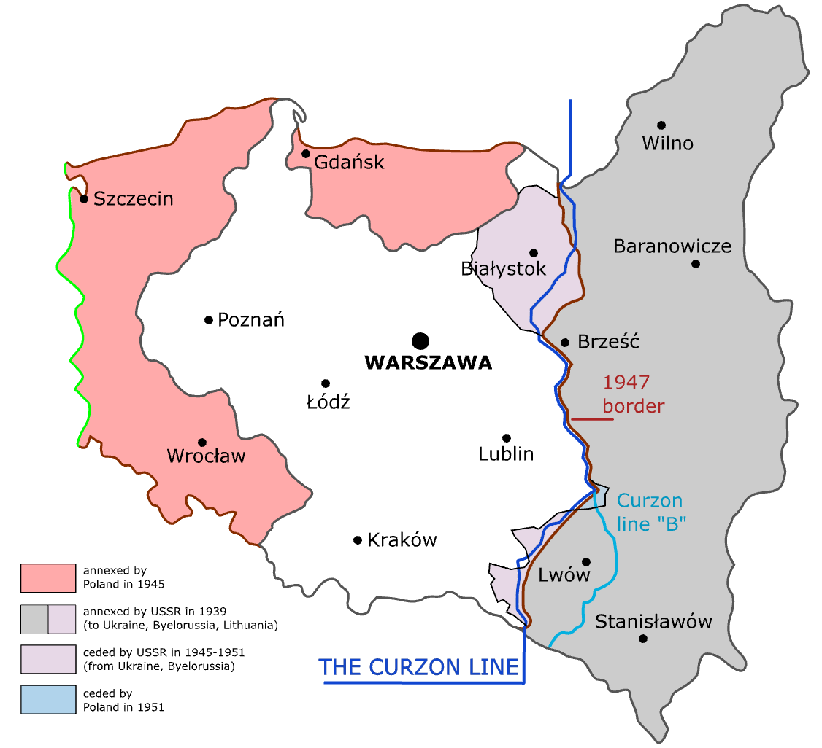

Image 1.1 A map presenting Poland and the Curzon Line (WWII).

Source: Radek.s. “A map presenting Poland and the Curzon Line (World War II). Version with English labels.” Wikimedia Commons, 2007, https://commons.wikimedia.org/wiki/File:Curzon_line_en.svg , CC BY-SA 3.0.

Activity 1: The map above (Image 1.1) demonstrates Curzon Line.

The Curzon Line is a part of “big history”. Maria Voiteshonok’s story is a part of “little history”, of an individual living through these political events and changes of borders.

Using the historical map and information from Maria Voiteshonok’s personal testimony, trace the place where she was born (if it is impossible, explain why, referencing the source).

According to Maria Voiteshonok’s story, where did she return to from Siberia? Label it on the map.

Curzon line: https://www.britannica.com/event/Curzon-Line

Activity 2: Using Google maps (https://www.google.com/maps), or the map provided below (Image 1.2), trace Maria’s family relocation from Western Belarus to Altai Krai.

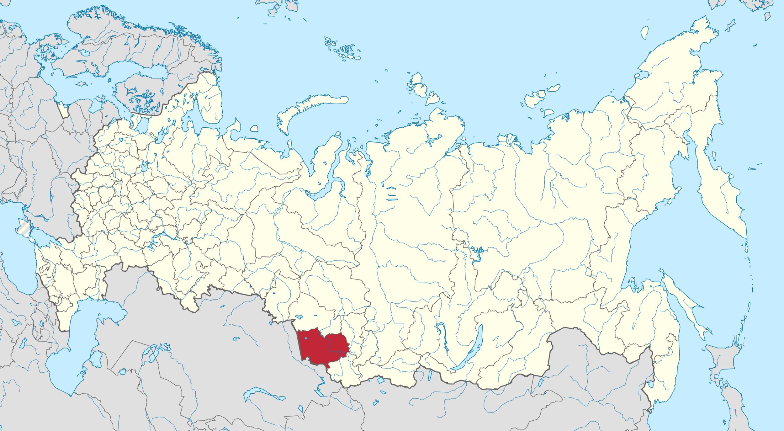
Altai region

Image 1.2 Map of Russia (2014-2022) – Altai Region.

Source: ‘Map of Russia (2014-2022) – Altai Krai.’ Wikimedia Commons, April 21, 2015, https://en.wikipedia.org/wiki/Altai_Krai#/media/File:Map_of_Russia_(2014–2022)_-_Altai_Krai_(Crimea_disputed).svg

Activity 3: Below, there are the photos collected from various online sources. While they are not from Svetlana Alexievich’s book, they help visualise the lives of people in exile.

Look at the photos provided below and write captions for them.

- To what extent can photographs be considered reliable historical sources?
- What needs to be considered when reviewing these photos?

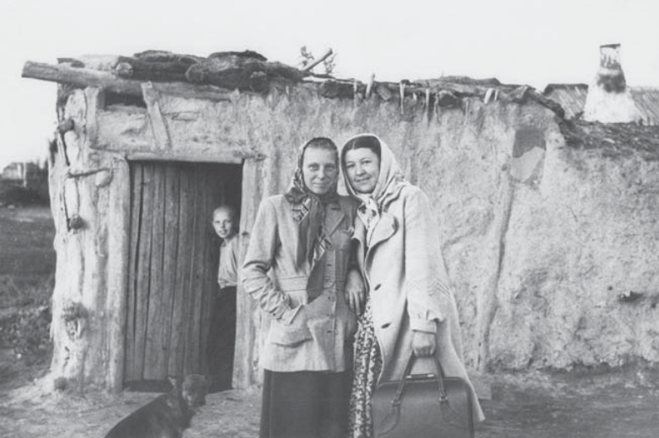

Image 1.3 Deported Estonians standing in front of a hut built of clay and manure.

Source: Rahi-Tamm, Aigi. ‘March Deportation. Arrival: “Slave Market” and First Lodgings.’ CommunistCrimes.org. March 31, 2021, https://communistcrimes.org/en/march-deportation-arrival-slave-market-and-first-lodgings

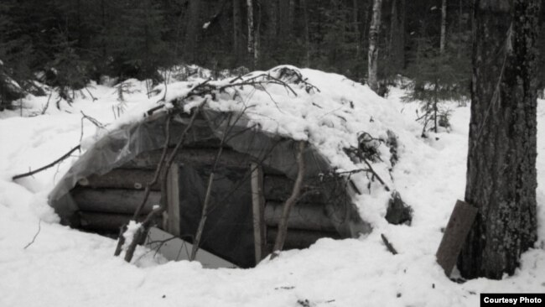

Image 1.4 A mud hut (dugout) where the exiles lived. Western Siberia.

Source: Filimonov Andrey. ‘"The Bolsheviks Took Everything Away from Me." Julius Wolfengaut's Steep Route.’ Sibreal.org. June 26, 2022 https://www.sibreal.org/a/krutoy-marshrut-yuliusa-volfengauta/31249946.html

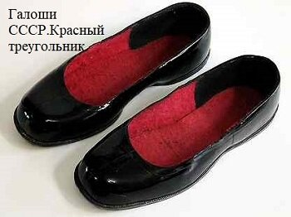

Image 1.5. Galoshes by Red Triangle Manufacturing.

Source: ‘Galoshes of former communists,’ Past and Present. Dzen.ru, July 16, 2021, https://dzen.ru/a/YPGZBrSZ0RypyEDg

Creative task: Create a visual timeline showing Maria’s life stages, linking them to Soviet policies such as the Molotov-Ribbentrop Pact, the deportation of osadniks, forced labour in Siberia.
To summarise: How does Maria’s story change your understanding of Molotov-Ribbentrop Pact? (What impact this document had on population?)

About the book

The Unwomanly Face of War
by Svetlana Alexievich, translated by Richard Pevear and Larissa Volokhonsky

© A screenshot of The Unwomanly Face of War book cover by Svetlana Alexievich, https://www.penguin.co.uk/books/295606/the-unwomanly-face-of-war-by-alexievich-svetlana/9780141983530

“Why, having stood up for and held their own place in a once absolutely male world, have women not stood up for their history? A whole world is hidden from us. Their war remains unknown... I want to write the history of that war. A women's history."
In the late 1970s, Svetlana Alexievich set out to write her first book, The Unwomanly Face of War, when she realized that she grew up surrounded by women who had fought in the Second World War but whose stories were absent from official narratives. Travelling thousands of miles, she spent years interviewing hundreds of Soviet women - captains, tank drivers, snipers, pilots, nurses and doctors - who had experienced the war on the front lines, on the home front and in occupied territories.
With the dawn of Perestroika, a heavily censored edition came out in 1985 and it became a huge bestseller in the Soviet Union.

Source: “The Unwomanly Face of War,” Penguin, n.d., https://www.penguin.co.uk/books/295606/the-unwomanly-face-of-war-by-alexievich-svetlana/9780141983530

Book Review:

This is a tough read, both emotionally and intellectually. But it would be hard to find a book that feels more important or original. There’s a visceral anger in Alexievich’s introduction that’s rare in any history book. Her message is: these stories deserve to be heard. But she doesn’t want us to forget either that for many years, no one bothered to hear them. Worse, they were suppressed.

The women themselves – as well as the men they fought with and those to whom they returned – worried that they would not portray “the Great Victory” as they should in their accounts. These are the discrepancies and miniature horrors Alexievich most wants to capture: “But ‘small details’ are what is most important for me, the warmth and vividness of life: a lock left on the forehead once the braid is cut; the hot kettles of kasha and soup, which no one eats, because out of a hundred persons only seven came back from battle; or how after the war they could not go to market and look at the rows of red meat.”

Alexievich presents this as oral history: fragments of conversation that are not always rooted in specific events and don’t carry the dates of battles next to them. This is an incredibly powerful way of bringing history to life. These women spoke to her as friends and treated her more as confessor than journalist and historian. The bravery of the women is often matched only by their belief in the Soviet project (love for Stalin is frequently mentioned, as often as fear of the Germans). It feels like a product of its time, not just in terms of their stories, but in terms of how they have remembered them. (The stories were gathered between 1978 and 2004.)

Source: Groskop, Viv. “The Unwomanly Face of War by Svetlana Alexievich review – ‘a monument to courage’.” The Guardian, 23 July 2017, https://www.theguardian.com/books/2017/jul/23/unwomanly-face-of-war-svetlana-alexievich-monument-to-courage-soviet-women-war

The Unwomanly Face of War on BBC Radio:

4-5: https://youtu.be/iSUK6LcFvZQ?si=HXpqBMtTfxXsoTnp
5-5: https://youtu.be/WGQjCWzr3bM?si=-8co0bpmCHT17Qa3

Questions for discussion:

- In the book’s review above, underline words that suggest the difference between this text and a ‘typical’ history book.

- In Exercise 1, you discussed the distinction between “big history” and “little history.” Drawing on previous discussions and your knowledge, why do you think the stories of Soviet women who participated in the Great Patriotic War (WWII) were initially unheard and then suppressed? In your opinion, why would the Soviet state want to show “big history” and suppress “little history” regarding the Great Patriotic War (WWII)?

- In the book’s review, underline the words that Alexievich refers to as “small details”. Can they be considered valuable historical evidence?

Exercise 2

Topic: Women’s Roles in the Soviet Military during the Second World War.

Task: Read the testimony of Alexandra Semyonovna Masakovskaya and the extract from the official report “On the mood of soldiers of the Stalingrad Front units,” dated 4 November 1942. Compare the testimony with the official document given below.

[1]

Alexandra Semyonovna Masakovskaya,
Private, Cook

I didn’t shoot … I cooked kasha* for the soldiers. They gave me a medal for that. I don’t even remember about it: did I ever fight? I cooked kasha, soup for the soldiers. I carried cauldrons, pails. Very heavy … I remember our commander used to say, “I’d shoot all these pails … How are you going to give birth after the war?” And once he up and shot at all those pails. We had to find smaller ones in some village. The soldiers would come back from the front line for some rest. The poor things were all filthy, exhausted, their hands and feet frostbitten. The Uzbeks and Tajiks were especially afraid of frost. In their parts it’s always sunny, and here we had minus twenty to minus forty. The man couldn’t get warm, I had to feed him, he couldn’t bring the spoon to his mouth.

*kasha – porridge (Russian).

(149 words)

Source: Alexievich, Svetlana. The Unwomanly Face of War. Translated by Richard Pevear and Larissa Volokhonsky, London: Penguin Random House, 2018.

Questions for discussion:

- What does Masakovskaya’s account reveal about role and perception of women in the Soviet Army?
- What challenges did women in non-combat roles face?

[2]
From the memorandum of the Special Department of the NKVD of the Stalingrad Front to the Special Department of the NKVD of the USSR and the Political Directorate of the Stalingrad Front: “On the Mood of Servicemen of Units of the Stalingrad Front, Based on VTs Materials” (4 November 1942).
Note: “VTs” refers to Military censorship.
[…] Many soldiers in their letters complain about poor nutrition. From the 1st to the 15th of October this year, 35 typical statements regarding poor food provisions have been recorded from servicemen of the 82nd Army alone.
As such, a soldier from the 1st Separate Rifle Battalion writes to his relative:
“...Aunt Lyuba, I’m asking you to come and bring me something to eat. Honestly, I feel awkward asking, but hunger is forcing me…”
A soldier from the farm platoon of UVSR-225 [military construction works department] writes to his wife:
“...Dear wife, we’re stationed in the forest and eating whatever comes to hand. Green pumpkin is the best food we have… Right now, I’d gladly eat a burnt crust and some homemade pohlyobka [broth]…”
Private Kurnaev of the 3rd Company, Unit No. 346, writes to his son in the city of Bukhara:
“...We haven’t been given any food for six days. We’ve been digging up potatoes from gardens and surviving on that…”
Due to poor nutrition and unsanitary conditions in some frontline units, various illnesses are spreading, as servicemen also report in their letters to relatives.
A serviceman from Unit No. 346, Chelushev, writes to his wife in Ivanovo Oblast:
“...I’m suffering from dysentery. The food is coarse and insufficient, and we receive no sugar or tobacco. If this continues, an epidemic will be unavoidable. We already have lice – the first breeding ground of infection…”
A soldier from Unit No. 346, Kuramov, writes to his sister in Penza Oblast:
“...Summer is passing, and we haven’t been to the banya [bathhouse] even once. We’re infested with lice, catching them by hand and throwing them away. I’ve been ill for two weeks and can barely drag my feet…”. […]
(284 words)
Source: ‘From the memorandum of the Special Department of the NKVD of the Stalingrad Front to the Special Department of the NKVD of the USSR and the Political Directorate of the Stalingrad Front: "On the Mood of Servicemen of Units of the Stalingrad Front, Based on VTs Materials. (4 November 1942)’ Russian Historical Society, http://stalingrad1942-1943.ru/index.php/node/2122
- What are the main problems reported by Soviet soldiers in the extract?
- What does the source suggest about conditions on the Stalingrad front in 1942?
- Consider the intended audience of the report (high-ranking officials and politicians in Moscow). How might this report have been received by them? Why would the NKVD be collecting and reporting on soldier’s private letters?
- Given that the intended audience of the report were high-ranking officials, do you think these accounts were accurate? How might this have influenced what was included and excluded?
- What similarities and differences can you identify between the NKVD report and Alexandra Semyonovna Masakovskaya’s testimony? Consider the following: daily conditions experienced by Soviet soldiers and non-combat staff; attitudes toward the war effort; food and hygiene.

Creative task 1: Drawing on evidence from the texts, write a letter from the point of view of Alexandra Semyonovna Masakovskaya to a family member about her job. While writing a letter, identify what you see as her potential motivations: was it duty, empathy or, perhaps, fear of punishment?

Before you proceed with this task, think about your own role as interpreter of these texts (and other historical documents). To what extent does historical knowledge always involve interpretation?
Creative task 2: Review the images provided below. Imagine you are preparing a virtual exhibition about the life and role of women in the Soviet Army. Browse the internet and consider what you might or might not include. You may include the following: historical photos, excerpts from letters, historical data, and other relevant materials. Write short descriptions next to the images or documents you have chosen that will be helpful to visitors of your virtual exhibition.

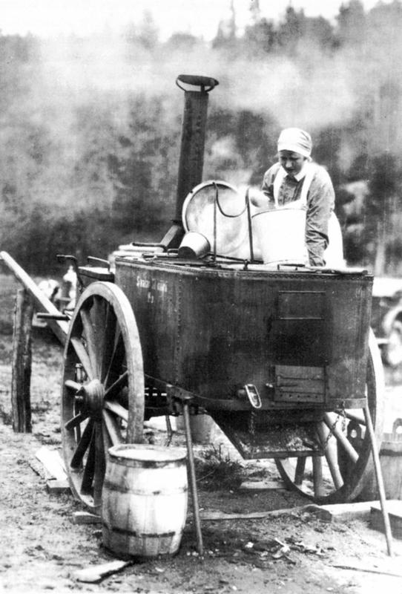
Image 2.1 Source: ‘Field kitchen during the Great Patriotic War: how and what Soviet soldiers ate’. Mmenu.com. May 6, 2016, https://www.mmenu.com/blogi/568581_polevaya_kukhnya_vremen_velikoy_otechestvennoy_kak_i_chem_pitalis_sovetskie_soldaty.html

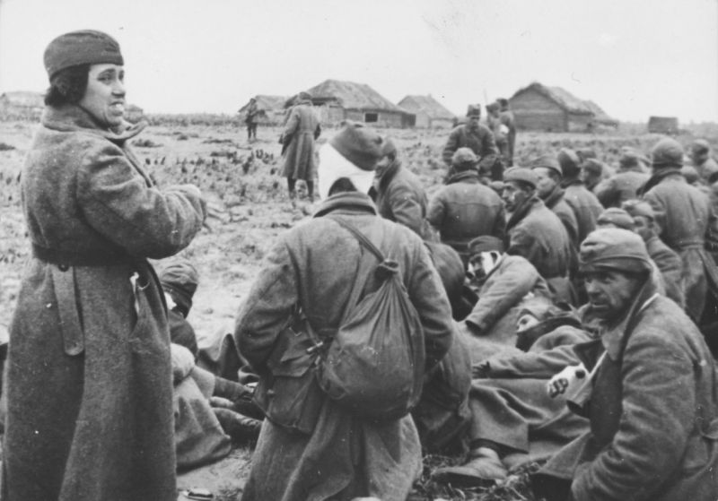
Image 2.2 Source: ‘A female soldier among a group of wounded Red Army prisoners on the outskirts of a village, 1941.’ Waralbum.ru. October 14, 2013, https://waralbum.ru/176295/

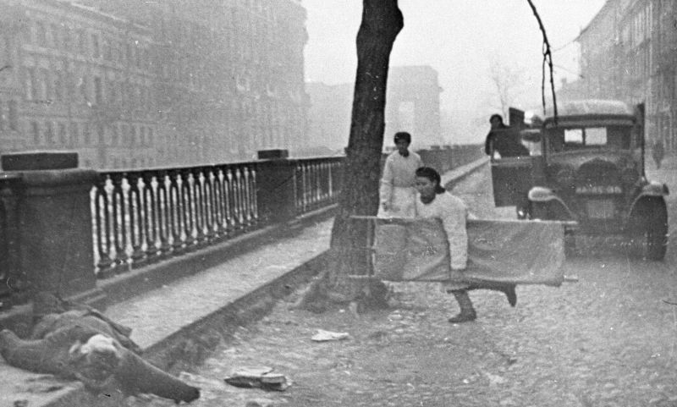
Image 2.3 Source: ‘A female nurse runs to a wounded man on the embankment in besieged Leningrad, 1942’ Waralbum.ru. February 23, 2019, https://waralbum.ru/176295/
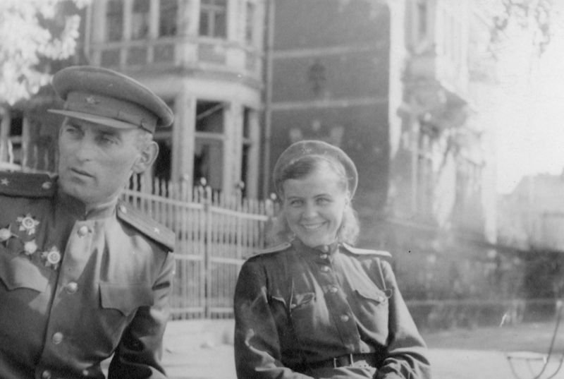
Image 2.4 Source: ‘A decorated Soviet major and a female officer on the street of post-war Berlin, May 1945.’ Waralbum.ru. December 5, 2018, https://waralbum.ru/362266/

Exercise 3

Topic: The Stalin Era

Task: Read the extract from Second-Hand Time provided and complete the activities suggested below the text.

Warning: Potentially Sensitive Content

[1]

“On the Beauty of Dictatorship and the Mystery of Butterflies Crushed Against the Pavement”

Elena Yurievna

I learned of how, in 1937, there had been a plan… quotas… for ‘exposing and rooting out enemies of the people’, just as in the eighties, they were lowering the quotas for people who could be rehabilitated district- and region-wide. The plan needed to be fulfilled and exceeded. It was all in Stalin’s style: the meetings, the pressure, the admonishments. More, more… [She shakes her head.] At night, I would sit there and read them, going through volumes of these documents. To be perfectly honest… honestly… it made my hair stand on end. Brother informed on brother, neighbour on neighbour… because they’d gotten into an argument about their vegetable patch, or over a room in the communal apartment. Someone sang a rhyme at a wedding, ‘We should thank Stalin, our brother, he put all our feet in rubber.’ That was enough. On one hand, the system was butchering people, but on the other hand, the people didn’t show one another much mercy, either. The people were ready…
A regular communal apartment… Five families live there – twenty-seven people in total. Sharing one kitchen and one bathroom. Two of the neighbours are friends: one of them has a five-year-old daughter and the other one is single with no kids. In communal apartments, people were always spying on one another, listening in on each other’s conversations. The people with ten-square-metre rooms envied the ones with twenty-five. Life… That’s just how it is… And then, one night, a Black Maria, a police van shows up… They arrest the woman with the five-year-old daughter. Before they take her away, she has a chance to cry out to her friend, ‘If I don’t come back, please look after my little girl. Don’t let them take her to an orphanage.’ So that’s what happened. The neighbour took the child in, and the building administration gave her a second room… The girl started calling her Mama… Mama Anya… Seventeen years went by… And seventeen years later, the real mother returned. She kissed her friend’s hands and feet in gratitude. If this were a fairy tale, this is where the story would end, but in real life, the ending was very different. Without a ‘happily ever after’. When Gorbachev came to power, after they unsealed the archives, they asked the former camp inmate whether she wanted to see her file. She did. So she went down to look at it, opened the folder… and the very first page was an informant’s report. Familiar handwriting… it was her neighbour’s, Mama Anya’s… She’d been the one who’d informed on her… Do you understand any of this? I don’t. And that woman couldn’t, either. She went home and hanged herself. [Silence.]

(465 words)

Source: Alexievich, Svetlana. Second-Hand Time. Translated by Bela Shayevich. London: Firzcarraldo Editions, 2016.

Questions for discussion:

- Based on the text, what is a communal apartment (kommunalka)?
- Why did communal apartment (kommunalka) make it easier to ‘spy’ on each other, as Elena describes?
- Drawing on evidence from the text, why does Elena think ordinary citizens participated in Stalin’s terror?
- Drawing on information from the text, what evidence does Elena provide for the motivations of ordinary citizens to be part of Stalin’s terror? Does she emphasise fear, ideology, or personal motivations? How would you research motivations further?
- Elena mentions “quotas for exposing and rooting out enemies of the people”. Can we believe this statement? What other evidence would need to be collected to support such a claim?
- How did living conditions under Stalinism shape people’s mentality and behaviour?
- Could a communal apartment (kommunalka) be considered another tool of state control? (Support your answer by providing examples from the text).
- Analyse the psychological and societal impact of opening Soviet archives during perestroika.

Creative task

[2]

Visit the website https://kommunalka.colgate.edu/index.cfm, a virtual museum of life in Soviet-era communal apartments.

Imagine that you need to prepare a visitor’s guide for this virtual exhibition. Select 2 – 3 items (e.g., photo, video, document) and write a 50 – 100-word description for each, explaining their historical significance to museum visitors.

[3]

Look at the image below, which is a snippet of someone’s day-to-day life (byt – in Russian). What can we learn from looking at this image? Can you identify alternative ways to capture day-to-day life? What are the advantages and disadvantages of these approaches?

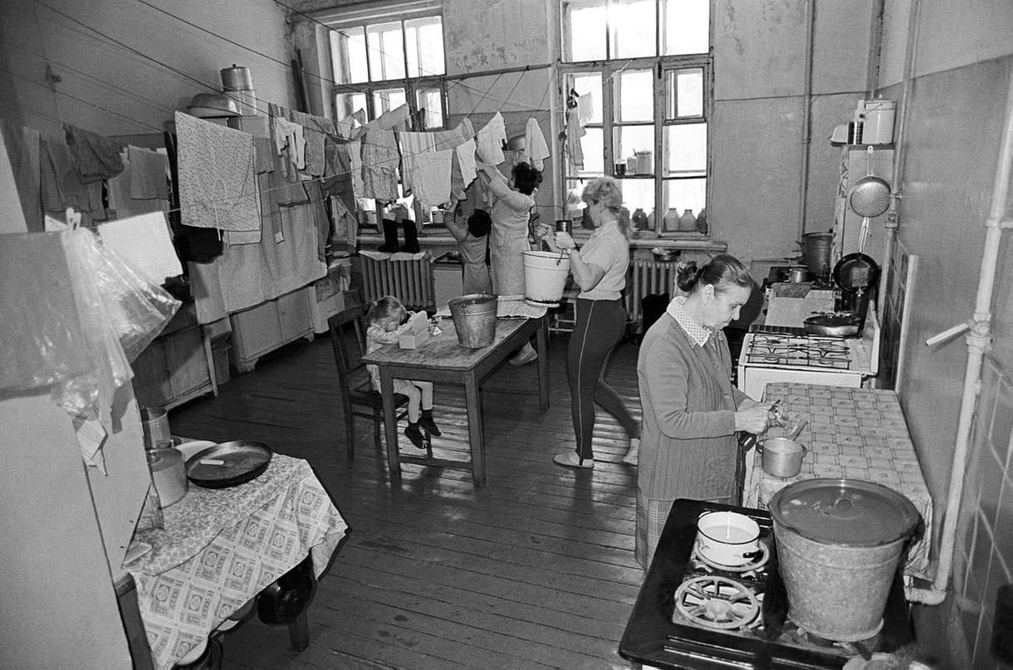

Image 3.1 Source: Efremov, Alexander. ‘Soviet communal apartments as a cultural phenomenon.’ Tripster.ru, November 1, 2024, https://experience.tripster.ru/articles/sovetskie-kommunalki-kak-yavlenie-kultury/

To read more about Soviet communal apartments:

Fitzpatrick, Sheila. Everyday life in Russia Past and Present. Indiana University Press. 2015

Messana, Paola. Soviet Communal Living: An Oral History of the Kommunalka. Palgrave Macmillan. 2011

Exercise 4

Topic: The Khrushchev Era

Task: Read the extracts from Second-Hand Time provided and complete the activities suggested below the text.

[1]

The Russian kitchen… The pitiful Khrushchyovka* kitchenette, nine to twelve square metres (if you’re lucky!), and on the other side of a flimsy wall, the toilet. […] In the nineteenth century, all of Russian culture was concentrated on aristocratic estates; in the twentieth century, it lived on in our kitchens. That’s where perestroika really took place. 1960s dissident life is the kitchen life. Thanks, Khrushchev! He’s the one who led us out of the communal apartments; under his rule, we got our own private kitchens where we could criticize the government and, most importantly, not be afraid, because in the kitchen you were always among friends. […] There’d always be someone who’d halt mid-conversation and point to the ceiling light or the power outlet with a little grin, ‘Did you hear that, Comrade Lieutenant?’ It felt a little dangerous, a little bit like a game. We got a certain satisfaction out of leading these double lives. A tiny handful of people resisted openly, but many more of us were ‘kitchen dissidents’, going about our daily lives with our fingers crossed behind our backs…

* Khrushchyovkas are cheap, prefabricated concrete-panel or brick apartment blocks that started being built in the 1950s, during the administration of their namesake, Nikita Khrushchev. Though they are cramped and shoddy, they provided many families with their first-ever private apartments. Mass-produced, Khrushchyovkas were identical in cities and towns across the entire Soviet Union.

(236 words)

Source: Alexievich, Svetlana. Second-Hand Time. Translated by Bela Shayevich. London: Firzcarraldo Editions, 2016.

Questions for discussion:

- In what ways does the above text romanticise dissident life?
- What can we learn from this text about people’s private lives during the Khrushchev era?
- Why did the kitchen become a space for political discussion and a symbol of “freedom” in the 1960s? (Support your answer by providing examples from the text.)
- Drawing on evidence from the text, does the speaker have a positive or negative view of dissident life?
- Using information from Exercise 3, compare the lives of ordinary people under Stalin and Khrushchev. How did their living conditions change?
- Using information from Exercise 3, discuss the advantages and disadvantages of living in a communal apartment (kommunalka) and in khrushchyovkas?
- If you were given a choice, would you have preferred a larger room in a communal apartment or a small but private khrushchevka? (Justify your answer with historical context).

Creative task:

- Work in small groups. Write a short play (1–2 pages) set in a Khrushchyovka kitchen, in which people (family and/or friends) discuss politics. Consider what you read about the kitchen debates in the extracts above.
- Write a 100-word diary entry from the perspective of a Soviet dissident living in the Khrushchev era. (You can reflect on daily life in a small apartment and their thoughts regarding Khrushchev’s reforms.)
- Below, there are two images depicting the typical Khrushchyovka and kitchen in such a building. Think about the appropriate titles and captions for the provided images, considering their historical context.

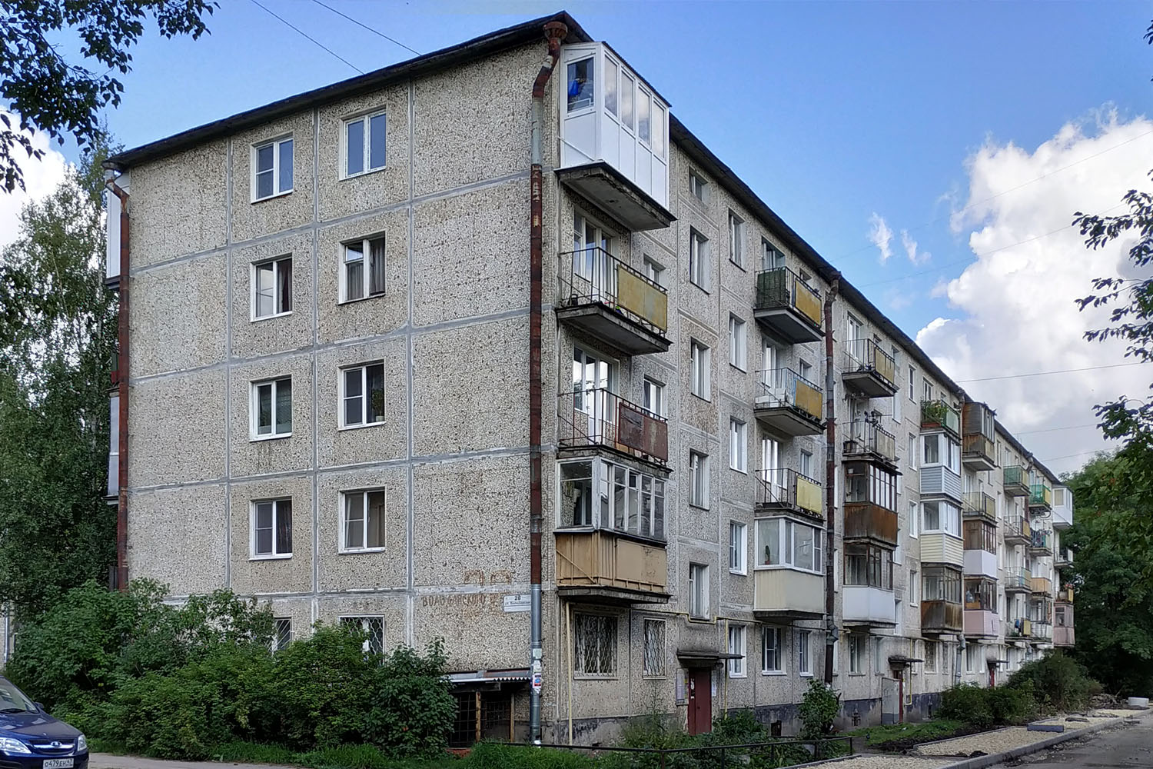

Image 4.1 Source: 3dfxVoodoo3. “Gatchina. Volodarsky Street, 28.” Wikimedia Commons. April 10, 2019, https://commons.wikimedia.org/w/index.php?curid=141171159, CC BY-SA 4.0.

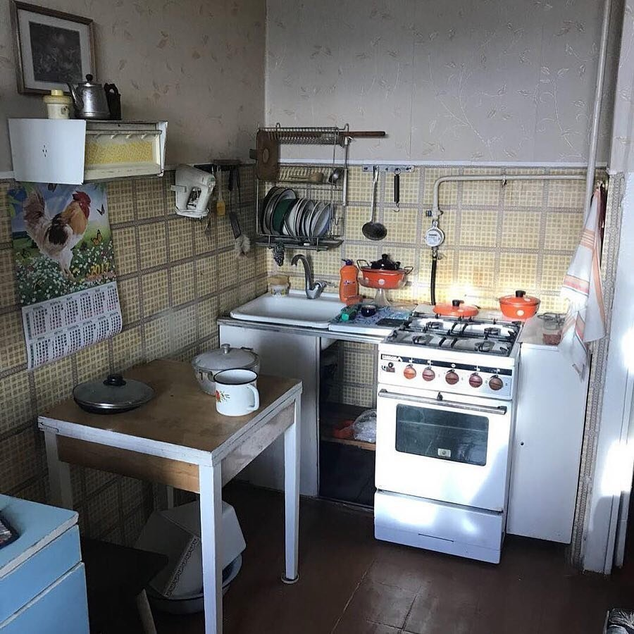

Image 4.2 Source: “Old kitchen in a Khrushchev-era building.” Obstanovka.club, n.d., https://obstanovka.club/67429-staraja-kuhnja-v-hruschevke.html

Topic: The Gorbachev Era

[2]

— The Gorbachev era… Huge crowds of people with radiant faces. Freedom! It was the air we breathed. Everyone hungrily devoured the newspapers. It was a time of great hope – at any moment, we might find ourselves in paradise. Democracy was an exotic beast. Like madmen, we’d run around to every demonstration: now we’d learn the truth about Stalin, the Gulag. We’d read Anatoly Rybakov’s forbidden Children of the Arbat and other good books: finally, we’d all become democrats. How wrong we were! A single message rang out from every loudspeaker: Hurry! Hurry! Read! Listen! Not everyone was prepared for all this… Most people were not anti-Soviet; they only wanted to live well. What they most wanted was blue jeans, VCRs, and most of all, cars. Everyone wanted nice clothes and good food. When I came home with a copy of The Gulag Archipelago, my mother was horrified. ‘If you don’t get that book out of my house immediately, I’m kicking you out.’ Before the war, my grandmother’s husband had been shot, but she would say, ‘I don’t feel sorry for Vaska. They were right to arrest him. He had a big mouth.’ ‘Grandma, why didn’t you tell me before?’ I’d ask her. ‘I hope that my life dies along with me so none of you will have to suffer the consequences.’ That’s how our parents lived, and their parents before them. Then it was all bulldozed over. Perestroika wasn’t created by the people, it was created by a single person: Gorbachev. Gorbachev and a handful of intellectuals…

(257 words)

Source: Alexievich, Svetlana. Second-Hand Time. Translated by Bela Shayevich. London: Firzcarraldo Editions, 2016.

Questions for discussion:

- According to the text, what emotions did people experience during the Gorbachev era? (Provide examples from the source).
- How did glasnost and perestroika transform access to information in the USSR?
- Have you heard of The Gulag Archipelago? Who was it written by? What is the significance of this book?
- Why do you think the narrator’s mother was horrified to see The Gulag Archipelago in their home?
- Do you agree with the last statement, “Perestroika wasn’t created by the people, it was created by a single person: Gorbachev”? (Justify your view)
- How did the Gorbachev era differ from other Soviet periods (e.g., under Stalin or Khrushchev)?
- If you could ask Gorbachev one question about that period, what would you ask and why?

Creative task:

Imagine if X (Twitter) had existed during Perestroika. Compose two fictional tweets: one from a supporter of Gorbachev’s reforms and another from the opponent.

Exercise 5

Topic: Soviet Life

Task: Read the extract from Gulnaz Sharafutdinova’s book The Afterlife of the ‘Soviet Man’: Rethinking Homo Sovieticus [1], and some short excerpts from Second-Hand Time [2], in which people express their thoughts and attitudes regarding of what it means to be a Soviet person. Discuss the questions and complete the activities suggested below the text.

[1]

Homo Sovieticus

In 2021, Ksenia Turkova conducted a survey on the meaning of sovok. The research revealed the multiplicity of meaning contained in the term sovok:
- Special mentality characterized by the infantilism;
- Closed mind;
- Xenophobia;
- Combination of all negative behavioural and psychological traits associated with the legacy of living in poverty and fear in a repressive Soviet State.

Similar to ‘sovok’, Homo Sovieticus (or ‘Soviet Man’) is often (though not always) used as stigmatizing term presumed to capture the imprint of totalitarism and a Soviet way of life on Soviet people. No single set of attributes associated with Homo Sovieticus exists.
The definition of Homo Sovieticus is often depends on a researcher’s perspective, experience, political views and disciplinary traditions, methodologies and approaches. The notion of Soviet man [person] have shifted from simple to complex, from good to evil and back. However, the primary meaning of HS – the negative and stigmatising one – was developed through the analytical lens of totalitarianism and the political stance on anti-communism. Its fullest and most empirically developed expression took place in the work of Yuri Levada and his colleagues. Their research emphasized the sense of Soviet exceptionalism, state paternalism, egalitarianism mingled with deference of authority and imperial syndrome as key characteristics of the Soviet personality type.
While the term Homo Sovieticus is typically first applied to Soviet citizens, it is also used in the context of other post-communist countries of the Eastern Bloc.

(239 words)

Source: Sharafutdinova, Gulnaz. The Afterlife of the ‘Soviet Man’: Rethinking Homo Sovieticus. London: Bloomsbury Academic, 2023.

Questions for discussion:

- Based on the information provided above, which definition of Homo Sovieticus do you agree with? Do you think it’s a useful term to define Soviet society?
- How might living under the Soviet regime have shaped people’s behavior and mentality?
- According to the text, the term Homo Sovieticus was also common among those from the Eastern Bloc. Does this mean that people shared similar experiences under Soviet influence?
- In your opinion, could researchers speak on behalf of all Soviet people? To what extent can the term Homo Sovieticus be applied to those who were born, grew up, and lived during the Soviet era?

Activity 1: Review the images below and identify which one may not be associated with Homo Sovieticus. Provide an explanation for your selection.

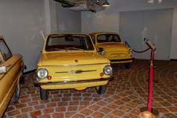 | 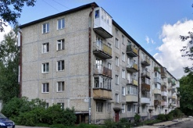 | 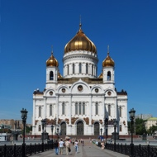 | 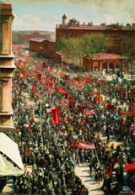
Image 5.1 | Image 5.2 | Image 5.3 | Image 5.4

Sources:

Image 5.1, Alexxx1979 - Own work, CC BY-SA 4.0, https://commons.wikimedia.org/w/index.php?curid=41830351

Image 5.2, 3dfxVoodoo3. https://photobuildings.com/photo/204635/, CC BY-SA 4.0, https://commons.wikimedia.org/w/index.php?curid=141171159

Image 5.3, Alvesgaspar, CC BY-SA 3.0, https://commons.wikimedia.org/w/index.php?curid=15860708

Image 5.4, Isaak Brodsky - http://i.allday.ru/uploads/posts/2008-12/1228233187_rrsrirrrrsryers-rrrrrsssrsrjos-rr-ryisrsryirryesr.jpg, Public Domain, https://commons.wikimedia.org/w/index.php?curid=20783770

[2]

Second-Hand Time

[a]

Elena Yurievna S., third secretary of the district Party committee, 49 years old

But I love the word ‘comrade’ and I’ll never stop loving it. It’s a good word. Sovok? Bite your tongue! The Soviet was a very good person, capable of travelling beyond the Urals, into the furthest deserts, all for the sake of ideals, not dollars. We weren’t after somebody else’s green bills. The Dnieper Hydroelectric Station, the Siege of Stalingrad, the first man in space – that was all us. The mighty sovok!

[b]

Sergey Fyodorovich Akhromeyev (1923–1991), marshal of the Soviet Union, Hero of the Soviet Union (1982), chief of the General Staff of the Soviet Armed Forces (1984–1988). Laureate of the Lenin Prize (1980). In 1990, he was named advisor to the President of the USSR on military affairs.

Only a Soviet person can understand another Soviet person. I wouldn’t have talked to anyone else…

[c]

— I’m a Soviet person, afraid of everything. Even ten years ago, I would have never gone out onto the square. Today, I don’t miss a single rally. I went to the demonstrations on Sakharov Prospekt and Novy Arbat. I was part of the White Ring*. I’m learning how to be a free person. I don’t want to die the way I am now, all Soviet.

*Name given to an anti-Putin protest during which opponents to the regime formed a human chain in the centre of Moscow in 2012.

[d]

I’m a sovok, huh? And my parents are sovoks, and my grandparents, too? My grandfather the sovok died defending Moscow in ’41… My sovok grandmother fought with the partisans… The liberals are working off their piece of the pie. They want us to think of our history as a black hole. I hate them all: gorbachev, shevardnadze, yakovlev** – don’t capitalize their names, that’s how much I hate them all. I don’t want to live in America, I want to live in the USSR…

(325 words)

Source: Alexievich, Svetlana. Second-Hand Time. Translated by Bela Shayevich. London: Firzcarraldo Editions, 2016.

Questions for discussion:

- Having read the extract from Sharafutdinova’s monograph, do you think that the excerpts from Alexievich’s book support or undermine the term Homo Sovieticus?
- In your opinion, why do some individuals romanticise the notion of being a Soviet person?
- Identify which excerpts from Second-Hand Time provide positive, negative, or mixed views about Soviet identity.
- People who were born and grew up in the USSR certainly share some common understandings about Soviet culture and life, but is it enough to put them all under the term Homo Sovieticus? How did Soviet ideology create the idea of a shared identity? (Support your answer giving the examples from Second-Hand Time).

Creative task:

- Write two short speeches: one praising the USSR’s achievements, and one condemning it.
- Complete an “identity card” for a fictional Soviet person, using supporting information provided in both texts discussed in class.

Photo | Surname, name
Photo | Age
Photo | Nationality
Photo | Values
Photo | Fears
Photo | Ambitions
Photo | Ideals
Photo | Views on the West

About the book

Boys in Zinc
by Svetlana Alexievich, translated by Andrew Bromfield

© A screenshot of the Boys in Zinc book cover by Svetlana Alexievich, https://www.penguin.co.uk/books/295485/boys-in-zinc-by-alexievich-svetlana/9780241264119

Haunting stories from the Soviet-Afghan War from the winner of the Nobel Prize in Literature.
From 1979 to 1989 Soviet troops engaged in a devastating war in Afghanistan that claimed thousands of casualties on both sides. While the Soviet Union talked about a 'peace-keeping' mission, the dead were shipped back in sealed zinc coffins. Boys in Zinc presents the honest testimonies of soldiers, doctors and nurses, mothers, wives and siblings who describe the lasting effects of war.
Weaving together their stories, Svetlana Alexievich shows us the truth of the Soviet-Afghan conflict: the killing and the beauty of small everyday moments, the shame of returned veterans, the worries of all those left behind. When it was first published in the USSR in 1991, Boys in Zinc sparked huge controversy for its unflinching, harrowing insight into the realities of war.

Source: “Boys in Zinc”. Penguin.co.uk, n.d., https://www.penguin.co.uk/books/295485/boys-in-zinc-by-alexievich-svetlana/9780241264119

Book Review:

An affecting, often haunting, compilation of first-person testimony on the Soviet experience in Afghanistan. From 1979-89, Moscow tried, unavailingly, through force of arms to support a puppet regime in a hostile land. But as those who found themselves at the sharp end of the bayonet and lived to share their grim memories with Byelorussian journalist Alexievich make clear, the state conducted the savage conflict in virtual secrecy. The ill-trained, poorly equipped teenage conscripts who did most of the fighting were told only that they were doing their international duty by defending the nation's southern borders against bandits; the realities of mortal combat with mujahideen, of course, were something else again. On the home front, grieving women were obliged to bury dead sons or husbands (who had been shipped back to the USSR in zinc coffins: hence the title) under cover of darkness in graves whose headstones offered no clues as to their untimely ends. Alexievich has traced down a host of officers, enlisted men, doctors, nurses, and civilian workers who served in Afghanistan—as well as those who waited, frequently in vain, for their safe return. Her witnesses tell their stories in brutally honest fashion, recalling the horrors of doing battle with a guerrilla foe; the shame of inflicting casualties on a civilian populace that was integral to the indigenous resistance; behind- the-lines profiteering; widespread drug abuse; how veterans preyed upon new arrivals in country; the shock of being reviled or ignored in the Soviet Union; and the anguish of bereavement without the anodyne of honour. An oral history that has considerable relevance for a superpower whose veterans and citizens are still coming to terms with the involvement in Vietnam.

Source: “Soviet Voices from a Forgotten War.” Kirkus Reviews, 19 May 2010, https://www.kirkusreviews.com/book-reviews/svetlana-alexievich/zinky-boys/

- Research information about war in Afghanistan (1979–89), using Encyclopedia Britannica or other reliable sources. What was the war in Afghanistan about? Specifically, focus on understanding the reasons behind the Soviet Union’s involvement.

Soviet invasion of Afghanistan: https://www.britannica.com/event/Soviet-invasion-of-Afghanistan

- Drawing on the information provided in the Glossary and previous discussions, how would you define an oral history?

- In Exercise 6, you will find various statements from the courtroom and excerpts from Boys in Zinc. Read them with the notion of oral history in mind. Consider whether you define these texts as examples of oral history.

Exercise 6

Topic: Soviet Life

In 1989, Svetlana Alexievich published her third book Boys in Zinc, which is based on the interviews collected with soldiers and their relatives about Soviet Afghan War (1979-1989). The book became controversial.

Numerous lawsuits were filed against Alexievich, accusing her of falsifying facts, being biased, exposing personal information without consent, and making money at the expense of people’s personal trauma.

Task: Read a few extracts from the courtroom [1-6] and the excerpt from Boys in Zinc [7]. Discuss the questions below.

[1]

From the lawsuit of Inna Sergeevna Golovneva, mother of deceased Senior Lieutenant Yu. Golovnev:

The newspaper Komsomolskaya Pravda of 15.02.90 published excerpts from the documentary story by S. Alexievich Zinky Boys, “Monologues of Those Who Went Through Afghanistan”. The monologue published under my name contains inaccuracies and distortions of facts reported by me to S. Alexievich, as well as obvious lies, fabrications, i.e. a presentation from my alleged words of circumstances that I did not report and could not report. Free interpretation of my statements, as well as obvious speculations, presented on my behalf, discredit my honor and dignity, especially since the story is documentary. As I believe, the author-documentarian is obliged to accurately present the information received, have records of conversations, and coordinate the texts with the interviewee. […] She had a voice recorder with her, she wrote everything down. But she didn't say that she would print it. I told her just like that, and she was supposed to print my son’s diary. The story is a documentary.

(159 words)

[2]

From the answers to questions:

Attorney S. Alexievich — V. Lushkinov: Tell me, Inna Sergeevna, did Alexievich record your story on a voice recorder?

I. Golovneva: She asked permission to turn on the voice recorder. I gave her permission.

V. Lushkinov: And did you ask her to show you later what she would transcribe and use in the book?

I. Golovneva: I thought she would publish my son’s diary. I already said that I understand that nonfiction is diaries and letters. But if it’s my story, then [it should have been] word for word, as I said.

V. Lushkinov: Why didn’t you sue Alexievich right away when Komsomolskaya Pravda came out with an excerpt from the book? And you decided to do this three and a half years later?

(128 words)

[3]

From the speech of T. M. Ketsmur:

I did not prepare to speak […]. How did I meet the most famous writer? We were introduced by a veteran of the war, Valentina Chudayeva. She told me that this writer wrote the book The Unwomanly Face of War, which is read all over the world. Then, at one of the meetings with the veterans, I talked with other women veterans, they told me that Alexievich managed to make a fortune and fame out of their lives, and now she has taken on the “Afghans”. […] She came to our “Memory” club with a voice recorder. She wanted to write about many guys, not just about me. Why did she write her book after the war? Why did this writer with a big name, a world name, remain silent for ten years? […] I’ll explain the situation a little... I can write a book myself... When we met, I refused to talk to her, I told her that we ourselves, who were there, will write the book. We’ll write it better, because she wasn’t there. What can she write? She'll only hurt us.

(187 words)

[4]

From conversations in the courtroom:

— We are defending the honour of our killed children. Give them back their honour! Give them back their Motherland! You have destroyed the country. The most powerful in the world! […]

— It was you who made our children murderers. It was you who wrote this horrible book. […]

(46 words)

[5]

Court decision:

On December 8, 1993, the Central District Court of Minsk officially recognised S. Alexievich as a liar and fined her. Having considered the claims of Taras Ketsmur, a participant in the war in Afghanistan, and Inna Golovneva, the mother of an officer who died there, the court found that while working on the book Zinky Boys S. Alexievich distorted the interviews she took from them or even made them up. In addition, the court found that the false interview with Ketsmur also disgraced the plaintiff, for which the defendant should pay him 1,320 rubles.

(98 words)

[6]

From the speech of S. Alexievich, author of Zinc Boys (From what was said and what was not allowed to be said)

[…] Then, five years ago, when the Communist Party and the KGB were still in power, I sometimes changed the names and surnames to protect the heroes of my book from reprisals. I was protecting them from the regime. And today I have to defend myself against those I recently protected. What should I stand up for? My writer’s right to see the world as I see it. And the fact that I hate war. Or must I prove that there is truth and plausibility, that a document in art is not a certificate from a military enlistment office or a tram ticket. The books I write are a kind of prose. It is a document and at the same time my image of time. I collect details and feelings not only from an individual human life but from the very air of time, its space, its voices. I do not invent or speculate; I organise the material within reality itself. The document is both those who tell me their stories and me as a person with my own worldview and perceptions. I write, I record contemporary, current history. Living voices, living destinies. Before they become history, they are still someone’s pain, someone’s cry, someone’s sacrifice or crime. […]

(229 words)

Source: “How Svetlana Alexievich Lies in Her Books. Testimonies and Court Documents.” WebArchive.org., January 4, 2018, https://web.archive.org/web/20180722141305/http://ross-bel.ru/about/news_post/kak-svetlana-aleksiyevich-lzhet-v-svoikh-knigakh-svidetelstva-i-dokumenty-suda

Questions for discussion:

- Inna Golovleva in her courtroom testimony states, ‘nonfiction is diaries and letters’, while Alexievich argues that ‘a document in art is not a certificate from a military enlistment office’. Drawing on information from Glossary and previous discussions, what is your definition of a historical document?

- To what extent can diaries, letters, and reordered testimonies be considered reliable historical sources?

- Alexievich states, ‘I organise the material within reality itself. The document is both those who tell me their stories and me as a person with my own worldview and perceptions. I write, I record contemporary, current history.’ Based on this statement, to what extent can the roles of a historian (recording facts) and a writer (curating and shaping narratives) be separated?

- Inna Golovleva states, ‘if it’s my story, then [it should have been] word for word, as I said.’ In your opinion, should the author include every word of the interviewee into the story, or can the story be edited and restructured to achieve a certain creative effect that the author has in mind?

- In your opinion, what is the role of the author in presenting such accounts?

- In his courtroom speech, Ketsmur says, ‘I can write a book myself...’. To what extent do you agree that an eyewitness and participant of such historical events like Afghanistan War has the ability to write a book as Alexievich did? What difficulties they would face?

- What are the rights and responsibilities of the author when they interview people for projects like Alexievich’s? Should the author coordinate the final draft of the story with the interviewee (as one of the claimants suggested)?

[7] From Boys in Zinc

[…] I was drafted in ’81. The war had already been going on for two years, but in ordinary life they didn’t know or talk about it much. My family thought that if the government had sent the troops in it needed to be done. That was the way my father and the neighbours reasoned. […] It was all still a long way away and not very frightening. A war and not a war; if it was war, then it was a strange kind of war, without anyone being killed or taken prisoner. No one had seen any zinc coffins yet. It was later that we found out they’d already bought coffins into the city, but they were burying them in secret, at night, and on the headstones they wrote ‘died’, not ‘killed’. But nobody bothered to ask themselves: how come nineteen-year-old boys have suddenly started dying in the army? Is it from vodka or the flu? […] They wrote in the newspapers that our soldiers were building bridges and planting avenues of friendship and our doctors were treating Afghan women and children.
At the Vitebsk training camp, it was no secret that we were being trained for Afghanistan. Lots of guys tried to dodge the army at any cost. One confessed he was afraid that we would all get shot out there I started despising him. […]
When a bullet hits someone you hear it; there’s no way to forget it or confuse it with anything else […] I wasn’t prepared to shoot anyone, I was still from ordinary life. From normal world … The first time you act as if it’s a dream: you run, drag, shoot, but you don’t remember anything. Afterwards you can’t tell anyone about it. […] As if you’re having a terrible dream. […]
[…] I got used to other people’s death, but I was afraid of my own. I saw how it took just one second, and there was nothing left of a man, as if he had never existed. And they send a dress uniform back to the Homeland in an empty coffin. […]

(351 words)

Source: Alexievich, Svetlana. Boys in Zinc. Translated by Andrew Bromfield. Penguin, 2017.

- Using the speaker’s testimony [7], underline the words and phrases that a) can be considered facts; b) express emotions. Is there a balance between facts in emotions in this text?
- As a historian, would you treat the speaker’s testimony as a primary source or secondary source?
- How does this testimony help us understand the Soviet state’s propaganda about the Afghanistan war? (Use quotes from the text to support your answer).
- Given the court statements and the speaker’s testimony from Boys in Zinc you have read, why do you think the participants (or their relatives) condemned the public exposure of these accounts?

To summarize:

- What do you think was Alexievich’s primary goal in writing Boys in Zinc (as well as her other books?)

Activity:

- Work in small groups.
- Review the list of historical events and important events in the life of Svetlana Alexievich below and complete the timeline by adding the date and title of each event.
- Ensure the events are in chronological order.
- Discuss the details of each event (e.g., the significance of the event, causes, and consequences).
- Find a suitable image online.

Historical events

- 1941-1945: The Great Patriotic War.
- 1953: Josef Stalin dies on 5 March.
- 14 September 1953: Nikita Khrushchev becomes First Secretary of the CPSU.
- 1964: Khrushchev is removed from power and replaced by Leonid Brezhnev.
- 1979: Soviet troops invade Afghanistan.
- March 1985: Chernenko dies of emphysema. Mikhail Gorbachev becomes General Secretary of the CPSU and takes steps towards reform, marking the beginning of perestroika.
- 26 April 1986: Chernobyl disaster.
- 19 Aug 1991 – 21 Aug 1991: Soviet coup attempt.
- 24 August 1991: Gorbachev dissolves the CPSU and resigns as General Secretary.
- 1994–1995: First Chechen War.

Svetlana Alexievich

- 1948: Svetlana Alexievich was born on 31 May in Ivano Frankivsk, Ukraine.
- 1983: The Unwomanly Face of War.
- 1992: Lawsuits were opened against Alexievich after the publication of Zinky Boys.
- 2013: Second-Hand Time.
- 2015: Svetlana Alexievich was awarded the Nobel Prize in Literature.

To be used by students

Historical events

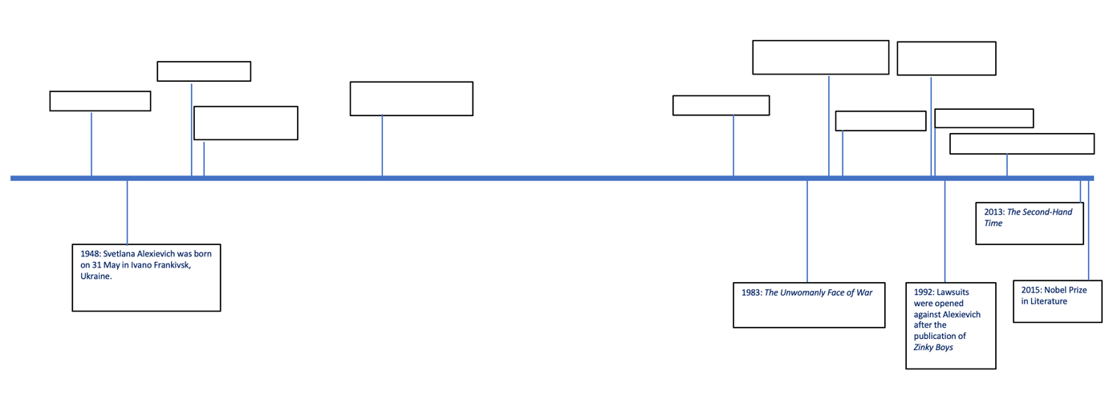

Svetlana Alexievich - Key Dates

To be use by educators

Historical events

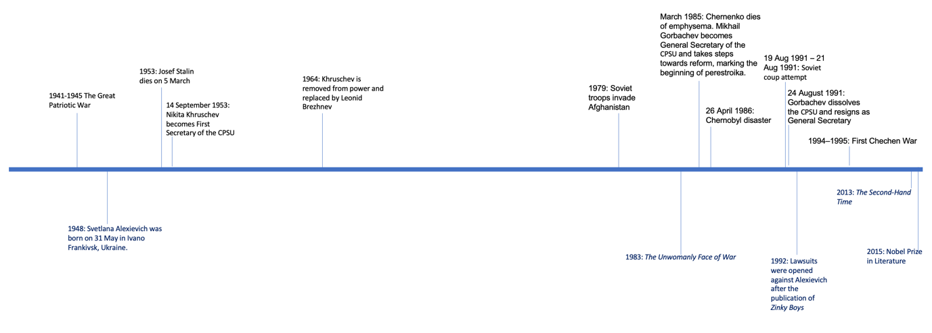

Svetlana Alexievich - Key Dates
To be use by educators

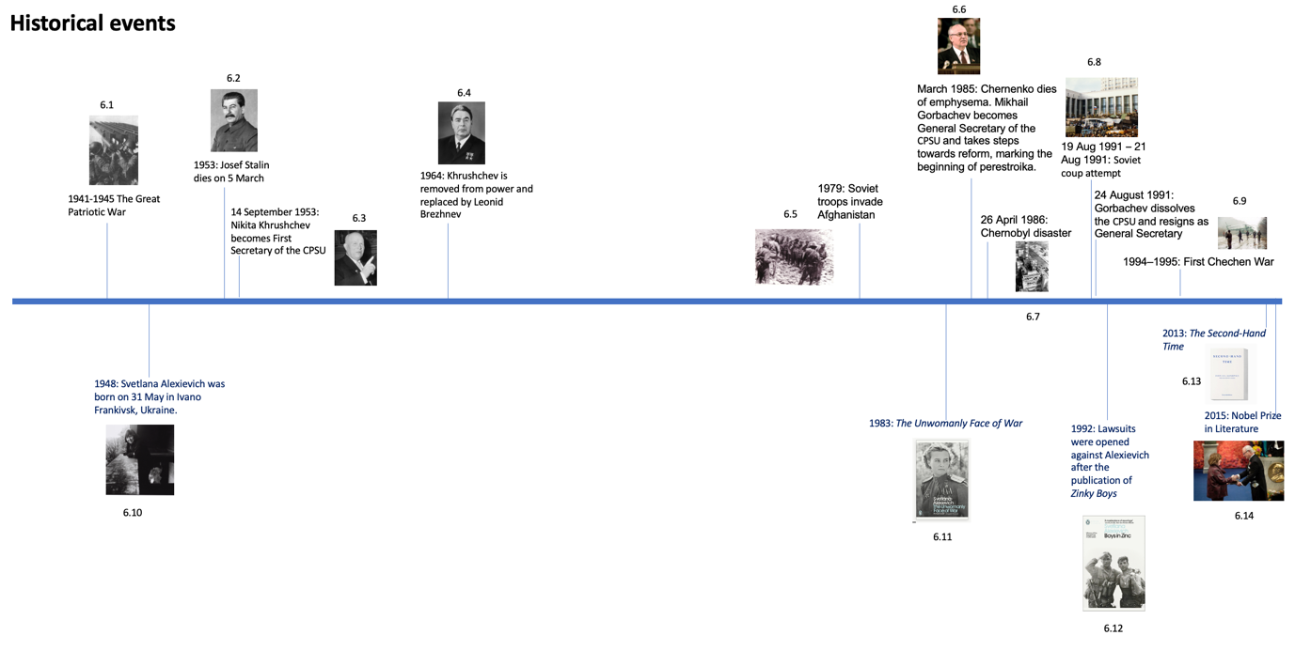

Svetlana Alexievich - Key Dates

Sources:
Image 6.1, St. Iwan - Scan from Tadeusz Burakowski, Aleksander Sala Wyrzutnia rakietowa Katiusza. TBiU 7 WMON, Warszawa 1971., Public Domain, https://commons.wikimedia.org/w/index.php?curid=729962

Image 6.2, James Abbe - Immediate source: [1]Initial publication: The New York Times, 8 May 1932 (image of first page available at [2]), as attested in Shooting Stalin: The Wonderful Years of James Abbe (2005), ISBN 9783865210432, Public Domain, https://commons.wikimedia.org/w/index.php?curid=163452326

Image 6.3, Unknown author - [1] Dutch National Archives, The Hague, Fotocollectie Algemeen Nederlands Persbureau (ANeFo), 1945-1989, bekijk toegang 2.24.01.04, Bestanddeelnummer 914-4385, CC BY-SA 3.0 nl, https://commons.wikimedia.org/w/index.php?curid=151251450

Image 6.4, Anefo - http://proxy.handle.net/10648/abec18ec-d0b4-102d-bcf8-003048976d84, CC0, https://commons.wikimedia.org/w/index.php?curid=163461227

Image 6.5, Kuvakin E. (1985); scanned and processed by User:Vizu (2009); own scan photo E.Kuvakin by personal collection, CC BY-SA 3.0, https://commons.wikimedia.org/w/index.php?curid=7046938

Image 6.6, RIA Novosti archive, image #850809 / Vladimir Vyatkin / CC-BY-SA 3.0, CC BY-SA 3.0, https://commons.wikimedia.org/w/index.php?curid=18955999

Image 6.7, IAEA Imagebank - 02790015, CC BY-SA 2.0, https://commons.wikimedia.org/w/index.php?curid=63251598
Image 6.8, David Broad, CC BY 3.0, https://commons.wikimedia.org/w/index.php?curid=52232654

Image 6.9, Mikhail Evstafiev, CC BY-SA 3.0, https://commons.wikimedia.org/w/index.php?curid=343762

Image 6.10, Barbara Niggl Radloff - https://sammlungonline.muenchner-stadtmuseum.de/objekt/svetlana-alexijewitsch-villa-waldberta-feldafing-10219667.html, CC BY-SA 4.0, https://commons.wikimedia.org/w/index.php?curid=113562094

Image 6.11, A screenshot of the book The Unwomanly Face of War, Penguin, https://www.penguin.co.uk/books/295606/the-unwomanly-face-of-war-by-alexievich-svetlana/9780141983530

Image 6.12, A screenshot of the book Boys in Zinc, Penguin, https://www.penguin.co.uk/books/295485/boys-in-zinc-by-alexievich-svetlana/9780241264119

Image 6.13, A screenshot of the book Second-Hand Time, Fitzcarraldo Editions, https://fitzcarraldoeditions.com/books/second-hand-time/

Image 6.14, Svetlana Alexievich – Photo gallery. NobelPrize.org. Nobel Prize Outreach 2025. Tue. 26 Aug 2025, https://www.nobelprize.org/prizes/literature/2015/alexievich/photo-gallery/
1979: Soviet troops invade Afghanistan
March 1985: Chernenko dies of emphysema. Mikhail Gorbachev becomes General Secretary of the CPSU and takes steps towards reform, marking the beginning of perestroika.
26 April 1986: Chernobyl disaster
19 Aug 1991 – 21 Aug 1991: Soviet coup attempt
24 August 1991: Gorbachev dissolves the CPSU and resigns as General Secretary
1983: The Unwomanly Face of War
1992: Lawsuits were opened against Alexievich after the publication of Zinky Boys
2013: The Second-Hand Time

Glossary

Accuracy in historical fiction denotes the extent to which a text’s representation is consistent with available evidence. An accurate text reflects the accepted facts about period, individual, or event.

Source: Saxton, Laura. “A True Story: Defining Accuracy and Authenticity in Historical Fiction.” Rethinking History 24 (2): 127–44, 2020, doi:10.1080/13642529.2020.1727189.

Authenticity in historical fiction refers to an impression of accuracy and the extent to which readers believe that a representation captures the past. Authentic representations need not be accurate.

Source: Saxton, Laura. “A True Story: Defining Accuracy and Authenticity in Historical Fiction.” Rethinking History 24 (2): 127–44, 2020, doi:10.1080/13642529.2020.1727189.

Accuracy in creative nonfiction: Unlike fiction, creative non-fiction must adhere to the truth. However, how facts are presented —through narrative or interpretation—is where the creativity comes into play. Facts should be verified, while details are not exaggerated or fabricated.

Source: “Creative non-fiction: tips for writing compelling narrative stories.” National Centre for Writing, n.d., https://nationalcentreforwriting.org.uk/writing-hub/unlocking-the-art-of-creative-non-fiction-tips-for-writing-compelling-narrative-stories/

Creative Nonfiction: is a genre that employs the creative writing techniques of literature, such as poetry and fiction, to retell a true story.

Source: Glatch, Sean. “Creative Nonfiction: What It Is And How To Write It.” Writers.com, 31 March 2024, https://Writers.Com/What-Is-Creative-Nonfiction#:~:Text=In%20short%2c%20creative%20nonfiction%20(Cnf,Into%20their%20own%20personal%20lives.

Documentary Prose (Nonfictional Prose): any literary work that is based mainly on fact, even though it may contain fictional elements.

Source: Peyre, Henri M. “Nonfictional Prose.” Encyclopedia Britannica, 1 April 2025, https://www.britannica.com/topic/nonfictional-prose.

Ethnographic Narratives (Ethnographic Writing): is a descriptive account that represents the complex realities of a culture or community based on immersive observation and in-depth study.

Source: “Ethnographic Narratives.” Vaia.com, n.d., https://www.vaia.com/en-us/explanations/anthropology/ethnographic-methods/ethnographic-narratives/#:~:text=Definition%20of%20Ethnographic%20Narrative,-In%20the%20fascinating&text=It%20can%20be%20understood%20within,drawn%20from%20close%2C%20detailed%20fieldwork.

Life Writing: It encompasses everything from the complete life to the day-in-the-life, from the fictional to the factional. Life-writing includes biography, autobiography, memoirs, letters, diaries, journals, anthropological data, oral testimony, eye-witness accounts, biopics, plays and musical performances, obituaries, scandal sheets, and gossip columns, blogs, and social media such as Tweets and Instagram stories. It is not only a literary or historical specialism, but is relevant across the arts and sciences, and can involve philosophers, psychologists, sociologists, ethnographers and anthropologists.

Source: “What is Life-Writing?” The Oxford Centre for Life-Writing, https://oclw.web.ox.ac.uk/what-life-writing. Accessed on 21.08.2025

Literary Journalism (Narrative Journalism): is a style of reportage that presents true stories in a more narrative way, using storytelling techniques to create a gripping and personal form of journalism. Literary journalism is a type of creative nonfiction.

Source: “How to Recognize and Write Literary Journalism.” MasterClass.com, last updated 8 September 2021, https://www.masterclass.com/articles/how-to-recognize-and-write-literary-journalism#:~:text=More%20About%20Writing%3F-,What%20Is%20Literary%20Journalism%3F,and%20personal%20form%20of%20journalism.

Oral History can be defined as the recording, preservation and interpretation of historical information, based on the personal experiences and opinions of the speaker. It may take the form of eye-witness evidence about the past, but can include folklore, myths, songs and stories passed down over the years by word of mouth. While it is an invaluable way of preserving the knowledge and understanding of older people, it can also involve interviewing younger generations.

Oral history is particularly useful for capturing stories from minority groups or small communities who will not often be represented in more formal histories. It is also useful when there is a lack of other sorts of evidence, whether written or visual.

Source: “What is oral history,” University of Leicester, n.d., https://le.ac.uk/history/outreach/besh/oral-history/what-is

Homo Sovieticus: According to Yuri Levada, Homo sovieticus—a human species presumed to have been irreparably damaged by the Soviet system.

(See Exercise 6 for additional details regarding the concept.)

Source: Sharafutdinova, Gulnaz. “R.I.P “Soviet Man”: Scrapping Homo Sovieticus in the Spirit of Yuri Levada.” Wilson Center, 29 April 2019, https://www.wilsoncenter.org/blog-post/rip-soviet-man-scrapping-homo-sovieticus-the-spirit-yuri-levada

Sovok: slang for “Soviet” is probably used most often to describe the Soviet Union and the Soviet way of life. In the 1990s, “sovok” could be used as an explanatory shorthand for why something is poorly run, or why a person behaves badly.

(See Exercise 6 for additional details regarding the concept.)

Source: Borenstein, Eliot. “A Sovok is a Person, Place, or Thing (Russia’s Alien Nations),” 29 March 2019, https://jordanrussiacenter.org/blog/a-sovok-is-a-person-place-or-thing-russias-alien-nations

