IAA USING LITERATURE FOR DIVERSIFYING AND DECOLONIZING THE SOVIET HISTORY

Supporting materials for teaching and studying A-level History through literature

Nino Haratischvili, The Eighth Life (2014)

Guzel Yakhina, Zuleikha (2015)
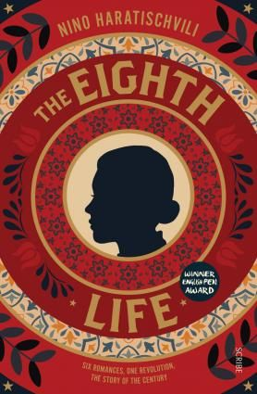


© Cover of The Eighth Life by Nino Haratischvili, https://thebookerprizes.com/the-booker-library/books/the-eighth-life
© Cover of Zuleikha by Guzel Yakhina, https://pushkin-house.squarespace.com/imported-products/zuleikha-by-guzel-yakhina

Elena Garcia Sale
University of Birmingham
2025

Material Guidelines

General Overview:

The exercises in this pack are mainly focused on two books - The Eighth Life by Nino Haratischvili (first published in 2014) and Zuleikha by Guzel Yakhina (published in 2015). Summaries of both books can be found on the pages that follow. It is recommended that students read the book summaries before attempting the exercises that follow, so that they understand the context of the specific extracts they are reading and who the characters are.

The aim of these exercises is to get students thinking about the role that literature can play in providing alternative historical perspectives that may not be available in their history textbooks. Specifically, these exercises seek to provide perspectives from minority ethnic groups in the Soviet Union, namely Georgians and Tartars. The Eighth Life focuses on a Georgian family, and Zuleikha focuses on a Tartar woman. Extracts from each book are cross-referenced with real historical sources or extracts from academic articles in order to encourage students to compare and contrast different source material. This is done in the hope that they will learn to think analytically about how historical narratives can be constructed in a variety of ways, and how this affects the way that these events are remembered and retold.

Each exercise has been specifically created with the Soviet A level history syllabus in mind, so that students can use the knowledge they already have of specific events and broaden their understanding of them.

Topics covered include:

Exercise 1 - Collectivisation and dekulakisation.
- Primary sources: Soviet propaganda poster promoting dekulakisation; extract from Zuleikha (in which the main character is labelled a kulak).
- Key themes: party/state narratives vs individual lived experience

Exercise 2 – Post-WII reconstruction.
- Primary sources: Soviet propaganda poster promoting national reconstruction following WWII; extract from The Eighth Life presenting alternative perspective on meaning of war and ‘victory’.
- Key themes: party/state narratives vs individual lived experience

Exercise 3 - Khrushchev’s secret speech 1956.
- Primary sources: Extract from The Eighth Life detailing the reaction to Khrushchev’s speech in the Soviet Union, and specifically in Georgia.
- Key themes: collective memory of historical events; continued popularity of Stalin in Georgia.

Exercise 4 - Group discussion on history and memory (no specific historical period/event).
- Primary sources: Extracts from academic articles
- Key themes: how history is remembered and the role of fiction in teaching history.

Exercise 5 - Accuracy and authenticity in historical fiction (no specific historical period/event).
- Primary sources: Extract from Zuleikha detailing the character's deportation; extracts from academic articles
- Key themes: difference between “accuracy” and “authenticity” in historical narratives.

Exercise 6 - Civil War.
- Primary sources: A longer extract from The Eighth Life detailing the years of the civil war through the eyes of one character.
- Key themes: This is a reading comprehension exercise that builds on Exercise 5 with questions focused on both analysing the text to identify the historical events of this era and examining its authenticity.

The Eighth Life (For Brilka) by Nino Haratischvili

The Eighth Life is a multi-generational novel set in Georgia and the Soviet Union, which tells the tale of the Jashi family from the 1900s all the way into the early 2000s. The book is split into 8 sections which contain the personal stories of each family member, set to the backdrop of momentous historical events in Georgia and the wider Soviet Union throughout this period.

See if you can find Georgia on the map!
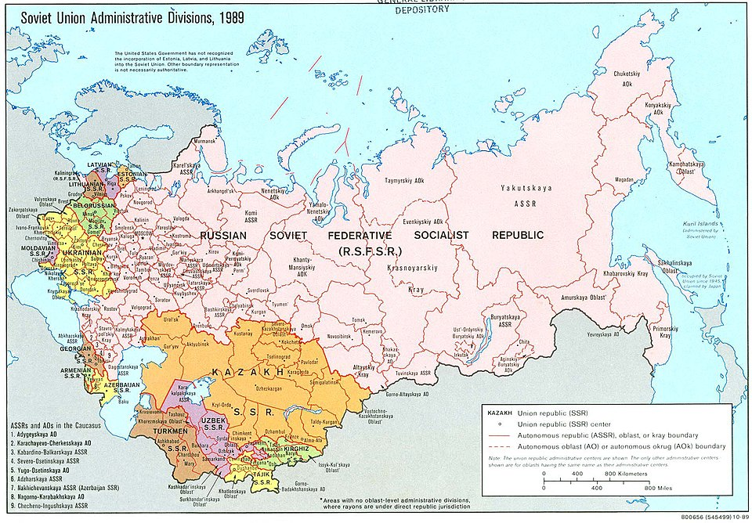

Source: Wikipedia , https://en.m.wikipedia.org/wiki/File:Soviet_Union_Administrative_Divisions_1989.jpg

They Jashi Family Tree

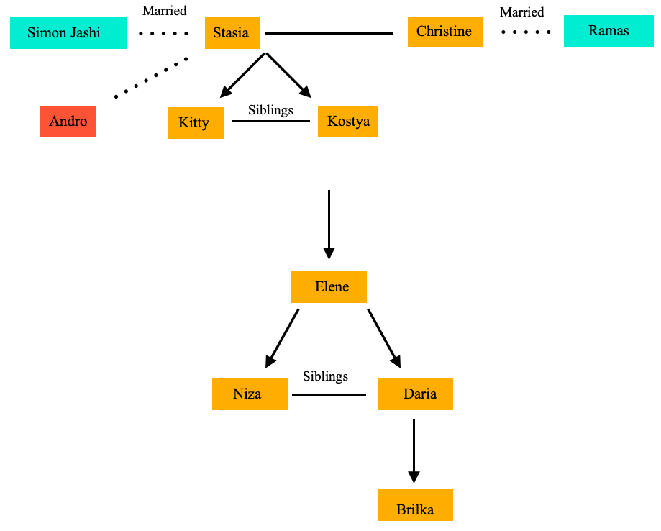

The book is narrated by Niza Jashi, addressing her niece Brilka, with the aim of helping her understand their complex family history. The eighth section is dedicated to Brilka and intentionally left blank, leaving the space for a life story waiting to be told. Niza writes this story as both confession and inheritance for Brilka, hoping to free her from the family’s tragic cycles.

At the heart of the book lies a secret hot chocolate recipe which adds an element of magical realism to the story. The recipe was created by the family's patriarch, a gifted Georgian chocolatier, who passes it down to his daughter Stasia, whose life is the first story in the book. When her father shares the secret recipe with her he makes her swear to never share it with anyone outside the family, to only serve it as something rare and special, warning that it can bring about true delight but also calamity. Throughout the book this hot chocolate is drunk by each of the characters at points in which they are in desperate need of hope or help, and its delicious taste seems to have an almost spellbinding effect on those who drink it and those who smell it. Stasia believes it is cursed and this belief is passed down through the family’s generations.

The saga begins with Stasia, born in 1900 and raised in a well-off family given that her father is a successful confectioner. She is independent and full of life, with dreams of becoming a ballerina in Paris. However, her life becomes dictated by the historical events of the time leading her to marry a Red Army officer, Simon Jashi. As well as having her two children, Kitty and Kostya, she also brings up the son of her good friend Sopio Eristavi. Sopio is sent to a labour camp and is eventually shot there, leaving her son, Andro, an orphan. Stasia endures the Soviet revolution, the Red Terror and purges, collectivisation, civil war, world wars and the collapse of the Soviet Union. She is present throughout the book almost until the end by which time she is a stoic and quiet old woman who sees the ghosts of those she has lost throughout the century.

Stasia’s sister Christine, described as supernaturally beautiful, marries Ramas, a Soviet official and therefore enjoys the glamorous life that her husband's position allows her. However, her beauty becomes a certain curse as she attracts the attention of a powerful figure named only ever in the book as the “Little Big Man,” who is meant to be Lavrentiy Beria. She becomes his mistress, a position which gains her considerable privilege but also causes immense trauma in her life which reverberates for decades.
In the following generation, Kostya and Kitty grapple with the consequences of their parents’ choices. Kostya becomes a loyal Soviet officer, gaining considerable privilege and recognition. He is proud of his position and is able to protect his family through difficult times, but it also means he is complicit in the very system that destroyed his family. He fights throughout the Second World War and is present during the siege of Leningrad. By the end of the book, as the Soviet Union collapses, he struggles to come to terms with his sudden lack of importance and loss of privileges he once enjoyed under the Soviet system.
Kitty, by contrast, rebels. After falling in love with Andro who is eventually accused of treason, and having a forced abortion of their child at the hands of the Soviet authorities, she flees Georgia, eventually becoming an extremely famous dissident singer in exile. As a result of her exile from the Soviet Union she becomes completely cut off from her family and a stranger to the generations after her, however her songs and the mystery that surrounds her in the family sparks an intense curiosity in both Elene and Brilka.
Kostya’s daughter Elene, tries to navigate post-Soviet Georgia in the 1990s, a time of civil unrest, economic collapse, and moral ambiguity. Elene is initially the ideal daughter raised with all the privilege and protection her father’s position provides her. However, as she grows older, begins to veer from this path and falls into alcoholism and addiction. Her daughters, Niza and Daria, inherit both personal trauma and historical disillusionment that by this point is felt heavily by all those in the family that they are raised by. Niza becomes a historian and eventually emigrates to Germany to flee the traumatic life she led in Georgia throughout the collapse of the Soviet Union. Her sister Daria, born with extreme beauty, becomes a successful actress in a time when the Soviet Union is starting to open up. However, her life takes a turn when she marries an abusive man and eventually falls into addiction and alcoholism. Daria is the mother of Brilka, however she dies in what is hinted as a suicide when Brilka is still a baby.
Through each of the characters we witness significant historical moments in Georgia through a deeply personal lens making the consequences of politics and ideology feel immediate and devastating. Each person wrestles with love, parenthood, betrayal, survival, and identity in a world that is consistently changing and unforgiving. Their stories are completely interwoven, as with all families and Haratishvili emphasises through their tale how memory and trauma can be passed down through generations.

Zuleikha by Guzel Yakhina
Zuleikha is a historical novel set in the 1930s Soviet Union, following the journey of Zuleikha Valieva, a young Tatar peasant woman living in a remote village in Tatarstan.
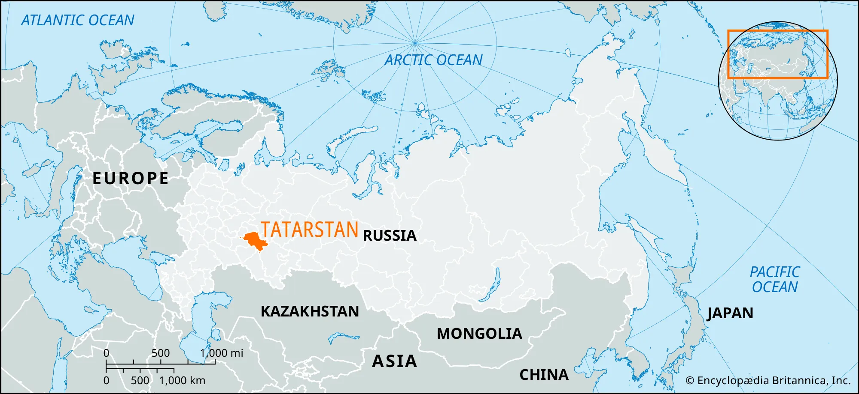
Source: Britannica, https://www.britannica.com/place/Tatarstan
Zuelikha is confined to the house where she lives with her oppressive husband and mother-in-law, both of whom abuse her physically and verbally. She has no children as all four of her daughters died in their infancy. Despite her situation, she is a very obedient and devoted wife working herself to the bone each day in her daily routine of cleaning, cooking and taking care of the livestock. She is symbolic of many of the women in her position in that she is illiterate, cannot speak much Russian (only Tatar), and is a devout Muslim (as is custom amongst the Tatars), whilst also holding beliefs in spirits that are mainly associated with nature and reside in the forests around her village.
Early on in the book Zueliekha and her husband, Murtaza, are hiding their food given the imminent threat of the Red Army soldiers coming to confiscate it. They have been accused of being kulaks and as a result have had their livestock and food confiscated throughout the previous years. Zuleikha describes how, along with many of the other villagers, they have cultivated techniques for hiding food such as under the floorboards or buried in the forest. On their way back from a trip to bury their grain, they run into an altercation with some Red Army officers, one of which, Ignatov, shoots and kills Murtaza.
Zuleikha’s house is then raided and she is arrested as the wife of a kulak. Deported along with other villagers, she is sent on a grueling train journey eastward with a diverse group of exiles—intellectuals, criminals, artists, and a German doctor, Volf Leibe, who looks after her and is the first to notice that Zuleikha is pregnant.
Many die during the journey that lasts months on the train due to starvation and disease, however the biggest catastrophe occurs on the last leg of the journey. The deportees are loaded into a ship which goes down the Yenisey and Angara rivers in Siberia however the ship sinks with hundreds of deportees locked in its basement. Zuleikha barely survives, saved by Ignatov—her husband’s killer. The few survivors are abandoned in the Siberian taiga with only a half-built barrack and no supplies. Under Ignatov’s reluctant leadership, they must build a settlement from scratch, enduring extreme cold, hunger, and wild animals.
Can you spot the Yenisey and Angara Rivers on the map?
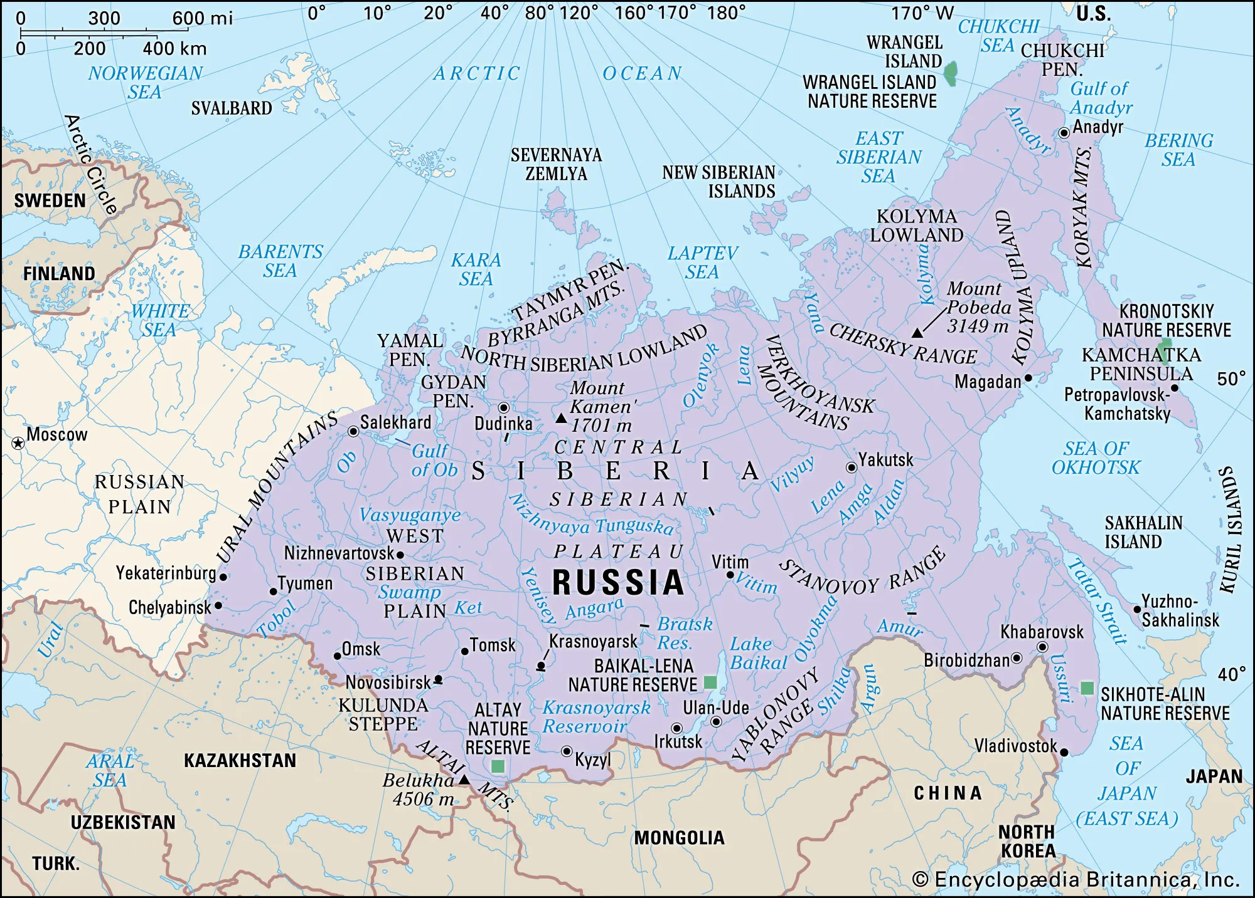
Source: Britannica, https://www.britannica.com/place/Siberia
It is during this first harsh winter that Zuleikha gives birth to her son, Yuzuf and over the years, the camp gradually evolves into a functioning village and labour camp where Zuleikha works and is a respected member. In her journey from the village up until this point Zuleikha has changed significantly - her Russian improves as a result of being the lingua franca amongst the prisoners, she questions her faith and becomes more spiritual and she becomes the most skilled hunter in the camp, earning her independence and respect. Ironically she finds more freedom in her exile than in her previous life in the village. Also throughout this time, Ignatov and Zuleikha develop a romantic relationship however it is broken off later on in the book and continues to be conflicted and confused as a result of their own personal sufferings.
Yuzuf, Zuleikha’s son grows up in the camp and develops a love for art as a result of one of the inmates Ikonnikov who is an artist, mentoring him. This inmate sparks his curiosity about the world outside of the camp. When WWII reaches even the distant camp, prisoners are offered freedom in exchange for fighting which by this time Ignatov, who is still in charge of the camp, finds his loyalty to the regime starting to erode. He increasingly defies Soviet authority and sides with the labourers of the camp instead.
At the end of the book Yuzuf makes a plan to run away from the camp and to enrol in the Academy of Arts in Leningrad, which Zuleikha soon realises. Despite her devastation, she turns to Ignatov to help Yuzuf. Ignatov forges documents for her son’s escape and the novel ends with Zuleikha waving Yuzuf off in the middle of the night from the camp.

Exercise 1: Dekulakisation and Collectivisation
Before attempting this exercise, you may wish to consult materials in your textbook relating to the topic “The emergence of Communist dictatorship 1917-1941”.
- Look at the below poster carefully and answer the questions that follow.
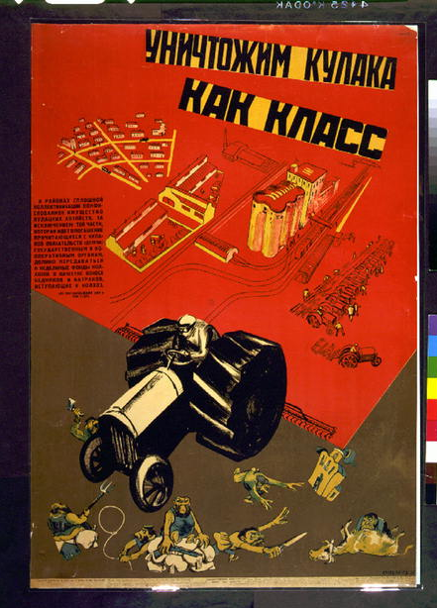

Kukryniksy (M.V. Kuprianov, P.N. Krylov, N.A. Sokolov), “We will annihilate kulaks as a class.” 1930. Source: https://www.loc.gov/item/95504359/

- What do you see depicted on this poster?
- What message is this poster trying to convey?
- Who is it for?
- Where do you think this poster would be seen?
- What story do you think it is trying to tell and from whose perspective?

You may want to think particularly about:
- Events of 1930s in the Soviet Union
- Depiction of the collective farm
- The tractor and its symbolism
- Depiction of people (e.g. are they racialised? Are they humanised?)
- Depiction of the church in the bottom right corner.

2) Now look at this extract from the book Zuleikha:
This extract is taken from the immediate aftermath of when a rock is thrown through the window of their house unexpectedly. Wrapped around the rock is the poster you analysed on the page above and here we read Zuleikha’s description of it:
“A gigantic black tractor’s large treads are crushing horrid little people who are scattering in every direction like cockroaches. One of them looks a lot like Murtaza, he's standing frightened and aiming the crooked wooden pitchfork at the tractor’s steel bulk. [...] “We’ll destroy the kulak as a class!” Zuleikha can’t read, especially in Russian. She understands, though, that the black tractor is about to run over the tiny Murtaza and his ridiculous pitchfork”
Straight after reading this Murtaza kills his own cow whilst shouting:

“There's your requisitions of 1916! [...] the food armies in 1918! 1919! 1920! There's taking our grain for resale! There's your food tax! There's your grain surplus! Take! That! If! You! Can!”

- Zuleikha, p.54

- Compare these two sources: What attitudes do they demonstrate towards collectivisation and dekulakization?
- How does the combination of these two sources (literature and historical source) affect the way you understand this period in history? Think about the stories they tell and from whose perspective.

Exercise 2

Before attempting this exercise, you may wish to consult materials in your textbook relating to the following topics: “Political authority, opposition and the state of Russia in wartime: the political, economic and social impact of war”; “effect on Stalin, government and ‘the people’”

    - Look at the below poster carefully and answer the questions that follow.

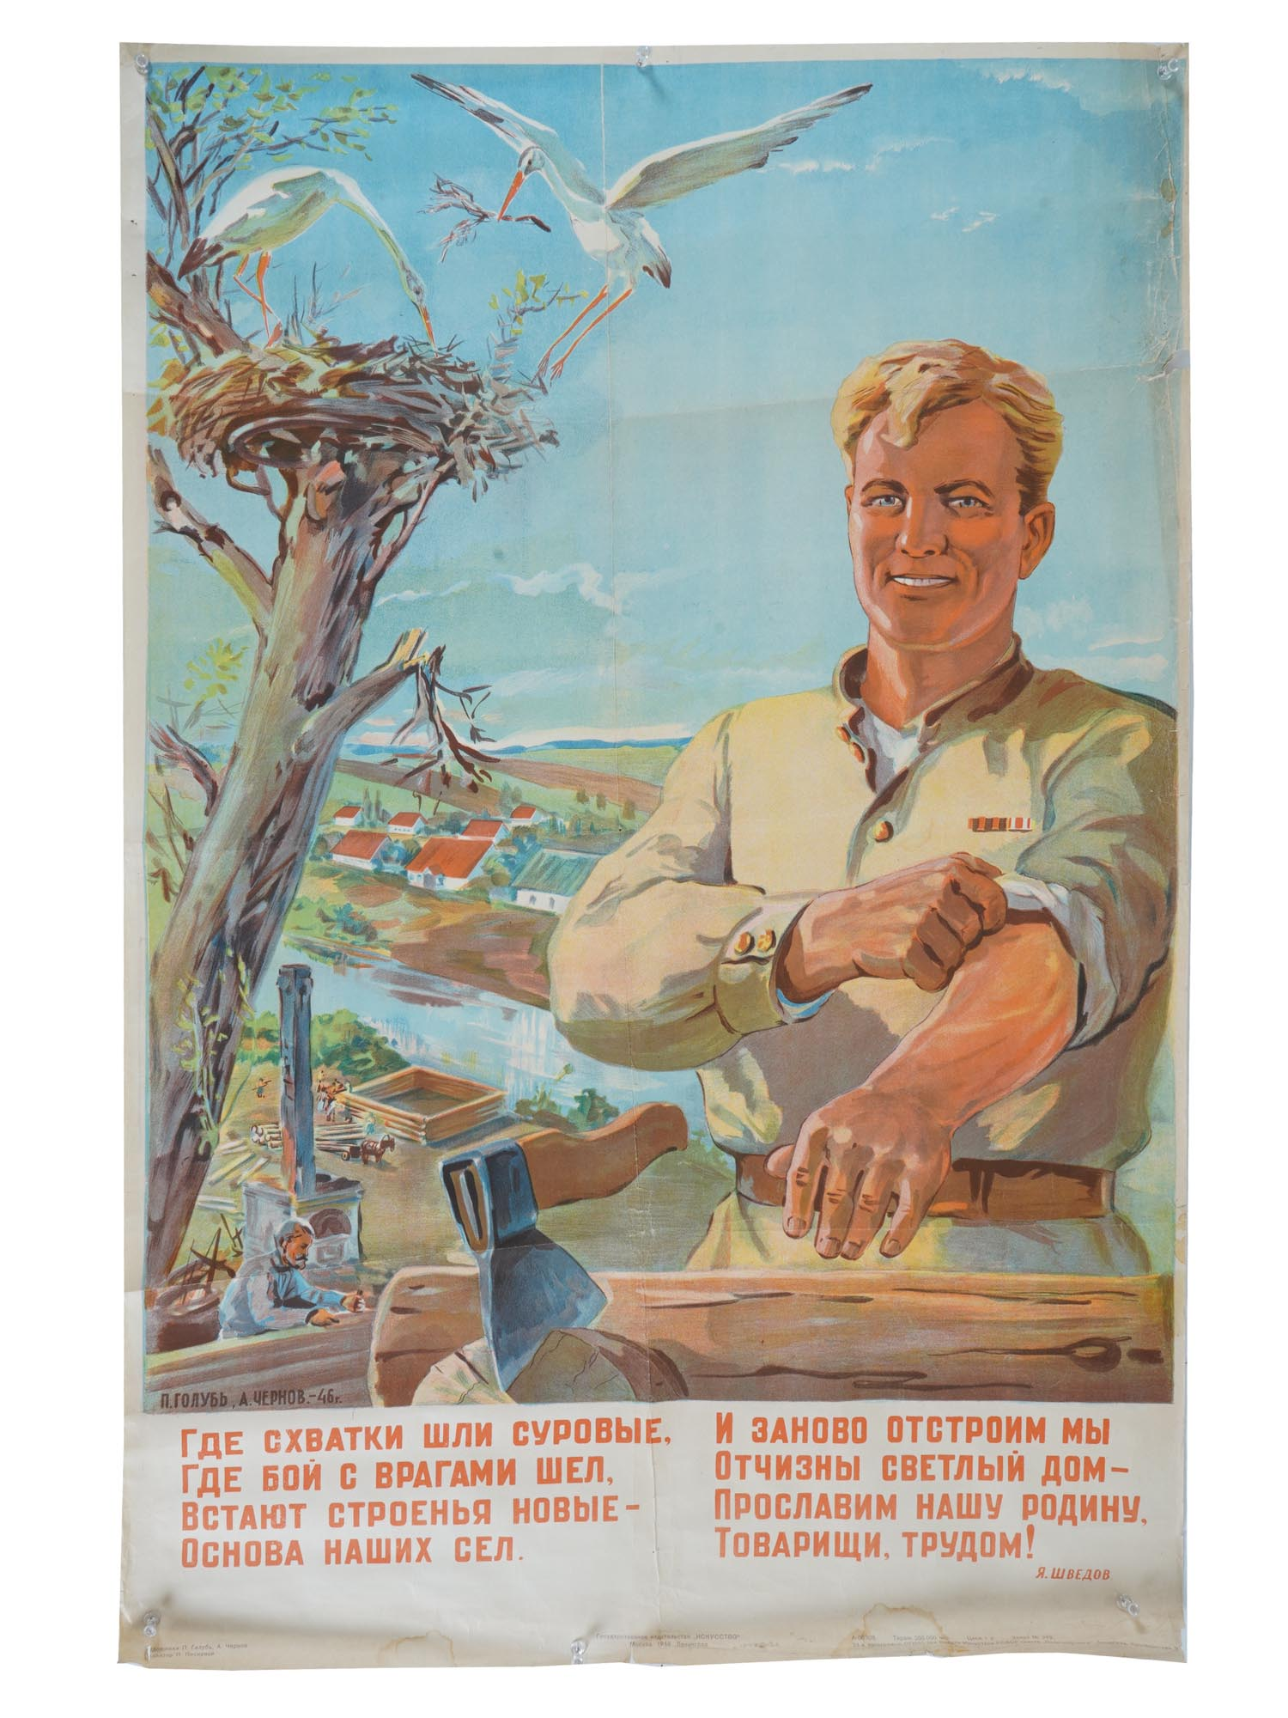

The text on this poster is a poem by Ia. Shvedov. It reads:

Where the battles were severe,
where the fight with the enemies was,
there new buildings are rising—
the foundation of our villages.

And we will rebuild
The bright house of the fatherland - We will glorify our homeland, comrades, with labor!”

P.S. Golub and A. Chernov, “Where the battles were severe…” 1946.
Source: https://permartmuseum.com/exhibit/18844

- What do you see depicted on this poster?
- What message is this poster trying to convey?
- Who is it for?
- Where do you think this poster would be seen?
- Do you think this poster achieved its goal - why/why not?

    - Now read the extract below from The Eighth Life.

During the war, Andro was persuaded to join the Georgian Legion, a breakaway army which allied with the Nazis in WWII to fight for Georgian independence against the USSR. Those in the Georgian Legion were labelled as traitors by the Soviet authorities and at the end of the war were shot or sent to Gulags (prison camps) as punishment, as in Andro’s own case. In this extract, he speaks of the Soviet soldiers who survived WWII, their lives after the war, and how they felt about the USSR:

“‘Do you know why we’re a threat, in their eyes?’ Andro began [...] Because we understand - because we’ve seen it all with our own eyes! We’re the ones who survived; we’ve come back, and they know we can't go on living inside a lie and they don't know what to do with us. [...] They want us to forget everything [...] how we've been lied to and abused. Now lots of these men are back again, in this emptiness, this darkness, and they have to start singing the praises of our state again. How do you bear that? How do you live with that? And the worst thing about it is not that this bloody war has turned us into cripples, taken away our friends, destroyed our lives, but that the war has actually legitimised the whole thing. Now they say: “Look, our great Leader led us to victory, we did it, we defeated the fascists, we survived. It was right, all of it, the path that brought us here” They say it was necessary, the sacrifices we had to make - yes: that it was necessary. And it's all so horrifically stupid, so unfair.”

- The Eighth Life, p.316.

- Compare the extract and the poster. What do they tell us about post-war reconstruction? Think about the Party narrative versus the personal narrative.
- How do these sources affect our understanding about who were the victors and who were the victims in this historical period?

Exercise 3
Before attempting this exercise, you may wish to consult materials in your textbook relating to the following topics: “Political authority and government: Khrushchev’s rise to power”; “policies and ideology”; “de-Stalinisation; political and party change”.
    - Read the following extract from The Eighth Life (pp. 382-383), which describes the aftermath of Khrushchev's secret speech in 1956, and answer the questions.
Khrushchev [...] publicly used the word ‘crimes’ in reference to his predecessor’s brutal purges. He spoke of ‘mass extermination’ and ‘execution without trial’; he also spoke of his own responsibility and asked, ‘how can we act as if we didn't know what went on?’ We are told there was an eerie silence; almost all those present [...] had participated in these arrests and executions with impressive dedication. Yet it was so unheard of for someone even to name what had really gone on that doing so called into question all the rules, structures, and internal agreements that had applied until that moment. Until then, the silence and taboos surrounding certain political practices in the USSR had signified stability for the country. Now, after these words, no one knew what was to come.
- What does the extract tell us about the contents of the secret speech?
- Who would have been present?
- How did this speech change the Party narrative?
[ In Georgia] [...] People were shocked. They felt aggrieved. Their national identity was being called into question, their great countryman, who over the course of decades had pacified the boundless Russian Empire, was being declared a criminal. Even people whose parents and grandparents had fallen victim to this countrymen of theirs could not endure the truth though they must have been aware of it for years. [...] People stormed onto the streets and boulevards, surrounded the university, blocked crossroads, rebelled against the truth. Because the victims had long since become perpetrators, the perpetrators, victims.
People were afraid of memories, of insights, knowing these might drag them into a bottomless pit, twist their own lives out of all recognition, and all of this could cause self-loathing to swell to immeasurable proportions. Besides, where was all this wretched truth-telling heading? [...] It became clear that the truth would be a hollow one, without serious consequences [...] What could you do with this view of things other than subordinate yourself to this truth until it buried you beneath it? The indescribable always builds a wall around the describable.

- Why did Georgians react so strongly to the speech, according to the extract? What happened?

    - The protests of 1956 turned violent with around 21 protestors being killed and hundreds arrested. The plaque below was erected in Tbilisi to remember those who died.

  - Do you think this plaque presents a different narrative of these events in comparison to the one given in The Eighth Life extract?
  - Who is portrayed as the victims and who as the perpetrators in the extract and on the plaque?
  - How do you think this monument contributes to the collective memory around this event?
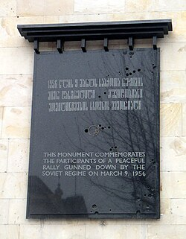

Source: Wikipedia, https://en.wikipedia.org/wiki/1956_Georgian_demonstrations

Research Task:

Research and write an article for a history focused newspaper, explaining why Stalin has maintained popularity in Georgia since his death up until the present day. Make sure you include answers to the following questions, on top of any other relevant information you find:

- Why is Stalin still popular in Georgia?
- How is he remembered in Georgia?
- What effect did WWII have on his glorification ?
- Why do you think that people in Georgia reacted strongly against Khrushchev’s secret speech?
- How do you think he will be remembered in the years to come in Georgia?

Helpful sources:

- Stalin Museum in Gori (Stalin’s birthplace) website - https://www.stalinmuseum.ge/
- Georgia Grapples with the memory of Stalin, documentary - https://www.youtube.com/watch?v=nxzjfdIgOYE
- The Ghost of Stalin and the Post Totalitarian image of Georgia, article - https://caucasuswatch.de/en/insights/the-ghost-of-stalin-and-the-post-totalitarian-image-of-georgia.html

Exercise 4 - Group discussion on history and memory

Exercise A

The extracts below are taken from The Generation of Postmemory by Marianne Hirsch (Columbia University Press, 2012).
In her book, Hirsch introduces the idea of postmemory—a concept that describes how the children and grandchildren of people who lived through traumatic events, like the Holocaust, can feel as though they’ve experienced those events themselves. Although they didn’t live through the trauma, the stories, images, and emotions passed down to them are so powerful that they become part of their own sense of memory and identity. Hirsch explains that by imagining and visualising these stories, younger generations develop “inherited memories,” which continue to shape their lives in the present, long after the events themselves have ended and despite never having experienced them directly.
With this in mind, read the extracts below and answer the questions that follow in groups:

“Descendants of victim survivors as well as of perpetrators and of bystanders who witnessed massive traumatic events connect so deeply to the previous generation’s remembrances of the past that they identify that connection as a form of memory, and that, in certain extreme circumstances, memory can be transferred to those who are not actually there to live an event.” (Hirsch, The Generation of Postmemory, p.3)

“‘Postmemory’ describes the relationship that the ‘generation after’ bears to the personal, collective, and cultural trauma of those who came before - to experiences they ‘remember’ only by means of the stories , images, and behaviours among which they grew up. But these experiences were transmitted to them so deeply and effectively as to seem to constitute memories in their own right.[...] These events happened in the past but their effects continue into the present.” (Hirsch, The Generation of Postmemory, p.5)

“The bodily, psychic, and affective impact of trauma and its aftermath, the ways in which one trauma can recall, or reactivate, the effects of another, exceed the bounds of traditional historical archives and methodologies. [...] Raul Hilberg [...] deferred to storytelling and poetry as skills historians need to learn if they are to be able to tell the difficult history of the destruction of the Jews of Europe. Hilberg is recalling a dichotomy between history and memory.” (Hirsch, The Generation of Postmemory, p.2)

“Even individual memory “include[s] much more than we, as individuals, have ourselves experienced." (Hirsch, The Generation of Postmemory, p.32)

Questions for group discussion:
- Do you think memory can be transferred or inherited?
- In your opinion, what is the difference between history and memory?

Exercise B

Read the extract below from The Eighth Life where Niza (the narrator) is addressing Brilka, her niece, directly. Throughout the book there are similar moments where Niza makes it clear that she is recounting memories and stories that she has been told throughout her life, rather than recounting historical facts.

“When I'm telling this story, Brilka, I sometimes feel as if I can't breathe. [...] It's not just because I can’t find the right words [...] It's because of the blanks. The stories overlap, intertwine, merge into one [...] you can't put the simultaneity of the world into words. [...] I often used to wonder what would happen if the world’s collective memory had retained different things and lost others. If we had forgotten all the wars and all the countries' rulers, leaders, and mercenaries, and the only people to be read about in books were those who had built a house with their own hands, planted a garden, discovered a giraffe, described a cloud [...] I wondered how we know that the people whose names have endured were better, cleverer, or more interesting just because they’ve stood the test of time. What of those who are forgotten? We decide what we want to remember and what we don’t. Time has nothing to do with it. Time doesn't care. [...] I must decide what’s worth telling and what isn’t [...] I’m fighting against my own personal, entirely subjective memory.”

- The Eighth Life, p.378

Now read this extract from an academic article by Richard Slotkin on “Fiction for the Purposes of History”:

‘Novels arise from the shortcomings of history.’[...] History is what it is, but it is also what we make of it. What we call ‘history’ is not a thing, an object of study, but a story we choose to tell about things. Events undoubtedly occur: the Declaration of Independence was signed on 4 July, 1776, yesterday it rained, Napoleon was short, I had a nice lunch. But to be construed as ‘history’ such facts must be selected and arranged on some sort of plan, made to resolve some sort of question which can only be asked subjectively and from a position of hindsight.

- Richard Slotkin (2005), “Fiction for the Purposes of History,” Rethinking History 9 (2-3): 221-236 (pp.2-3)

Questions for group discussion

- Compare the extract from The Eighth Life with the point made by Slotkin. Why do you think the authors are making this point? Does it make you think differently about how history is typically taught?
- The phrase ‘collective memory’ is mentioned in the extract. What do you think this term means? Can you give any other examples of ‘collective memory’ that you have seen in your course?
- What do you think about what Niza is saying? Do you agree with her that “we decide what we want to remember and what we don’t. Time has nothing to do with it”?
- What role do you think literature plays in teaching history and preserving memory?

Exercise 5

This extract is from the beginning of Zuleikha, where Zuleikha has just been deported from her village. After a long journey, along with the other deportees, she reaches Kazan, the capital of the region, where they are pushed into what is described as “a squat, dirty white building with tiny squares of windows [...] and a tall stone wall around it, three times her height”. The extract below recounts the moment she enters this building.

As you read, think about how the author describes the prison cell and its atmosphere.

Voices carry from behind heavy doors that have tiny windows with crosses in their gratings: Russian, Tatar, Mari, and Chavush speech; songs, cursing, a child's crying…
“Could use some water, boss! Need to drink…”
“...I must ask you - no, I demand an attorney! A Soviet court should …”
“I want a woman, commander. Bring that one to me, huh?”
“... I beg you, the telephone number is 2-35. Just say you're calling on behalf of Pavlusha Semyonych…”
“I’ve remembered! I've remembered everything! Send for the Investigator Ivashov! And tell him Sidorchuk will sign the confession…”
“...and you will burn in the fires of Gehenna until the end of time…”
“...I’m begging you! Aspirin! The child has a fever…”
“On Deribasovskaya Street they’ve opened a new bar. It's loud with beer, and there, my dear, is where the jailbirds are…”
“... Let me go, sons of bitches! Bastards! Scum! Ahhhh!”

[...] The young soldier nods: In here. Zuleikha steps into an inky darkness that breathes with the smell of bodies long unwashed; the cold metal door nudges her forwards. A lock clicks outside. She listens to many moths breathing as she waits for her eyes to grow accustomed to the dark. [...] two tiers of bunks are crowded with people. Others sit on the crates, on heaps of old clothes, and on the floor. There are so many people that there's nowhere to move to. A mother whispered a fairytale to her child. In one corner they’re murmuring, “Lord Jesus, have mercy upon us sinners” while another voice pleads to Allah for refuge from the devil.

- Zuleikha, pp.127-8

- Instead of describing what the prison cell looks like, the author imagines the multitude of voices and sounds that Zuleikha hears when she enters the prison. Why do you think the author chooses to do this? What does it achieve?

- How does this method of recreating historical scenes differ from the way you would learn about this same scenario in a history textbook? What effect does it have?

Now read these extracts from an academic article by Laura Saxton which explores the definitions and distinctions between ‘accuracy’ and ‘authenticity’ in historical fiction:

Accuracy denotes the extent to which a text’s representation is consistent with available evidence. [...] Authenticity, however, refers to an impression of accuracy and the extent to which readers believe that a representation captures the past. (Saxton, “A True Story,” p.2)

Accuracy is, to a degree, measurable because we can compare the details found in novels to details that have been uncovered by historical research.[...] In contrast, authenticity is the impression that a text is accurate, even if it is not, and this sense of authenticity can be shaped intertextually, culturally, and subjectively. (Saxton, “A True Story,” p.3)

The categories of ‘accuracy’ and ‘authenticity’ provide language that acknowledges historical novelists do not merely add colour to facts but offer their historical interpretation [...] In taking the viewpoint of an historical individual, [...] historical fictions must imagine that person’s thoughts, motives, emotions, and the minutiae of their lives. The truth of such details is often lost from the historical record and thus we are unable to assess whether the writer’s interpretation is accurate. (Saxton, “A True Story,” p.5)

- Laura Saxton (2020), “A True Story: Defining Accuracy and Authenticity in Historical Fiction,” Rethinking History 24 (2): 127-44.

Questions:

- To what extent do you agree with the point that Saxon is making between accuracy and authenticity?

- In your own experience, have historical dramas (novels, TV shows, films) felt ‘authentic’ to you? Explain why (or why not), referring to a specific example (something you have recently read or watched).

- What other sources of information would we need to consult to determine the “accuracy” of the above extract from Zuleikha? Think about:

  - Which parts of the extract would it be more difficult to confirm the “accuracy” of?

  - Does the extract feel “authentic” to you? If so, what makes it feel authentic? Refer to specific details from the text in your answer.

Homework - Writing task

- Research and give a brief explanation of the following ethnic groups mentioned at the beginning of the extract: Tartar, Mari, Chavush

- Imagine you are one of the people in this cell and that you are writing a letter to a close friend or family member recounting what has happened to you and how you have ended up there. Include details such as:
- Where you are from and for what reason you were taken away from your home.
- What happened before and the events leading up to you arriving in the cell.
- What the conditions in the cell are like.
- What you think will happen to you, what will happen next.

Exercise 6

Read this excerpt from The Eighth Life. It is from the first chapter following Stasia’s early life. At this point in the book, she has just got married to Simon Jashi, a Georgian Red Army Officer.

Tasks while reading the text:

- Think about which parts give you a feeling of what the atmosphere was really like during these years and highlight them.

- There are clues throughout this extract in the form of dates, events and prominent names which tell us what was happening on a wider political and historical scale. In a different colour highlight these references and annotate them with your existing knowledge of what was happening at this point, including dates and details of your own.

Simon left town barely two weeks after the wedding [...] All this happened at the start of the chaotic year 1918, the same year that our countryman, who was simply called Joseph Koba, or, affectionately, Soso, was made commander of Trotsky’s Red Army.

Only after several requests did Stasia manage to discover exactly what her husband was doing: he had joined the RKKA, and was responsible for procuring bread.
Since January 1918, Russia had been in the grip of terrible hunger. The RKKA had the task of confiscating bread; farmers were unable to maintain the required rate of production, and were subject to looting and raids.
In May of the same year, the first Democratic Republic of Georgia was proclaimed. [...] Stasia and her husband agreed that she would follow him in February. After months of waiting, she could stand it no longer, and , when summer arrived, she informed her father that she wanted to go to her husband and stand by him, come what may.

[...]

When, in July, the telegrams stopped, concern for her husband finally brought Stasia’s free thinking ideals crashing down, and she went to the Church of St George, sought out the priest, Seraphim, and asked him for help. [...] He went to Stasia and whispered in her ear that a carpet-seller had agreed to take her as far as the station in his coach. He couldn't get her past Military Road, but if she dared to make the long train journey alone in these troubled times, then he would get her to the train.

[...]

In the meantime, the Russian Empire, so recently powerful, sank ever deeper into chaos: the expropriation and communisation of property, banks, and housing, and the downfall of the free-market economy, had catastrophic consequences. As did replacing the courts with the so-called people’s tribunals.
The whole country was in the grip of unrest, as there were not enough professional organisers to implement these radical reforms. The Soviet Constitution, established in July, denied entire social classes in the country their rights. Only eight months after the revolution, a leadership profile had established itself that would lead inevitably to civil war: the concentration of power in the hands of a few leaders, the pursuit of economic and information monopolies, and discrimination against certain sections of the population.
And, by the time Stasia reached Petrograd, Nicholas II and his blue blooded family were no longer alive. Their story had ended anonymously with shots fired in a cellar in Ekaterinburg.
But, as yet, Stasia knew nothing of this. Nor did she know where Simon Jashi was to be found .
She wandered the cold streets of Petrograd, asking for her husband in her accent-free Russian, which was spoken at the time by every sophisticated lady on her side of the endless Silk Road.

[...]

Uniformed men were patrolling the countless bridges. Peasants pushed wheelbarrows laden with furniture; there were endless queues outside the shops, and people were running about with worried faces. Even the river, murky, angry, and loud, seemed to be in tune with this strange atmosphere.
Outside the imposing St Isaac’s Cathedral, a public assembly was taking place: a large crowd of people stood holding banners and constantly shouting noisy slogans.
On the Fontanka - the riverbank promenade with its freen and pale yellow villas and courtyards - people were clustering around fire pits where food was being prepared. The manicured city of the tsars seemed absurdly contradictory as a backdrop to these goings-on.

Stasia eventually contacts her father as she is in need of somewhere to stay, given that she cannot find her husband. Stasia’s father tells her to find the house of a relative called Thekla who lives on the riverbank. After asking around she eventually finds it.

She [...] knocked on the classical villa’s monumental iron door - no, she positively hammered on it with the door knocker, as a column of shouting people was coming up the promenade towards her [...] eventually a frightened girl wearing a traditional Russian headscarf opened the door and hastily bundled Stasia into the house without saying a word. Then she slid home the numerous bolts and barricaded the door with furniture.
Cautiously, Stasia looked around. She found herself in one of the most beautiful houses she had ever set foot in. A marble staircase led up from the wide, welcoming entrance hall. The floor was inlaid with beautiful black and white tiles. Stasia was shown into a light spacious drawing room, in which, to her surprise, there was no furniture beyond a fantastically long oak table and two chairs.

[...]

After a while she heard footsteps and a woman appeared at the top of the staircase. [...] She was wearing a pale-pink dressing gown decorated with a feather collar [...] she ordered the peasant girl, who was the only servant to have stayed on in the house, to prepare some strong tea and fetch some biscuits from the pantry. ‘But biscuits are for emergencies,’ the girl muttered, before being silenced by a stern look from the lady of the house.
‘And what does this look like to you? My own flesh and blood, arriving here from my homeland in times like these…What do you think it is?’

[...]

[Thekla says] ‘Those swine may have taken everything they could find, but I'm still permitted to remain in the house. There are two beds left. And I think this is a temporary state of affairs. Those imbeciles can't stay in power forever, the resistance is too great, and then…Then everything will go back to how it was before. I’m so glad you're here, Anastasia. Since those idiots started ramapaging around, a lot of my friends have fled abroad or taken to hiding in their houses, and it's grown rather lonely here.’

The house really was outrageously large. But the absence of furniture made it seem like a strange purposeless palace. Like a warped memory of a place from before.

Thekla also kept a large, secret cellar of provision, which the Bolsheviks had not been able to access. It was full of wonderful things: peppers pickled Venetian style, artichokes from Greece, chocolates from Moscow, jams from the Crimea, Spanish ham, English butter biscuits, and several bottles of expensive wine, cognac, and even champagne.
Every day, Masha, the peasant girl, who had remained with her mistress more out of hopelessness than loyalty, conjured up a small portion of these delicacies to go with the daily bread rations and the two or three eggs she managed to brain on her forays into the city
[...]
Stasia noticed that sometimes, before the peasant girl went out into the city, Thekla would slip her a necklace or a ring and whisper something to her. On those days Masha usually brought back more than just eggs and bread.

[...]

The lady of the house had as little interest in knowing about the civil war raging around her as did the house itself. Thekla dressed and made herself up as if she was hosting a gala dinner in the house every night - as if, at any second, they would smell the aroma of delicious food, the great front door would open, the high society guests would stream in, an orchestra would immediately start playing, and stylish ladies and gentlemen would take to the floor for a foxtrot, just like before.

The house had been looted months ago, but Thekla had succeeded in bribing the Bolsheviks to let her stay; it must have cost her a great deal of money, or other goods, as they were in the middle of a brutal civil war over expropriation and living space.
[...] Thekla harbored the illusion that one merely had to wait it out [...] and soon this idiotic putsch would be over, too, and everything would be the same as before. [...] Countless friends had already left the country, or had simply disappeared, but she refused to even entertain this possibility for herself. She lived in hope, and she needed this hope like she needed air to breathe.
[...] They played cards together in these events, ignoring the noise outside, the screams, the footfalls, the slogans, the threats, the hammering, and yes, also the occasional shot.

[...]

Outside, hundreds of thousands of workers went on strike against ‘the dictatorship of the communists,’ businesses were crippled, hunger brought more and more criminals into the city, pogroms took place as regularly as clockwork, and the bread ration fell to a hundred grams, while the Cheka, which was already operating successfully, went on arresting and shooting people. Meanwhile, the two of them sat there drinking tea and playing patience, in the relief that the horror would not find its way into the house.

[...]

As the cold set in, it seemed to spur the people on to greater bitterness and cruelty. Here and there, government buildings and houses in the neighborhood were burning. And the shots were now an everyday occurrence.
The ominous quiet of isolation reigned in the big house on the Fontanka, an ice-cold peace and a preserved past; but the present reigned outside, on the streets, on the grand promenades and riverbanks, and it as cruel, bloody, dangerous, full of hunger and want.

On the first day of New Year, Masha gave her notice. [...] Stasia and Thekla knew neither what to do in the miserably long bread queues to make sure they actually got bread, nor even where the back market was located. Without Masha they would starve, they would perish, and they would quite certainly go mad - of this they were sure.

In March of the year 1919, workers began to strike in all the notable factories of Petrograd. And Masha finally left them. She had inducted Stasia into everything: she had twice taken her to buy bread, introduced her to a Siberian girl who knew people from the black market and would help her in emergencies, and explained the principles of shoving, shouting, and getting oneself noticed, which were needed in those times in order to survive. [...] Standing in the endless queues from bread, Stasia eavesdropped on people angrily discussing the country’s future. The front at the Don, the front at Kharkov, the front at Novgorod, the front near Minsk, the front near Irkutsk - the very word ‘front’ made her feel sick. The peasants just wanted to be left in peace. The Cossacks wanted to defend their independence and their worldly possessions; the monarchists didn’t want to cooperate with the Mensheviks because they were collaborating with the Red’s; the Mensheviks were drawing even closer to the Bolsheviks, to escape the chaos of the monarchists and the liberals; while people with no affiliations, anarchists, and criminals were taking advantage of the situation: they were seeing to their own prosperity and earning money on the black market.

[...]

In the summer of 1920, Stasia reached the second anniversary of her Petrograd imprisonment. [...] [Stasia said to Thekla]

‘I can’t go on like this. One way or another, they'll take the house from you, or people will just break in and stay here. Only yesterday I had to threaten two of them with a carving knife again, when they tried to climb in through the cellar. If only I had a gun - they're more afraid of those than of my knife… I don't have the strength any more to stand in the queues for hours, to always be afraid that somebody's going to break in and cut our throats. A silver ring and a chain are all that's left in your casket. The bonds you still own are with nothing any more, and the tsar is dead. I know you don't want to believe it but it's true. You've always said, Nicholas will come back, he won't hand over his country to these wretched drinkers, but that's not going to happen. They shot the tsar almost two years ago. In Ekaterinburg. His children, his wife - they're all dead. We're at war. Everywhere is at war. It will never again be like it was before. Never. I'm sorry. Be we have to do something, Thekla. I'm going home’

- The Eighth Life, pp. 50 - 66

Questions:

- Look back at your highlighted extracts, in what way do they give you a sense of the atmosphere of this time? What tools does the author use to do this? Do you see any similarities with the author of Zuleikha’s literary techniques?

- Does reading these historical events through a personal perspective affect the way you think about them? If so, how?

- Why do you think the author has written about the civil war in this way, rather than listing the facts?

- There is a strong difference between life inside and outside Thekla’s house, why do you think the author has chosen this setting?

- The word ‘before’ is mentioned multiple times. What is this in reference to and how does that era differ to the one playing out in this extract?

All exercises refer to the following editions: Nino Haratischvili, The Eighth Life (for Brilka), translated by Charlotte Collins and Ruth Martin (Scribe Books, 2019); Guzel Yakhina, Zuleikha, translated by Lisa C. Hayden (Oneworld Publications, 2019).

