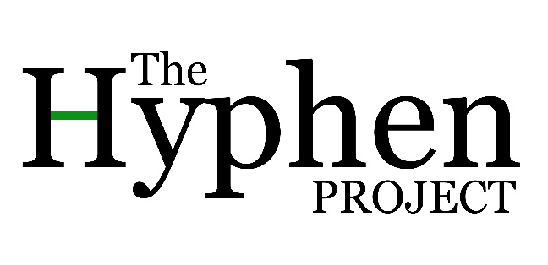

Interview Consent Form
Research project title: The Hyphen Project Research investigator: Dr Grace Milton
Thank you for submitting your story as part of the Hyphen Project. We don’t anticipate that there are any risks associated with your participation.
This consent form is necessary for us to be sure that you understand how your data will be treated and the rights you have as a participant. Would you therefore read the accompanying information sheet and then sign this form to confirm that you understand and agree.
What will happen?
- Your submission will be analysed by Grace Milton (the Researcher).
- Your name and any identifying information (such as church name or location) will be changed to protect your identity.
- You will be invited for a follow-up meeting to discuss the transcript, any changes you wish to make and anything that you would like to clarify. The Researcher will also share some of her analysis with you at this stage to make sure that you are happy with the way your story is being interpreted.
- Access to the (anonymised) document will be limited to the Researcher and academic colleagues and researchers with whom she might collaborate as part of the research process.
- Any summary content, or direct quotations from your submission, that are made available through academic publication or other academic outlets will be anonymised so that you cannot be identified, and care will be taken to ensure that other information in the interview that could identify you is not revealed.
- The submission will be kept for ten years following completion of the project and then deleted. This is in line with the University of Birmingham’s Code of Practice for Research. If you choose to leave the study (within three months following submission), your transcript and data will be deleted immediately.
Any variation of the conditions above will only occur with your further explicit approval

How will data be used?
You will have the opportunity to review the transcription of your interview and make any changes that you wish. You will also have the opportunity to discuss the researchers’ initial analysis of your interview and make comments and corrections. Once this process has been completed then the final anonymised transcript may be used as follows.
All or part of the content of your interview may be used;
- In printed and online resources made available for churches
- In academic papers, policy papers or news articles
- On our website and in other media that we may produce such as spoken presentations
- On other feedback events
- In an archive of the project as noted above

Agreement
By signing this form I agree that;
- I am voluntarily taking part in this project. I understand that I don’t have to take part;
- I can withdraw my involvement in the project within three months after this submission by contacting the researcher.
- The anonymised written submission or extracts from it may be used as described above;
- I have read this Information sheet;
- I don’t expect to receive any benefit or payment for my participation;
- I can view a copy of the anonymised story and make edits I feel necessary to ensure that my identity has been protected;
- I have been able to ask any questions I might have, and I understand that I am free to contact the Researcher with any questions I may have in the future.
Printed Name_____________________________________________________________________

Participant’s Signature _____________________________________Date ____________________

Researcher’s Signature _____________________________________Date ____________________
Contact Information
This research has been reviewed and approved by the University of Birmingham Research Ethics Board. If you have any further questions about this study, please contact:
Name of researcher: Grace Milton Full address: Edward Cadbury Centre, Department of Theology and Religion, University of Birmingham, Edgbaston, B15 2TT E-mail: g.milton@bham.ac.uk
What if I have concerns about this research?
If you are worried about this research, or if you are concerned about how it is being conducted, you can contact Susan Cottam (Research Ethics Officer, University of Birmingham) at s.l.cottam@bham.ac.uk.

