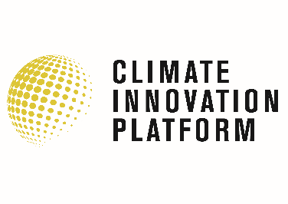
Climate Innovation Platform – Cohort 5
Core Application Questions
Word limit for most questions is 200 words, unless otherwise specified.

- Can you simply describe the innovation and the business opportunity? (Maximum 300 words)
- What environmental, societal, and/or economic impact will your innovation or business have, and how does your innovation reduce carbon emissions?
- Does your innovation change the market through a transforming technology or a new business model?
- What are the differentiating features (product capabilities), functions (uses of the product and features), and/or benefits (advantages delivered to the intended customers or users)?
- What IP can be or has been protected?
- Who are the primary customer groups (target groups)?
- What are the team’s core competencies, what gaps exist, and how will these be developed?
- How do you plan to scale the business?
- What funds are available now, and will these last long enough to complete the commercialisation journey? (Please specify – public and private funding.)
- What funds are required in the next 12–18 months, and what funding opportunities are you currently engaging with? (Please specify – public and private funding.)
- What are the benefits of the CIP programme to you, and how will working with the University of Birmingham / Energy Systems Catapult / Tyseley Energy Park / Sustainable Ventures support your business development?
- Please share if you are interested in desk, office, and/or workspace*. (*Unmarked question)

