 | The School of Biosciences

This is a series of practicals we have run for our own students and in schools.

It work best with real bone replicas which we obtained from the following suppliers

- Bone Clones http://www.boneclones.com/index.html
- 3B scientific http://www.3bscientific.com/global/3bscientific/index.cfm/abspath/com/domainID/2/Language/1/search/meta also have quite a good range of products.
- Timstar http://www.timstar.co.uk/ is the supplier we bought the human skeletons from

For those of you who don’t have real fossil replicas there are a set photographs of the material with scale bars in a folder on our web site

- http://www.biosciences.bham.ac.uk/links/teachers/teachers.htm, follow ‘secondary school resources’

You can either measure these on the screen or print them out for the students to use

Forensic examination of Human fossils

What is a species?

Biologists define members of the same species as organisms that can mate to produce fertile offspring. With fossils we cannot do that, so we have rely on what they look like. Because appearance can be a matter of opinion, there have been many disputes about classification of hominids (a hominid is all human relatives including chimps and gorillas whereas hominin refers to those organisms in the lineage following the split from chimps about 6 MYA).

If we use what something looks like as our species definition then we might put males and females, or young and old individuals into different species. So, as biologists, we need to know something about the variation in a population to give us more confidence in our allocation of organisms into different species.

The aim of this practical is to:

- introduce you to assessing variation in populations
- to determine how brain size has changed over evolutionary time.

Exercise 1: Human evolution

Put the fossils in the following order: (This sequence represents the proposed sequence of evolution of these hominids)

- Ramapithecus
- Australopithecus africanus
- Homo habilis
- Homo erectus
- Homo ergaster
- Homo sapiens (cro magnon)
- Homo sapiens (modern)

Think about the difference between individuals 2 and 3 – what characteristics mean that Australopithecus africanus is not in the genus Homo?

Compare 4 & 5 with 6 & 7; what features do you think justify the classification of 6 & 7 into sapiens?

You have not used all the replicas – where do you think the others fit in the sequence?

  - How might material from juveniles and different sexes affect the analysis?

Exercise 2, Evolution of brain size: Variation

If you only have a small number of fossils you will need to have some idea of the variation in the character you are measuring in order to decide if you have two members of the same species or two members of different species.

In this exercise we will get an estimate of the brain size of the people in this room to get a feel for the amount of variation in a population.

For the human skull(s) look at how the brain fills the cranium. The space it is in can be defined by the brow ridges and the hole behind your ear (the mastoid process). Obviously your neck prevents you following your brain case right round as you can for the skull, so you will have to guess this bit. Estimate your own brain size use the following procedure:

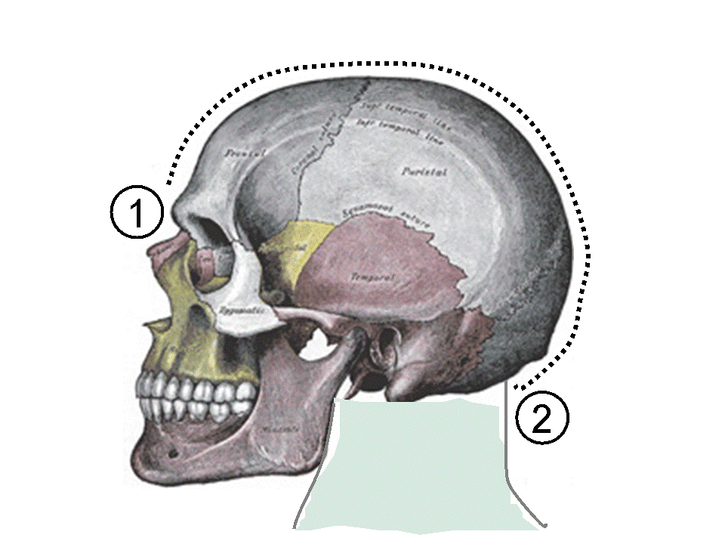 | 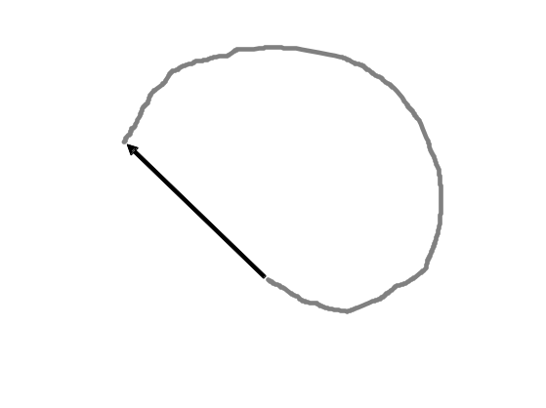
Lay your head (ear down) on a piece of A3 paper. Get a friend to draw round your head. | Draw a line between the ends of your trace to complete the shape

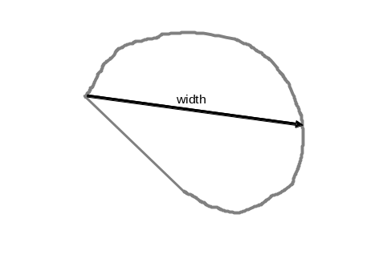 | 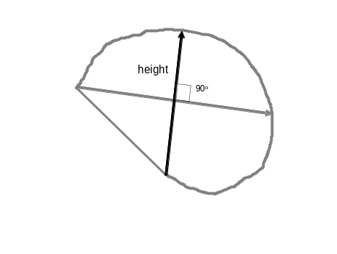
Draw a straight line from the brow ridge where you started drawing to the back of the skull. Measure the length of this line to the nearest half cm: this is the skull width. | Draw a second line from the mastoid process where you stopped drawing to the top of the skull. This line should be at approximately 90º to the width line. Measure the length of this line to the nearest half cm: this is the skull height.

Calculate the average skull diameter by taking the average of the height and width. Read your brain volume from the table on the next page. Record this value here:

My brain is cm³

Enter your brain size in the male or female column on the laptop. Also, weigh yourself and put your weight next to your brain size – this information will be important in interpreting the data. You will see a graph of males and female cranial sizes appear as you put in your data.

- Is there a difference between male and female brain size?

- If there is difference between male and females, can you think of a reason for this? (it might help to look at a plot of weight vs. brain capacity)

Skull average diameter | Brain capacity
8 | 148
8.5 | 183
9 | 223
9.5 | 270
10 | 323
10.5 | 383
11 | 450
11.5 | 526
12 | 611
12.5 | 704
13 | 808
13.5 | 922
14 | 1047
14.5 | 1184
15 | 1333
15.5 | 1495
16 | 1671
16.5 | 1861
17 | 2066
17.5 | 2287
18 | 2524
18.5 | 2778
19 | 3050
19.5 | 3340
20 | 3649
20.5 | 3979
21 | 4329
22 | 5094
23 | 5952
24 | 6908
25 | 7969
26 | 9141
27 | 10432
28 | 11848
29 | 13397

Exercise 3: Clever than an ape? How has brain size changed during evolutionary time?

Brain size is one character used in classifying hominoid fossils. Estimate the cranial volume of the skulls using the same procedure you used for yourselves. Put the data in the table below.

 | Age (Million Years ago (MYA) | Brain size (cm³)
Paranthropus boisei | 2
Homo habilis | 2.5
Australopithecus africanus | 3
Homo erectus | 1
Homo sapiens (modern) | 0
Homo neanderthalensis | 0.1
Pan troglodytes | 0
Ramapithecus | 7.5
Homo ergaster | 2.0
Homo sapiens (cro magnon) | 0.04
Gorilla gorilla | 0
Me | 0

Plot a graph of age vs. brain size (put yourself on if you dare!!).
Cranial capacity (cm³)
0
 | 0 |  | 0.5 |  | 1 |  | 1.5 |  | 2 |  | 2.5 |  | 3 |  | 3.5 |  | 4 |  | 4.5 |  | 5 |  | 5.5 |  | 6 |  | 6.5 |  | 7 |  | 7.5

Age (MYA)

Exercise 4; Sexing material

In this session you will obtain forensic information from skeletal material. These techniques are used both for the study of archaeological finds dating back to the early stages of human evolution and in modern day forensics. If skeletal material is in good condition it is possible to identify the sex of the individual, age at death, height, illnesses during life and cause of death.

Using the skeletal characteristics guide at the end of this book, establish whether a modern human skeleton is most likely to be male or female, according to the following characteristics:

Sex characteristic | Male | Female | Indeterminate
Sub-pubic angle
Sciatic Notch
Sacrum
Brow Ridge
Forehead
Mastoid Processes
Nuchal Crest
Mandible - overall
Chin shape
Goneal angle
Total

The sex of the skeleton is probably:

Exercise 5: How tall is a skeleton?

The most accurate way of estimating stature from skeletal material when you don’t have the entire skeleton is to measure the length of the long bones. You would expect the length of the long bones to be proportional to height – but is this true?

Measure your height and the length of your femur (upper leg bone). Put your data into the computer at the front of the lab so we can get a class estimate. Sketch the class data plotted on the computer.

You
Height (cm)
Femur (cm)

- Do your results suggest that it is possible to predict height from femur length? Can you get a linear equation to use on other material?

- Is there sexual dimorphism for this character among the group?

- Use the relationship you have obtained to calculate the height of the modern human (HS_modern_HF.jpg) and Homo ergaster (Ergaster_HF.jpg).

- Class relationship between height and femur length
Femur length
Height

Exercise 5: How did an organism walk?

- Now you have analysed the time course of brain size evolution the following exercise will in allow you to compare this with the evolution of bi-pedalism.

- The humero-femoral index is an important measure in the analysis of locomotion as it can reflects differences in how they walk.

- It is calculated as [humerus length x 100] / femur length.

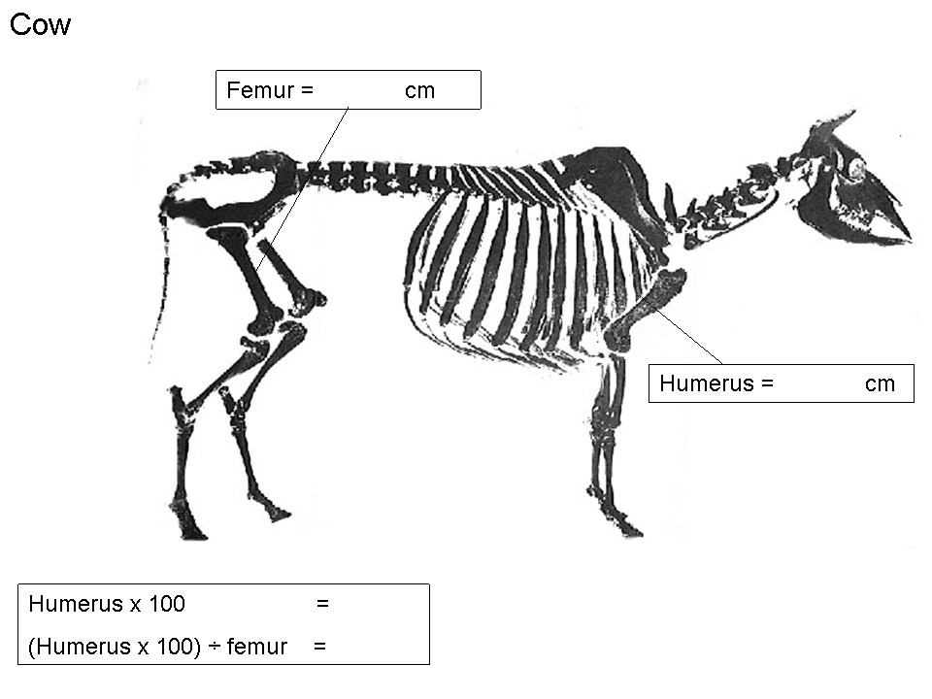

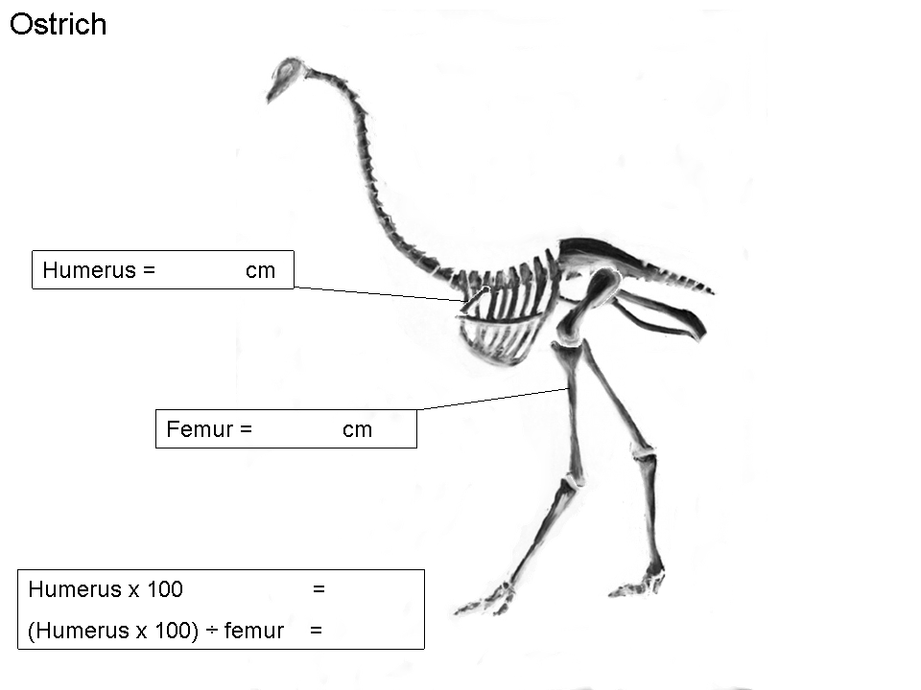
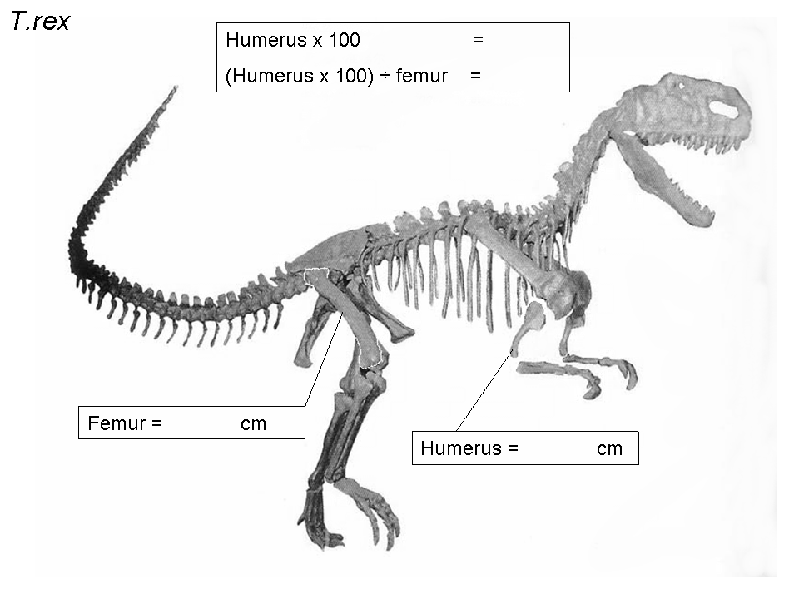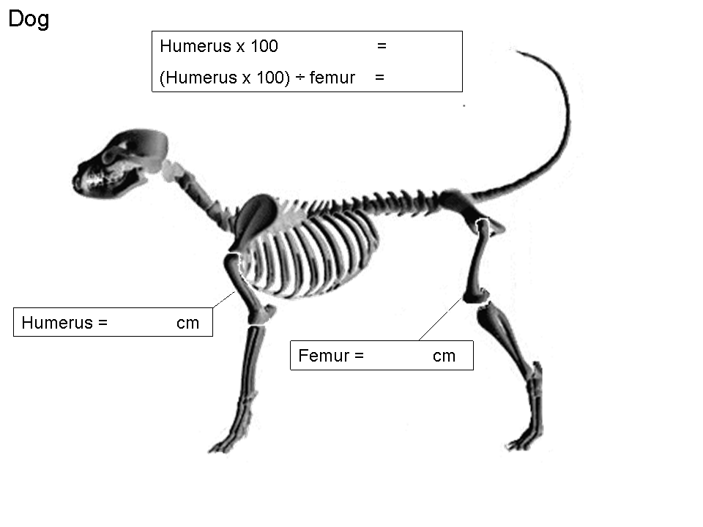
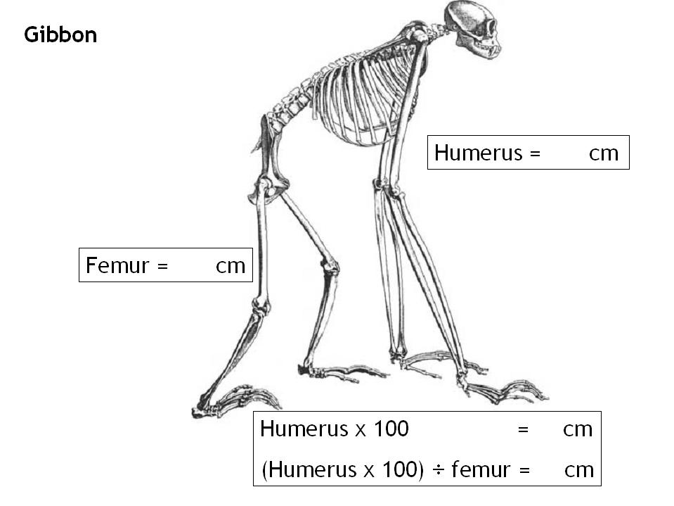

Calculate the Humero/Femoral index for each organism

Animal | H/F index | Mode of locomotion
T. rex
Ostrich
Dog
Gibbon
Cow

What does the H/F index tell you about how an animal moved around?

Calculate the index for the modern and fossil hominids.

 | Humerus length | Femur length | Humero-femoral index
Modern human
HS_modern_HF.jpg
Gorilla
Gorrilla_HF.jpg
Chimp
Chimp_HF.jpg
Me (i.e. you)

Homo ergaster
(Ergaster_HF.jpg
Australopithecus afarensis
Picture
Homo Neanderthalensis
picture

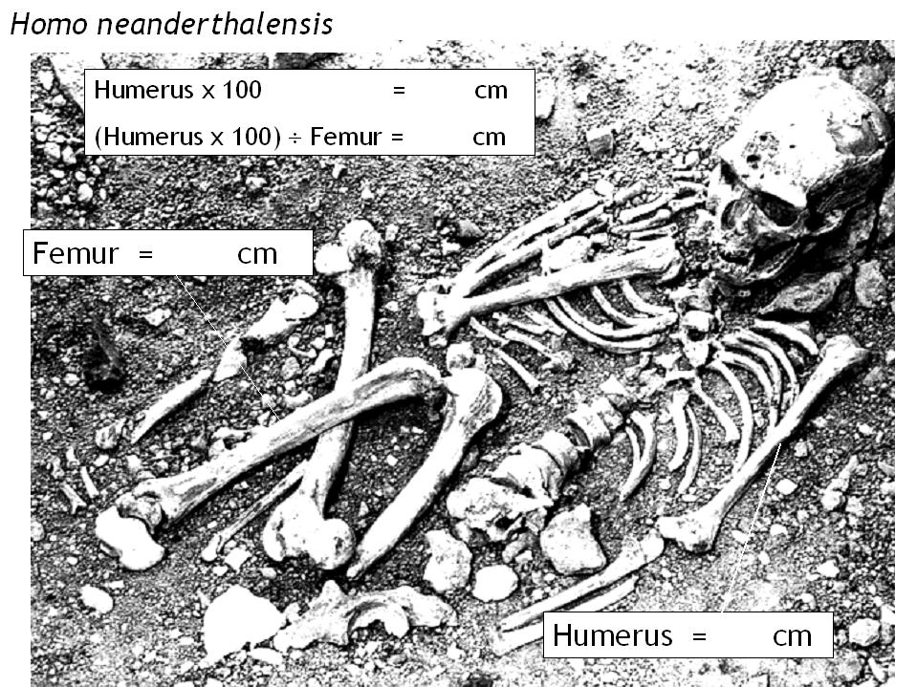

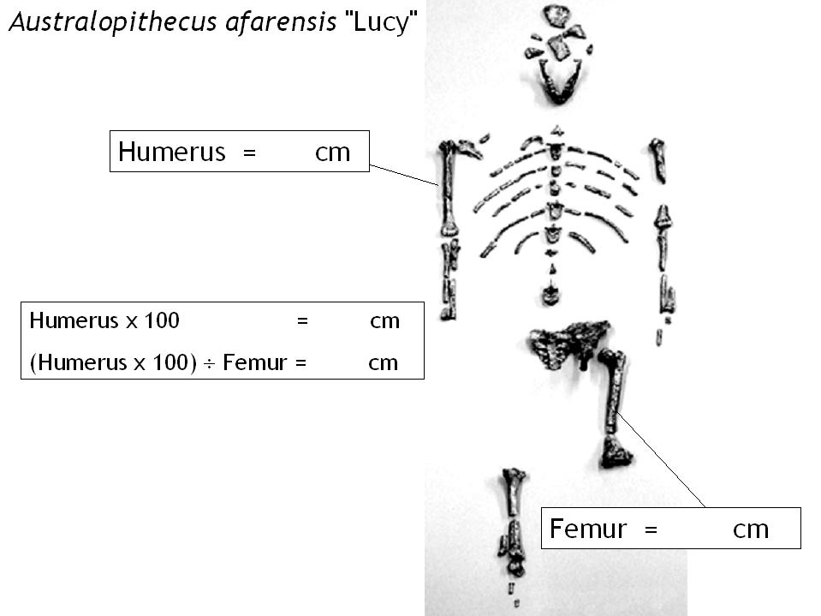
Appendix
Human Skeletal Characteristics guide

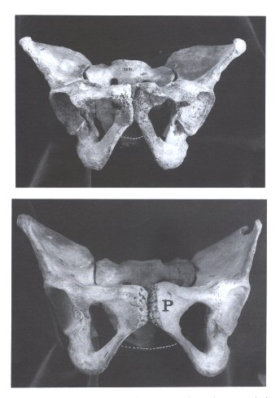
SEX
Figure 1
♂
♀

The pelvis

In general the female pelvis is broader than the male due to it forming the birth canal. The greater width of the female bony pelvis manifests itself in a number of ways. An important area is the sub-pubic angle of the pubic bone, part of the front of the pelvis shown with arrows in Figure 1. In females it tends to be wider and more U-shaped whereas in the male it tends to be narrower (generally less than 90º) and more V shaped.

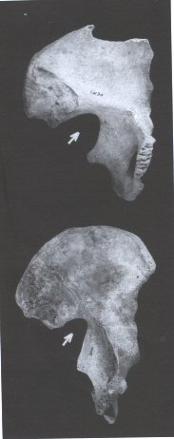
♂
♀
Figure 2
One of the clearest distinctions between the male and female pelvis is the Sciatic Notch (indicated by the arrows in Figure 2).This is situiated on the posterior part of the pelvis. It is wider and shallower in females than in males, which is another manifestation of the broader female pelvis.

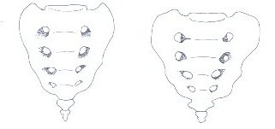
♂
♀
Figure 3
Figure 2

The sacrum (your tail bone!) at the back of the pelvis also gives an indication of sex. In the female the coccyx (the very tip of the sacrum) is relatively and absolutely smaller in comparison to the rest of the sacrum than in the male.
The Skull

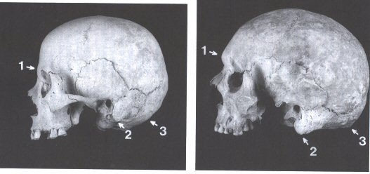
♂
♀
Figure 4

Key areas of the skull for determining the sex of skeletons are shown in Figure 4. The Brow Ridge (1) is more developed in the male and the forehead is more sloping. In the female the brow ridge is smaller and the forehead more vertical. The Mastoid Processes (2) and the Nuchal Crest (3) are more developed in the male.

The Mandible

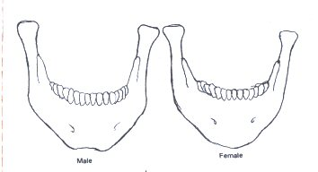
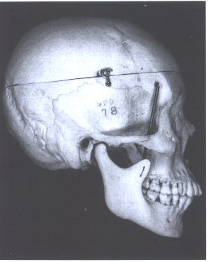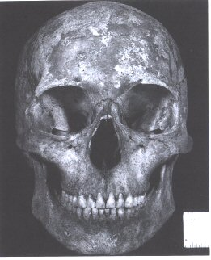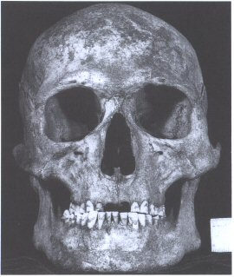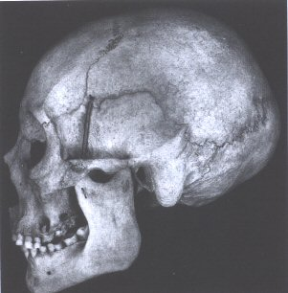
♀
♂
Figure 5

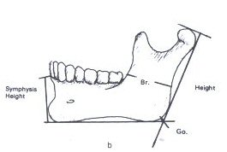
The mandible (jaw bone) is comparatively shorter, narrower, more gracile and lightweight in females than in males (Figure 5). Males also have a squarer chin than females, often with a slight dimple.
Figure 6
Goneal Angle

The Goneal angle (Figure 6) is another indicator of sex in the mandible. In females it is generally obtuse (>125°) and rounded, whereas in males it is acute (<125°) and more rectangular.

Note for teachers: see the Introductory lecture on Human evolution on the web site which may provide useful background material.
This is asking about the morpho species concept but takes no account of variation within a species. It helps to focus on qualitative differences rather than quantitative ones
There are pictures of juvenile skull material on the web site
The students will need to be familiar with the biological and the morpho (or phenetic) species concepts to fully grasp this.
Students nearly always fail to get to the mastoid process and therefore underestimate their brain size.
Note for teachers: this is based on an empirical relationship – it tends to overestimate when used by enthusiastic students. You can tweak the number down if needed. You may need to reassure small brained pupils that this is not a real measure of brain size! I usually discuss the various sources of error at this point.
You may get some problems with measuring weight – stress that this is anonymous, the computer and the scales can be sympathetically placed
Plot males and females separately. Weight and brain size usually show sexual dimorphism but the ratio does not. This is useful in discussion of what a species is. For fossils you have to use the morpho-species concept (not the biological species concept). If there is significant sexual dimorphism then males and females would be classed as different species.
A leading question – this invariably stimulates debate about whether a large brain makes you more intelligent and indeed, the nature of intelligence.
Brain size should increase in our ancestors, but remains around 400 cm³ in chimps. Worth pointing out that both we and chimps are equally fit (i.e. we are here at present). A large brain is not necessary for evolutionary success. Indeed it is useful to consider both costs and benefits of a large brain.
Note for teachers – see the power point pictures of skeletons on the CD – these have been used with primary school kids to introduce the idea of the humero – femural index but are probably a good introduction to this practical.
You really need a full human skeleton for this
There are male and female skull pictures on the web site
If you can’t get a relationship use Height (cm) = 2.6 x Femur length (cm) + 65
Plot males and females separately. Femur length and height usually show sexual dimorphism but the ratio does not. This is useful in discussion of what a species is. For fossils you have to use the morpho-species concept (not the biological species concept). If there is significant sexual dimorphism then males and females would be classed as different species.
There is a simpler practical exercise that introduces the concept of the humero-femural index (skeleton femur humerus introduction.ppt)

