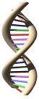
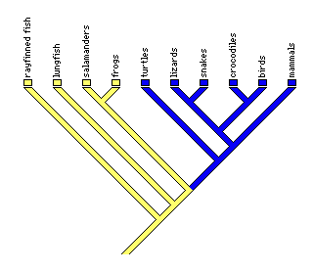

Exercise 1. Arabidopsis - The model plant for functional genomics

The aim of the exercise to use online data banks to examine the function and relationship between some plant genes in the model plant Arabidopsis.

Introduction

Before starting make sure you should understand something of the following:

- What is DNA and a gene ?
- Why might we need GM approaches in plant breeding?
- What are the DNA sequencing projects (e.g http://www.genomesonline.org)?
- What is the plant Arabidopsis and why we should bother with it ?
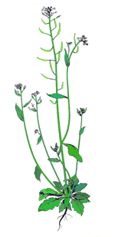

.

Section 1. How do we know what a gene does?

1. Predicting gene function from its DNA sequence
- The DNA code is translated into a string of amino acids that make a protein.
- The 3-D structure of proteins is central to their function.
- The way the chain of amino acids folds up is central to determining the function of the protein.
- Properties of individual amino acids will determine how the chain folds up

The triplet code
Here is a short DNA sequence:
ATGGGAGGAGACGAAGTCAGCAGCTTCAAAAGATGCTAA
 Using the table on the web (http://en.wikipedia.org/wiki/Amino_acid) predict the protein sequence (using the single letter code) of this DNA. To help you each triplet has been copied into the table below.

triplet code | ATG | GGA | GGA | GAC | GAA | GTC | AGC | AGC | TTC | AAA | AGA | TGC | TAA
amino acid
(single letter code)
Charge?

2. Using computers to help

- Check your translation with the online tool

http://web.expasy.org/translate/

Met G G D E V S S F K R C Stop
What you should see:
- The DNA sequence with the amino acid sequence written out underneath it.
- Six possible translations of your DNA sequence are shown. This is because there are six possible reading frames depending on where you start reading the sequence from.
- The first reading frame with a Methionine at the beginning and a dash (indicating a stop codon) at the end is the correct translation.

3. Protein folding
- The sequence of amino acids in this protein doesn’t tell you much about what the protein might do. However we know quite a lot about amino acid properties. Follow the link on the web to the resource describing the properties individual amino acids. (http://en.wikipedia.org/wiki/Amino_acid, or http://www.russell.embl.de/aas/).
- These sites tells you, for example, that Asparate and Glutamate are positively charged at physiological pH whereas Arginine and Lysine are usually negatively charged.
- Given that amino acids in a chain can flop around like beads on a string, and that positive and negative charges attract, how do you think the protein you have translated would fold up?
Sketch your guess at the shape below:

What you have just done is a simple exercise in bioinformatics. Using a lot more information and a lot more computing power you could predict the function of a protein from only knowing the DNA sequence. This is one of the uses of the DNA sequencing projects.
Depending how you are getting on you could continue looking at prediction of protein function or you might want to go on to look at other data base resources. If so go straight to Section 2.
Membrane domain prediction
Another approach is to use what we know about amino acids - how hydrophobic or hydrophilic they are - to predict how they arrange themselves in a cell. Hydrophobic domains are inserted into the membrane whereas hydrophilic regions stick out. How many there are may tell you something about protein function.

 | Membrane transporters often have 12 of these membrane spanning domains these form a pore through the membrane (click on the picture to enlarge) | 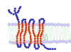
 | Some proteins are soluble and have no hydrophobic domains | 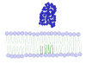
 | Some proteins might be anchored into the membrane | 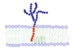

- A range of web based programmes allow you to make these predictions.
- A file of some real protein sequences can be found at the end of the document
- Copy the CHX21 protein into a membrane prediction web site
http://www.cbs.dtu.dk/services/TMHMM/

How many domains does CHX21 protein have?
Does CHX23, have the same number of membrane domains?
Try some of the other listed proteins, - does the pattern of membrane spanning domains give you any clues as to their structure and function?
Try a few more different proteins and make some predictions about their structure.

Section 2: What sort of things can the databases tell us?

- Computers are the only sensible way to manage the huge volumes of DNA sequence data
- Massive amounts of DNA sequence information are stored on computers around the world and you can access them for free.
- Arabidopsis thaliana is a model experimental plant – like Humans, its DNA has been fully sequenced
- What can we find out about the plant Arabidopsis in the databases?
- Links from the NCBI Genome page allow you to search the genomes of many sequenced organisms
http://www.ncbi.nlm.nih.gov/genome

From the information on the NCBI page, find out which other plants Arabidopsis is related to?

How many chromosomes does Arabidopsis have?

What other plant have been sequenced?

http://www.ncbi.nlm.nih.gov/genomes/PLANTS/PlantList.html

- Click on Chromosome 1
- The window shows the entire chromosome with all the genes on it,
- Click on the chromosome column, you will be able to zoom in (and out) until you can clearly see individual genes,
- Surf around the genome for a few minutes and get a feel for the genome
- Can you identify Gene structure, specifically Introns and Exons
- A gene sequence with introns and exons is the genomic sequence
- Once the introns are removed this is the coding sequence (CDS)
- Coding sequence make the mRNA and so the protein.
- The sequences in the appendix are annotated as Genomic, CDS or protein.

Now you know something about the databases let’s interrogate them with a real DNA sequence... move on to Section 3

Section 3: Finding out what protein a gene codes for

- CHX21 gene sequence is given to you in the appendix,
- Use the online data bases to find out what the gene sequence represents.

- Use the TAIR web site http://arabidopsis.org/
- Got to ‘tools’ then ‘Blast’
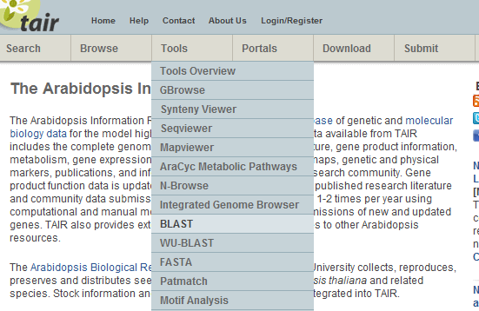

- Paste in the coding (CDS) into the box

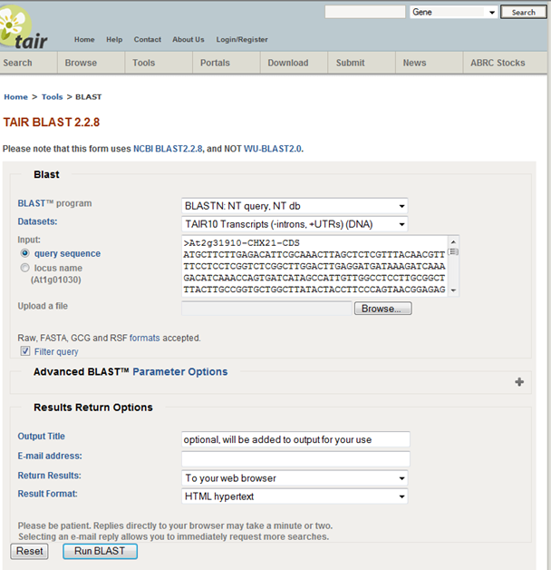

- Get a list of the best matching genes.
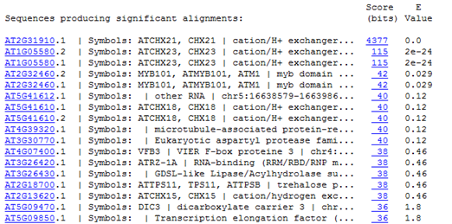

- Note that the lower the e value the better the match is. ) is therefore exact,
- We tend not to consider scores greater than 1e⁻¹⁰ as significant.

Click on the gene name of the best matching gene, this will take you to a page of information about it-

What information can you find about what it does - or might do?

Write down any alternative names for it.

What is the next most similar gene to yours? Write down its number

What is its function?

On which chromosome(s) are your two genes?

Note: Using NCBI BLAST gives you the option of searching for similar sequences in other genomes http://blast.ncbi.nlm.nih.gov/
What’s in a name?

Note that the code At1G12340 for a gene contains some important information:

‘At’ stands for the organism (Arabidposis thaliana in this case)
‘1’ refers to the chromosome the gene is on (1 in this case, Arabidopsis has 5)
‘G’ refers to Genomic rather than chloroplast or mitochondrial
‘12340’ The number is the distance along the chromosome, these are usually in decades so that new discoveries can be assigned an intermediate number.

Section 4: Genes and their relationships: Are genes next to each other on a chromosome similar in their function?

- Follow the links on the web to the NCBI Arabidopsis page http://www.ncbi.nlm.nih.gov/genome/4
- Click on Chromosome 2
- Type CHX21 (At2g31910) into the search chromosome 2 and click 'find'
- The position of your gene will be indicated by a red tick next to the chromosome
- Click on CHX21 and you will be taken to a close up map of your gene
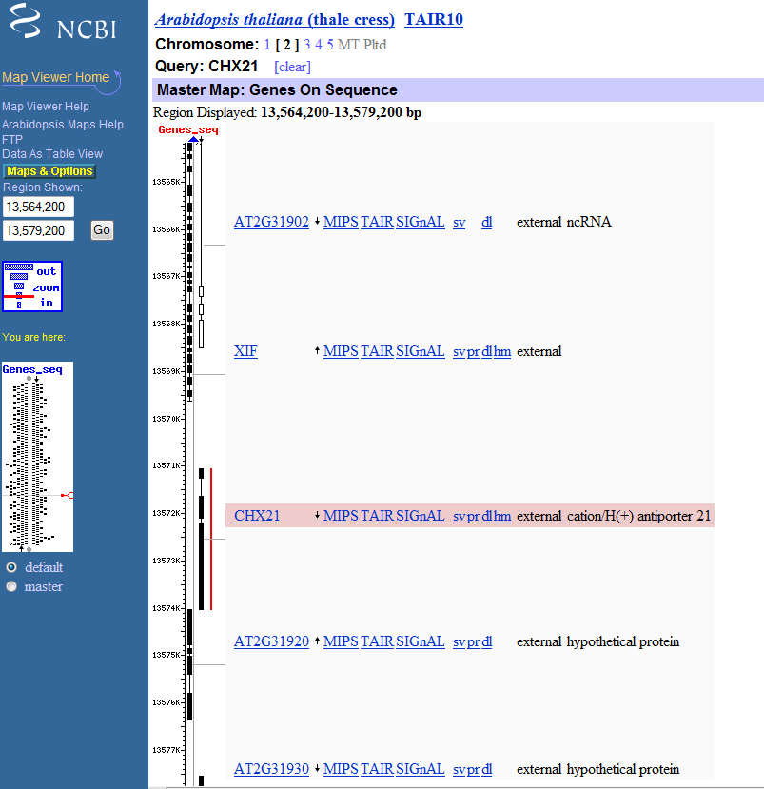
What are the functions of the two genes immediately above and below it?
Is there any obvious similarity in the function of these genes?

Repeat this for CHX23 on Chromosome 1
What are the functions of the two genes immediately above and below the second gene? Are they of similar function?

Now go to the gene families in Section 5 to find out more

Section 5: Gene families
- You have already compared two genes and found out about their function
- In Evolution, organisms have descended from a common ancestor
- Closely related organisms will have similar features (characters)
- DNA can be used like any other character to compare relationships
- Genes evolve just like organism, new genes form (like speciation) and their sequences change as their function changes (diversification)
- Computer programmes can produce 'trees' showing how similar pairs of genes are.
- The relationship between different plant Cation transporters are shown in the tree on the following page
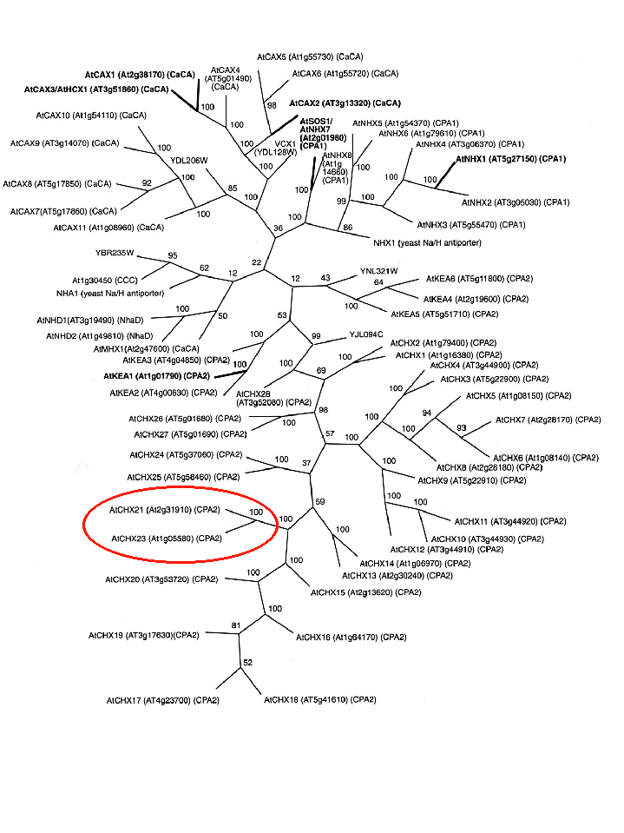

- Look at some other members of the CHX family

Find CHX 14 and CHX15 on the diagram
Write down their gene numbers
Which chromosome is each of them on (Remember ‘what’s in a name?’)
Now find CHX6 and CHX7
Write down their gene numbers
Which chromosomes are they on?

There is a pattern between closely related gene pairs and the chromosome they are on
What sort of evolutionary events might have led to this? (Think about the different ways that variation for natural Selection can be produced in organisms)

Section 6: Comparing gene sequences

- Closely related genes will have more similar sequence
- Open one of the sequence comparison sites
- http://www.ebi.ac.uk/Tools/msa/clustalw2/
- Paste a pair of your sequences into the appropriate box, first compare the coding(CDS) and genomic sequences of CHX21
- An asterix shows where sequences are the same
- The Intron should be clearly visible
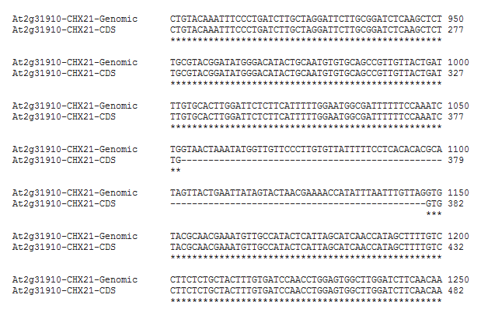

You can repeat this to compare CHX21 and CHX23

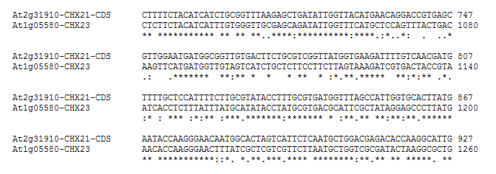

Similarity trees

The comparison you have just done for pairs of genes can be done by computers for many genes.
- Go to one of the sites that hosts the phylogenetic programmes
http://www.genome.jp/tools-bin/clustalw

- Paste in the CDS sequences of your CHX genes from the web file
- It will compare all genes – when complte click ‘Guige tree’ to get a grpahiocal output
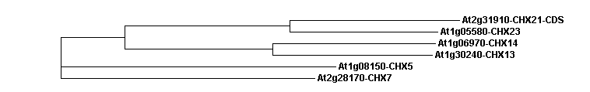
What does the tree produced tell you about the relationship between the genes?
You could also use the protein sequences – will the result be the same?

Try a multiple alignment for all the protein sequences in the appendix

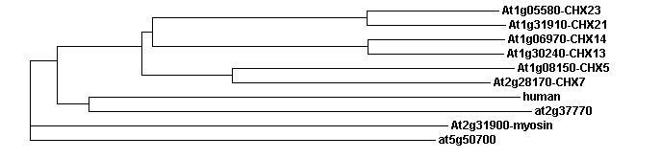
What comments can you make the different evolutionary selection pressures on genomic DNA, coding DNA and protein sequence?

Glossary
FASTA
BLAST
NCBI
TAIR
CDS
Genomic

