**SRK CONSULTING UK LTD SCHOLARSHIP PROGRAMME**

SRK Consulting is an independent, international consulting practice, providing globally integrated consulting services to the international resources and engineering sectors. The SRK Group employs over 1,400 professional consultants internationally and has 45 offices in over 20 countries. SRK has been providing its clients with innovative, practical and cost-effective solutions for over 35 years. Our client base covers a wide range of industries, particularly within the mining and metals sector

SRK Consulting (UK) Ltd (SRK (UK)) is a leading international operation with the UK head office based in Cardiff the vibrant capital of Wales – Europe’s youngest capital city. We offer a variety of interesting and challenging projects working from a capital city location. Many of our projects are of an international nature and utilise SRK’s international consulting network.

SRK hydrogeologists work internationally on projects such as mine dewatering design, slope depressurisation, groundwater baseline and impact assessment, water remediation and water supply. Our hydrogeologists are skilled at well installation, VWP installs, pumping, packer and spinner tests, numerical groundwater modelling, contaminant sampling, hydrochemical analysis, plume modelling, and water balances, as well as having a deep understanding of the differences in hydrological systems in permafrost, desert and tropical climates.

SRK (UK) is pleased to announce our scholarship programme for 2019, created to assist students undertaking the MSc Hydrogeology which can be applied in the resources and engineering industries.

The scholarship is intended to encourage and support students to complete a university master’s degree and to provide the successful recipient with a financial contribution to assist furthering their MSc studies.

It will also provide the recipient with the opportunity to work alongside our hydrogeologists and gain hands-on experience in their selected field, during their summer MSc dissertation.

This is a unique learning experience providing exposure to the international consulting environment.

**Value**

The value of the scholarship is up to a maximum of GBP1,500 which will be payable directly to the University for course fees.

**Additional student opportunity**

Recipients of the scholarship may be provided with the opportunity to undertake a suitable research project for their MSc, of up to a maximum of 16 weeks. SRK will provide various options for projects in the second term of the MSc course. Should this involve working in the office in SRK Cardiff an hourly payment may be given in lieu of accommodation and temporary relocation expenses. The recipient will be provided with further details when their scholarship has been confirmed.

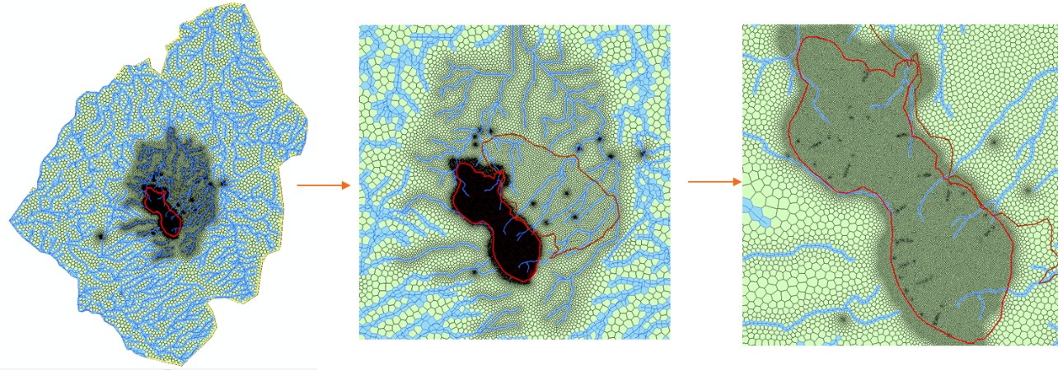

*USG MODFLOW model refinement around an open pit mine area, streams and monitoring wells*

**Eligibility requirements**

To be eligible to apply for a scholarship, an applicant must:

* have the right to study and work in the UK ;
* have an appropriate undergraduate degree qualification; and;
* meet the admission requirements and be enrolled in a scientific/engineering MSc which could be applied in the mining industry as per the above definition.

**Selection criteria**

Applicants will be assessed on the following criteria:

* academic achievement as evidenced by their academic record;
* a written recommendation by university reference and/or previous employer;
* a written statement of no more than 500 words outlining;

1. the benefit they will obtain from the scholarship;
2. their appreciation of water issues in mining and ground engineering industries;
3. their previous experience in hydrogeology, or consultancy (if any); and
4. any other information the applicant considers relevant to their application, for example skills such as coding, languages, travel in remote areas of the world or other areas of interest such as voluntary work undertaken, involvement/management of teams, or outdoor pursuits

**Selection process**

1. Selection of the recipient is made by the scholarship panel having regard to the applicant’s completed application form and supporting documentation.
2. The scholarship panel may interview short-listed applicants.
3. The successful applicants will be notified by SRK (UK) by the end of August 2019 Prior to enrolment of a course to start in the academic year (normally September).
4. The selection decision is at the complete discretion of the SRK (UK) scholarship panel and while the panel may provide reasons for an unsuccessful application, it is under no obligation to do so.

**Scholarship terms and conditions**

The successful applicant will be asked to sign a contract containing the terms of the scholarship. Circumstances under which repayment of the scholarship may be required include:

* non-completion of studies.

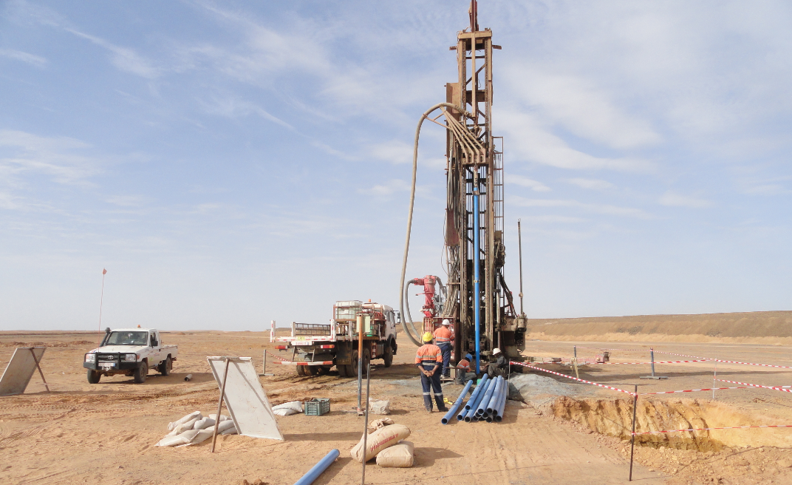

*Well installation, Sub-Sahara*

**Application procedure**

1. Applications must be submitted by the advertised closing date.
2. Applications must be accompanied by:
3. a brief curriculum vita (no more than 2 pages), including details of present and previous work experience where applicable;
4. a written statement of no more than 500 words; and
5. a written recommendation by university reference and/or previous employer
6. Applications must be submitted online and as one document
7. Please submit any enquiries to Bethan Humphreys, HR Advisor [bhumphreys@srk.co.uk](mailto:bhumphreys@srk.co.uk).
8. Please submit your application [here](https://srk.amrislive.com/wizards_v2/srk/vacancyView.php?requirementId=596&source=UoB)

**Payments**

The scholarship will be paid directly to the university at the start of the course. The recipient must provide evidence of enrolment in the appropriate academic year.

**Concurrent scholarships**

The recipient should make SRK (UK) aware of any funding received, in addition to the scholarship.

**Closing Date**

Applications for the SRK (UK) 2018 Scholarship close **17 August 2019.**