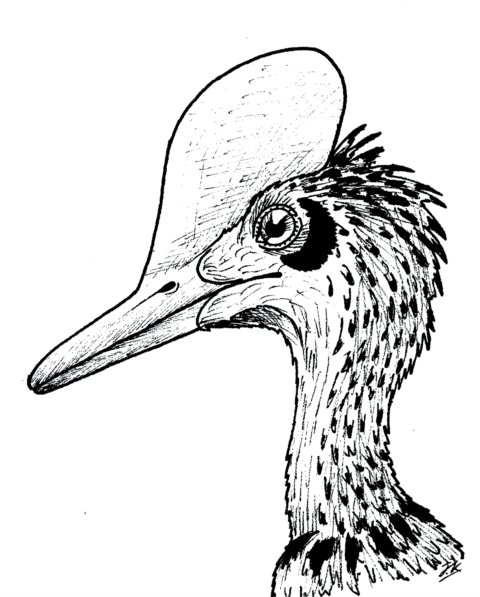


MALE DARWINOPTERUS MODULARIS
Age: 160 million years ago
Wingspan: 1 metre
Weight: 0.5 Kilograms Diet: Lizards and Insects

