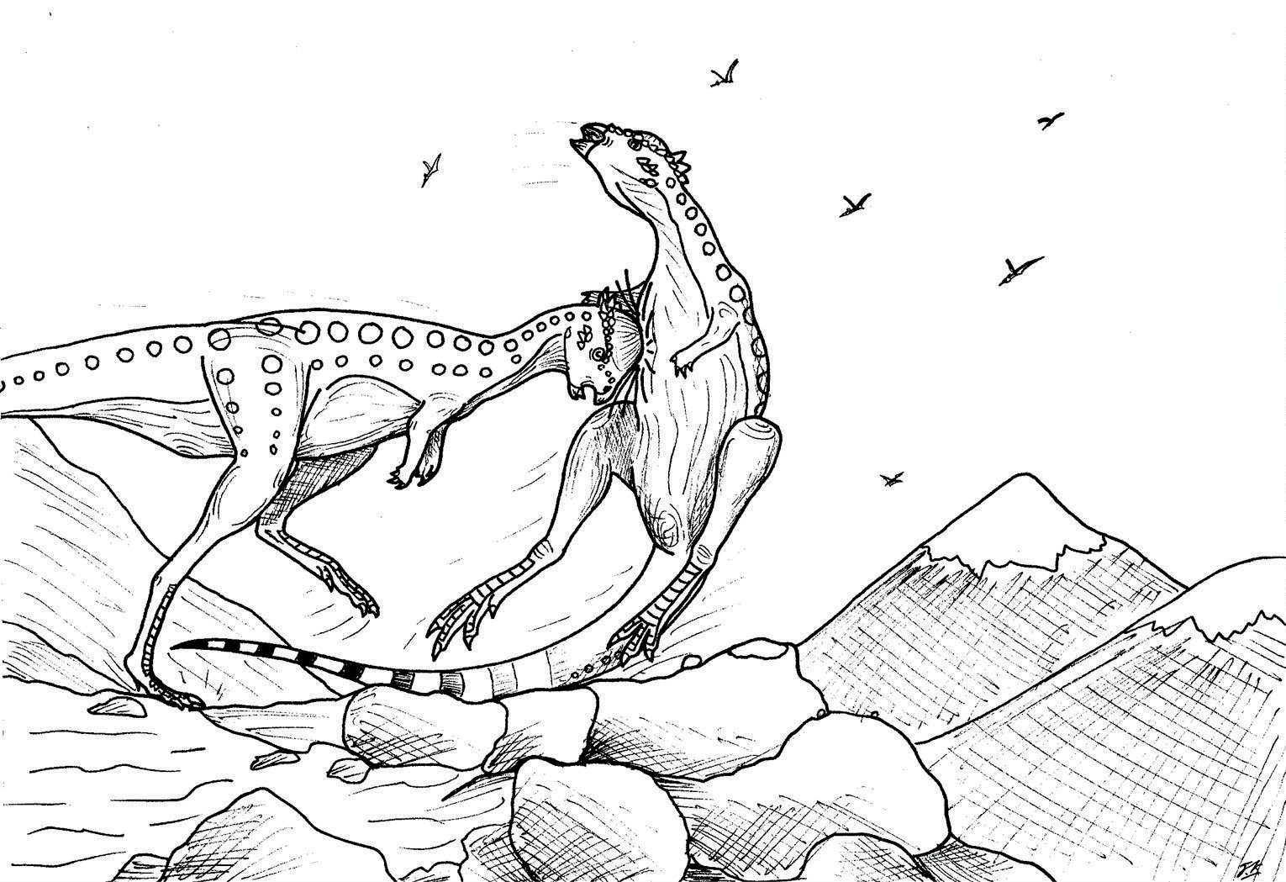

FIGHTING PACHYCEPHALOSAURUS

