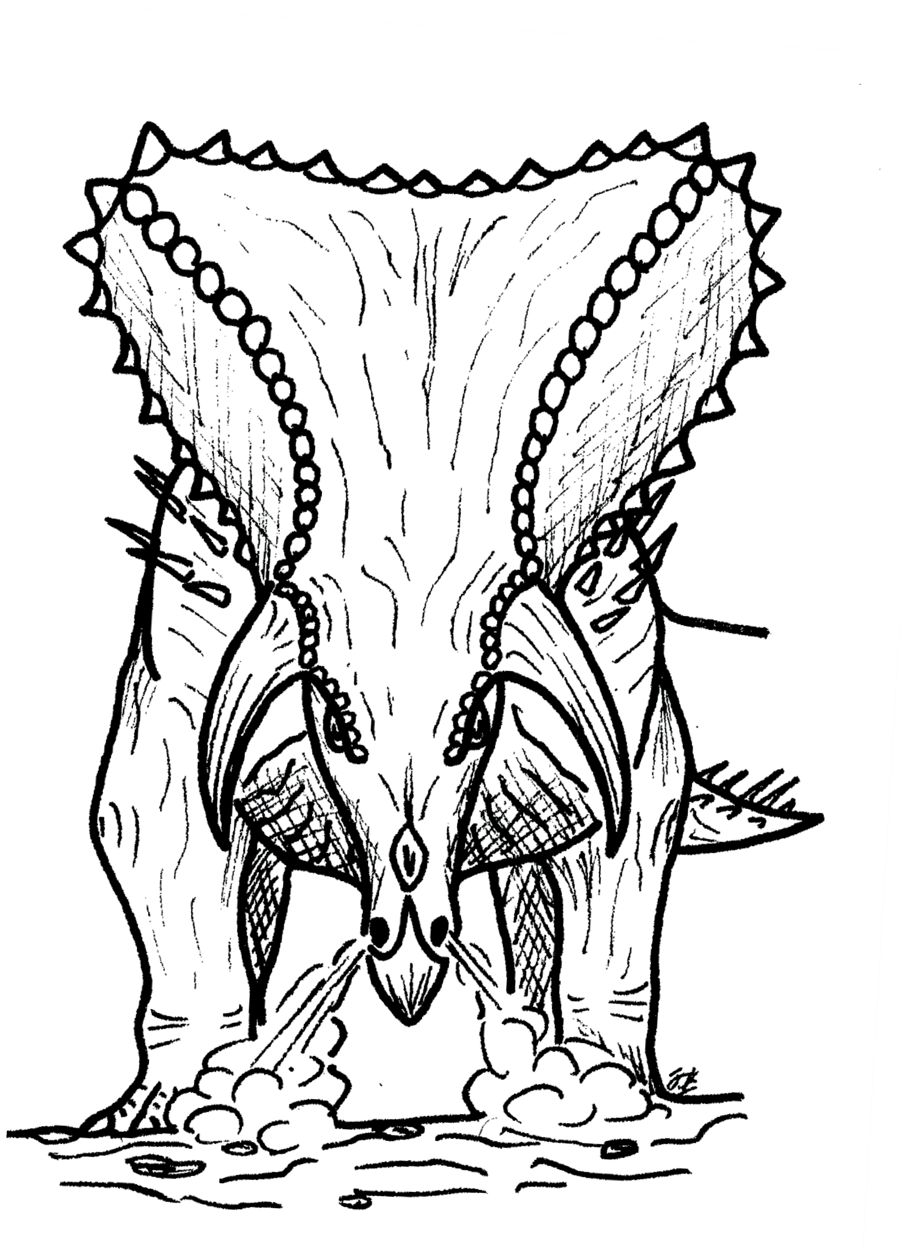
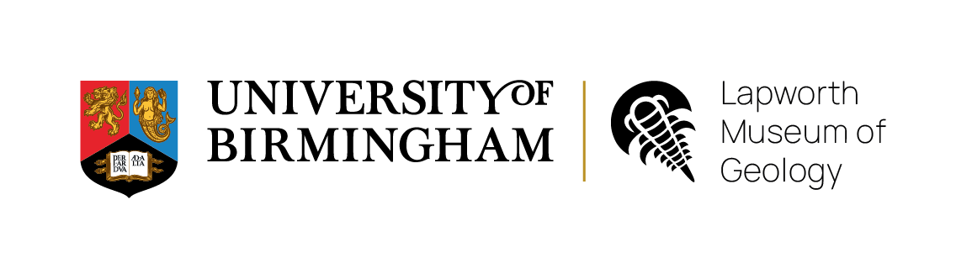
TRICERATOPS HORRIDUS
Age: 65 million years ago Length: 8 metres
Weight: 9,000 Kilograms Diet: Plants

