Isla’s A-maze-ing Journey

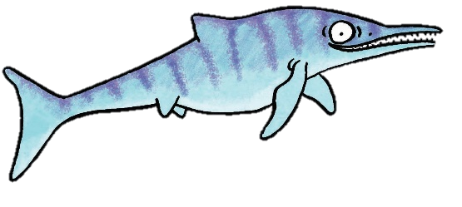

Help Isla the Ichthyosaur swim her way to a delicious ammonite supper!
Illustrations by Emma Metcalfe

