Albertosaurus Diplodocus
Allosaurus Megalosaurus
Ankylosaurus Spinosaurus
Baryonyx Triceratops
Carnotaurus Velociraptor
Deinonychus
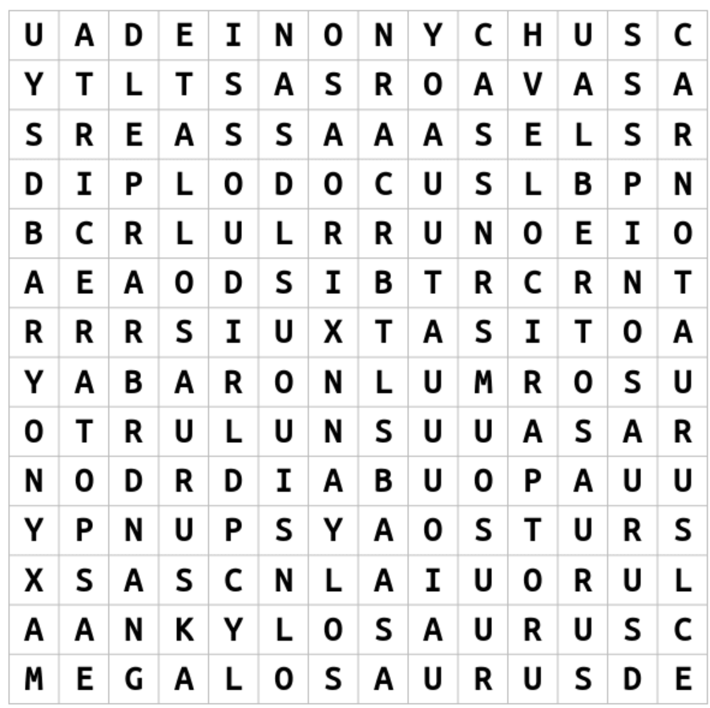
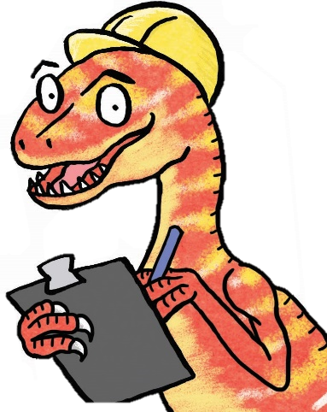
Dino-mite Wordsearch
Illustration by Emma Metcalfe
Can you find any of these dinosaurs in our galleries?

