Gabbro Obsidian
Gneiss Sandstone
Granite Sedimentary
Igneous Slate
Limestone Volcano
Metamorphic

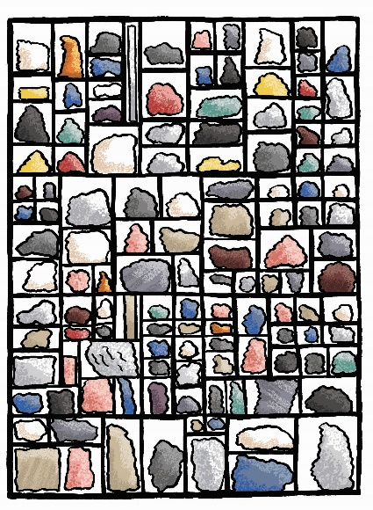
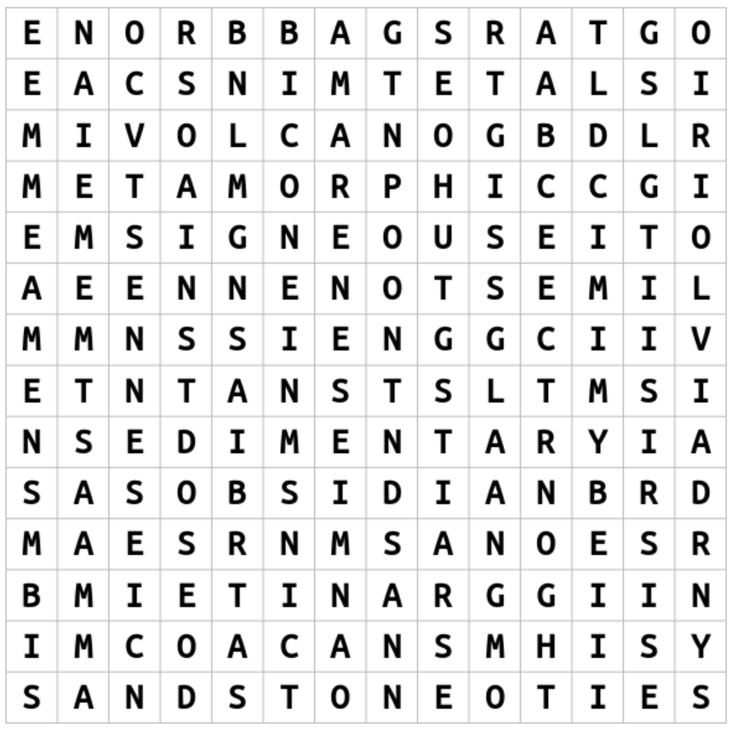
Rock Star Wordsearch
Illustration by Emma Metcalfe
Can you find any of these rocks in our galleries?

