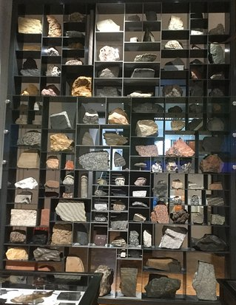
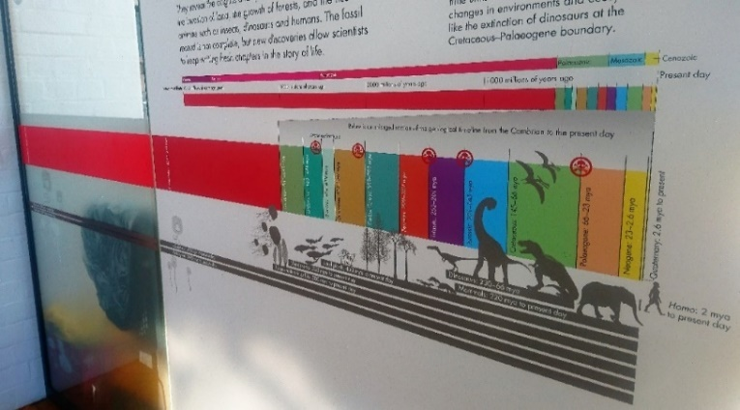
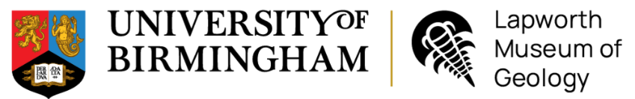
- During the Carboniferous the West Midlands was covered by tropical forests and swamps. What fossil evidence is there for this?

What rock type eventually formed from these forests?

Geology Trail – KS5
13. Which 2 rocks on the Rock Wall would produce a discordant coastline and why?

12. Find the sandstone with ripples on the Rock Wall. Describe how the ripples were formed:

What environment(s) would you see ripples forming in today?

11. Explain how each rock group is formed and how they link to the Rock Cycle.

10. Rocks can be classified into 3 groups based on how they form. Name the 3 rock groups:
1. ______________________
2.______________________
3.________________________
Examine our Rock Wall
8. Why was ‘Archaeopteryx’ an important fossil discovery? (It is on display in the Jurassic case)

7. What type of animals walked across the West Midlands during the Late Carboniferous?

What traces did it leave behind?
9. What disastrous event happened at the end of the Cretaceous? What caused it?

- What type of animal is the Dudley bug? How did they protect themselves from predators?

- Describe the environment of the West Midlands during the Silurian period. What is the fossil evidence for this? (Look in the black Victorian cabinets behind you)

- Charles Lapworth named the Ordovician period. What did he use fossilised graptolites for?

- Where was the West Midlands located during the Precambrian period? Describe the environment.

- How old is the Earth?

Find the start of our Geological Timeline in our Evolution of Life Gallery
Name:
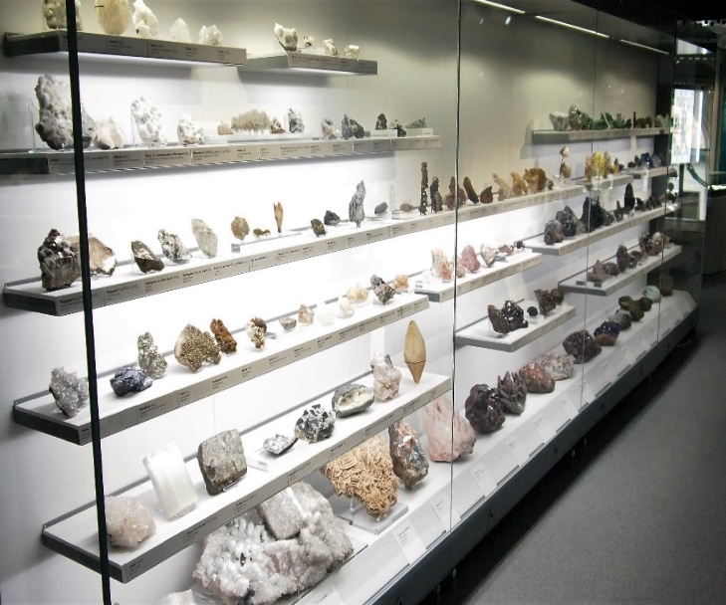
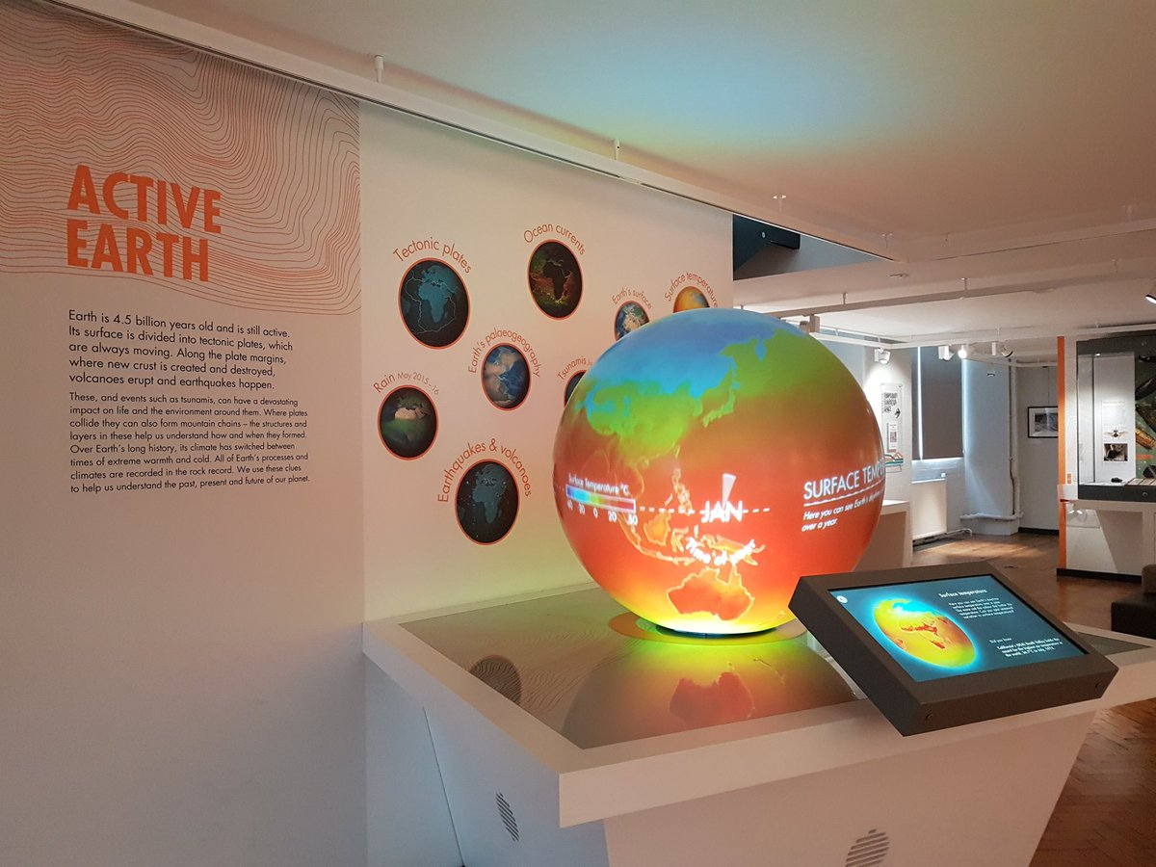
23. Investigate the different physical properties that can be used to identify minerals. Try the mineral tests for density.
Name five other properties you would use to help you identify a mineral.
22. Read the information about mining in the Midlands. Lead mines have been worked in Shropshire since the Romans. What is the primary ore (mineral) of lead? What shape does the mineral grow in?

21. What is the difference between rocks and minerals?

20. Why did Professor G.R Coope study beetles and what did he prove with his research?

Go upstairs to our Mineral Wealth Gallery
19. Look at the microfossils under the microscope. What can studying microfossils tell us?

18. Describe the type of volcanic eruption that would have ejected volcanic bombs and ash.

17. Name four different volcanic hazards.

14. Watch the Earth’s tectonic plates clip and earthquakes and volcanoes clip on the Active Earth globe. Describe what controls the distribution of volcanoes and earthquakes.

15. Watch the 2011 Japan tsunami clip on the Globe. Suggest a management strategy that countries could have used to decrease the hazard risk.

16. What machine is used to measure earthquakes?

Find our Active Earth Gallery

