A guide for educational groups visiting
the Lapworth Museum of Geology

We are looking forward to your group visiting the Museum! Here are some guidelines we expect you to read through prior to your visit. This is not a document to read out to your group, but something for those responsible for younger guests to keep in mind when visiting.

General expectations  - We expect a minimum ratio of 1 adult for every 10 learners.  - We expect adults to be responsible  for behaviour of learners.  - Please be respectful of other visitors and staff members in the Museum.  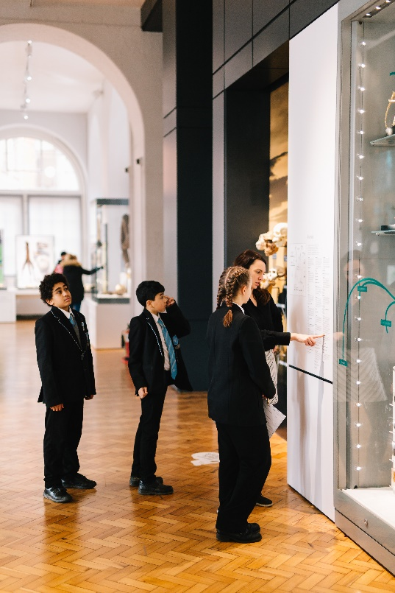  During a Museum-led workshop  - Primary: You don’t need to bring anything - all pencils, paper etc. are provided.  - Secondary: Please bring pencils, however there are a limited amount if someone forgets.  - Please ensure adults always listen to the Museum learning officer for instructions regarding entering and leaving the Education Room and navigating the activities during the workshop to avoid conflicting instructions.  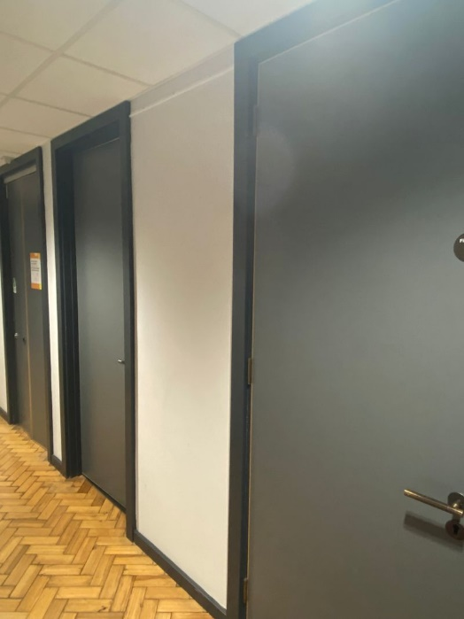  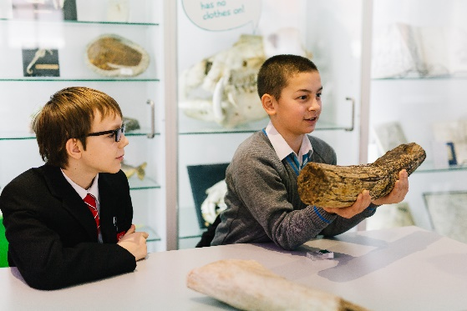  Visiting the shop  - You are welcome to visit the shop during your visit. Please note the shop is card-only.  Photography  - Primary: teachers may photograph their pupils, the learning officer’s artefacts, powerpoint slides and handouts.  - Secondary: teachers may photograph their pupils, the learning officer’s artefacts, powerpoint slides and handouts. Students are welcome to take photographs but to please keep phones away during the workshop.  - Please do not record video or audio of the workshops themselves. | 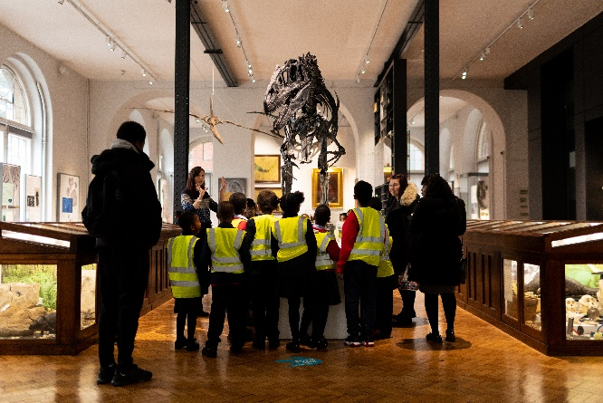  During a self-led visit / Museum Gallery trail  - We want you to enjoy your time in the Museum so we don't expect total silence and accept raised voices. However, there may be other visitors also in the Museum, be mindful of their experience.  - For your own safety, avoid running in the Museum and take care when interacting with display cabinets.  - Our Visitor Services Assistant (VSA), the staff member on reception, is there to help you with any questions you might have.  - Please be mindful of blocking entrances and pathways in the Museum.  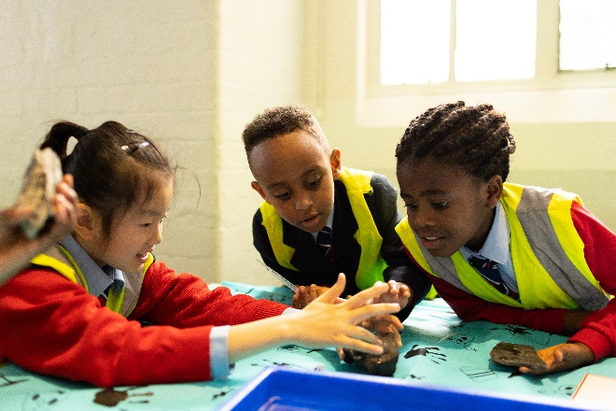  Using the toilet  - Primary: Teachers should manage a formal toilet stop before or after the workshop and accompany any pupils to the toilets if they leave the workshop.  - Secondary: Students are free to use the toilet with permission from their teacher during their visit.  - We recommend encouraging learners to use the toilet during the self-led trail portion of your visit as to not disrupt the workshop.  Lunch break  - We do not have a lunch space in the Museum and ask you to avoid eating in the Gallery as much as possible to avoid pests which could damage our archives and specimens.  - If you wish to book a lunch space on campus, please let us know in advance.  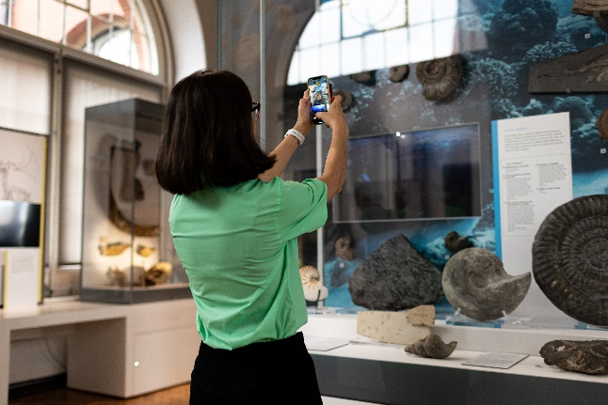

Thanks for reading – we look forward to your visit!
If you have any questions, please get in touch with the Learning team.
- For Primary (Key Stage 1 and 2) or Family enquiries please contact Jake Atterby at j.atterby@bham.ac.uk.
- For Secondary (Key Stage 3 and 4) and Sixth Form (KS5) enquiries please contact Anna Leppänen at a.z.a.leppanen@bham.ac.uk.

