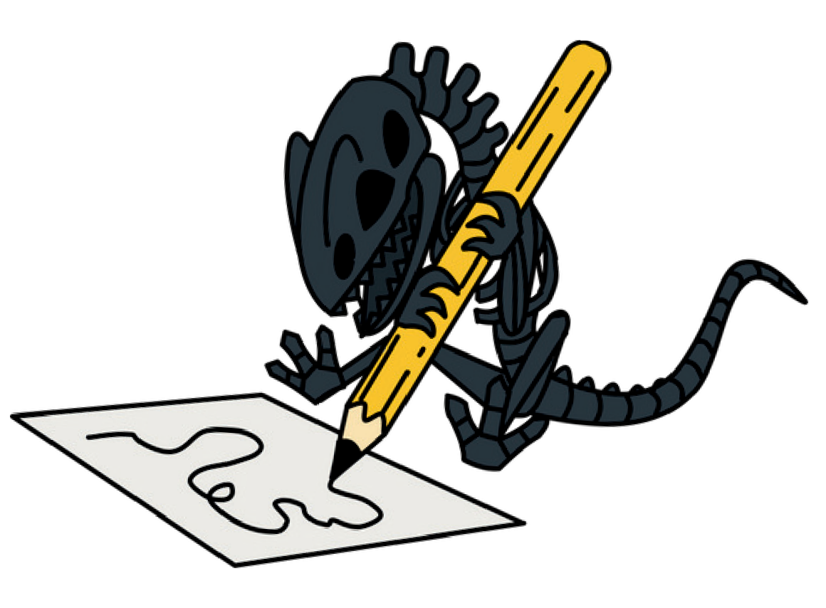
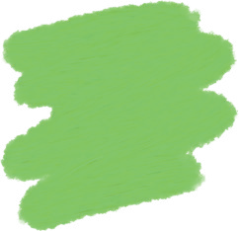
Look for these shapes and patterns around the museum.
KS1+
Patterns

square circle triangle rectangle
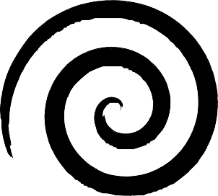
spiral zig-zag stripes spots


sharp tooth
leaf fish diamond

