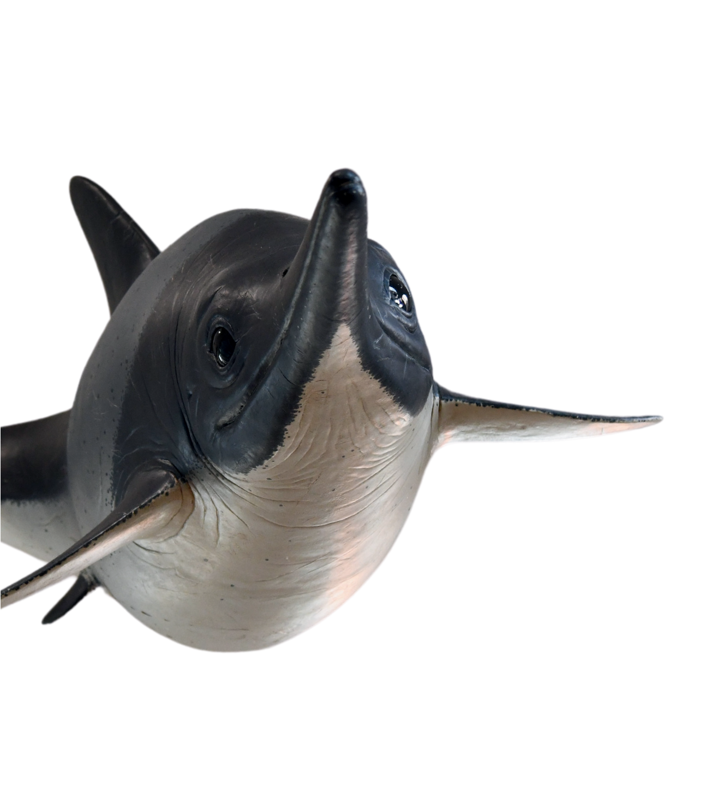
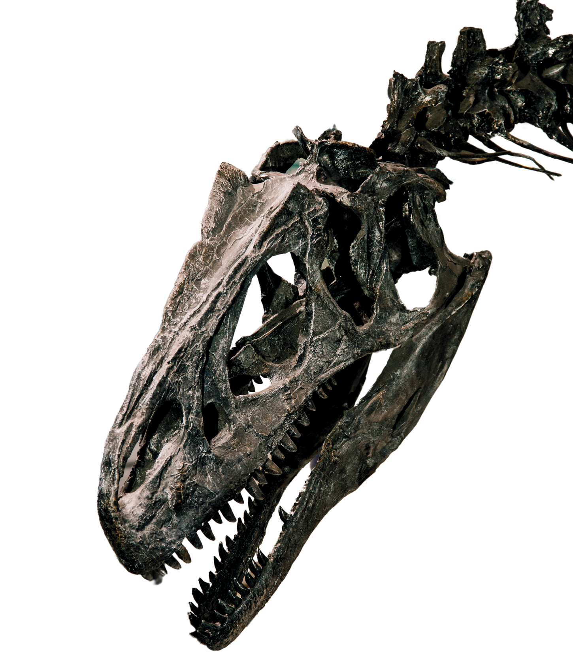
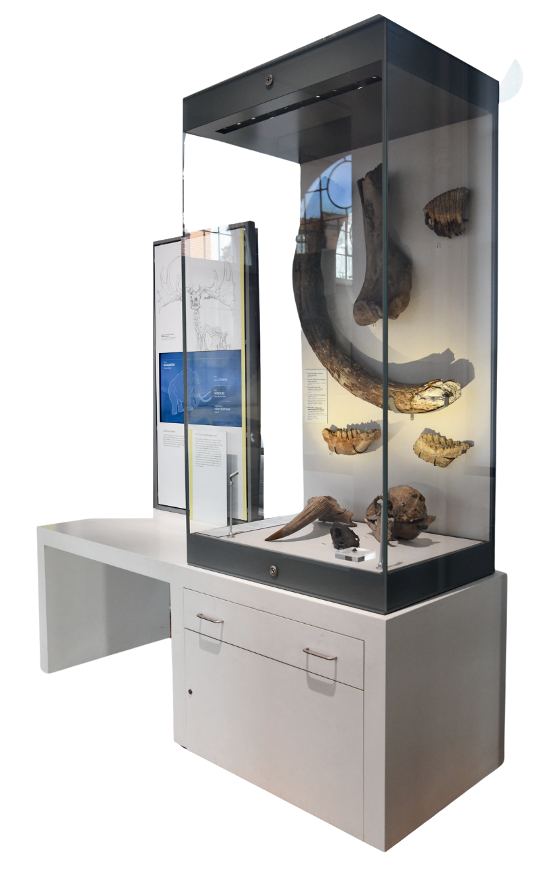
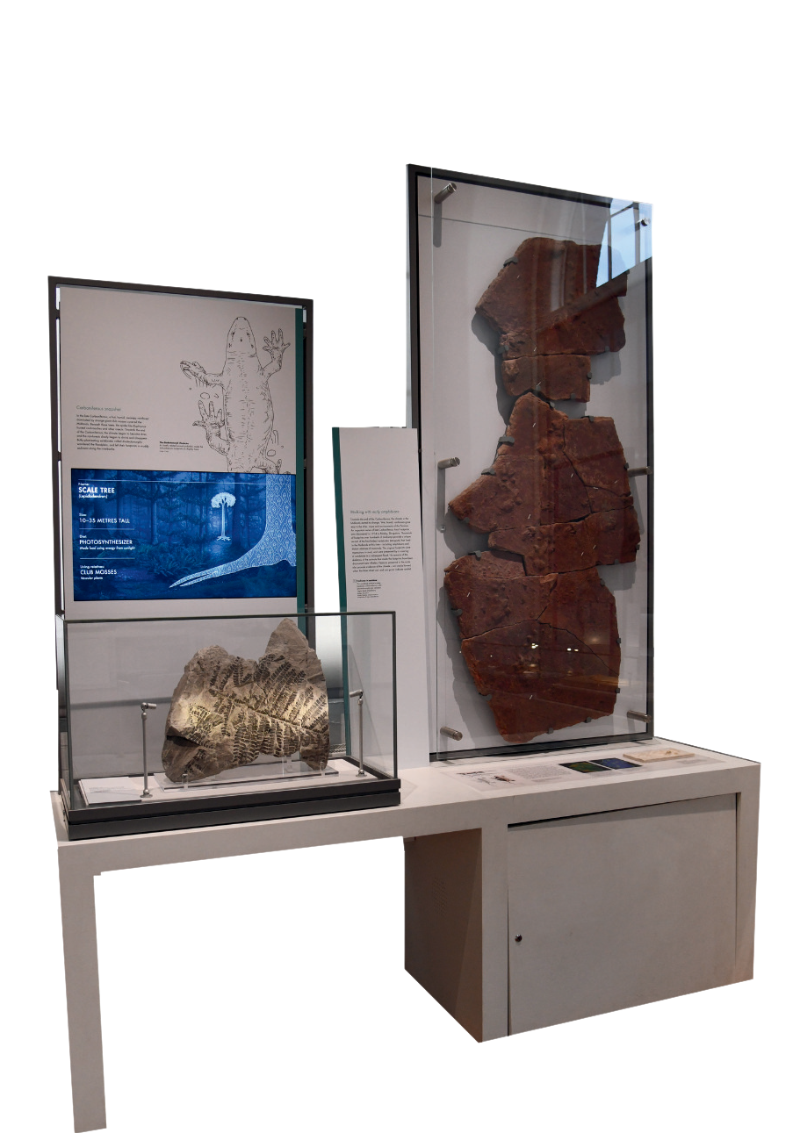
NAME ............................................

Jurassic Seas
What does “Ichthyosaur” mean?
................ .........................
Do Ichthyosaurs remind you of any animals alive today?
...................................................

Ancient Footsteps
How long ago was the Carboniferous Period?

million years ago
What ancient animal do we think left these footprints behind?
...............................

Dinosaur Detectives
How much did Roary weigh?
How do we know Roary was a meat eating dinosaur?
..........................................
..........................................

Ice Age Wonders Open the drawer in the Quaternary display. Inside is
a real piece of Woolly Mammoth fur! What colour is it?

..........................................
Why was thick fur a useful adaptation for mammoths?
...............................
............................................

