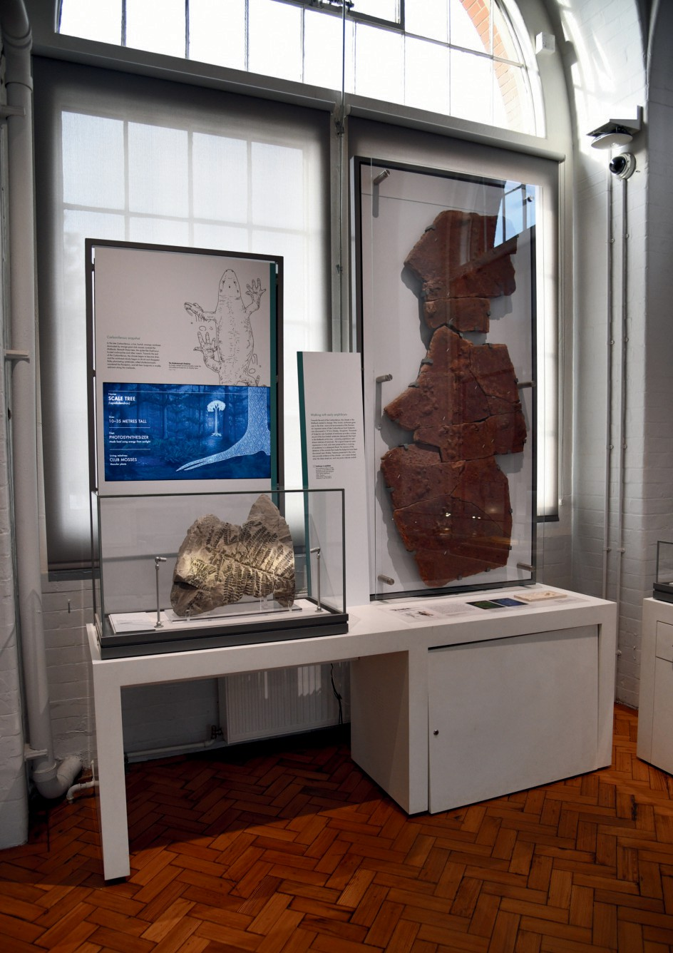
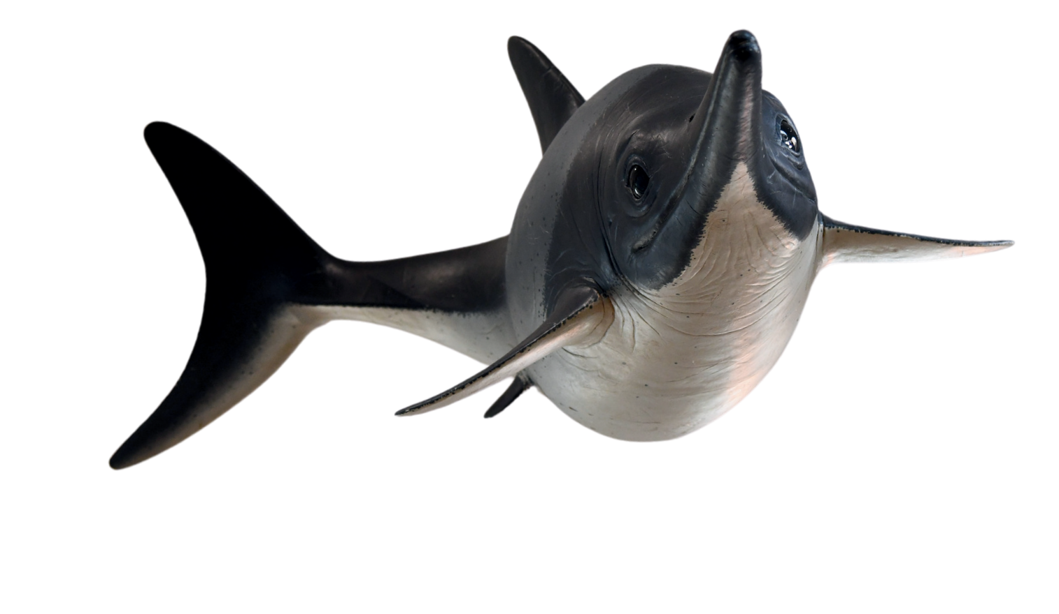

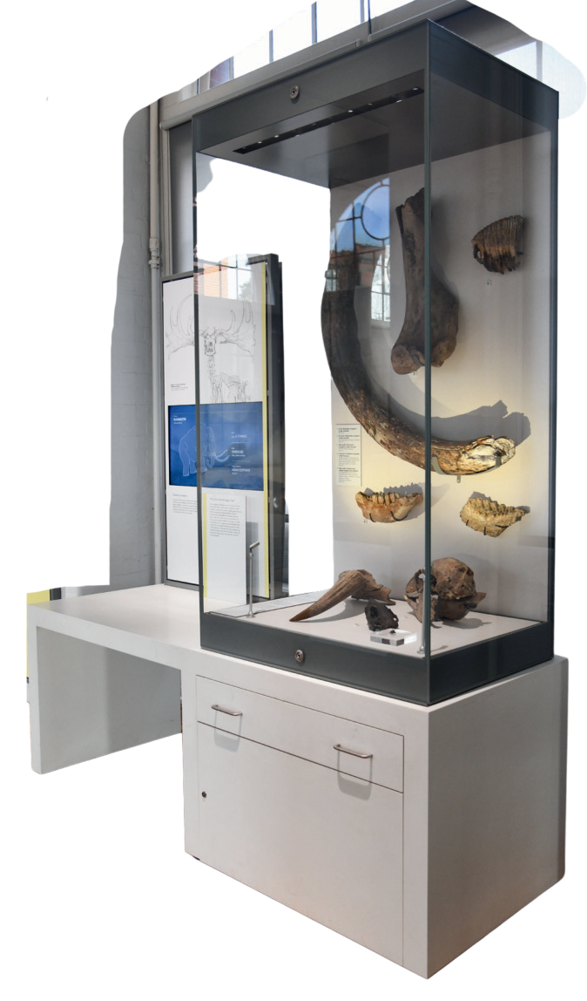

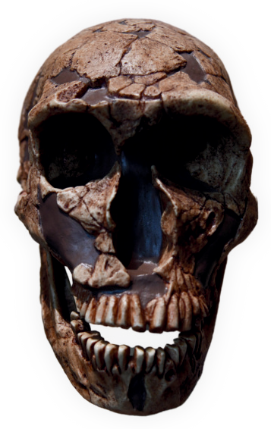
Jurassic Seas
During the Jurassic period, where you are stood was deep beneath a tropic ocean, home to marine reptiles
like Ichthyosaurs. What does the name Ichthyosaur mean?

..................................................................................................................................

Does our model Ichthyosaur remind you of any animals alive today? What body parts do they have in common?

....................................................................................................................................

....................................................................................................................................

...................................................................................................................................

Bonus Challenge: What did Ichthyosaurs eat? How do we know?

Carboniferous Footsteps
How long ago was the Carboniferous Period?

..................................................................................

What ancient animal do we think left
these footprints behind?

...............................................................

Bonus Challenge: Are fossil footprints a type of Body Fossil or a type
of Trace Fossil?

Human Evolution
Homo sapiens (that’s us!) are the only species of humans alive today. But, when we first evolved, we shared the planet with many other types of human. Of these skulls, which extinct human species were we most closely related to?

........................................................................................

Bonus Challenge:
What skull belongs to our closest living relative?

Ice Age Wonders
Find the Quaternary (Ice Age) Display and open the drawer. Inside is a real piece of Woolly Mammoth fur! What colour is it?

.......................................................................................

Why was thick fur a useful adaptation for mammoths?

...........................................................................................

............................................................................................
The drawer also contains teeth belonging to several Ice Age mammals. Can you name three of the animals who’s teeth are in the drawer?

- ............................................................................

- ...........................................................................

- ..........................................................................

Bonus Challenge: What do you think these animals ate?

The Rock Wall
Find Rock 78 and Rock 80. What are they?

............................................................. and .........................................

.

Are these rocks igneous, sedimentary or metamorphic?

..........................................................................................................................................

These rocks look very different. How many differences can you spot?

......................................................................................................................................

.......................................................................................................................................

Find Rock 10. What type of rock is it?

................................................................................

Is it sedimentary, igneous or metamorphic?

.........................................................................

Rock 10 is a very special type of sandstone which has ripples marks. Ripple marks form when sand is moved backwards and forwards by water. Can you think of an environment where sand is moved backwards and forwards by water?

........................................................................................................................................
Can you find a rock in the Rock Wall that contains an ammonite fossil?

..........................................................................................................................
NAME ............................................

Mineral Gallery (upstairs!)
Rocks are made of minerals. Can you find a mineral that is...

Blue? ...............................................................

Made of blobs? ............................................................

Made of cubes? ..............................................

Has a hat? .......................................................................

Bonus Challenge: what colour does Halite glow under Ultraviolet Light?

Active Earth
How did the Glacial Erratic (3) come to Birmingham?

...........................................................................

..........................................................................

..........................................................................

Which contains more ice?

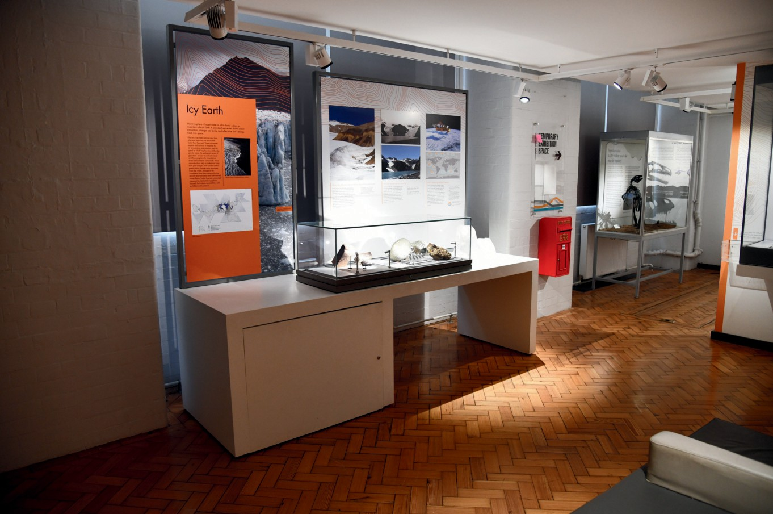
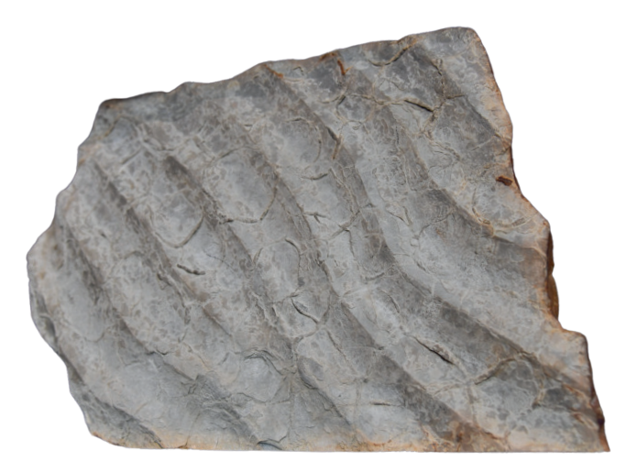
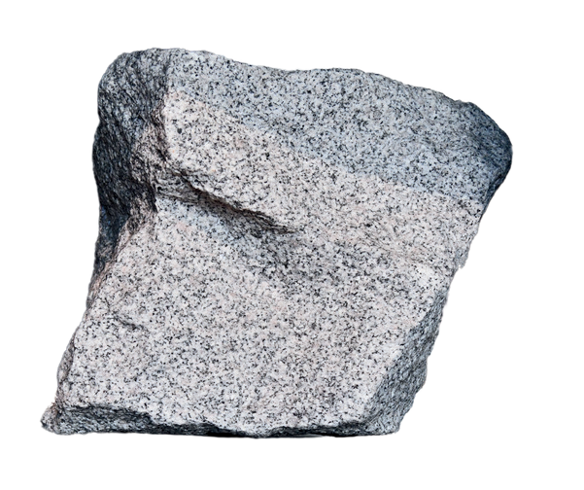
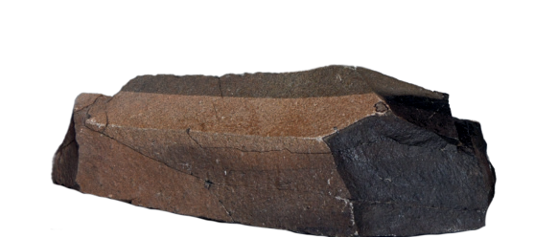
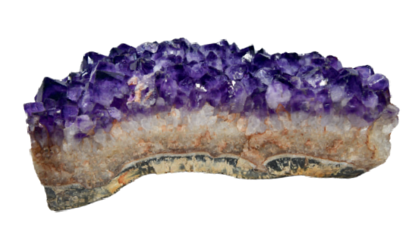
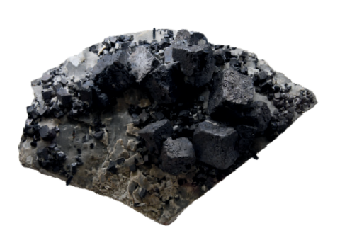
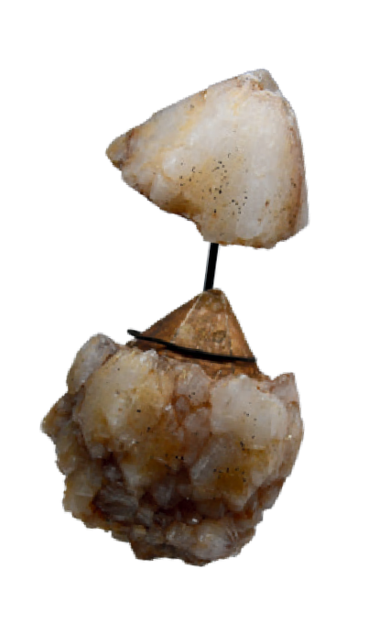
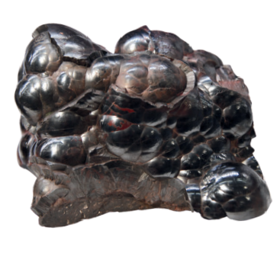

Bonus Challenge: Why would you never find fossils in igneous rock?
Greenland Ice Sheet?
Antarctic Ice Sheet?

