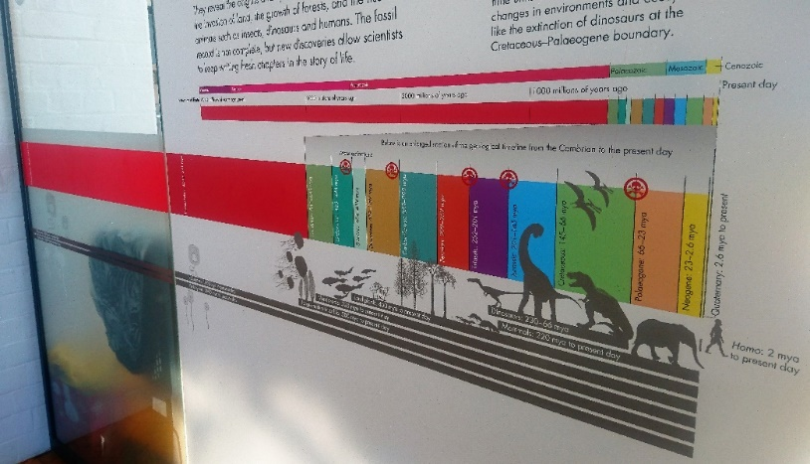
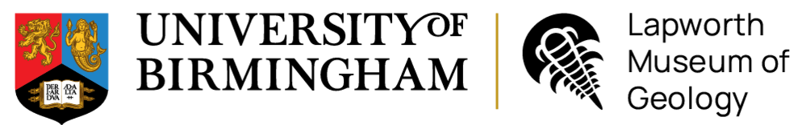
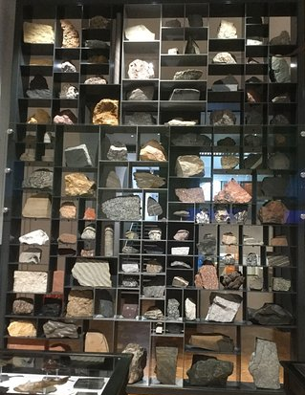
Geology Trail
– KS3
- What type of animal is the Dudley bug? (Hint: it is found in the Silurian time period)
_______________________________
- Name three animals that would have lived in the Jurassic seas.
1. _______________________________________
2. _______________________________________
3. _______________________________________
- What type of animal walked across the West Midlands during the Late Carboniferous?
______________________________
What traces did it leave behind?
________________________________________
Name:
Turn over to explore the Active Earth Gallery and Mineral Wealth Gallery
- Look at all the rocks on the Rock Wall. Decide which type of rock would be best to use as:
A kitchen work surface
_________________________________________
Roof tiles
_________________________________________

Examine our Rock Wall
- Rocks can be classified into 3 groups based on how they form. Name the 3 rock groups:
1. _____________________
2._____________________
3.____________________________________
- What happened to the dinosaurs at the end of the Cretaceous period? What caused this?
_________________________________________
_________________________________________
_________________________________________
- During the Silurian time period, the West Midlands would have been under a shallow tropical sea. What animals would have lived there?
________________________________________________________________________________________________________________________
- What happened to animals in the Cambrian period?
__________________________________________________________________________________________
- What is the name of the first geological time period?
________________________________
- How old is the Earth?
________________________________
Find the start of our Geological Timeline in our Evolution of Life Gallery
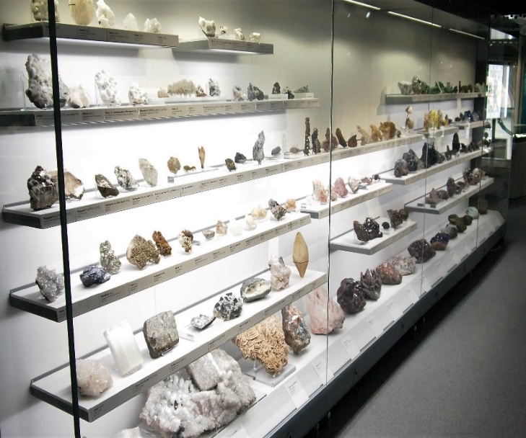
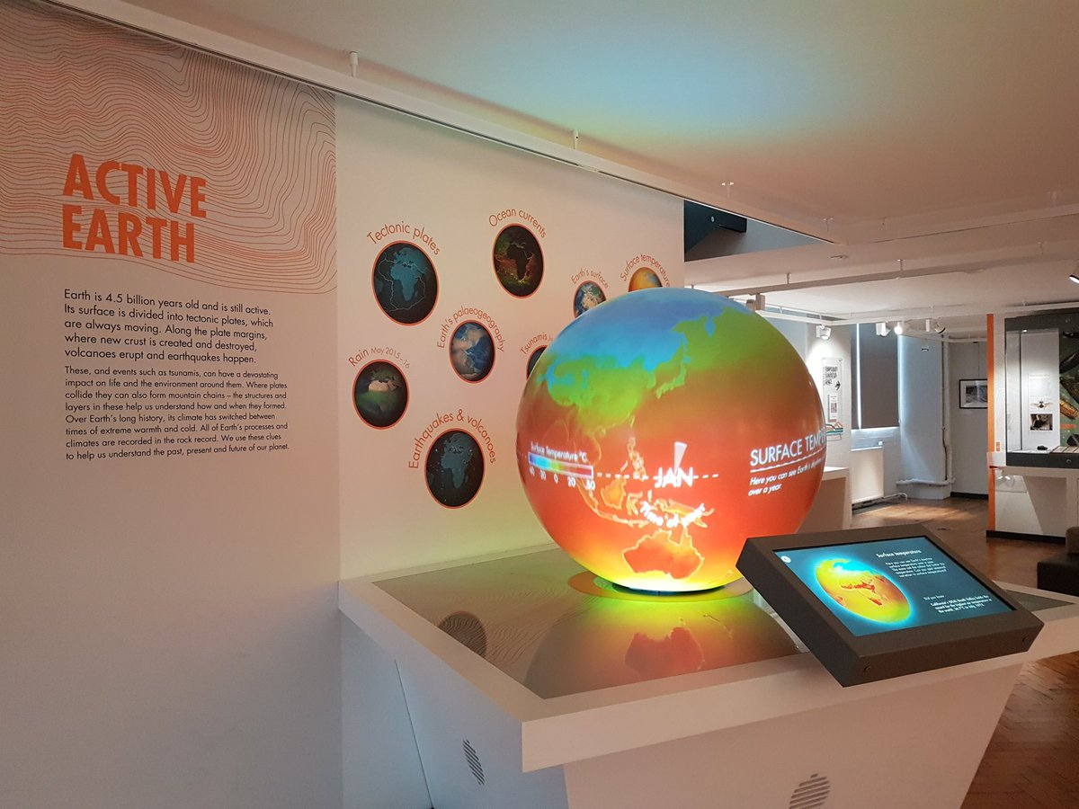
13. What is obsidian? (Hint: it is volcanic in origin)
__________________________________________

OR draw your favourite object here:
Bonus activity: what was your favourite object in the Museum and why?
________________________________________
________________________________________
________________________________________
________________________________________
________________________________________
20. What mineral looks orange under Longwave Ultraviolet Light?
_________________________________________
19. Which mineral is a purple variety of quartz?
___________________________________________
18. Which white mineral has the highest density?
___________________________________________
17. Find the mineral Pyrite. What shape and colour is it?
___________________________________________
Go upstairs to our Mineral Wealth Gallery
14. What are microfossils and what do they teach us about past climate change?
__________________________________________
__________________________________________
__________________________________________
__________________________________________
15. Look at the microfossils under the microscope. They come in lots of different shapes, draw an example of one below.
16. Where will you find the largest amount of ice in the world today?
_____________________________________________

12. What machine is used to measure earthquakes?
_____________________________________________

- Watch the Earth’s Palaeogeography clip on the Active Earth globe. At what time did the continents join to form the supercontinent Pangaea?
_______________________________
Find our Active Earth Gallery

