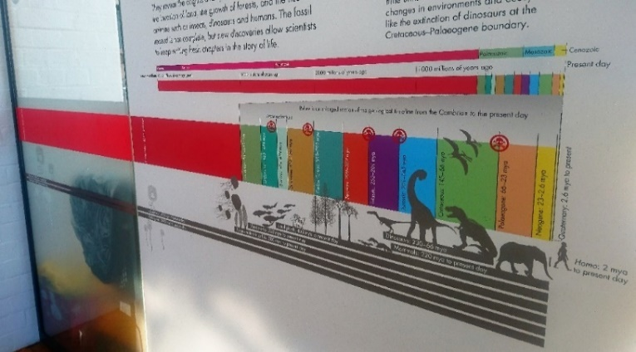
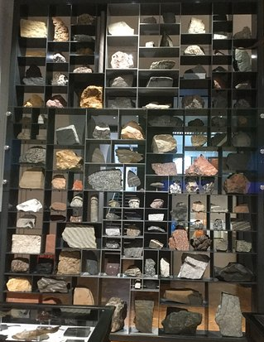

8. Why was ‘Archaeopteryx’ an important fossil discovery? (It is on display in the Jurassic case)
__________________________________________
7. What type of animals walked across the West Midlands during the Late Carboniferous?
______________________________
What traces did it leave behind?
________________________________________
11. Explain how each rock group is formed.
____________________________________________
____________________________________________
____________________________________________
____________________________________________
12. Find the sandstone with ripples on the Rock Wall. Describe how the ripples were formed:
____________________________________________
What environment(s) would you see ripples forming in today?
____________________________________________
- What type of animal is the Dudley bug? (Hint: it is found in the Silurian time period)
_______________________________
Examine our Rock Wall
9. What disastrous event happened at the end of the Cretaceous? What caused it?
_________________________________________
_________________________________________
_________________________________________
Name:
10. Rocks can be classified into 3 groups based on how they form. Name the 3 rock groups:
1. ______________________
2.______________________
3.________________________
- During the Carboniferous the West Midlands was covered by tropical forests and swamps. What fossil evidence is there for this?
______________________________
What rock type eventually formed from these forests?
________________________________________
- Describe the environment of the West Midlands during the Silurian period.
______________________________
What is the fossil evidence for this environment? (Look in the black Victorian cabinets behind you)
_________________________________________
_________________________________________
- Charles Lapworth named the Ordovician period. What important group of fossils did he study?
______________________________
- Where was the West Midlands located during the Precambrian period?
________________________________
- How old is the Earth?
________________________________
Find the start of our Geological Timeline in our Evolution of Life Gallery
Geology Trail
– KS4
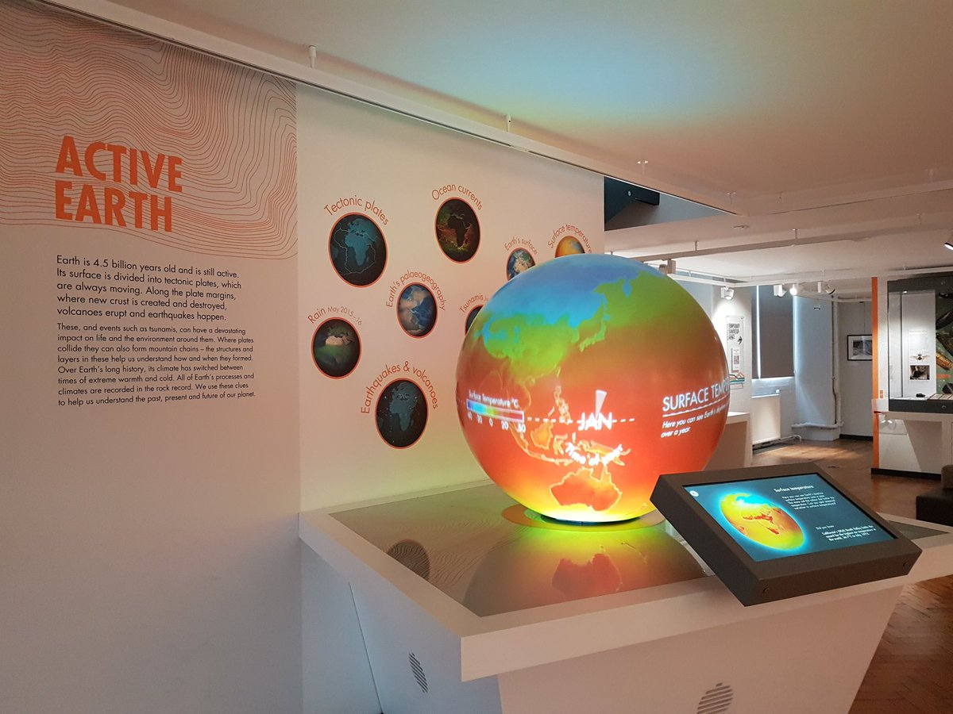
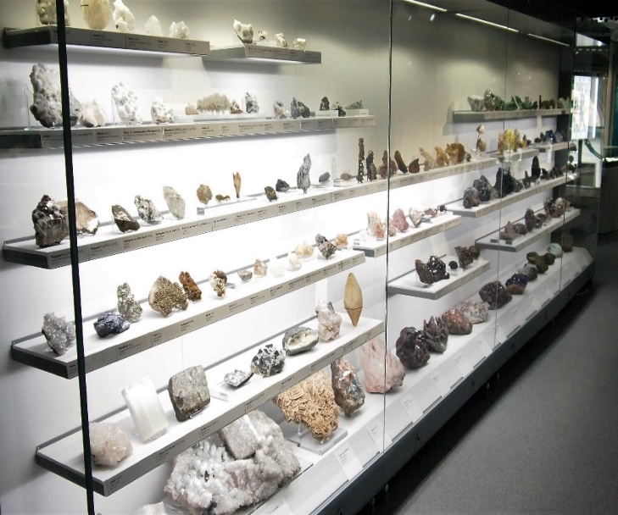
13. Watch the Earth’s tectonic plates clip and earthquakes and volcanoes clip on the Active Earth globe. Describe what controls the distribution of volcanoes and earthquakes.
_______________________________
_______________________________
14. Watch the 2011 Japan tsunami clip on the Active Earth Globe. Suggest a management strategy that countries could have used to decrease the hazard risk.
___________________________________________
___________________________________________
___________________________________________

15. What machine is used to measure earthquakes?
__________________________________________

23. Name five other properties you would use to help you identify a mineral.
________________________________________
________________________________________
________________________________________
________________________________________
22. Investigate the different physical properties that can be used to identify minerals. Try the mineral tests for density.
What is the densest mineral?
_________________________________________
21. Name 3 minerals which glow under ultraviolet light.
________________________________________
________________________________________
20. Read the information about mining in the Midlands. Lead mines have been worked in Shropshire since the Romans. What is the primary ore (mineral) of lead? What shape does the mineral grow in?
___________________________________________
19. What is the difference between rocks and minerals?
_________________________________________
___________________________________________
Go upstairs to our Mineral Wealth Gallery
18. Look at the microfossils under the microscope. What can studying microfossils tell us?
___________________________________________
___________________________________________
___________________________________________

17. Describe the type of volcanic eruption that would have ejected volcanic bombs and ash.
___________________________________________
___________________________________________

16. Name four different volcanic hazards.
__________________________________________
__________________________________________
Find our Active Earth Gallery

