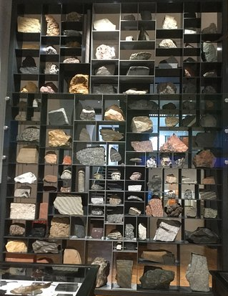
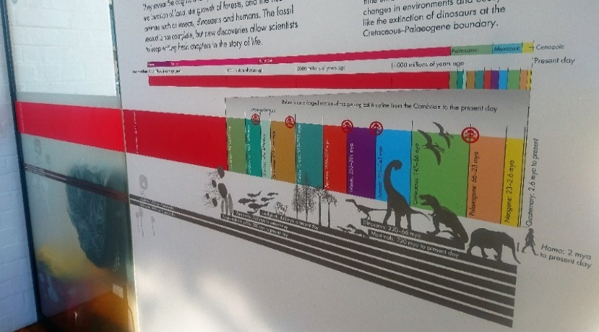
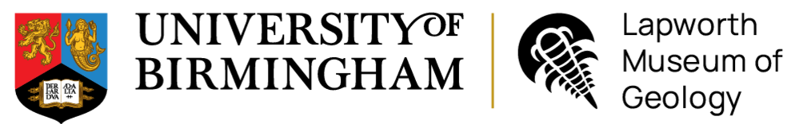
12. Look at all the rocks on the Rock Wall. Decide which type of rock would be best to use as:
A kitchen work surface
_________________________________________
Roof tiles
_________________________________________

11. Find the rock ‘Marble’ on the rock wall.
Which rock group does it belong to?
____________________________________________
Describe its colour and texture:
____________________________________________
10. Rocks can be classified into 3 groups based on how they form. Name the 3 rock groups:
1. ______________________
2.______________________
3.________________________
Examine our Rock Wall
Name:
9. What time period did the animal ‘Smilodon’ live in? Hint it has large teeth!
_________________________________________
- What type of animal walked across the West Midlands during the Late Carboniferous?
______________________________
What traces did it leave behind?
________________________________________
- Name three animals that would have lived in the Jurassic seas.
1. _______________________________________
2. _______________________________________
3. _______________________________________
- What happened to the dinosaurs at the end of the Cretaceous period? What caused this?
_________________________________________
_________________________________________
_________________________________________
- What type of animal is the Dudley bug? (Hint: it is found in the Silurian time period)
_______________________________
- During the Silurian time period, the West Midlands would have been under a shallow tropical sea. What animals would have lived there?
________________________________________________________________________________________________________________________
- Find the display case for the Ordovician time period. Look at the fossils of Graptolites, were they plants or animals?
______________________________
- What is the name of the first geological time period?
________________________________
- How old is the Earth?
________________________________
Find the start of our Geological Timeline in our Evolution of Life Gallery
Geology Trail
– Upper KS3
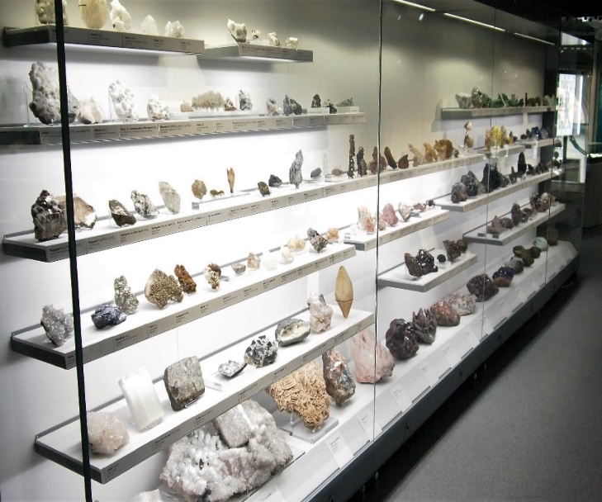
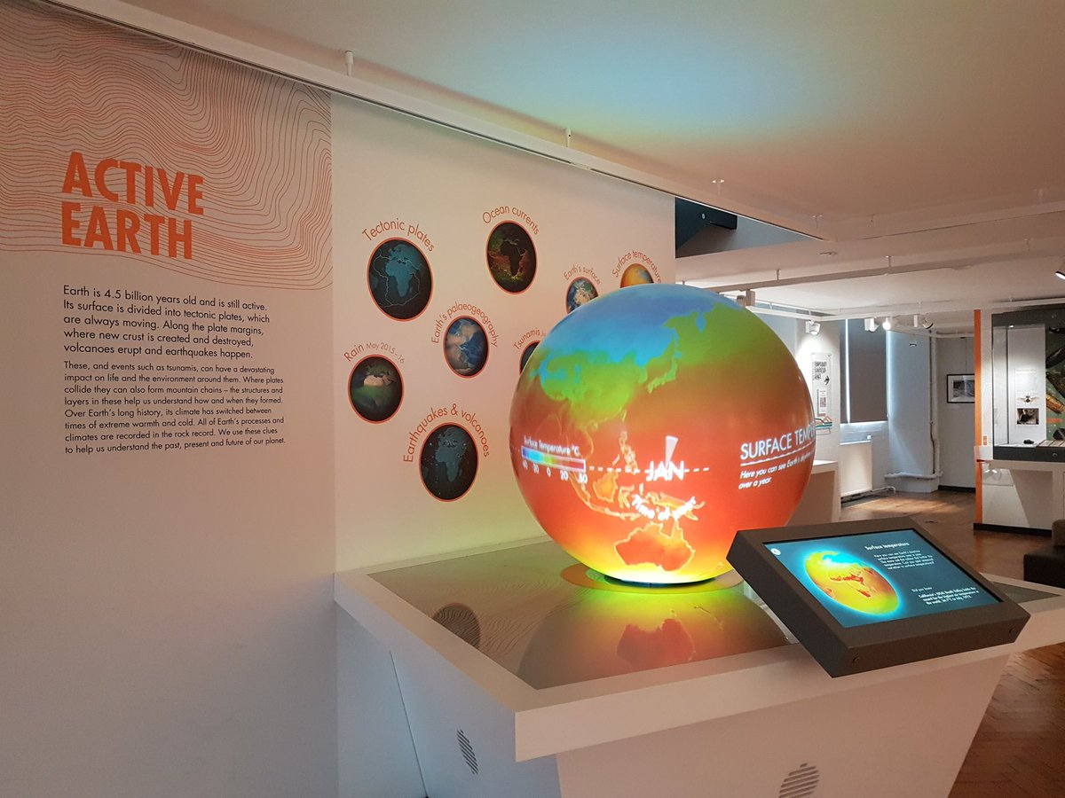
23. What mineral looks orange under Longwave Ultraviolet Light?
_________________________________________
22. Which mineral is a purple variety of quartz?
___________________________________________
21. Which white mineral has the highest density?
___________________________________________
20. Find the mineral Pyrite. What shape and colour is it?
___________________________________________
19. What is the difference between rocks and minerals?
___________________________________________
___________________________________________
Go upstairs to our Mineral Wealth Gallery
18. By how many centimetres will global sea level rise by the year 2100 if all global glaciers melt?
_____________________________________________

17. Where will you find the largest amount of ice in the world today?
_____________________________________________

15. What is obsidian? (Hint: it is volcanic in origin)
__________________________________________

OR draw your favourite object here:
Bonus activity: what was your favourite object in the Museum and why?
________________________________________
________________________________________
________________________________________
________________________________________
________________________________________
16. What are microfossils and what do they teach us about past climate change?
__________________________________________
__________________________________________
__________________________________________
__________________________________________
14. What machine is used to measure earthquakes?
_____________________________________________

13. Watch the Earth’s Palaeogeography clip on the Active Earth globe. At what time did the continents join to form the supercontinent Pangaea?
_______________________________
Find our Active Earth Gallery

