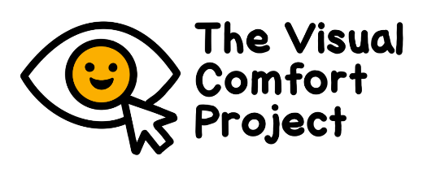
CHILD INFORMATION SHEET
Part 1: Rating images and videos

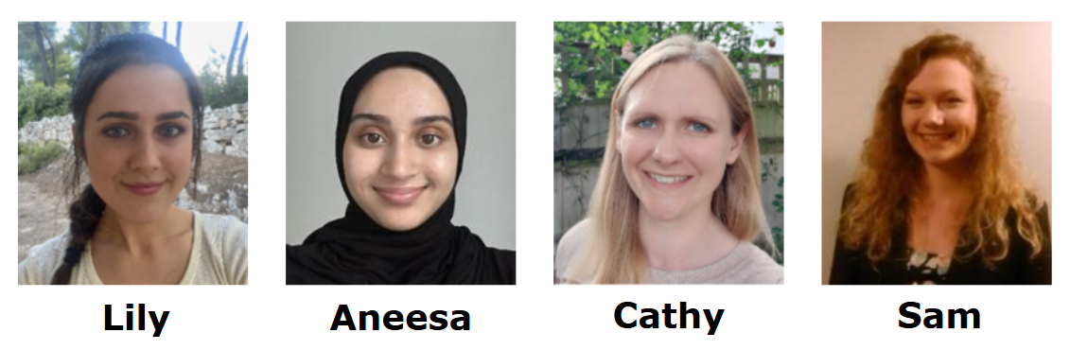
We are Lily Herbert, Aneesa Begum, Cathy Manning and Sam Tyler. We are researchers from the University of Birmingham.

We are inviting you to take part in our project. The project looks at how comfortable or uncomfortable young people find different images and videos to look at. This can help us make the world more comfortable for children in future.

What will I be asked to do if I take part?

We will invite you into the University of Birmingham, or somewhere else if needed. We will invite you to:

- Play a computer game. We will show you lots of images and videos. We will ask you to say how comfortable or uncomfortable you find them to look at, using a thermometer scale. There are no right or wrong answers.

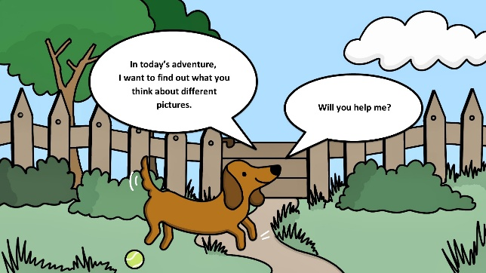
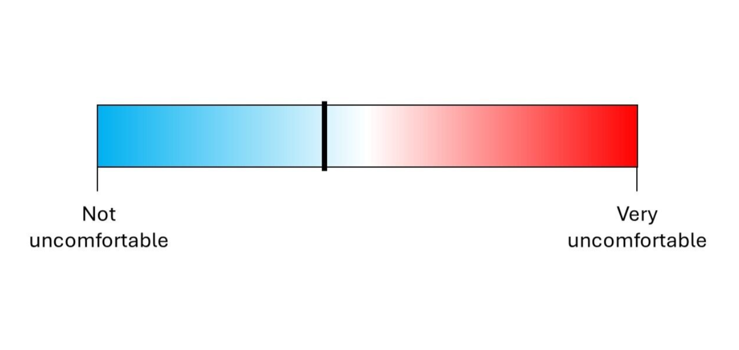

You can take an eye break at any point by pressing a button or telling the researcher. This will show you something you find nice to look at.

- Do some word games and puzzles

- Check your vision with some quick eye charts. You should bring your glasses with you if you need them.

- Answer some questions about how you see and feel about things.

We are doing these activities to find out more about how young people see things. It is not a test. We just want to know what you think.

Everything will take up to 2 hours. We can split the activities up with lots of breaks. You can tell the researcher if you need a break. We can also see you on different days for different activities.

What will I get if I take part?

At the end, you will get a personalised certificate. Your parent will be sent a £10 voucher. You will be helping future children, by telling us what visual information is comfortable or uncomfortable. This will mean we can design better schools, public spaces, and materials.

Do I have to take part?

No. It’s OK if you don’t want to take part. You don’t have to say why you don’t want to take part. If you ever want to take a break, or stop doing the project, just tell your parent or the researcher. We hope that the research will help us make the world more comfortable for you and other children.

What will happen to the results of the project?

We will keep your personal information (like your name) private. Only members of the project team will see it. Some information we collect from you will be kept and shared with other researchers, but we will not let anyone else see your personal information. Nobody will be able to tell that the information came from you.

What should I do next?

Ask your parent or the researcher if you have any questions. If you want to take part, your parent will be asked to fill in a form giving their permission. You will also be asked to fill in a form.

What if there is a problem?

If something goes wrong or you are worried about something, please talk to your parent about it, or a researcher in the pictures.

